Day - 1
Steps to be followed in Github (Pull and Push) -
- Install Git bash
- Install VS code
- Clone a repository locally
- Select GitHub Pull Requests and click on install.
- Created a folder “Devops_<your_rollno>” inside D:\Git Repository folder.
- To pull a repository -
  - In VS code , press Ctrl + Shift + P
  - Put Git:clone in search box:
  - Put the copied URL of your Github repo and click on “Copy from URL ...”
  - Created a folder inside D:\Git Repository folder.
  - Open a folder and select the folder named “Devops_<your_rollno>” and click “Select as Repository Destination
  - Click on “Open” if it asks. You can also add it into current VsCode workspace as well.
  - Check mark on – “Trust the authors of ...” and click on “Yes, I trust the authors”

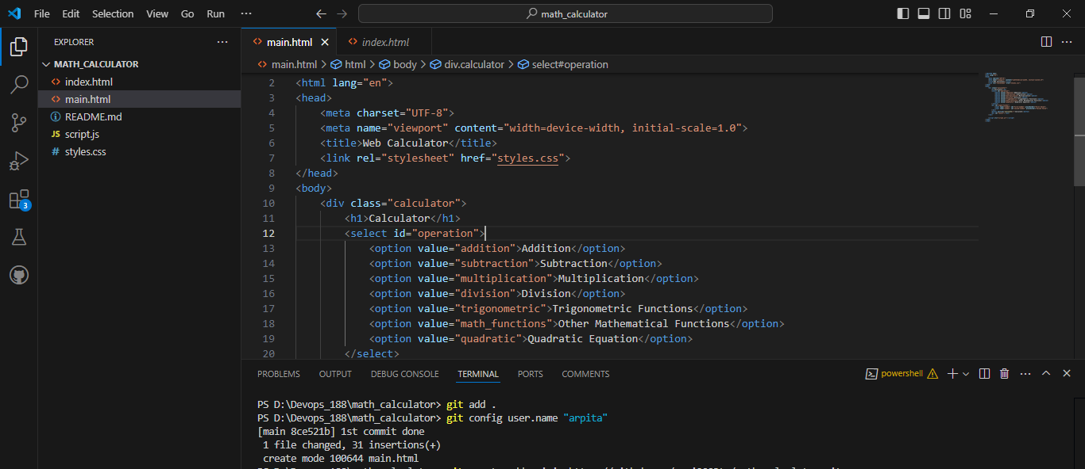
- To push a repository -
  - git add .
  - git config user.name “arpita”
  - git config user.email “natharpita2004@gmail.com”
  - git commit -m “1st commit done”
  - git push
  - It will ask for authentication from browser.
