Day 3
Chocolatey Software -> Main -> Looking For Packages? -> Search the software that u want to install in the search box

Windows PowerShell
Copyright (C) Microsoft Corporation. All rights reserved.

Try the new cross-platform PowerShell https://aka.ms/pscore6

PS C:\Windows\system32> choco install virtualbox
Chocolatey v2.5.0
Installing the following packages:
virtualbox
By installing, you accept licenses for the packages.
Downloading package from source 'https://community.chocolatey.org/api/v2/'
Progress: Downloading virtualbox 7.1.12... 100%

virtualbox v7.1.12 [Approved]
virtualbox package files install completed. Performing other installation steps.
The package virtualbox wants to run 'chocolateyInstall.ps1'.
Note: If you don't run this script, the installation will fail.
Note: To confirm automatically next time, use '-y' or consider:
choco feature enable -n allowGlobalConfirmation
Do you want to run the script?([Y]es/[A]ll scripts/[N]o/[P]rint): A

Downloading virtualbox 64 bit
from 'https://download.virtualbox.org/virtualbox/7.1.12/VirtualBox-7.1.12-169651-Win.exe'
Progress: 100% - Completed download of C:\Users\DevOps\AppData\Local\Temp\chocolatey\virtualbox\7.1.12\VirtualBox-7.1.12-169651-Win.exe (118.67 MB).
Download of VirtualBox-7.1.12-169651-Win.exe (118.67 MB) completed.
Hashes match.
Installing virtualbox...
virtualbox has been installed.
Adding to PATH if needed
virtualbox installed to 'C:\Program Files\Oracle\VirtualBox'
virtualbox registered as vbox
virtualbox may be able to be automatically uninstalled.
The install of virtualbox was successful.
Software installed as 'EXE', install location is likely default.

Chocolatey installed 1/1 packages.
See the log for details (C:\ProgramData\chocolatey\logs\chocolatey.log).
PS C:\Windows\system32> choco list
Chocolatey v2.5.0
chocolatey 2.5.0
chocolatey-compatibility.extension 1.0.0
chocolatey-core.extension 1.4.0
chocolatey-windowsupdate.extension 1.0.5
KB2919355 1.0.20160915
KB2919442 1.0.20160915
KB2999226 1.0.20181019
KB3033929 1.0.5
KB3035131 1.0.3
vcredist140 14.44.35211
virtualbox 7.1.12
11 packages installed.
PS C:\Windows\system32> choco install vagrant
Chocolatey v2.5.0
Installing the following packages:
vagrant
By installing, you accept licenses for the packages.
Downloading package from source 'https://community.chocolatey.org/api/v2/'
Progress: Downloading vagrant 2.4.7... 100%

vagrant v2.4.7 [Approved]
vagrant package files install completed. Performing other installation steps.
The package vagrant wants to run 'chocolateyinstall.ps1'.
Note: If you don't run this script, the installation will fail.
Note: To confirm automatically next time, use '-y' or consider:
choco feature enable -n allowGlobalConfirmation
Do you want to run the script?([Y]es/[A]ll scripts/[N]o/[P]rint): A

Downloading vagrant 64 bit
from 'https://releases.hashicorp.com/vagrant/2.4.7/vagrant_2.4.7_windows_amd64.msi'
Progress: 100% - Completed download of C:\Users\DevOps\AppData\Local\Temp\chocolatey\vagrant\2.4.7\vagrant_2.4.7_windows_amd64.msi (233.32 MB).
Download of vagrant_2.4.7_windows_amd64.msi (233.32 MB) completed.
Hashes match.
Installing vagrant...
vagrant has been installed.
Updating installed plugins...
All plugins are up to date.
Repairing currently installed global plugins. This may take a few minutes...
Installed plugins successfully repaired!
vagrant may be able to be automatically uninstalled.
Environment Vars (like PATH) have changed. Close/reopen your shell to
see the changes (or in powershell/cmd.exe just type `refreshenv`).
The install of vagrant was successful.
Software installed as 'msi', install location is likely default.

Chocolatey installed 1/1 packages.
See the log for details (C:\ProgramData\chocolatey\logs\chocolatey.log).

Packages requiring reboot:
- vagrant (exit code 3010)

The recent package changes indicate a reboot is necessary.
Please reboot at your earliest convenience.

Enjoy using Chocolatey? Explore more amazing features to take your
experience to the next level at
https://chocolatey.org/compare
PS C:\Windows\system32> choco list
Chocolatey v2.5.0
chocolatey 2.5.0
chocolatey-compatibility.extension 1.0.0
chocolatey-core.extension 1.4.0
chocolatey-windowsupdate.extension 1.0.5
KB2919355 1.0.20160915
KB2919442 1.0.20160915
KB2999226 1.0.20181019
KB3033929 1.0.5
KB3035131 1.0.3
vagrant 2.4.7
vcredist140 14.44.35211
virtualbox 7.1.12
12 packages installed.
PS C:\Windows\system32> choco install git
Chocolatey v2.5.0
Installing the following packages:
git
By installing, you accept licenses for the packages.
Downloading package from source 'https://community.chocolatey.org/api/v2/'
Progress: Downloading git.install 2.50.1... 100%

git.install v2.50.1 [Approved]
git.install package files install completed. Performing other installation steps.
The package git.install wants to run 'chocolateyInstall.ps1'.
Note: If you don't run this script, the installation will fail.
Note: To confirm automatically next time, use '-y' or consider:
choco feature enable -n allowGlobalConfirmation
Do you want to run the script?([Y]es/[A]ll scripts/[N]o/[P]rint): A

Using Git LFS
Installing 64-bit git.install...
git.install has been installed.
git.install installed to 'C:\Program Files\Git'
git.install can be automatically uninstalled.
Environment Vars (like PATH) have changed. Close/reopen your shell to
see the changes (or in powershell/cmd.exe just type `refreshenv`).
The install of git.install was successful.
Deployed to 'C:\Program Files\Git\'
Downloading package from source 'https://community.chocolatey.org/api/v2/'
Progress: Downloading git 2.50.1... 100%

git v2.50.1 [Approved]
git package files install completed. Performing other installation steps.
The install of git was successful.
Deployed to 'C:\ProgramData\chocolatey\lib\git'

Chocolatey installed 2/2 packages.
See the log for details (C:\ProgramData\chocolatey\logs\chocolatey.log).
PS C:\Windows\system32> choco list
Chocolatey v2.5.0
chocolatey 2.5.0
chocolatey-compatibility.extension 1.0.0
chocolatey-core.extension 1.4.0
chocolatey-windowsupdate.extension 1.0.5
git 2.50.1
git.install 2.50.1
KB2919355 1.0.20160915
KB2919442 1.0.20160915
KB2999226 1.0.20181019
KB3033929 1.0.5
KB3035131 1.0.3
vagrant 2.4.7
vcredist140 14.44.35211
virtualbox 7.1.12
14 packages installed.
PS C:\Windows\system32>

HashiCorp Cloud Platform
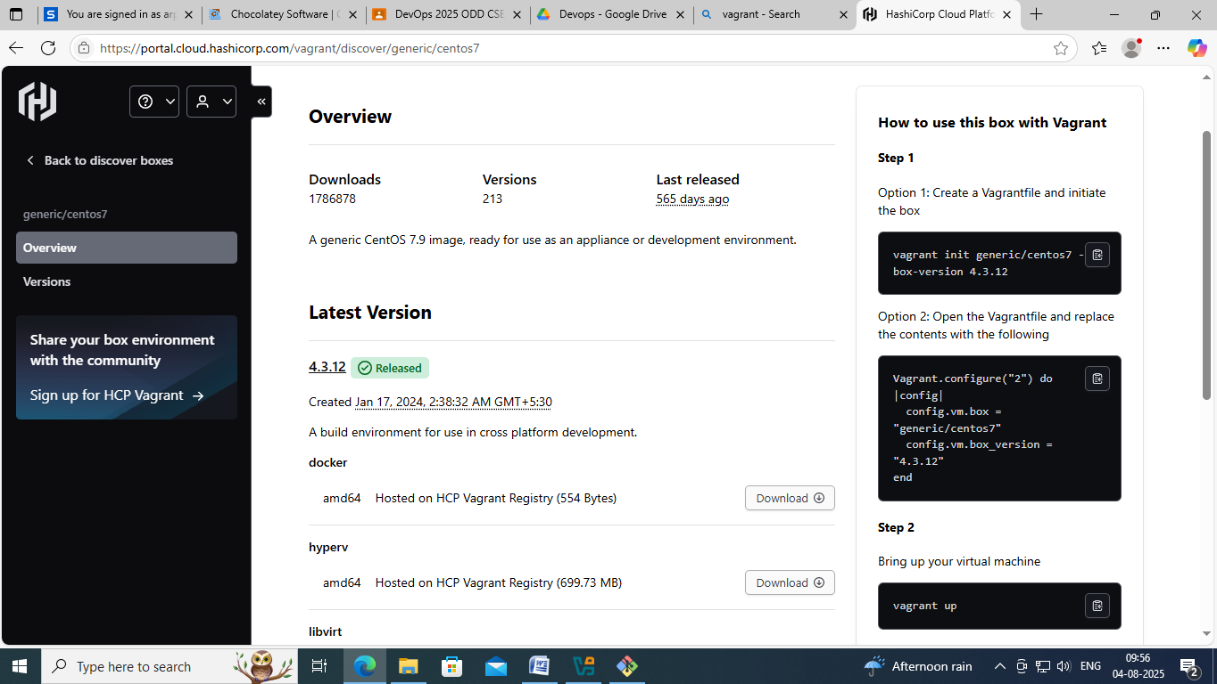

In Git Bash ->

DevOps@DESKTOP-Q6VS425 MINGW64 ~
$ cd d:

DevOps@DESKTOP-Q6VS425 MINGW64 /d
$ cd Arpita_188/

DevOps@DESKTOP-Q6VS425 MINGW64 /d/Arpita_188
$ mkdir centos

DevOps@DESKTOP-Q6VS425 MINGW64 /d/Arpita_188
$ cd centos/

DevOps@DESKTOP-Q6VS425 MINGW64 /d/Arpita_188/centos
$ vagrant init generic/centos7 --box-version 4.3.12
A `Vagrantfile` has been placed in this directory. You are now
ready to `vagrant up` your first virtual environment! Please read
the comments in the Vagrantfile as well as documentation on
`vagrantup.com` for more information on using Vagrant.

DevOps@DESKTOP-Q6VS425 MINGW64 /d/Arpita_188/centos
$ ls
Vagrantfile

DevOps@DESKTOP-Q6VS425 MINGW64 /d/Arpita_188/centos
$ cat Vagrantfile
DevOps@DESKTOP-Q6VS425 MINGW64 /d/Arpita_188/centos
$ cat Vagrantfile
# -*- mode: ruby -*-
# vi: set ft=ruby :

# All Vagrant configuration is done below. The "2" in Vagrant.configure
# configures the configuration version (we support older styles for
# backwards compatibility). Please don't change it unless you know what
# you're doing.
Vagrant.configure("2") do |config|
# The most common configuration options are documented and commented below.
# For a complete reference, please see the online documentation at
# https://docs.vagrantup.com.

# Every Vagrant development environment requires a box. You can search for
# boxes at https://vagrantcloud.com/search.
config.vm.box = "generic/centos7"
config.vm.box_version = "4.3.12"

# Disable automatic box update checking. If you disable this, then
# boxes will only be checked for updates when the user runs
# `vagrant box outdated`. This is not recommended.
# config.vm.box_check_update = false

# Create a forwarded port mapping which allows access to a specific port
# within the machine from a port on the host machine. In the example below,
# accessing "localhost:8080" will access port 80 on the guest machine.
# NOTE: This will enable public access to the opened port
# config.vm.network "forwarded_port", guest: 80, host: 8080

# Create a forwarded port mapping which allows access to a specific port
# within the machine from a port on the host machine and only allow access
# via 127.0.0.1 to disable public access
# config.vm.network "forwarded_port", guest: 80, host: 8080, host_ip: "127.0.0.1"

# Create a private network, which allows host-only access to the machine
# using a specific IP.
# config.vm.network "private_network", ip: "192.168.33.10"

# Create a public network, which generally matched to bridged network.
# Bridged networks make the machine appear as another physical device on
# your network.
# config.vm.network "public_network"

# Share an additional folder to the guest VM. The first argument is
# the path on the host to the actual folder. The second argument is
# the path on the guest to mount the folder. And the optional third
# argument is a set of non-required options.
# config.vm.synced_folder "../data", "/vagrant_data"

# Disable the default share of the current code directory. Doing this
# provides improved isolation between the vagrant box and your host
# by making sure your Vagrantfile isn't accessible to the vagrant box.
# If you use this you may want to enable additional shared subfolders as
# shown above.
# config.vm.synced_folder ".", "/vagrant", disabled: true

# Provider-specific configuration so you can fine-tune various
# backing providers for Vagrant. These expose provider-specific options.
# Example for VirtualBox:
#
# config.vm.provider "virtualbox" do |vb|
# # Display the VirtualBox GUI when booting the machine
# vb.gui = true
#
# # Customize the amount of memory on the VM:
# vb.memory = "1024"
# end
#
# View the documentation for the provider you are using for more
# information on available options.

# Enable provisioning with a shell script. Additional provisioners such as
# Ansible, Chef, Docker, Puppet and Salt are also available. Please see the
# documentation for more information about their specific syntax and use.
# config.vm.provision "shell", inline: <<-SHELL
# apt-get update
# apt-get install -y apache2
# SHELL
end

DevOps@DESKTOP-Q6VS425 MINGW64 /d/Arpita_188/centos
$

Note

config.vm.box = "generic/centos7"
config.vm.box_version = "4.3.12"
we can manually change this box name

DevOps@DESKTOP-Q6VS425 MINGW64 /d/Arpita_188/centos
$ vagrant up
The checksum of the downloaded box did not match the expected
value. Please verify that you have the proper URL setup and that
you're downloading the proper file.

Expected: cc3f526b61b3647dd5c35922824cf8cad04bca2fb25577bca8992eb5c84ab4b6
Received: 2fce5e5974ff5f59504dbc6c653f2b927edec0c4a1f66ff587a417aba109a680
Bringing machine 'default' up with 'virtualbox' provider...
==> default: Box 'generic/centos7' could not be found. Attempting to find and install...
default: Box Provider: virtualbox
default: Box Version: 4.3.12
==> default: Loading metadata for box 'generic/centos7'
default: URL: https://vagrantcloud.com/api/v2/vagrant/generic/centos7
==> default: Adding box 'generic/centos7' (v4.3.12) for provider: virtualbox (amd64)
default: Downloading: https://vagrantcloud.com/generic/boxes/centos7/versions/4.3.12/providers/virtualbox/amd64/vagrant.box
==> default: Box download is resuming from prior download progress
default:
default: Calculating and comparing box checksum...
==> default: Successfully added box 'generic/centos7' (v4.3.12) for 'virtualbox (amd64)'!
==> default: Importing base box 'generic/centos7'...
==> default: Matching MAC address for NAT networking...
==> default: Checking if box 'generic/centos7' version '4.3.12' is up to date...
==> default: Setting the name of the VM: centos_default_1754282748265_34917
==> default: Clearing any previously set network interfaces...
==> default: Preparing network interfaces based on configuration...
default: Adapter 1: nat
==> default: Forwarding ports...
default: 22 (guest) => 2222 (host) (adapter 1)
==> default: Running 'pre-boot' VM customizations...
==> default: Booting VM...
==> default: Waiting for machine to boot. This may take a few minutes...
default: SSH address: 127.0.0.1:2222
default: SSH username: vagrant
default: SSH auth method: private key
default:
default: Vagrant insecure key detected. Vagrant will automatically replace
default: this with a newly generated keypair for better security.
default:
default: Inserting generated public key within guest...
default: Removing insecure key from the guest if it's present...
default: Key inserted! Disconnecting and reconnecting using new SSH key...
==> default: Machine booted and ready!
==> default: Checking for guest additions in VM...
default: The guest additions on this VM do not match the installed version of
default: VirtualBox! In most cases this is fine, but in rare cases it can
default: prevent things such as shared folders from working properly. If you see
default: shared folder errors, please make sure the guest additions within the
default: virtual machine match the version of VirtualBox you have installed on
default: your host and reload your VM.
default:
default: Guest Additions Version: 5.2.44
default: VirtualBox Version: 7.1

DevOps@DESKTOP-Q6VS425 MINGW64 /d/Arpita_188/centos
$ vagrant status
Current machine states:

default running (virtualbox)

The VM is running. To stop this VM, you can run `vagrant halt` to
shut it down forcefully, or you can run `vagrant suspend` to simply
suspend the virtual machine. In either case, to restart it again,
simply run `vagrant up`.

DevOps@DESKTOP-Q6VS425 MINGW64 /d/Arpita_188/centos
$
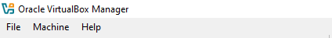

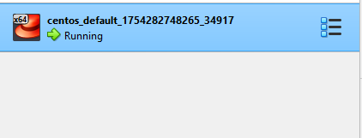

DevOps@DESKTOP-Q6VS425 MINGW64 /d/Arpita_188/centos
$ vagrant ssh
[vagrant@centos7 ~]$ mkdir Arpita_188
[vagrant@centos7 ~]$ cd Arpita_188
[vagrant@centos7 Arpita_188]$ pwd
/home/vagrant/Arpita_188
[vagrant@centos7 Arpita_188]$exit
logout
DevOps@DESKTOP-Q6VS425 MINGW64 /d/Arpita_188/centos
$ vagrant status
Current machine states:

default running (virtualbox)

The VM is running. To stop this VM, you can run `vagrant halt` to
shut it down forcefully, or you can run `vagrant suspend` to simply
suspend the virtual machine. In either case, to restart it again,
simply run `vagrant up`.

DevOps@DESKTOP-Q6VS425 MINGW64 /d/Arpita_188/centos
$ vagrant halt
==> default: Attempting graceful shutdown of VM...
Connection to 127.0.0.1 closed by remote host.
Connection to 127.0.0.1 closed by remote host.

DevOps@DESKTOP-Q6VS425 MINGW64 /d/Arpita_188/centos
$ vagrant status
Current machine states:

default poweroff (virtualbox)

The VM is powered off. To restart the VM, simply run `vagrant up`

DevOps@DESKTOP-Q6VS425 MINGW64 /d/Arpita_188/centos
$ vagrant up
Bringing machine 'default' up with 'virtualbox' provider...
==> default: Checking if box 'generic/centos7' version '4.3.12' is up to date...
==> default: Clearing any previously set forwarded ports...
==> default: Clearing any previously set network interfaces...
==> default: Preparing network interfaces based on configuration...
default: Adapter 1: nat
==> default: Forwarding ports...
default: 22 (guest) => 2222 (host) (adapter 1)
==> default: Running 'pre-boot' VM customizations...
==> default: Booting VM...
==> default: Waiting for machine to boot. This may take a few minutes...
default: SSH address: 127.0.0.1:2222
default: SSH username: vagrant
default: SSH auth method: private key
==> default: Machine booted and ready!
==> default: Checking for guest additions in VM...
default: The guest additions on this VM do not match the installed version of
default: VirtualBox! In most cases this is fine, but in rare cases it can
default: prevent things such as shared folders from working properly. If you see
default: shared folder errors, please make sure the guest additions within the
default: virtual machine match the version of VirtualBox you have installed on
default: your host and reload your VM.
default:
default: Guest Additions Version: 5.2.44
default: VirtualBox Version: 7.1
==> default: Machine already provisioned. Run `vagrant provision` or use the `--provision`
==> default: flag to force provisioning. Provisioners marked to run always will still run.

DevOps@DESKTOP-Q6VS425 MINGW64 /d/Arpita_188/centos
$ vagrant ssh
Last login: Mon Aug 4 04:52:44 2025 from 10.0.2.2
[vagrant@centos7 ~]$ ls
Arpita_188
[vagrant@centos7 ~]$ exit
logout

DevOps@DESKTOP-Q6VS425 MINGW64 /d/Arpita_188/centos
$ vagrant status
Current machine states:

default running (virtualbox)

The VM is running. To stop this VM, you can run `vagrant halt` to
shut it down forcefully, or you can run `vagrant suspend` to simply
suspend the virtual machine. In either case, to restart it again,
simply run `vagrant up`.

DevOps@DESKTOP-Q6VS425 MINGW64 /d/Arpita_188/centos
$ vagrant halt
==> default: Attempting graceful shutdown of VM...

DevOps@DESKTOP-Q6VS425 MINGW64 /d/Arpita_188/centos
$ vagrant status
Current machine states:

default poweroff (virtualbox)

The VM is powered off. To restart the VM, simply run `vagrant up`

DevOps@DESKTOP-Q6VS425 MINGW64 /d/Arpita_188/centos
$
DevOps@DESKTOP-Q6VS425 MINGW64 /d/Arpita_188/centos
$ vagrant up
Bringing machine 'default' up with 'virtualbox' provider...
==> default: Checking if box 'generic/centos7' version '4.3.12' is up to date...
==> default: Clearing any previously set forwarded ports...
==> default: Clearing any previously set network interfaces...
==> default: Preparing network interfaces based on configuration...
default: Adapter 1: nat
==> default: Forwarding ports...
default: 22 (guest) => 2222 (host) (adapter 1)
==> default: Running 'pre-boot' VM customizations...
==> default: Booting VM...
==> default: Waiting for machine to boot. This may take a few minutes...
default: SSH address: 127.0.0.1:2222
default: SSH username: vagrant
default: SSH auth method: private key
==> default: Machine booted and ready!
==> default: Checking for guest additions in VM...
default: The guest additions on this VM do not match the installed version of
default: VirtualBox! In most cases this is fine, but in rare cases it can
default: prevent things such as shared folders from working properly. If you see
default: shared folder errors, please make sure the guest additions within the
default: virtual machine match the version of VirtualBox you have installed on
default: your host and reload your VM.
default:
default: Guest Additions Version: 5.2.44
default: VirtualBox Version: 7.1
==> default: Machine already provisioned. Run `vagrant provision` or use the `--provision`
==> default: flag to force provisioning. Provisioners marked to run always will still run.

DevOps@DESKTOP-Q6VS425 MINGW64 /d/Arpita_188/centos
$ vagrant halt
==> default: Attempting graceful shutdown of VM...

DevOps@DESKTOP-Q6VS425 MINGW64 /d/Arpita_188/centos
$ ls
Vagrantfile

DevOps@DESKTOP-Q6VS425 MINGW64 /d/Arpita_188/centos
$ cat Vagrantfile
# -*- mode: ruby -*-
# vi: set ft=ruby :

# All Vagrant configuration is done below. The "2" in Vagrant.configure
# configures the configuration version (we support older styles for
# backwards compatibility). Please don't change it unless you know what
# you're doing.
Vagrant.configure("2") do |config|
# The most common configuration options are documented and commented below.
# For a complete reference, please see the online documentation at
# https://docs.vagrantup.com.

# Every Vagrant development environment requires a box. You can search for
# boxes at https://vagrantcloud.com/search.
config.vm.box = "generic/centos7"
config.vm.box_version = "4.3.12"

# Disable automatic box update checking. If you disable this, then
# boxes will only be checked for updates when the user runs
# `vagrant box outdated`. This is not recommended.
# config.vm.box_check_update = false

# Create a forwarded port mapping which allows access to a specific port
# within the machine from a port on the host machine. In the example below,
# accessing "localhost:8080" will access port 80 on the guest machine.
# NOTE: This will enable public access to the opened port
# config.vm.network "forwarded_port", guest: 80, host: 8080

# Create a forwarded port mapping which allows access to a specific port
# within the machine from a port on the host machine and only allow access
# via 127.0.0.1 to disable public access
# config.vm.network "forwarded_port", guest: 80, host: 8080, host_ip: "127.0.0.1"

# Create a private network, which allows host-only access to the machine
# using a specific IP.
# config.vm.network "private_network", ip: "192.168.33.10"

# Create a public network, which generally matched to bridged network.
# Bridged networks make the machine appear as another physical device on
# your network.
# config.vm.network "public_network"

# Share an additional folder to the guest VM. The first argument is
# the path on the host to the actual folder. The second argument is
# the path on the guest to mount the folder. And the optional third
# argument is a set of non-required options.
# config.vm.synced_folder "../data", "/vagrant_data"

# Disable the default share of the current code directory. Doing this
# provides improved isolation between the vagrant box and your host
# by making sure your Vagrantfile isn't accessible to the vagrant box.
# If you use this you may want to enable additional shared subfolders as
# shown above.
# config.vm.synced_folder ".", "/vagrant", disabled: true

# Provider-specific configuration so you can fine-tune various
# backing providers for Vagrant. These expose provider-specific options.
# Example for VirtualBox:
#
# config.vm.provider "virtualbox" do |vb|
# # Display the VirtualBox GUI when booting the machine
# vb.gui = true
#
# # Customize the amount of memory on the VM:
# vb.memory = "1024"
# end
#
# View the documentation for the provider you are using for more
# information on available options.

# Enable provisioning with a shell script. Additional provisioners such as
# Ansible, Chef, Docker, Puppet and Salt are also available. Please see the
# documentation for more information about their specific syntax and use.
# config.vm.provision "shell", inline: <<-SHELL
# apt-get update
# apt-get install -y apache2
# SHELL
end

DevOps@DESKTOP-Q6VS425 MINGW64 /d/Arpita_188/centos
$ code Vagrantfile

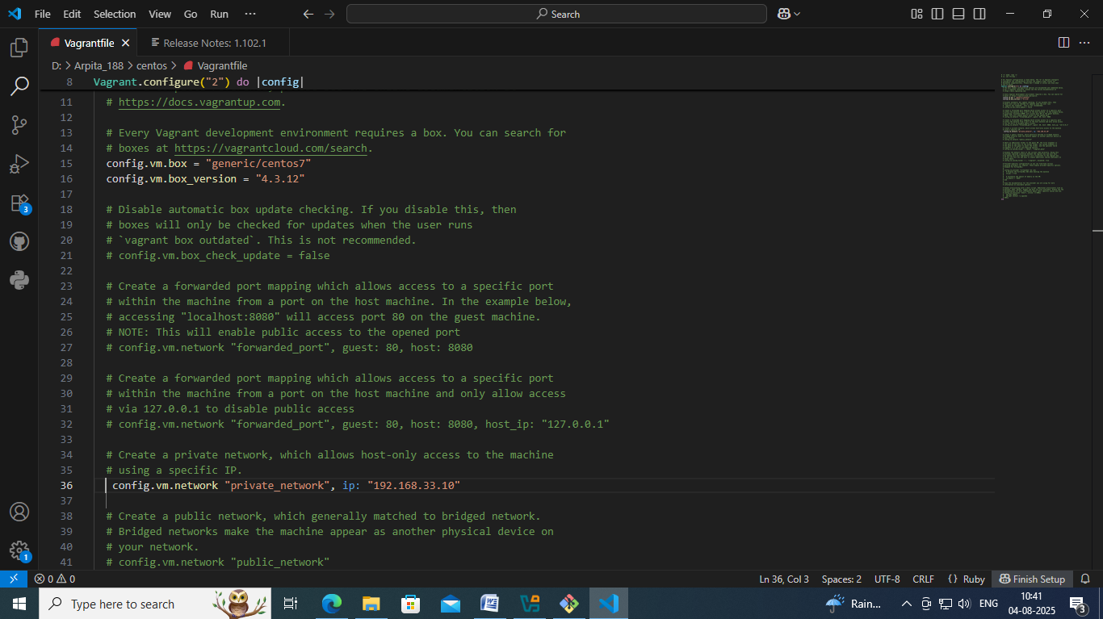
DevOps@DESKTOP-Q6VS425 MINGW64 /d/Arpita_188/centos
$ vagrant reload
==> default: Checking if box 'generic/centos7' version '4.3.12' is up to date...
==> default: Clearing any previously set forwarded ports...
==> default: Clearing any previously set network interfaces...
==> default: Preparing network interfaces based on configuration...
default: Adapter 1: nat
default: Adapter 2: hostonly
==> default: Forwarding ports...
default: 22 (guest) => 2222 (host) (adapter 1)
==> default: Running 'pre-boot' VM customizations...
==> default: Booting VM...
==> default: Waiting for machine to boot. This may take a few minutes...
default: SSH address: 127.0.0.1:2222
default: SSH username: vagrant
default: SSH auth method: private key
default: Warning: Connection reset. Retrying...
default: Warning: Connection aborted. Retrying...
default: Warning: Remote connection disconnect. Retrying...
default: Warning: Connection aborted. Retrying...
default: Warning: Connection reset. Retrying...
default: Warning: Connection aborted. Retrying...
default: Warning: Connection reset. Retrying...
==> default: Machine booted and ready!
==> default: Checking for guest additions in VM...
default: The guest additions on this VM do not match the installed version of
default: VirtualBox! In most cases this is fine, but in rare cases it can
default: prevent things such as shared folders from working properly. If you see
default: shared folder errors, please make sure the guest additions within the
default: virtual machine match the version of VirtualBox you have installed on
default: your host and reload your VM.
default:
default: Guest Additions Version: 5.2.44
default: VirtualBox Version: 7.1
==> default: Configuring and enabling network interfaces...
==> default: Machine already provisioned. Run `vagrant provision` or use the `--provision`
==> default: flag to force provisioning. Provisioners marked to run always will still run.

DevOps@DESKTOP-Q6VS425 MINGW64 /d/Arpita_188/centos
$ vagrant status
Current machine states:

default running (virtualbox)

The VM is running. To stop this VM, you can run `vagrant halt` to
shut it down forcefully, or you can run `vagrant suspend` to simply
suspend the virtual machine. In either case, to restart it again,
simply run `vagrant up`.

DevOps@DESKTOP-Q6VS425 MINGW64 /d/Arpita_188/centos
$
DevOps@DESKTOP-Q6VS425 MINGW64 /d/Arpita_188/centos
$ vagrant ssh
Last login: Mon Aug 4 05:02:17 2025 from 10.0.2.2
[vagrant@centos7 ~]$ ls
Arpita_188
[vagrant@centos7 ~]$ exit
logout

DevOps@DESKTOP-Q6VS425 MINGW64 /d/Arpita_188/centos
$ vagrant halt
==> default: Attempting graceful shutdown of VM...

DevOps@DESKTOP-Q6VS425 MINGW64 /d/Arpita_188/centos
$ vagrant status
Current machine states:

default poweroff (virtualbox)

The VM is powered off. To restart the VM, simply run `vagrant up`

DevOps@DESKTOP-Q6VS425 MINGW64 /d/Arpita_188/centos
$ vagrant destroy
default: Are you sure you want to destroy the 'default' VM? [y/N] y
==> default: Destroying VM and associated drives...

DevOps@DESKTOP-Q6VS425 MINGW64 /d/Arpita_188/centos
$
Server will be deleted
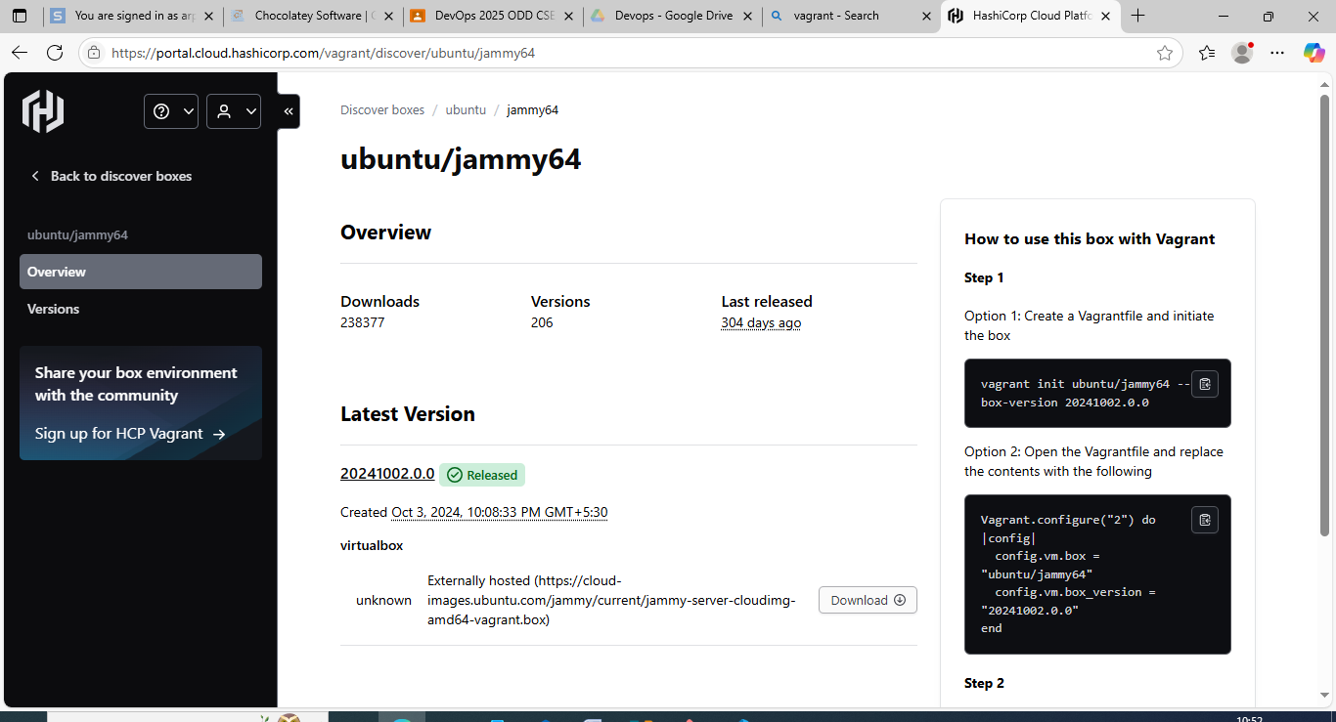
DevOps@DESKTOP-Q6VS425 MINGW64 /d/Arpita_188/centos
$ cd ..

DevOps@DESKTOP-Q6VS425 MINGW64 /d/Arpita_188
$ mkdir ubuntu_jammy

DevOps@DESKTOP-Q6VS425 MINGW64 /d/Arpita_188
$ cd ubuntu_jammy

DevOps@DESKTOP-Q6VS425 MINGW64 /d/Arpita_188/ubuntu_jammy
$ pwd
/d/Arpita_188/ubuntu_jammy

DevOps@DESKTOP-Q6VS425 MINGW64 /d/Arpita_188/ubuntu_jammy
$ ls

DevOps@DESKTOP-Q6VS425 MINGW64 /d/Arpita_188/ubuntu_jammy
$ vagrant init ubuntu/jammy64 --box-version 20241002.0.0
A `Vagrantfile` has been placed in this directory. You are now
ready to `vagrant up` your first virtual environment! Please read
the comments in the Vagrantfile as well as documentation on
`vagrantup.com` for more information on using Vagrant.

DevOps@DESKTOP-Q6VS425 MINGW64 /d/Arpita_188/ubuntu_jammy
$ vagrant up
Bringing machine 'default' up with 'virtualbox' provider...
==> default: Box 'ubuntu/jammy64' could not be found. Attempting to find and install...
default: Box Provider: virtualbox
default: Box Version: 20241002.0.0
==> default: Loading metadata for box 'ubuntu/jammy64'
default: URL: https://vagrantcloud.com/api/v2/vagrant/ubuntu/jammy64
==> default: Adding box 'ubuntu/jammy64' (v20241002.0.0) for provider: virtualbox
default: Downloading: https://vagrantcloud.com/ubuntu/boxes/jammy64/versions/20241002.0.0/providers/virtualbox/unknown/vagrant.box
default:
==> default: Successfully added box 'ubuntu/jammy64' (v20241002.0.0) for 'virtualbox'!
==> default: Importing base box 'ubuntu/jammy64'...
==> default: Matching MAC address for NAT networking...
==> default: Checking if box 'ubuntu/jammy64' version '20241002.0.0' is up to date...
==> default: Setting the name of the VM: ubuntu_jammy_default_1754285374703_64549
==> default: Clearing any previously set network interfaces...
==> default: Preparing network interfaces based on configuration...
default: Adapter 1: nat
==> default: Forwarding ports...
default: 22 (guest) => 2222 (host) (adapter 1)
==> default: Running 'pre-boot' VM customizations...
==> default: Booting VM...
==> default: Waiting for machine to boot. This may take a few minutes...
default: SSH address: 127.0.0.1:2222
default: SSH username: vagrant
default: SSH auth method: private key
default:
default: Vagrant insecure key detected. Vagrant will automatically replace
default: this with a newly generated keypair for better security.
default:
default: Inserting generated public key within guest...
default: Removing insecure key from the guest if it's present...
default: Key inserted! Disconnecting and reconnecting using new SSH key...
==> default: Machine booted and ready!
==> default: Checking for guest additions in VM...
default: The guest additions on this VM do not match the installed version of
default: VirtualBox! In most cases this is fine, but in rare cases it can
default: prevent things such as shared folders from working properly. If you see
default: shared folder errors, please make sure the guest additions within the
default: virtual machine match the version of VirtualBox you have installed on
default: your host and reload your VM.
default:
default: Guest Additions Version: 6.0.0 r127566
default: VirtualBox Version: 7.1
==> default: Mounting shared folders...
default: D:/Arpita_188/ubuntu_jammy => /vagrant

DevOps@DESKTOP-Q6VS425 MINGW64 /d/Arpita_188/ubuntu_jammy
$ vagrant status
Current machine states:

default running (virtualbox)

The VM is running. To stop this VM, you can run `vagrant halt` to
shut it down forcefully, or you can run `vagrant suspend` to simply
suspend the virtual machine. In either case, to restart it again,
simply run `vagrant up`.

DevOps@DESKTOP-Q6VS425 MINGW64 /d/Arpita_188/ubuntu_jammy
$ vagrant halt
==> default: Attempting graceful shutdown of VM...

DevOps@DESKTOP-Q6VS425 MINGW64 /d/Arpita_188/ubuntu_jammy
$
