Pipeline Job
Create job 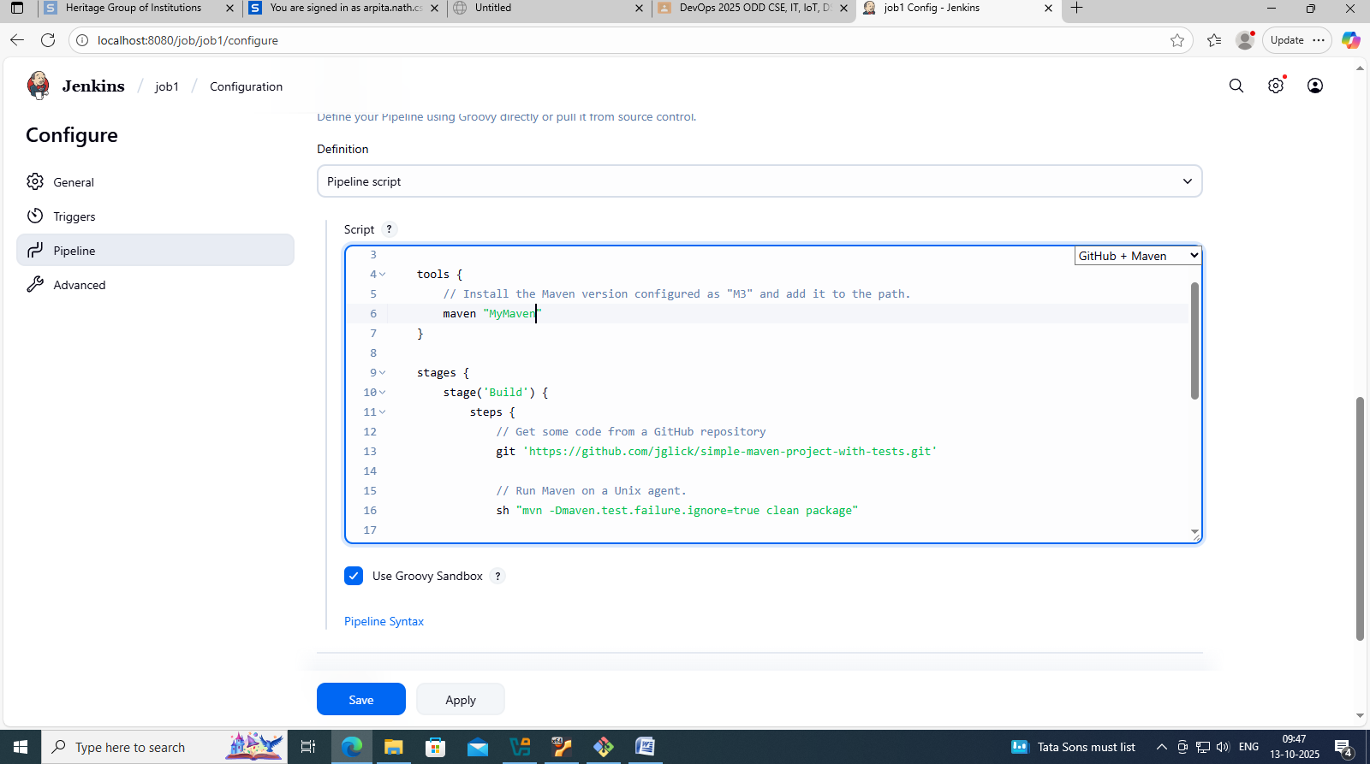
pipeline {
agent any

tools {
// Install the Maven version configured as "M3" and add it to the path.
maven "MyMaven"
}

stages {
stage('Build') {
steps {
// Get some code from a GitHub repository
git 'https://github.com/jglick/simple-maven-project-with-tests.git'

// Run Maven on a Unix agent.
sh "mvn -Dmaven.test.failure.ignore=true clean package"

// To run Maven on a Windows agent, use
// bat "mvn -Dmaven.test.failure.ignore=true clean package"
}

post {
// If Maven was able to run the tests, even if some of the test
// failed, record the test results and archive the jar file.
success {
junit '**/target/surefire-reports/TEST-*.xml'
archiveArtifacts 'target/*.jar'
}
}
}
}
}

Save
Build now
If failed -> in git bash -> apt install git
