Docker
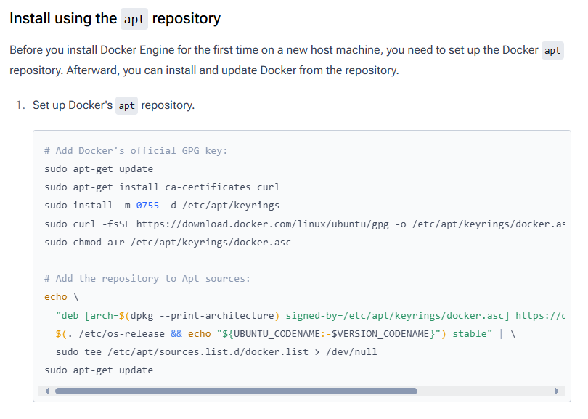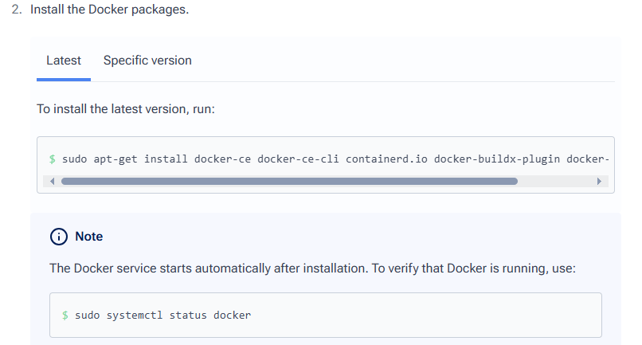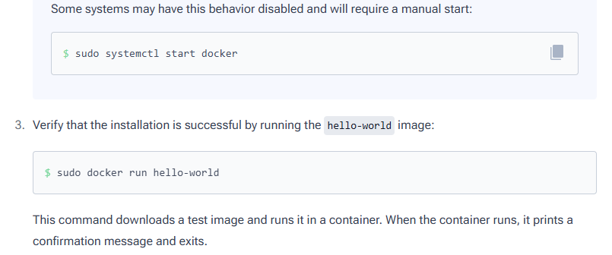

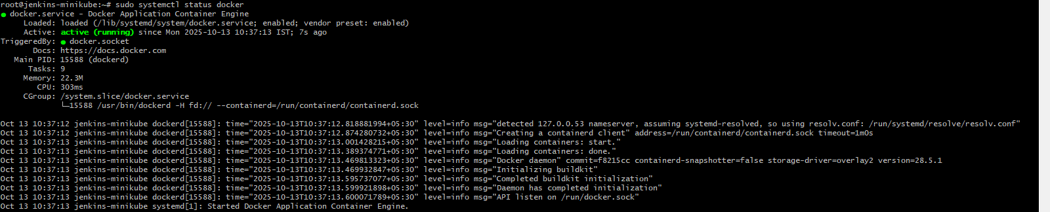
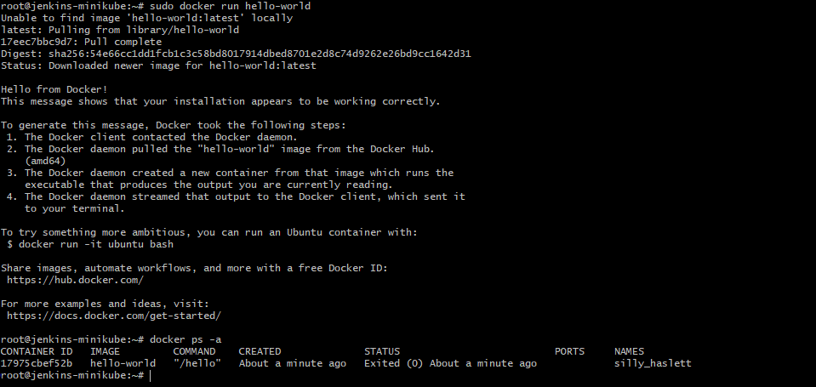
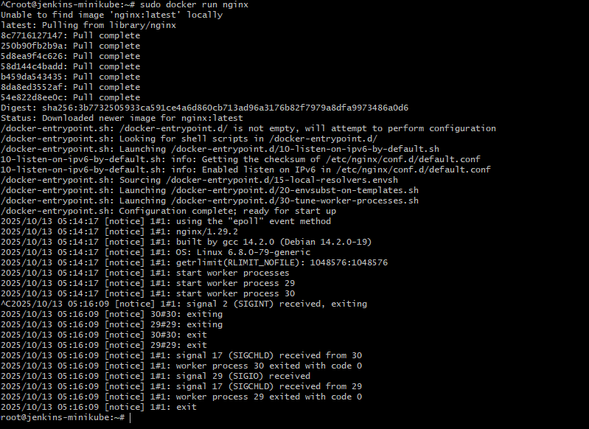
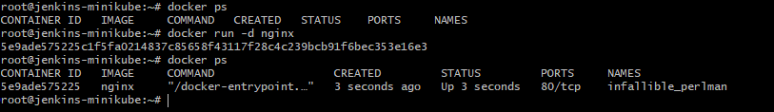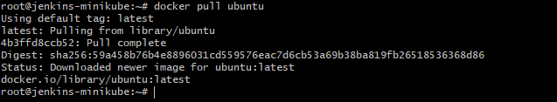
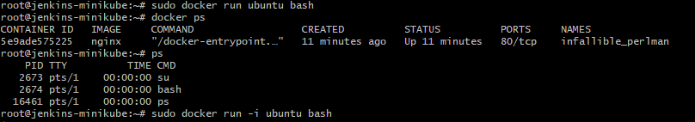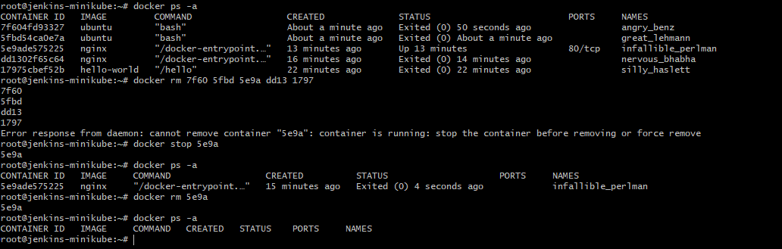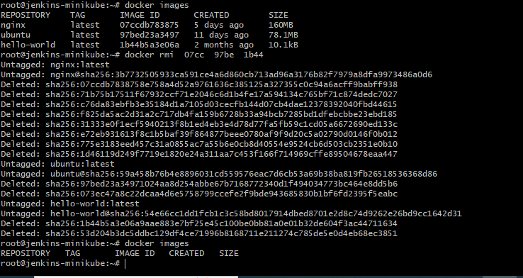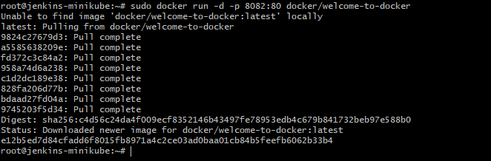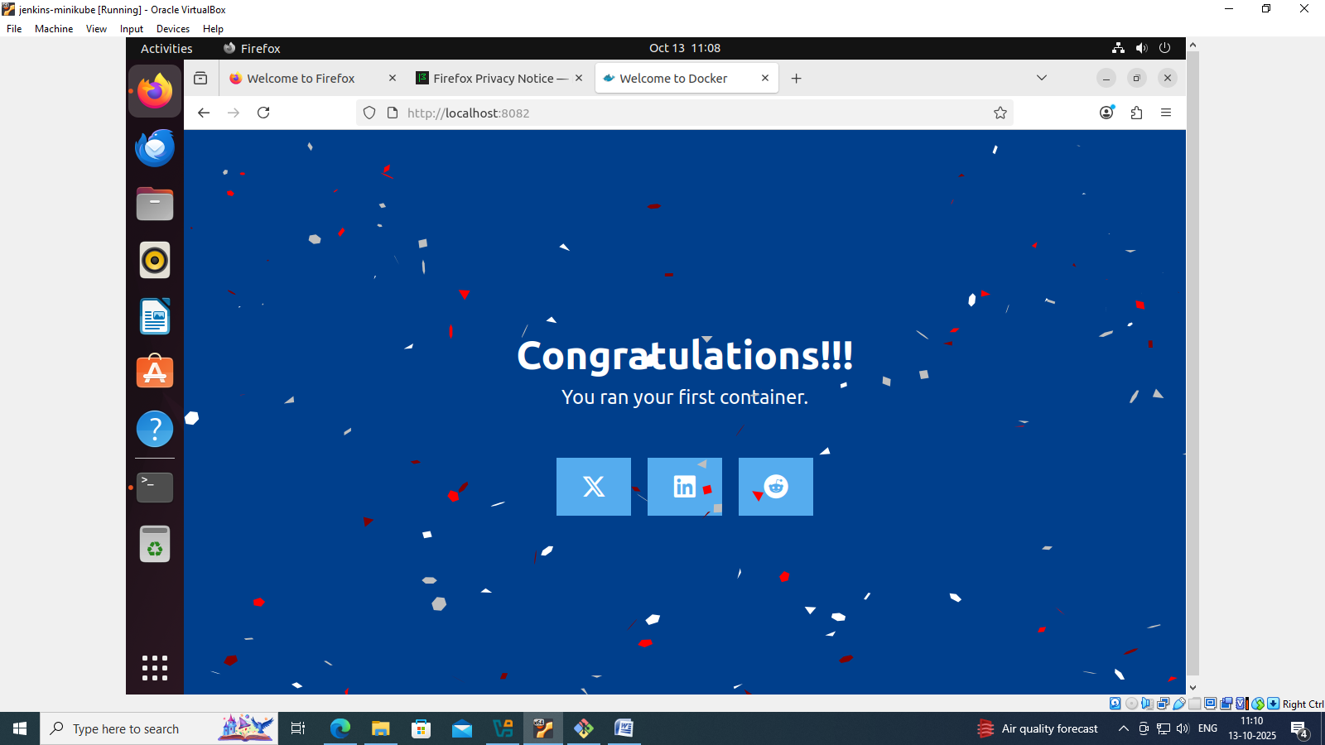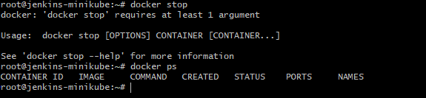

Run common Docker commands

sudo docker run nginx
sudo docker ps
sudo docker ps -a
sudo docker stop <container_name>
sudo docker rm <container_name>
sudo docker images
sudo docker rmi <image_name>
sudo docker pull ubuntu
sudo docker run ubuntu sleep 100
sudo docker run -d ubuntu sleep 50
sudo docker ps
sudo docker attach quirky_dubinsky
sudo docker exec quirky_dubinsky cat /etc/hosts
sudo docker run -d ubuntu sleep 50
sudo docker ps
sudo docker exec 4057 cat /etc/hosts
sudo docker attach 4057
sudo docker ps
sudo docker inspect b2
sudo docker logs b2
sudo docker ps
sudo docker run -it ubuntu bash
sudo docker ps
sudo docker run -d -p 8082:80 docker/welcome-to-docker

