Arpan Nagar 180905256

LAB 3

1.

#include <sys/types.h>
#include <unistd.h>
#include <stdlib.h>
#include <stdio.h>
#define pint pid_t
#include <sys/wait.h>

int main(){
pint t;
printf("Fork begins.\n");
int t1 = 0;
t = fork();
if(t == -1){
printf("ERROR\n");
exit(0);
}
else if(t == 0){
printf("In Child Process\n");
}
else{
wait(&t1);
printf("Parent\n");
}
printf("End.\n");
}
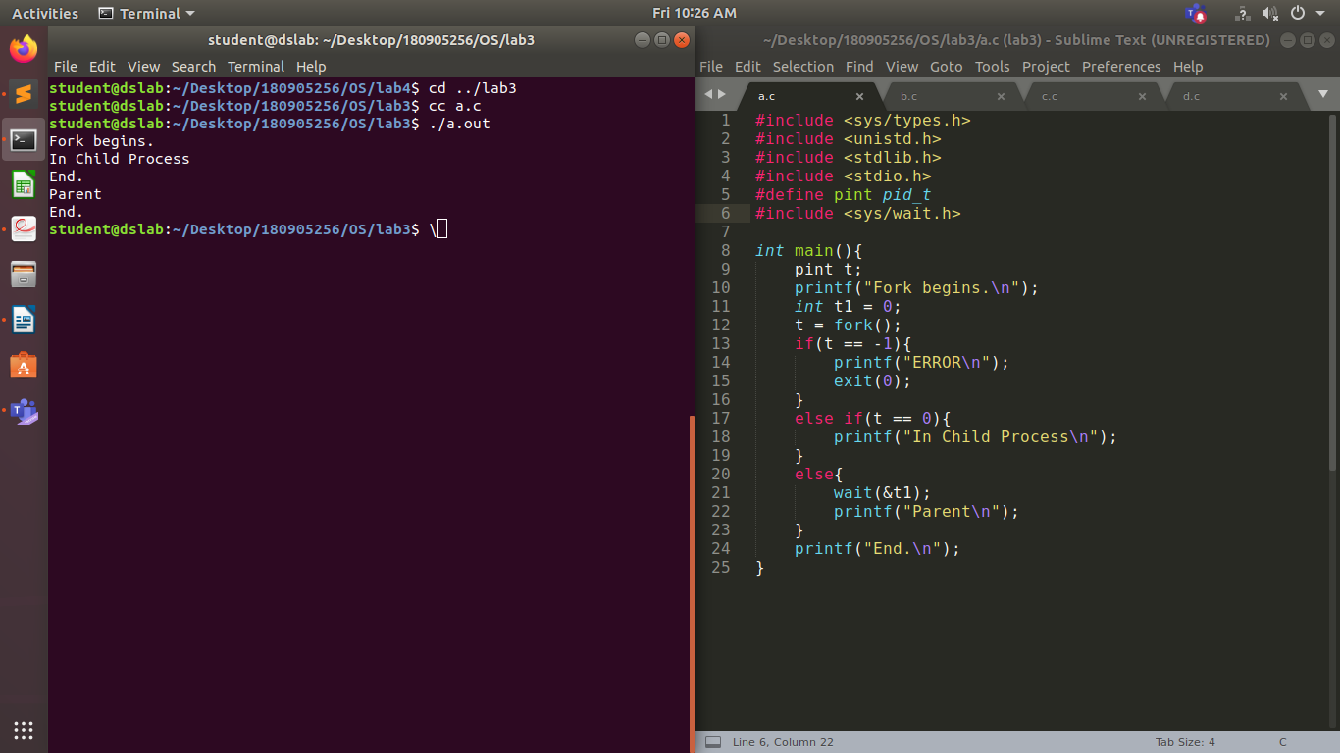

2.

#include <sys/types.h>
#include <unistd.h>
#include <stdlib.h>
#include <stdio.h>
#define pint pid_t
#include <sys/wait.h>

int main(){
pint t;
printf("Fork begins.\n");
int t1 = 0;
t = fork();
if(t == -1){
printf("ERROR\n");
exit(0);
}
else if(t == 0){
execl("./a", "a", NULL);
exit(0);
}
else{
wait(&t1);
printf("Parent\n");
}
printf("End.\n");
}
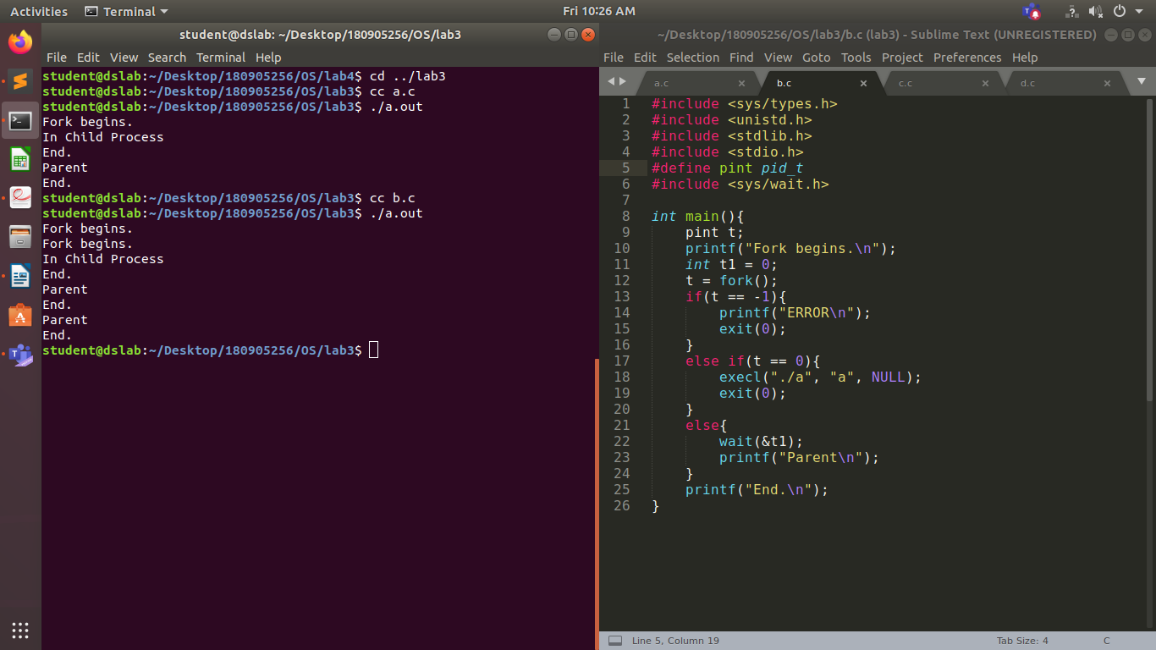
3.

#include <sys/types.h>
#include <unistd.h>
#include <stdlib.h>
#include <stdio.h>
#define pint pid_t
#include <sys/wait.h>

int main(){
pint t;
t = fork();
int t1 = 0;
if(t == -1){
printf("Error.\n");
exit(0);
}
else if(t == 0){
int p1 = getpid();
int p2 = getppid();
printf("Child: %d \n Parent: %d\n",p1,p2);
exit(0);
}
else{
wait(&t1);
int p1 = getpid();
int p2 = getppid();
printf("Child: %d \n Parent: %d\n",p1,p2);
exit(0);
}
printf("Done.\n");
}
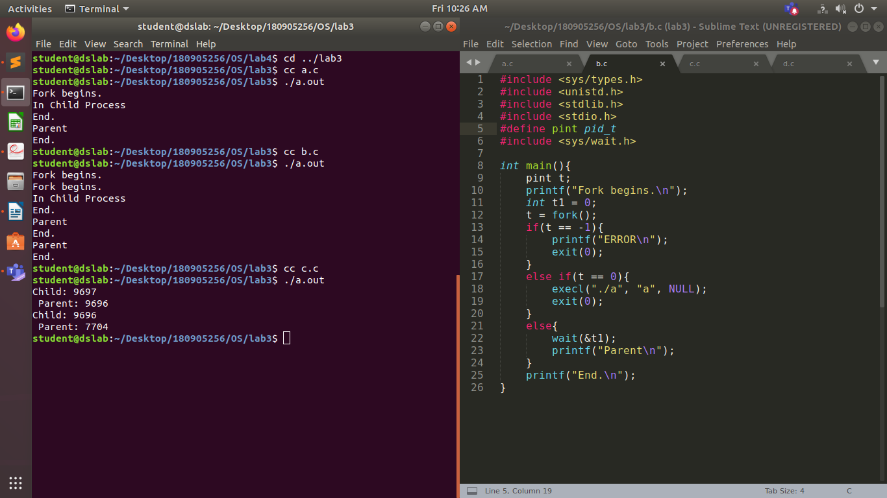
4.
#include <sys/types.h>
#include <unistd.h>
#include <stdlib.h>
#include <stdio.h>
#define pint pid_t
#include <sys/wait.h>

int main(){
pint t;
t = fork();
int t1 = 0;
if(t == -1){
printf("Error\n");
exit(0);
}
else if(t == 0){
printf("Child.\n");
exit(0);
}
else{
printf("In Parent.\n");
}
char *argv[3] = {"ps", "-l", NULL};
execv("/bin/ps", argv);
printf("Done.\n");
}

