Arpan Nagar 180905256 CSE B

LAB 4

1.

#include <sys/types.h>
#include <sys/stat.h>
#include <unistd.h>
#include <stdlib.h>
#include <stdio.h>
#define pint pid_t
#include <sys/wait.h>

int main(){
struct stat sb;
int t;
char filename[100];
scanf("%s",filename);
t = stat(filename,&sb);
if(t){
printf("ERROR.\n");
return 1;
}
else{
printf("ENODE number is: %lld\n", sb.st_ino);
exit(0);
}
return 0;
}
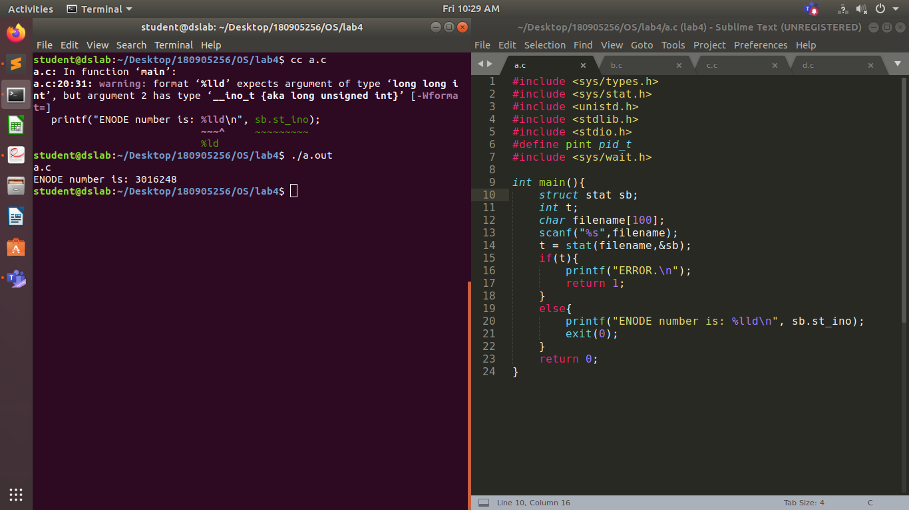
2.

#include <sys/types.h>
#include <sys/stat.h>
#include <unistd.h>
#include <stdlib.h>
#include <stdio.h>
#define pint pid_t
#include <sys/wait.h>

int main(){
struct stat sb;
int t;
char filename[100];
scanf("%s",filename);
t = stat(filename,&sb);
t = stat(filename,&sb);
if(t){
printf("ERROR.\n");
return 1;
}
else{
printf("%d dev id\n", sb.st_dev);
printf("%d inode number\n", sb.st_ino );
printf("%d perm\n",sb.st_mode );
printf("%d hard links\n", sb.st_mode);
printf("%d st_uid\n",sb.st_uid );
printf("%d st_gid\n",sb.st_gid );
printf("%d st_rdev\n",sb.st_rdev );
printf("%d st_size\n",sb.st_size );
printf("%d st_blksize\n",sb.st_blksize );
printf("%d st_blocks\n",sb.st_blocks );
printf("%d st_ctime\n",sb.st_ctime );
printf("%d st_atime\n",sb.st_atime );
printf("%d st_mtime\n",sb.st_mtime );
}
return 0;
}
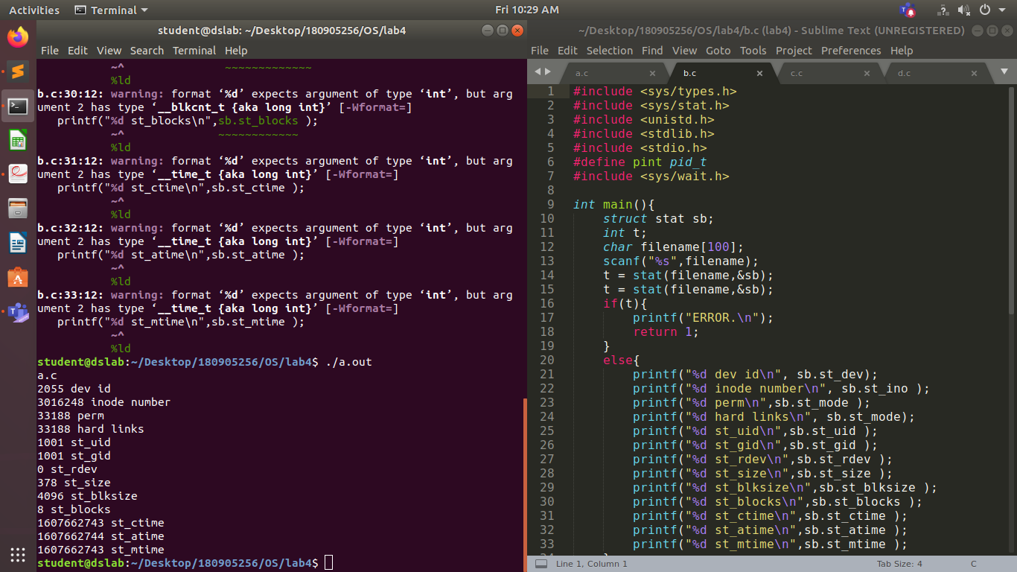
3.

#include <sys/types.h>
#include <sys/stat.h>
#include <unistd.h>
#include <stdlib.h>
#include <stdio.h>
#define pint pid_t
#include <sys/wait.h>

int main(){
struct stat sb;
char path[100], path1[100];
scanf("%s",path);
scanf("%s",path1);
int t;
t = link(path,path1);
if(t){
printf("ERROR\n");
return 1;
}
printf("DONE\n");
char *argv[2] = {"pwd", NULL};
execv("/bin/pwd", argv);
t = unlink(path1);
if(t){
printf("ERROR\n");
return 1;
}
printf("DONE\n");
return 0;
}
4.

#include <sys/types.h>
#include <sys/stat.h>
#include <unistd.h>
#include <stdlib.h>
#include <stdio.h>
#define pint pid_t
#include <sys/wait.h>

int main(){
struct stat sb;
char path[100], path1[100];
scanf("%s",path);
scanf("%s",path1);
int t;
t = symlink(path,path1);
if(t){
printf("ERROR\n");
return 1;
}
printf("DONE\n");
t = unlink(path1);
if(t){
printf("ERROR\n");
return 1;
}
printf("DONE\n");
return 0;
}
