LAB3

solved exercise

code

#include<stdio.h>
#include<string.h>
#include<stdlib.h>
int main()
{
char c, buf[10];
FILE *fp = fopen("input1.c", "r");
c = fgetc(fp);
if (fp == NULL)
{
printf("cannot open file \n");
exit(0);
}
while (c != EOF)
{
int i = 0;
buf[0] = '\0';
if (c == '=')
{
buf[i++] = c;
c = fgetc(fp);
if (c == '=')
{
buf[i++] = c;
buf[i] = '\0';
printf("Relational operator:%s \n", buf );
}
else
{
buf[i] = '\0';
printf("\n Assignment operator :%s\n", buf);
}
}
else
{
if (c == '<')
{
buf[i++] = c;
c = fgetc(fp);
if (c == '=')
{
buf[i++] = c;
buf[i] = '\0';
printf("Less than equal: %s\n", buf );
}
else
{
buf[i] = '\0';
printf("Less than: %s\n", buf );
}
}
if (c == '>')
{
buf[i++] = c;
c = fgetc(fp);
if (c == '=')
{
buf[i++] = c;
buf[i] = '\0';
printf("greater than equal: %s\n", buf );
}
else
{
buf[i] = '\0';
printf("greater than: %s\n", buf );
}
}
if (c == '!')
{
buf[i++] = c;
c = fgetc(fp);
if (c == '=')
{
buf[i++] = c;
buf[i] = '\0';
printf("Not equal to: %s\n", buf );
}
}
}
c = fgetc(fp);
}
}

INPUT/OUTPUT

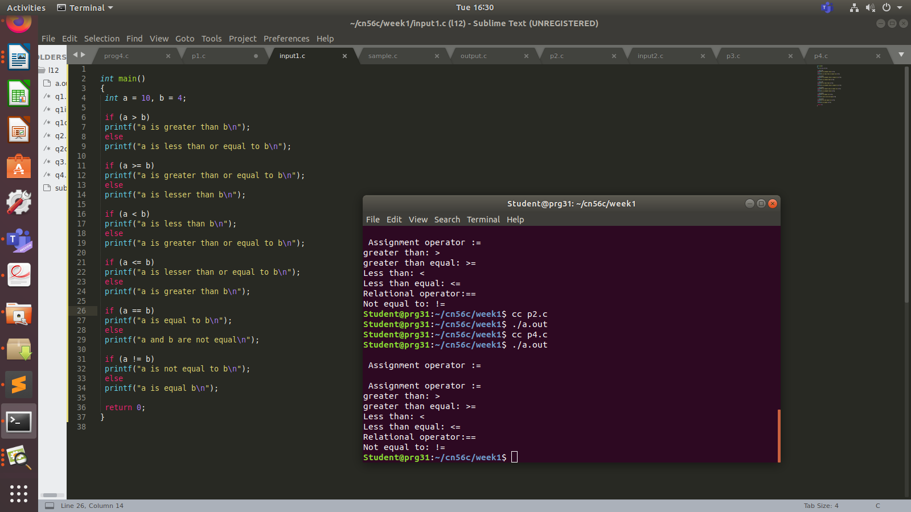

Q1.

code

#include <stdio.h>
#include <stdlib.h>
#include <string.h>
#include <ctype.h>

struct token
{
char lexeme[64];
int row,col;
char type[20];
};
static int row=1,col=1;
char buf[2048];

const char specialsymbols[]={'?',';',':',','};
const char *keywords[] = {"const", "char", "int","return","for", "while", "do",
"switch", "if", "else","unsigned", "case", "break" };

const char arithmeticsymbols[]={'*'};

int isKeyword(const char *str)
{
for(int i=0;i<sizeof(keywords)/sizeof(char*);i++)
{
if(strcmp(str,keywords[i])==0)
{
return 1;
}
}
return 0;
}

int charBelongsTo(int c,const char *arr)
{
int len;
if(arr==specialsymbols)
{
len=sizeof(specialsymbols)/sizeof(char);
}
else if(arr==arithmeticsymbols)
{
len=sizeof(arithmeticsymbols)/sizeof(char);
}
for(int i=0;i<len;i++)
{
if(c==arr[i])
{
return 1;
}
}
return 0;
}

void fillToken(struct token *tkn,char c,int row,int col, char *type)
{
tkn->row=row;
tkn->col=col;
strcpy(tkn->type,type);
tkn->lexeme[0]=c;
tkn->lexeme[1]='\0';
}

void newLine()
{
++row;
col=1;
}

struct token getNextToken(FILE *f1)
{
int c;
struct token tkn=
{
.row=-1
};
int gotToken=0;
while(!gotToken && (c=fgetc(f1))!=EOF)
{
if(charBelongsTo(c,specialsymbols))
{
fillToken(&tkn,c,row,col,"SS");
gotToken=1;
++col;
}
else if(charBelongsTo(c,arithmeticsymbols))
{
fillToken(&tkn,c,row,col,"ARITHMETIC OPERATOR");
gotToken=1;
++col;
}
else if(c=='(')
{
fillToken(&tkn,c,row,col,"specialsymbols");
gotToken=1;
++col;
}
else if(c==')')
{
fillToken(&tkn,c,row,col,"specialsymbols");
gotToken=1;
++col;
}
else if(c=='{')
{
fillToken(&tkn,c,row,col,"specialsymbols");
gotToken=1;
++col;
}
else if(c=='}')
{
fillToken(&tkn,c,row,col,"specialsymbols");
gotToken=1;
++col;
}
else if(c=='+')
{
int d=getc(f1);
if(d!='+')
{
fillToken(&tkn,c,row,col,"ARITHMETIC OPERATOR");
gotToken=1;
++col;
fseek(f1,-1,SEEK_CUR);
}
else
{
fillToken(&tkn,c,row,col,"UNARY OPERATOR");
strcpy(tkn.lexeme,"++");
gotToken=1;
col+=2;
}
}
else if(c=='-')
{
int d=getc(f1);
if(d!='-')
{
fillToken(&tkn,c,row,col,"ARITHMETIC OPERATOR");
gotToken=1;
++col;
fseek(f1,-1,SEEK_CUR);
}
else
{
fillToken(&tkn,c,row,col,"UNARY OPERATOR");
strcpy(tkn.lexeme,"--");
gotToken=1;
col+=2;
}
}
else if(c=='=')
{
int d=fgetc(f1);
if(d!='=')
{
fillToken(&tkn,c,row,col,"ASSIGNMENT OPERATOR");
gotToken=1;
++col;
fseek(f1,-1,SEEK_CUR);
}
else
{
fillToken(&tkn,c,row,col,"RELATIONAL OPERATOR");
strcpy(tkn.lexeme,"==");
gotToken=1;
col+=2;
}
}
else if(isdigit(c))
{
tkn.row=row;
tkn.col=col++;
tkn.lexeme[0]=c;
int k=1;
while((c=getc(f1))!=EOF && isdigit(c))
{
tkn.lexeme[k++]=c;
col++;
}
tkn.lexeme[k]='\0';
strcpy(tkn.type,"NUMBER");
gotToken=1;
fseek(f1,-1,SEEK_CUR);
}
else if(c == '#')
{
while((c = getc(f1)) != EOF && c != '\n');
newLine();
}
else if(c=='\n')
{
newLine();
c = fgetc(f1);
if(c == '#')
{
while((c = getc(f1)) != EOF && c != '\n');
newLine();
}
else if(c != EOF)
{
fseek(f1, -1, SEEK_CUR);
}
}
else if(isspace(c))
{
++col;
}
else if(isalpha(c)||c=='_')
{
tkn.row=row;
tkn.col=col++;
tkn.lexeme[0]=c;
int k=1;
while((c=getc(f1))!= EOF && isalnum(c))
{
tkn.lexeme[k++]=c;
++col;
}
tkn.lexeme[k]='\0';
if(isKeyword(tkn.lexeme))
{
strcpy(tkn.type,"KEYWORD");
}
else
{
strcpy(tkn.type,"IDENTIFIER");
}
gotToken=1;
fseek(f1,-1,SEEK_CUR);
}
else if(c=='/')
{
int d=getc(f1);
++col;
if(d=='/')
{
while((c=getc(f1))!= EOF && c!='\n')
{
++col;
}
if(c=='\n')
{
newLine();
}
}
else if(d=='*')
{
do
{
if(d=='\n')
{
newLine();
}
while((c==fgetc(f1))!= EOF && c!='*')
{
++col;
if(c=='\n')
{
newLine();
}
}
++col;
}while((d==getc(f1))!= EOF && d!='/' && (++col));
++col;
}
else
{
fillToken(&tkn,c,row,--col,"ARITHMETIC OPERATOR");
gotToken=1;
fseek(f1,-1,SEEK_CUR);
}
}
else if(c == '"')
{
tkn.row = row;
tkn.col = col;
strcpy(tkn.type, "STRING LITERAL");
int k = 1;
tkn.lexeme[0] = '"';
while((c = fgetc(f1)) != EOF && c != '"')
{
tkn.lexeme[k++] = c;
++col;
}
tkn.lexeme[k] = '"';
gotToken = 1;
}
else if(c == '<' || c == '>' || c == '!')
{
fillToken(&tkn, c, row, col, "RELATIONAL OPERATOR");
++col;
int d = fgetc(f1);
if(d == '=')
{
++col;
strcat(tkn.lexeme, "=");
}
else
{
if(c == '!')
{
strcpy(tkn.type, "LOGICAL OPERATOR");
}
fseek(f1, -1, SEEK_CUR);
}
gotToken = 1;
}
else if(c == '&' || c == '|')
{
int d = fgetc(f1);
if(c == d)
{
tkn.lexeme[0] = tkn.lexeme[1] = c;
tkn.lexeme[2] = '\0';
tkn.row = row;
tkn.col = col;
++col;
gotToken = 1;
strcpy(tkn.type, "LOGICAL OPERATOR");
}
else
{
fseek(f1, -1, SEEK_CUR);
}
++col;
}
else
{
++col;
}
}
return tkn;
}

int main()
{
FILE *f1=fopen("input1.c","r");
if(f1==NULL)
{
printf("Error! File cannot be opened!\n");
return 0;
}
struct token tkn;
while((tkn=getNextToken(f1)).row!=-1)
{
printf("<%s, %d, %d, %s>\n",tkn.lexeme,tkn.row,tkn.col,tkn.type);
}
fclose(f1);
}

INPUT/OUTPUT

