Arpan Nagar 180905256 CSE B (9/12/2020)

CD LAB Day 1.

Lab 2:

Q1. (tabs and multipspace to space)

#include <stdio.h>
#include <stdlib.h>

int main()
{
FILE *fptr1, *fptr2;
char filename[100];
scanf("%s", filename);
fptr1 = fopen(filename, "r");
if(fptr1 == NULL)
{
printf("Cannot open this file.\n");
exit( 0);
}
scanf("%s", filename);
fptr2 = fopen(filename, "w+");
char ch;
ch = fgetc(fptr1);
const char space = ' ';
char chdp = 'a';
while(ch != EOF)
{
ch = fgetc(fptr1);
if(ch == ' ' || ch == '\t'){
chdp = ' ';
continue;
}

if(chdp == ' ')putc(space, fptr2);
putc(ch, fptr2);
chdp = ch;
}
printf("Done.\n");
return 0;
}

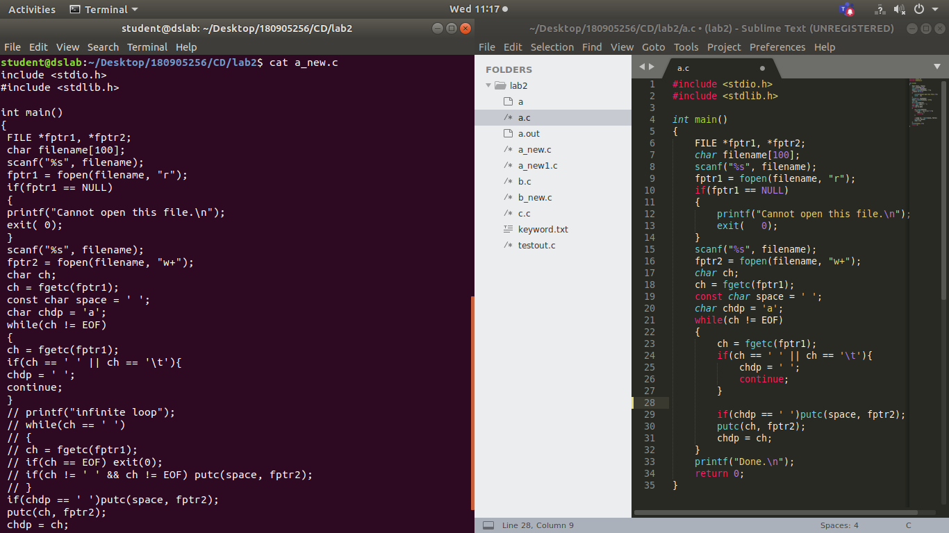

Q2. (Remove Preprosessors)

#include <stdio.h>
#include <stdlib.h>

int main ()
{
char filename[100];
scanf("%s", filename);
FILE *input = fopen(filename, "r");
scanf("%s", filename);
FILE *output = fopen(filename, "w+");
if(input == NULL)
{
printf("No file found\n");
exit(0);
}
char ch = ' ';
for(;;)
{
ch = getc(input);
if (ch == '#')
{
while (ch != '\n')
{
ch = getc(input);
}
}
putc(ch, output);
if(ch == EOF) break;
}
return 0;
}

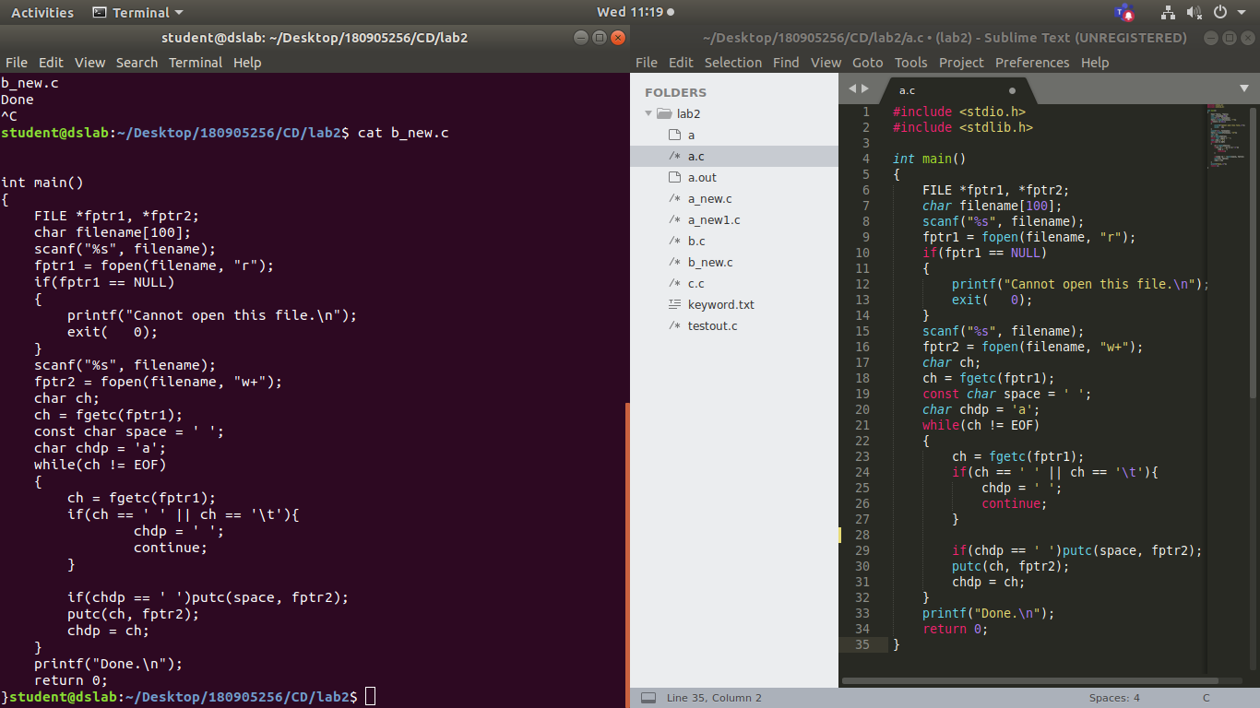

Q3. (Keyword)

#include <stdio.h>
#include <stdlib.h>
#include <string.h>
char keyword[32][32];
void getkey(){
FILE *input = fopen("keyword.txt", "r");
for (int i = 0; i < 32; ++i)
{
int j = 0;
char ch = fgetc(input);
while(ch != '\n'){
keyword[i][j++] = ch;
ch = fgetc(input);
}
keyword[i][j] = '\0';
}
}

void print(char* s){
for (int i = 0; i < sizeof(s)/sizeof(char); ++i)
{
if(s[i] >= 'a' && s[i] <= 'z')
printf("%c",(char)(s[i]-32));
}
printf("\n");
}

int main ()
{
char filename[100];
scanf("%s", filename);
FILE *input = fopen(filename, "r");
getkey();
char buf[100];
int i = 0;
char ch = fgetc(input);
while(ch != EOF){
if(ch == ' '){
if(i!=0){
for (int j = 0; j < 32; ++j)
{
if(strcmp(keyword[j],buf) == 0){
print(buf);
}
}
}
memset(buf,0,sizeof(buf));
i = 0;
}
else{
buf[i++] = ch;
}
ch = fgetc(input);
}
return 0;
}

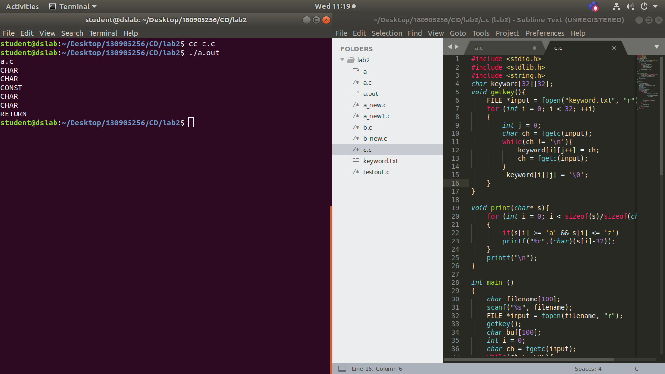

Q4. (Comments)

#include <stdio.h>
#include <stdlib.h>

int main()
{
FILE *fa, *fb;
int ca, cb;
fa = fopen("a.c", "r");
if (fa == NULL)
{
printf("Cannot open file \n");
exit(0);
}
fb = fopen("d_new.c", "w");
ca = getc(fa);
while (ca != EOF)
{
if(ca == ' ')
{
putc(ca, fb);
while(ca == ' ')ca = getc(fa);
}
if (ca == '/')
{
cb = getc(fa);
if (cb == '/')
{
while(ca != '\n')ca = getc(fa);
}
else if(cb == '*')
{
do
{
while(ca != '*')ca = getc(fa);
ca = getc(fa);
}
while (ca != '/');
}
else
{
putc(ca, fb);
putc(cb, fb);
}
}
else putc(ca, fb);
ca = getc(fa);
}
fclose(fa);
fclose(fb);
return 0;
}

