Arpan Nagar 180905256 CSE B 35

LAB 6

Q1.

#include<stdio.h>

#include<stdlib.h>

#include<string.h>

int curr = 0;

char str[100];

void S();

void T();

void Tprime();

void reject()

{

printf("reject\n");

exit(0);

}

void valid()

{

printf("accept\n");

exit(0);

}

void S()

{

if(str[curr] == 'a')

{

curr++;

return;

}

else if(str[curr] == '>')

{

curr++;

return;

}

else if(str[curr] == '(')

{

curr++;

T();

if(str[curr] == ')')

{

curr++;

return;

}

else

reject();

}

else

reject();

}

void T()

{

S();

Tprime();

}

void Tprime()

{

if(str[curr] == ',')

{

curr++;

S();

return;

}

}

int main()

{

printf("Enter the String:\n");

scanf("%s", str);

S();

if(str[curr] == '$')
{

valid();

}

else

reject();

}

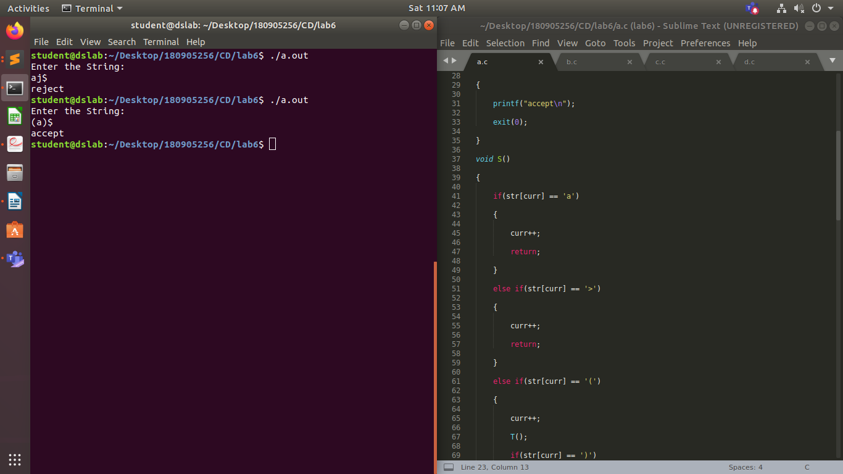

Q2.

#include<stdio.h>
#include<stdlib.h>
#include<string.h>

int curr = 0;

char s[100];

void invalid()
{
printf("-----------------ERROR!----------------\n");
exit(0);
}
void valid()
{
printf("----------------SUCCESS!---------------\n");
exit(0);
}

void U();
void V();
void W();

void S()
{
U();
V();
W();
}

void U()
{
if(s[curr] == '(')
{
curr++;
S();
if(s[curr] != ')')
{
invalid();
}
curr++;
}
else if(s[curr] == 'a')
{
curr++;
S();
if(s[curr] != 'b')
{
invalid();
}
curr++;
}
else if(s[curr] == 'd'){
curr++;
}
else{
invalid();
}

}

void V(){
if(s[curr] == 'a'){
curr++;
V();
}
}

void W(){
if(s[curr] == 'c'){
curr++;
W();
}
}

int main()
{
printf("Enter the String:\n");
scanf("%s", s);
S();
if(s[curr] == '$')
{
valid();
}
else
{
invalid();
}
}

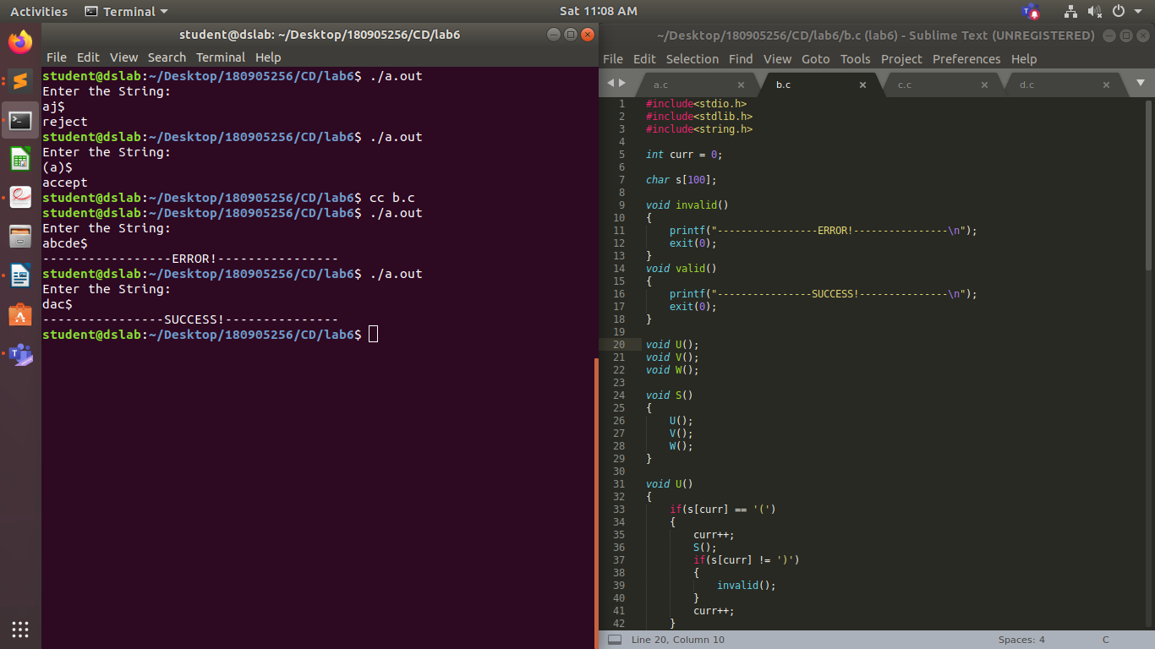

Q3.

#include<stdio.h>
#include<stdlib.h>
#include<string.h>

int curr = 0;

char s[100];

void invalid()
{
printf("-----------------ERROR!----------------\n");
exit(0);
}
void valid()
{
printf("----------------SUCCESS!---------------\n");
exit(0);
}

void A(){
if(s[curr] == 'b'){
curr++;
}
else{
A();
if(s[curr] == 'b') curr++;
else invalid();
}
}

void B(){
if(s[curr] == 'd'){
curr++;
}
else invalid();
}

void S(){
if(s[curr] == 'a'){
curr++;
A();
if(s[curr] == 'c'){
curr++;
}
else invalid();
B();
if(s[curr] == 'e') curr++;
else invalid();
}
else{
invalid();
}
}

int main()
{
printf("Enter the String:\n");
scanf("%s", s);
S();
if(s[curr] == '$')
{
valid();
}
else
{
invalid();
}
}

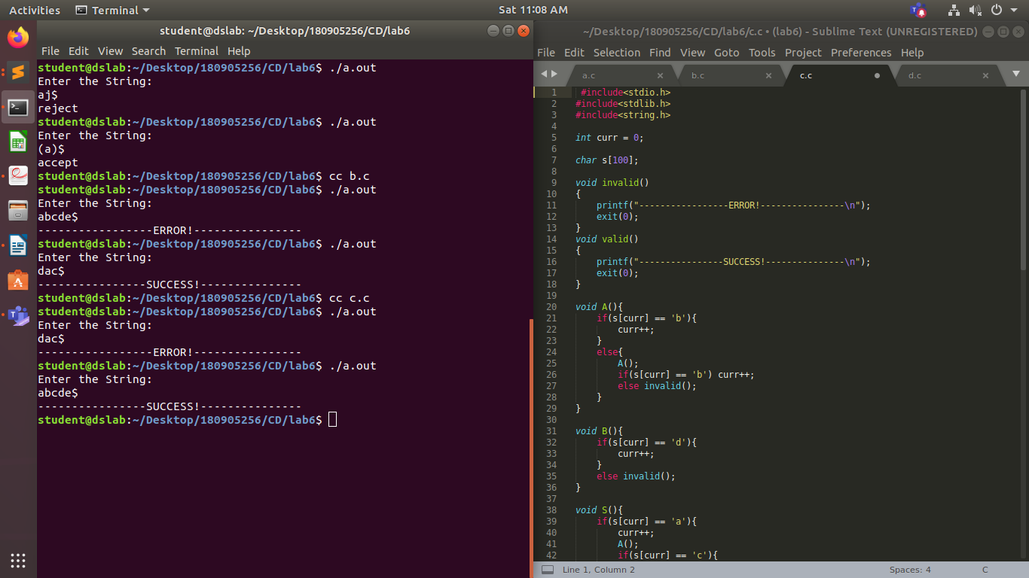

Q4.
#include<stdio.h>
#include<stdlib.h>
#include<string.h>

int curr = 0;

char s[100];

void invalid()
{
printf("-----------------ERROR!----------------\n");
exit(0);
}
void valid()
{
printf("----------------SUCCESS!---------------\n");
exit(0);
}

void S();

void L();

void Ldash();

void S(){
if(s[curr] == '('){
curr++;
L();
if(s[curr] == ')'){
curr++;
}
else invalid();
}
else if(s[curr] == 'a'){
curr++;
}
else invalid();
}

void L(){
S();
Ldash();
}

void Ldash(){
if(s[curr] == ','){
curr++;
S();
Ldash();
}
}

int main()
{
printf("Enter the String:\n");
scanf("%s", s);
S();
if(s[curr] == '$')
{
valid();
}
else
{
invalid();
}
}

