Arpan Nagar 180905256 CSE B 35

Lab 5

Q1.
Producer:

// Writing a set of 4 integers. Producer

#include <stdio.h>
#include <string.h>
#include <fcntl.h>
#include <sys/stat.h>
#include <sys/types.h>
#include <unistd.h>

int main()
{
char *myfifo="myfifo";
mkfifo(myfifo,0777);
int i=0,fd;
char arr[80];
while(i<4)
{
fd=open(myfifo,O_WRONLY);
printf("Enter the integer:\n");
fgets(arr, 80, stdin);
write(fd,arr,strlen(arr)+1);
close(fd);
i++;
}
}

Consumer:

#include <stdio.h>
#include <string.h>
#include <fcntl.h>
#include <sys/stat.h>
#include <sys/types.h>
#include <unistd.h>

int main()
{
char *myfifo="myfifo";
mkfifo(myfifo,0777);
int i=0,fd;
char str[80];
while(i<4)
{
fd=open(myfifo,O_RDONLY);
//printf("Enter the integer:\n");
//scanf("%c",ch);
read(fd, str, 80);
close(fd);
printf("The number entered: %s\n", str);
i++;
}
}
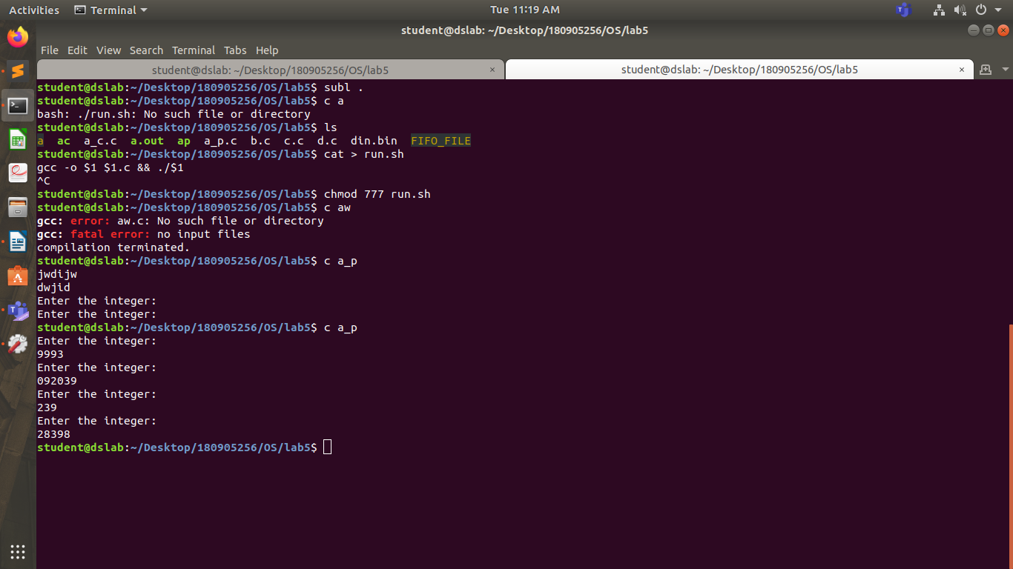
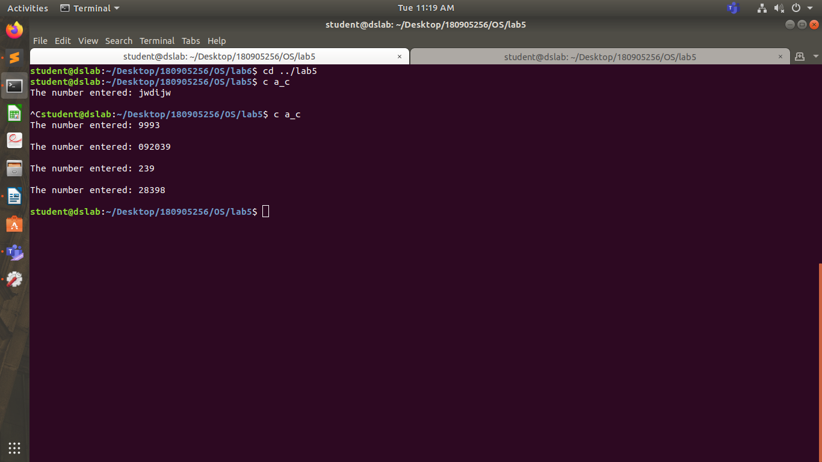

Q2.

#include <unistd.h>
#include <stdlib.h>
#include <stdio.h>
#include <string.h>
int main()
{
int data_processed;
int file_pipes[2];
const char some_data[] = "AB18";
char buffer[BUFSIZ + 1];
memset(buffer, '\0', sizeof(buffer));
if (pipe(file_pipes) == 0) {
data_processed = write(file_pipes[1], some_data, strlen(some_data));
printf("Wrote %d bytes\n", data_processed);
data_processed = read(file_pipes[0], buffer, BUFSIZ);
printf("Read %d bytes: %s\n", data_processed, buffer);
exit(EXIT_SUCCESS);
}
exit(EXIT_FAILURE);
}

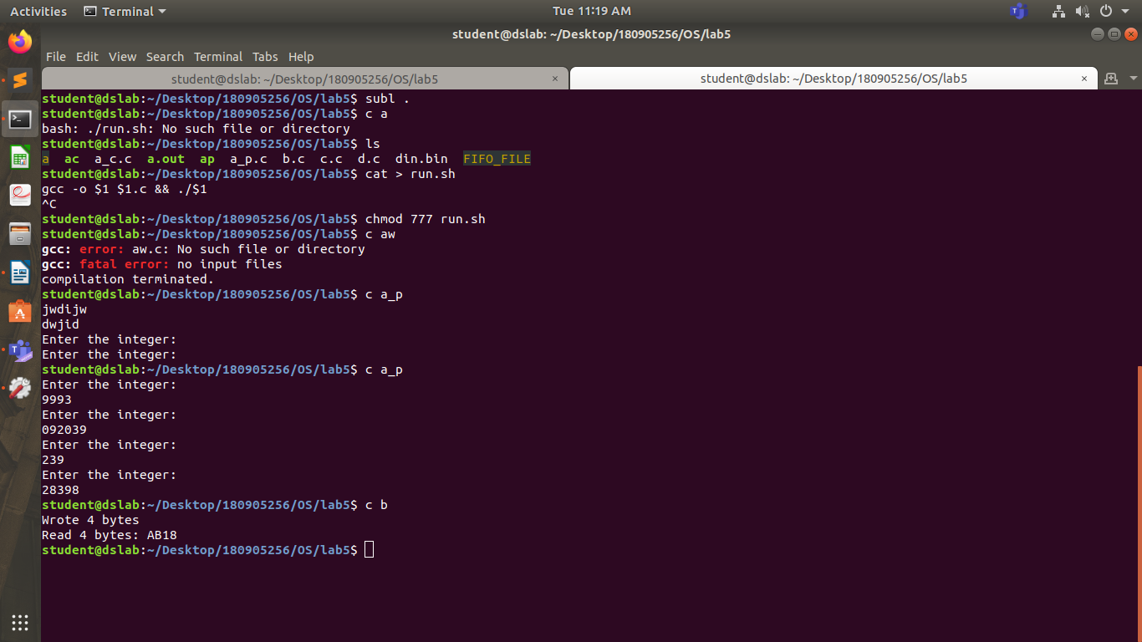
Q3.

Writer:

// Write:

#include <stdio.h>
#include <string.h>
#include <fcntl.h>
#include <sys/stat.h>
#include <sys/types.h>
#include <unistd.h>
int main()
{
int fd;
char * myfifo = "/tmp/myfifo";
mkfifo(myfifo, 0666);
char arr2[80];
while (1)
{
fd = open(myfifo, O_WRONLY);
fgets(arr2, 80, stdin);
write(fd, arr2, strlen(arr2)+1);
close(fd);
}
return 0;
}

Reader:

#include <stdio.h>
#include <string.h>
#include <fcntl.h>
#include <sys/stat.h>
#include <sys/types.h>
#include <unistd.h>
int main()
{
int fd1;

char * myfifo = "/tmp/myfifo";

mkfifo(myfifo, 0666);
char str1[80];
while (1)
{
fd1 = open(myfifo,O_RDONLY);
read(fd1, str1, 80);
printf("Read: %s", str1);
close(fd1);
}
return 0;
}

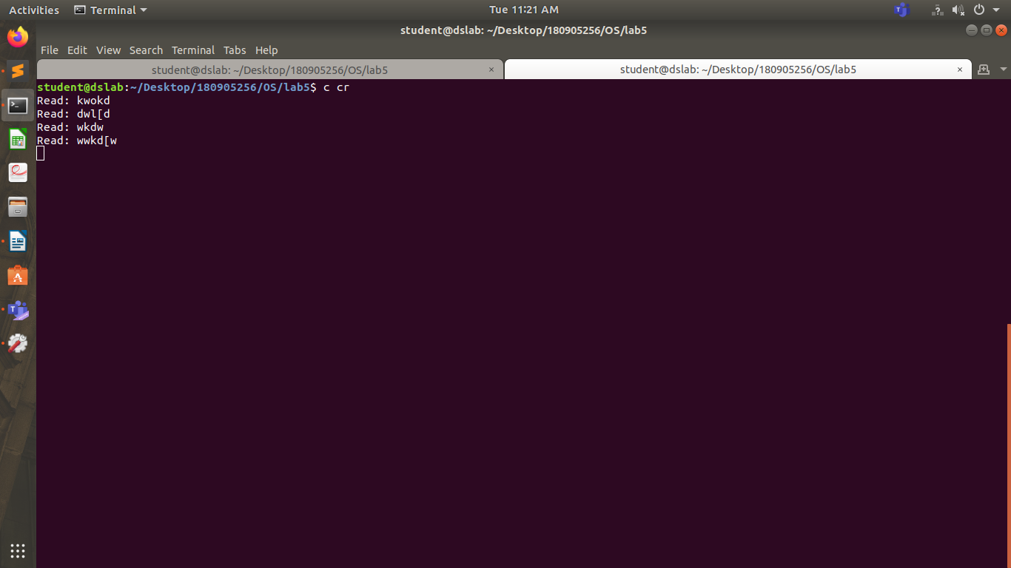
Q4.

#include <stdio.h>

int main()
{
char ch;
FILE *fpbr, *fpbw;
fpbr = fopen("din.bin", "rb");
if (fpbr == NULL){
puts("Input Binary file is having issues while opening");
}
fpbw= fopen("dout.bin", "wb");
if (fpbw == NULL){
puts("Output binary file is having issues while opening");
}
while(1)
{
ch = fgetc(fpbr);
if (ch==EOF)
break;
else
fputc(ch, fpbw);
}
fclose(fpbr);
fclose(fpbw);

return 0;
}

