Arpan Nagar 180905256 CSE B 35

LAB 6

Q1.

Writer:

#include <stdio.h>
#include <sys/ipc.h>
#include <sys/msg.h>
#include <assert.h>
#include <string.h>
#define MAX 10

struct mesg_buffer {
long mesg_type;
char mesg_text[100];
} message;

void isPalindrome(char str[])
{
int l = 0;
int h = strlen(str) - 2;
while (h > l)
{
if (str[l++] != str[h--])
{
printf("String: %s Verdict:Not Palindrome\n", str);
return;
}
}
printf("String:%s Verdict:Palindrome\n", str);
}

int main()
{
key_t key;
int msgid;
key = ftok("progfile", 65);
msgid = msgget(key, 0666 | IPC_CREAT);
msgrcv(msgid, &message, sizeof(message), 1, 0);
isPalindrome(message.mesg_text);
msgctl(msgid, IPC_RMID, NULL);
return 0;
}

Reader:

#include <stdio.h>
#include <sys/ipc.h>
#include <sys/msg.h>
#include <assert.h>
#define MAX 10

struct mesg_buffer {
long mesg_type;
char mesg_text[100];
} message;

int main()
{
key_t key;
int msgid;
key = ftok("progfile", 65);
msgid = msgget(key, 0666 | IPC_CREAT);
message.mesg_type = 1;

printf("Write Data : ");
fgets(message.mesg_text,MAX,stdin);
msgsnd(msgid, &message, sizeof(message), 0);
printf("Data send is : %s \n", message.mesg_text);
return 0;
}

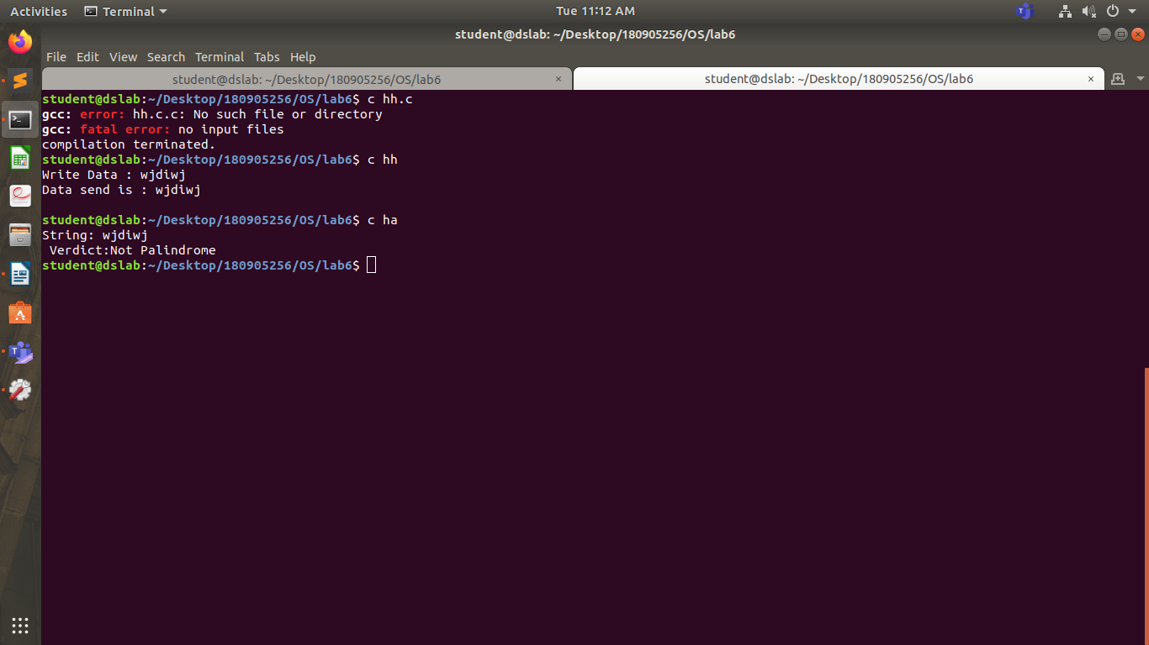

Q2.

#include <stdio.h>
#include <stdlib.h>
#include <sys/stat.h>
#include <sys/shm.h>
#include <sys/wait.h>
#include <unistd.h>

#define SIZE 2

void getNextAlphabet (char *alp)
{
char *next = (char *)calloc(2, sizeof(char));
next[1] = '\0';
if (*alp == 'Z')
next[0] = 'a';
else if (*alp == 'z')
next[0] = 'A';
else
next[0] = *alp + 1;
*alp = *next;
}

int main (int argc, const char *argv [])
{
int segment_id = shmget(IPC_PRIVATE, SIZE, S_IRUSR | S_IWUSR);
char *shared_memory = (char *)shmat(segment_id, NULL, 0);
*shared_memory = '\0';
pid_t pid;
int i;
*shared_memory = 'A';
for (i = 0; i < 52; ++i)
{
pid = fork();
if (pid == 0)
{
while (*shared_memory == '\0');
getNextAlphabet(shared_memory);
exit(0);
}
else
{
printf("%s -> ", shared_memory);
wait(NULL);
printf("%s\n", shared_memory);
}
}
shmdt(shared_memory);
}

