Context Diagram
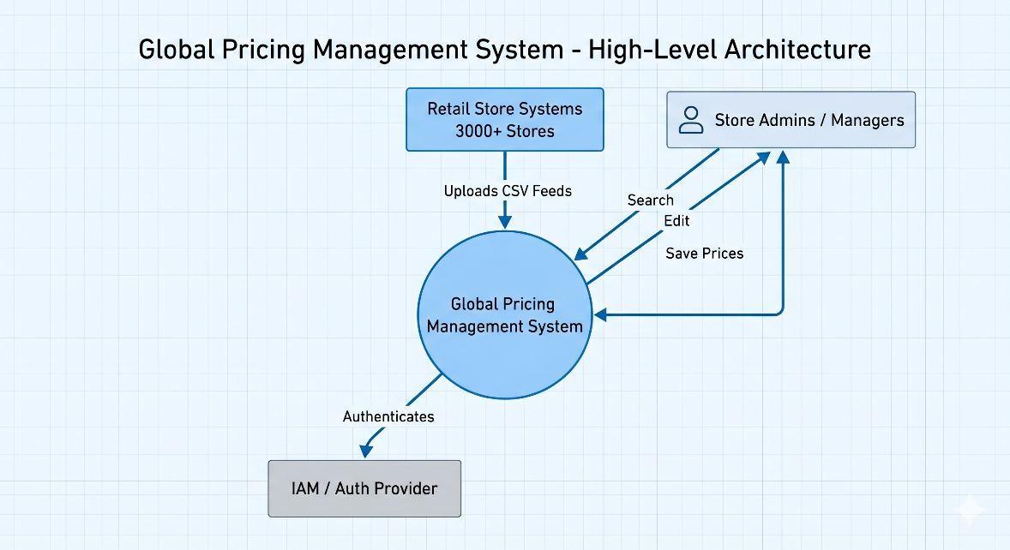
Solution Architecture
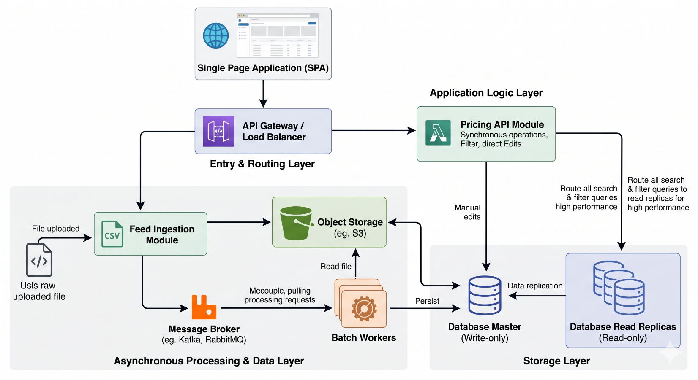
Design Decisions
1. Asynchronous Event-Driven Ingestion
- Decision: Decoupling the file upload process from the actual data parsing and database insertion using a Message Broker (like Kafka or RabbitMQ).
- Justification: If hundreds of stores upload their end-of-day pricing feeds at the exact same time, doing it synchronously would tie up all the HTTP threads and cause timeouts. Pushing a message to a broker allows the system to immediately return a "Success/Accepted" response to the UI, while background workers process the heavy load at a steady, predictable pace without crashing the app.
2. Separation of Read and Write Workloads (CQRS Pattern)
- Decision: Implementing Command Query Responsibility Segregation at the database level by using a Master-Replica MySQL setup. All CSV batch inserts and manual UI edits go to the Master (Write) node, while all search and filter queries from the UI go to the Replica (Read) nodes.
- Justification: Batch inserting thousands of rows creates heavy database locks. By separating the traffic, a store manager searching for a specific SKU won't experience UI lag just because another store's feed is currently being saved to the database.
3. Chunk-Based File Processing
- Decision: Using a framework like Spring Batch to read, process, and write the CSV data in fixed chunks (e.g., 1,000 records per transaction) instead of loading the entire file into memory at once.
- Justification: A massive CSV file could easily cause an OutOfMemoryError in the Java Virtual Machine (JVM). Chunking keeps the memory footprint low and predictable, and if a chunk fails (e.g., bad data format), it can be rolled back and logged without failing the entire file.
4. Optimistic Locking for Concurrent Edits
- Decision: Adding a version control mechanism (like JPA's @Version annotation) to the pricing records in the database.
- Justification: In a highly concurrent system, an admin might be manually editing a price in the UI at the exact same millisecond a delayed CSV feed is updating that same product. Optimistic locking prevents "lost updates" and ensures no one's data is silently overwritten without locking the whole database table.
5. Stateless Backend Architecture
- Decision: Designing the Spring Boot application to be completely stateless, utilizing token-based authentication (JWT) instead of server-side sessions.
- Justification: This allows the API Gateway to route traffic to any available backend instance without worrying about "sticky sessions." If traffic spikes, you can just spin up more instances of the app to handle the load horizontally.
6. Server-Side Pagination and Filtering
- Decision: Enforcing strict pagination and delegating all search filtering to the database level (using SQL indexes on Store ID, SKU, Date) rather than filtering in the application layer.
- Justification: A system with 3,000 stores will quickly generate millions of rows. Pulling all that data to the frontend or even the backend memory just to filter it would bring the system to a halt.

Non-functional requirements considered and how the design addresses them
1. Scalability
- Requirement: The system must handle varying loads, particularly the "thundering herd" problem when thousands of stores upload their end-of-day pricing CSVs simultaneously, while still serving regular UI traffic.
- How the design addresses it: * Stateless Backend: The Spring Boot API nodes store no session state (using JWTs instead). The Load Balancer can spin up and route traffic to dozens of identical API nodes during peak hours.
  - Asynchronous Decoupling: Heavy CSV processing is completely separated from the web servers. Using a Message Broker (Kafka) acts as a shock absorber. It queues the upload events so the backend worker nodes can process them at a safe, sustainable rate without exhausting server resources.
2. Performance & Low Latency
- Requirement: Store managers distributed across multiple countries must experience fast UI load times and sub-second responses when searching or filtering millions of pricing records.
- How the design addresses it:
  - Global CDN: The Single Page Application (React/Angular) is served via a Content Delivery Network, ensuring the UI downloads instantly regardless of geographic location.
  - Database Read Replicas (CQRS): Search queries never hit the main database handling the heavy CSV inserts. They are routed to dedicated Read Replicas.
  - Strategic Indexing: The MySQL tables will have composite indexes on the most queried fields (store_id, sku, date) to ensure searches run in milliseconds rather than doing full table scans.
3. High Availability & Fault Tolerance
- Requirement: The system must remain operational even if individual components fail. A crashed server should not result in lost data.
- How the design addresses it:
  - Message Durability: If a Spring Batch worker node crashes in the middle of processing a CSV, the original file is safe in Object Storage, and the event remains in the Message Broker. Another worker will simply pick it up and process it. No data is lost.
  - No Single Point of Failure: Multiple instances of the API Gateway, Spring Boot applications, and Batch Workers are deployed. If the Master Database goes down, a Read Replica can be promoted to Master automatically.
4. Security & Auditability
- Requirement: Pricing data is highly sensitive. The system must restrict access based on roles and keep a strict trail of who changed what.
- How the design addresses it:
  - Gateway Protection: The API Gateway enforces SSL/TLS encryption for all data in transit and handles rate-limiting to prevent DDoS attacks or API abuse.
  - IAM & JWT: All requests require a valid JSON Web Token validated against a central Identity Provider, ensuring only authorized store managers can edit prices.
  - Database Auditing: Using Spring Data JPA auditing annotations (@CreatedBy, @LastModifiedBy, @LastModifiedDate), every single manual price change is tracked to the specific user ID that made the edit.
5. Data Integrity & Concurrency
- Requirement: With automated feeds and human administrators interacting with the same data simultaneously, the system must prevent race conditions and data corruption.
- How the design addresses it:
  - ACID Compliance: Relying on a robust relational database (MySQL) ensures transactional integrity. If a batch of 1,000 prices is being inserted and the 999th fails validation, the entire database transaction rolls back, preventing partial or corrupted data states.
  - Optimistic Locking: Using a version column on the database row ensures that if an admin opens a record to edit it, and an automated feed updates that same record milliseconds before the admin clicks "Save," the admin's save will be rejected rather than silently overwriting the automated feed's data.
Assumptions
- Standardized Data Format: We are assuming that the CSV file structure (Store ID, SKU, Product Name, Price, Date) is strictly standardized across all 3,000 stores globally, and that data governance policies are in place at the store level to prevent malformed files.
- Distributed Peak Loads: Because the 3,000 stores are spread across "multiple countries," we assume that "end-of-day" CSV uploads will be naturally staggered across different global time zones, preventing a single massive spike and distributing the load over a 24-hour period.
- Idempotent Operations (Safe Retries): We assume that if a store experiences a network glitch and accidentally uploads the exact same CSV file twice, the system's database logic handles this via "Upserts" (Update if exists, Insert if not) based on a composite key of Store ID + SKU + Date, ensuring no duplicate records are created.
- Currency & Localization: We assume that the "Price" field in the CSV is accompanied by an implied or explicit currency code based on the Store ID, and that all dates provided in the CSV will be standardized to UTC before being saved to the database.

