Regarding server understand that:-

TCP is protocol thought which data is send over internet. it is just like sending string.
when this string is in particular format like we have header, status code, body, other request param then we can call that like HTTP protocol.
So it means HTTP runs over TCP.

Now we are going to create TCP server. which will send byte slice / string between client and server.
and if that string formatted in HTTP way it will acts like http server.

In Golang docs there is package name "net" which is responsible for all networking stuff in Golang.

Inside "net" package we will see some important API like:- Listern

net.Listern() => this take two argument as string; 1 --> whether it is TCP or UDP , 2 --> port number
both the argument as string,

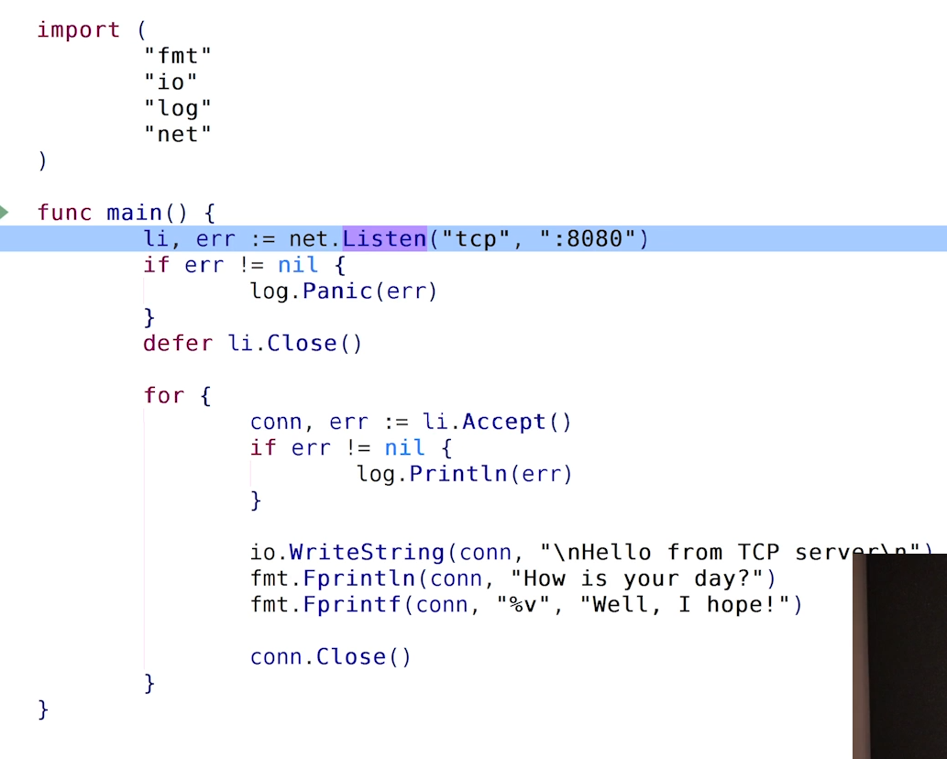

net.Listern will return type -- listener . in above picture it is li

so lets look at this listener type:-

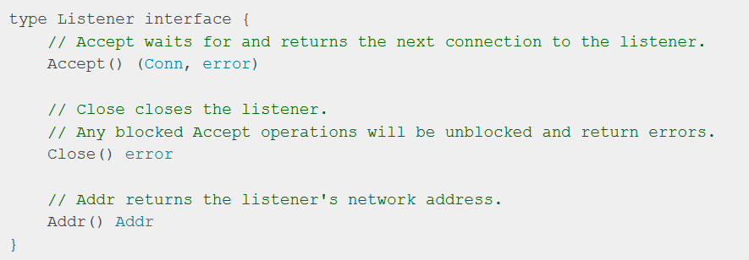

so listerner is a interface which have this much of function.

also here we can see Accept return "conn".

so what is this conn, so conn is a type of interface.
and this type has read and write function.
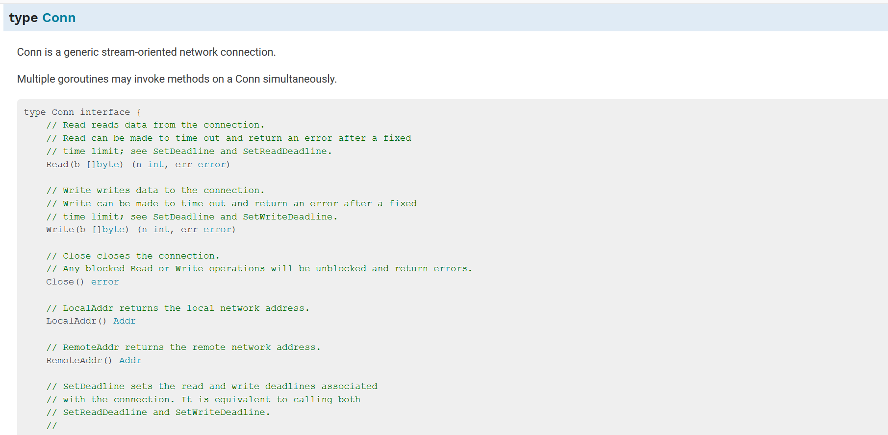

so anything which has "Read(b []byte) (n int, err error)" implements type Reader, as for Writer.

so when you have connection like a phone connection you can write to it and you can read to it.

Follow this step to turn on telnet on windows:-
To enable Telnet follow these steps:

Select Start, Control Panel, then Programs and Features (or Programs)
Select Turn Windows Features on or off
Check the box for both Telnet Client and Telnet Server
Select OK
Verify that you can now Telnet the port

Look a io.WriteString function

Syntax:
func WriteString(w Writer, s string) (n int, err error)

this take a string and put that string into Writer interface. this writer interface actually takes a file
in linux every things is file, even it is object of stdout, is also a file.

io.WriteString(conn, "send from client")

