Templates allow us to personalize web pages for user.

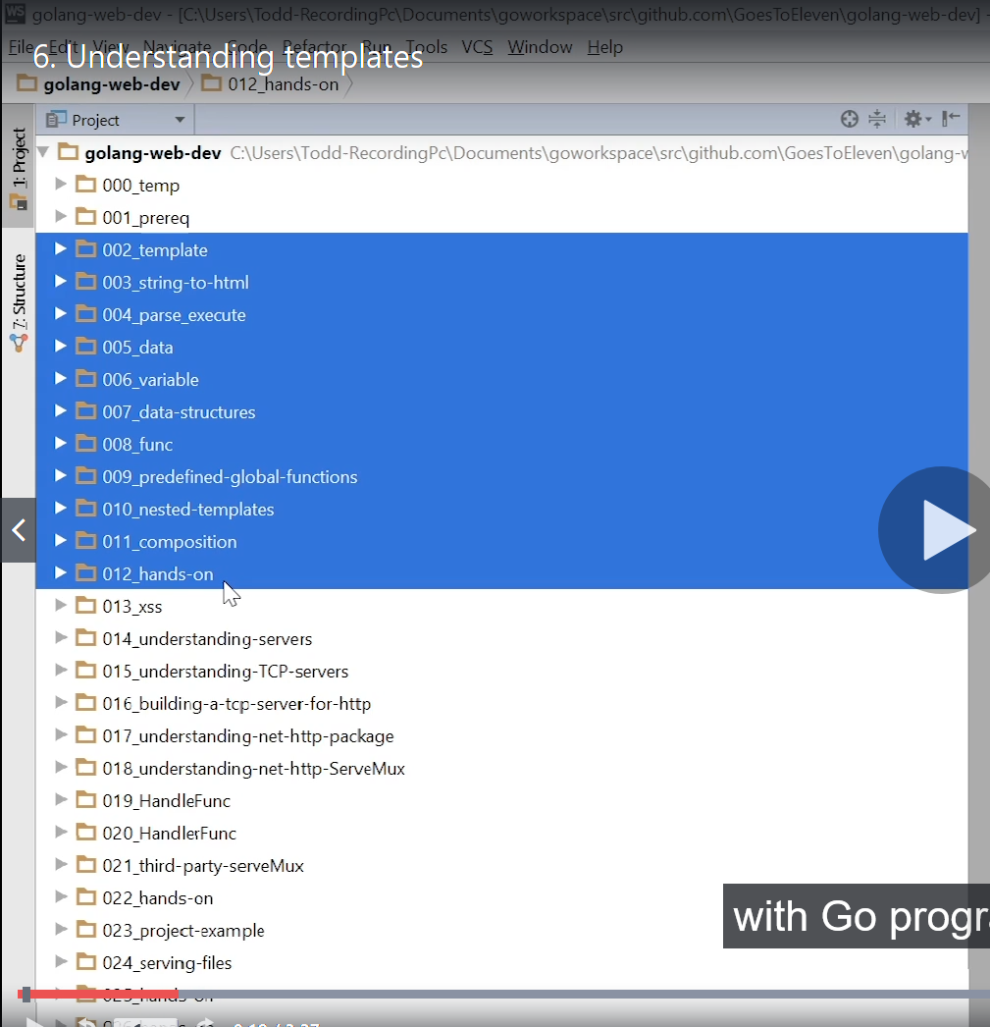

these are folders (002 to 012), this will tell you how template work with go programming.

- how to use template.
pass function to templates.
- how to access data.
- how to range or loop over data.
- how to abstract and modularization our code.
- how to use nested template.

So templates are like Form Letters.

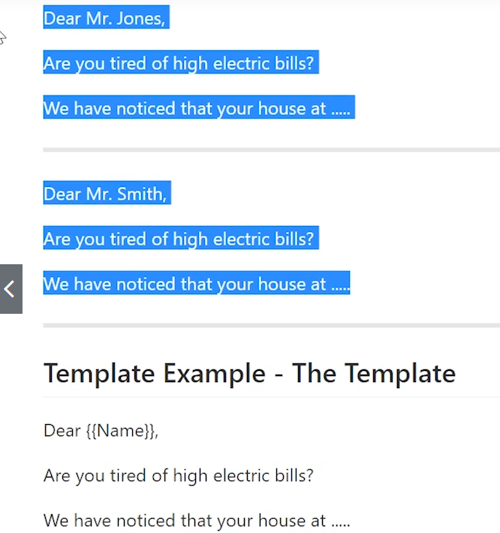

So here we can see that Dear {{name}} kind of form in which we put any name and above line will get generated.

and when we use template in web programming, this is how we can personalize web pages.
like we create one page and we will put user profile.

In Go we have two packages:-

- text/template
- html/template

"html/template" is "text/template" with some additional functionality of html things.

Understanding templates

A template allows us to create one document and then merge data with it.
We are learning about templates so that we can create one document, a web page, and then merge customized data to that page.
Web templates allow us to serve personalized results to users.

Think of Facebook - you log into your main page and see results tailored for you. That main page was created once. It is a template. However, for each user, that template gets populated with data specific to that user.

Another common exposure to templates that most of us get every day - junk mail.

A company creates a piece of mail to send to everyone, and then they merge data with that template to customize the mailing for each individual.

