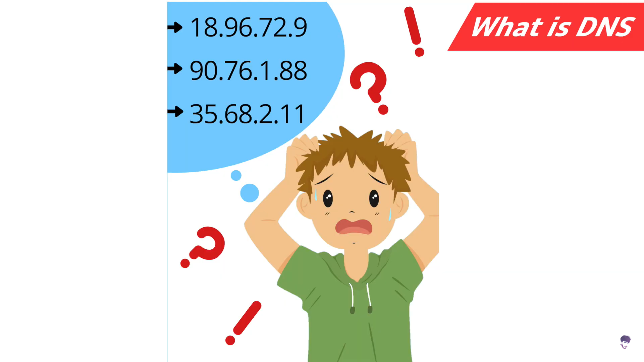

DNS records:- help us to get information about those records.

this is shared hosting:-
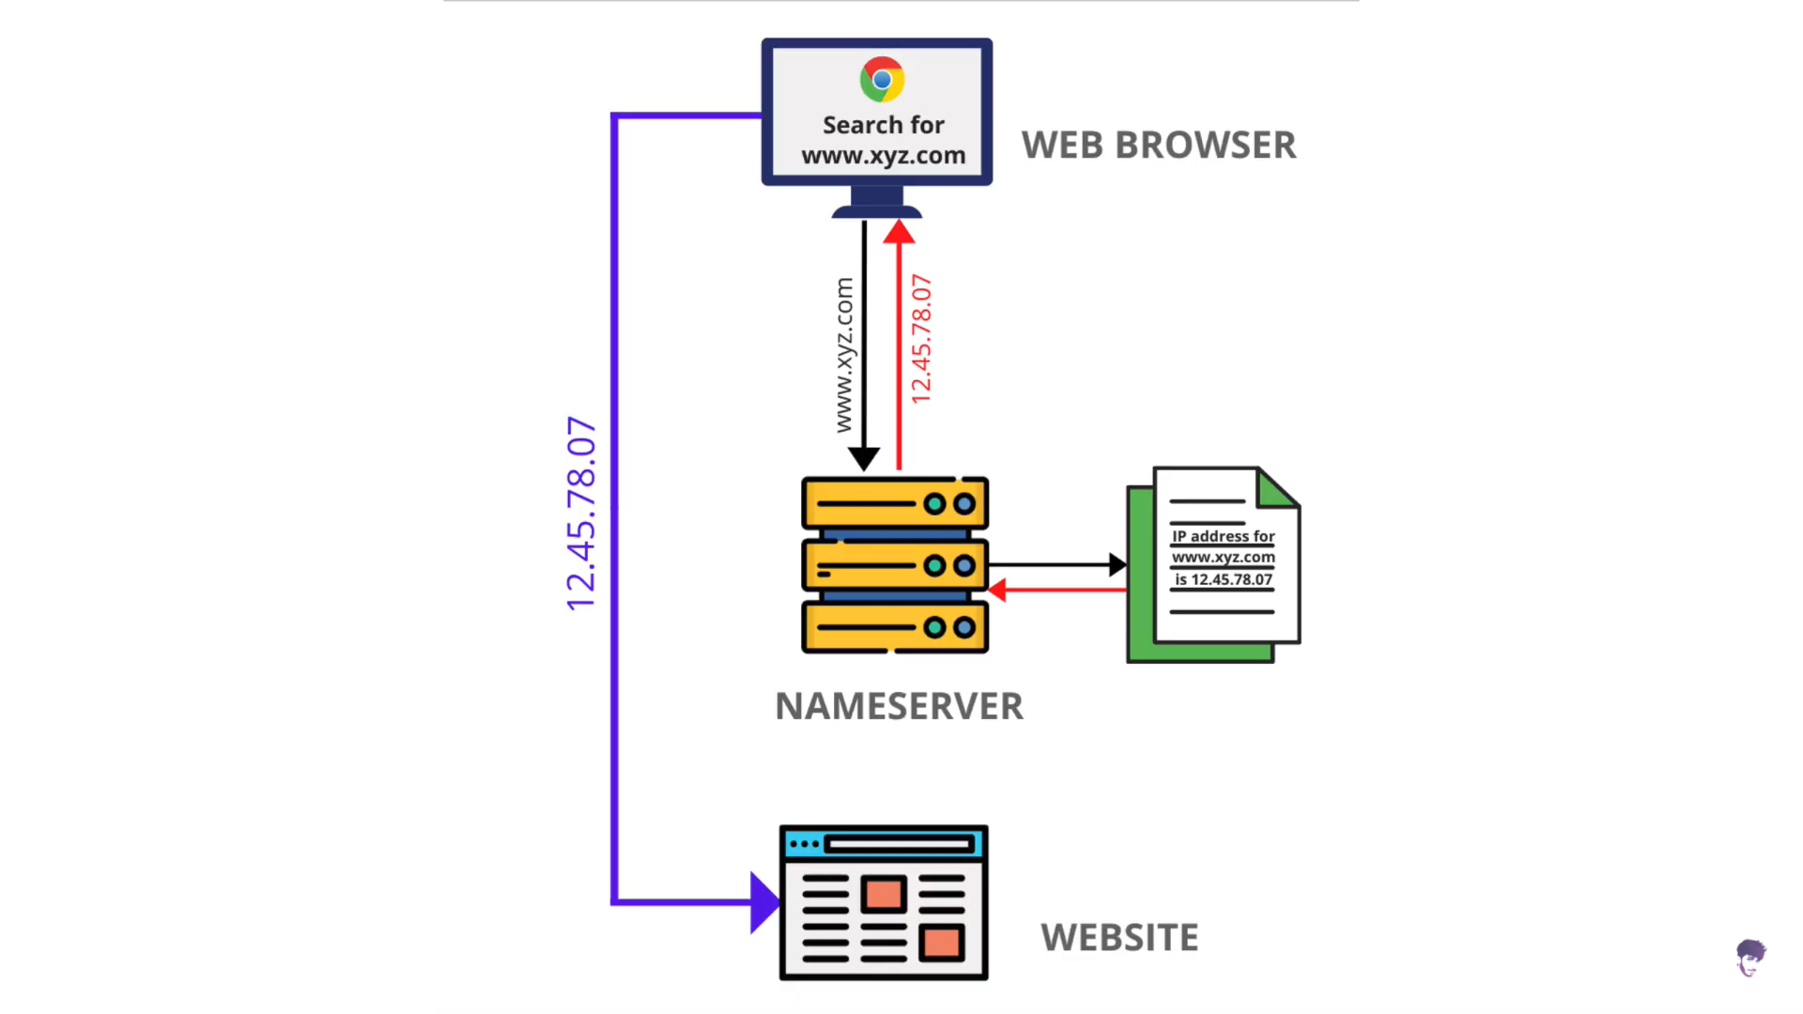

DNS record:-

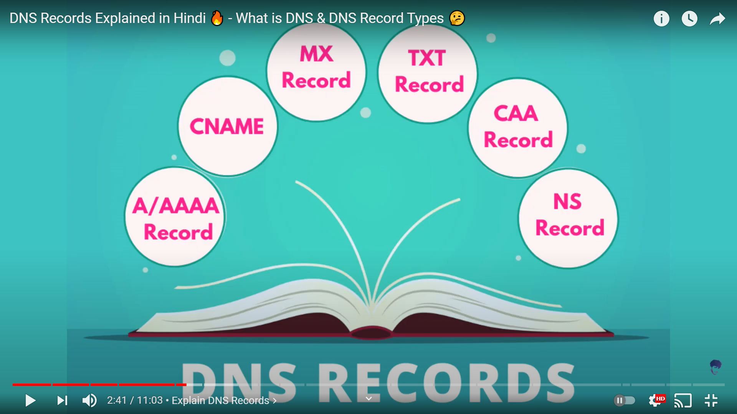

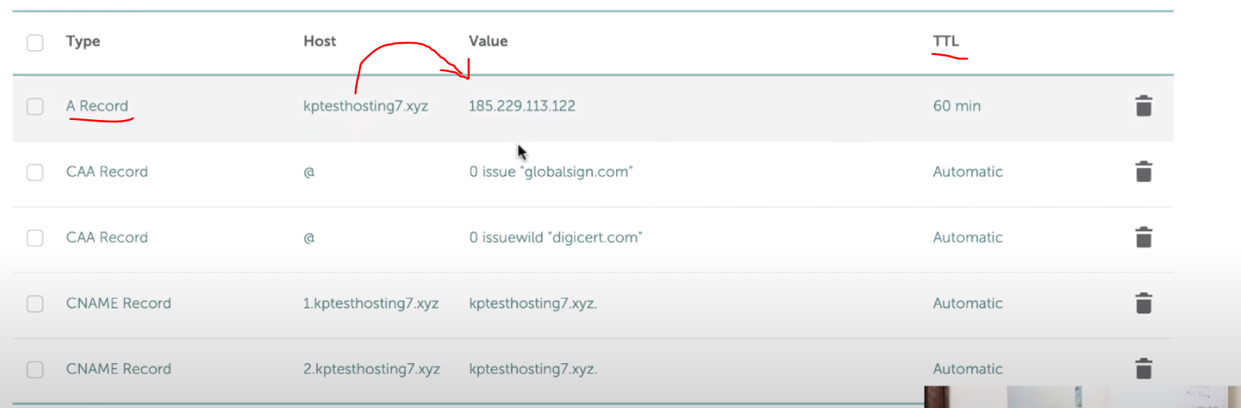

A record :- this is most important record it will tell about which hostname will get attached to which IP.

Also all record have TTL time which will tell about how much time a record will put in cache .
If you change any setting in TTL it will take upto around 48hr to be in affect.

AAAA record :- this will be given to IPv6

CName Record :- This we will use for sub domain record like "arpit.gupta.com" there "arpit" will be sub domain for "gupta.com".
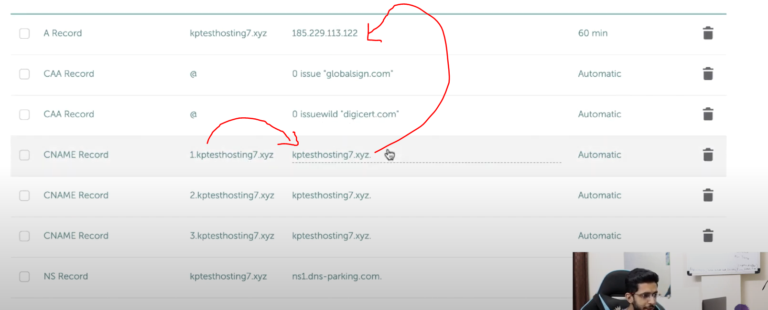

we use this sub record as suppose we want to change my IP address so we need to change that entry on single point only.

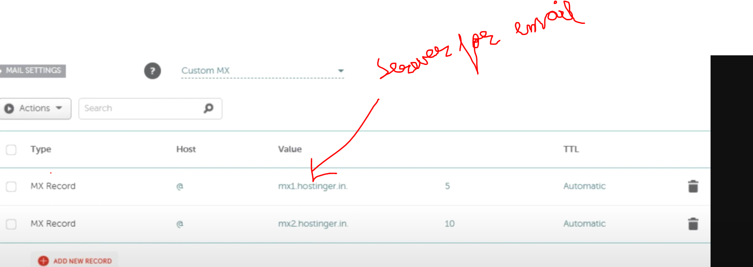

MX Record :- this record we need to use to direct our email server.

TXT record :- now if you want to put any additional Txt data with your Domain then you have to use TXT record.
This is basically use to authenticate your domain to various platform. Like this you can put your key or token here.

SPF record :- also for email, like this will catagories your main whether it will go to promotion, spam or main . but this use TXT record only.

CAA record :- this will be useful if we want our SSL cert from certain provider only.
generally use for internet banking, E commerce, Payment Gateway.

SRV record :- this basically tell us about location of our service.

for more info :- https://kripeshadwani.com/dns-records-explained/

