When you have python script -> go to menubar and press on “debugging”.

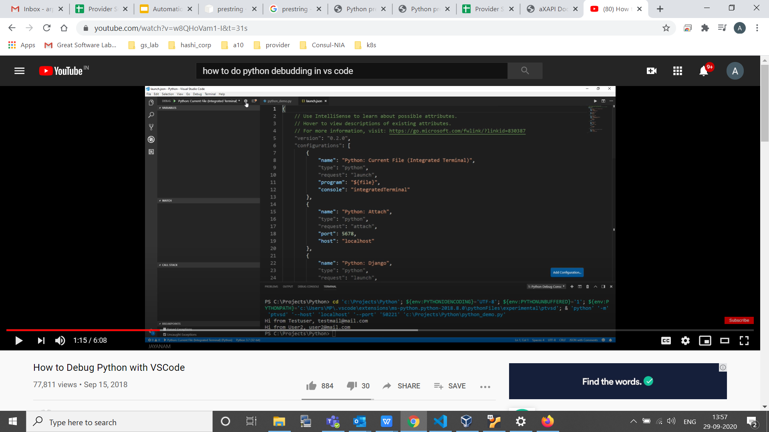

Just press this button so that we can set configuration for debugging , this step to be done before setting up breakpoint.

This will launch default json file.

Now we have option to debug current file in integrated terminal or we can attach debugger to different python process that runs on the web server.

Just put red dot to set breakpoint.

Now press F5 to execute script and execution will stop in that breakpoint.

By Left click on variable we can add variable to watch.

By left click on breakpoint “red dot” we can edit breakpoint as well like make it conditional breakpoint and also we can pass breakpoint and do log instead print.