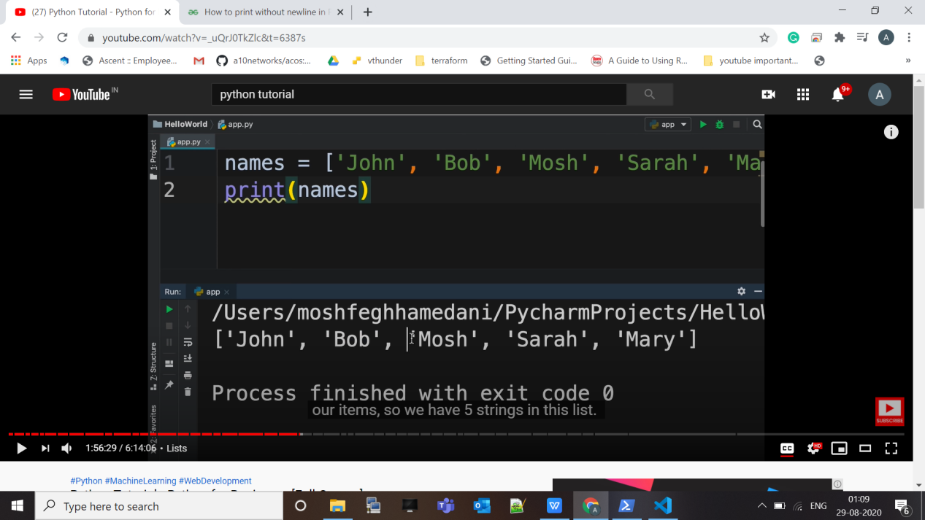

Here we define list of name ,

But here one things to be noted that **while print thing list directly we have also square bracket as well.**

We can also access individual element by element like in array.

Like print (name[2]) => Mosh

Index start from zero, and -ve index point to last item of the list like :-

Like print (name[-1]) => Mary

To select range of item we can use colon “:” .

Like print (name[2:]) => [‘Mosh’, ‘Sarah’ ,‘Mary’]

So it actually produce another list .

To replace an element in a list is also very easy , just we need index.

Like name[0] = “jon”

**2D list:-**

Just like matrix in maths.

We can model this as list .

A 2D list is a list contain another list inside it.

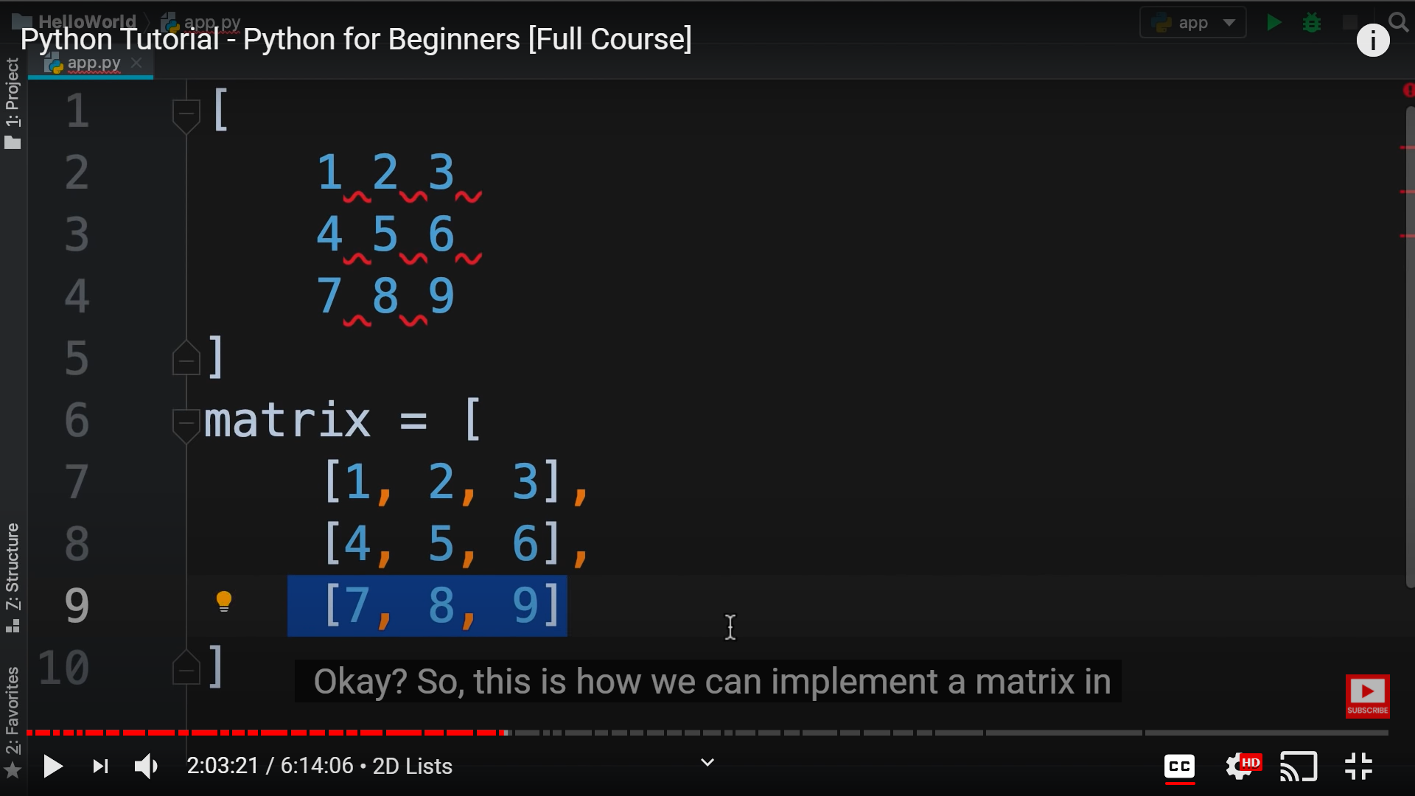

So to access that we need to do like:-

martix[0] => this will return another list, which is of 0th index.

print(matrix[0][2]) => this will return “2” an individual item in list.

Also we can modify that value using this syntax.

Here we can also use **nested loop** to iterate over all items.

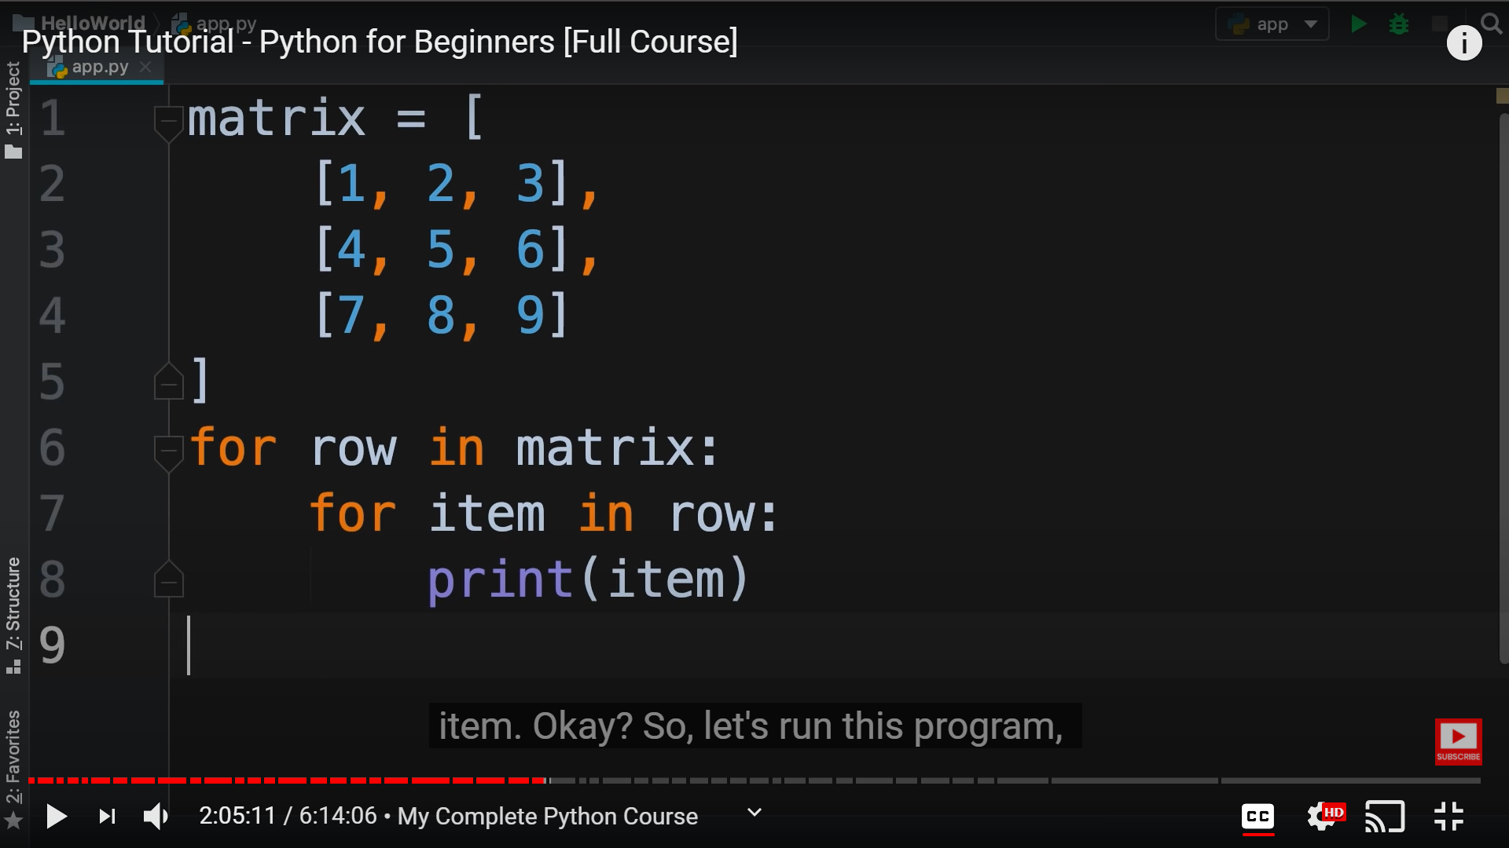

List Methods :-

These are bunch of operation that is provided on list.

Like:- list_name.append(20) => by using “dot” “.” , we can use list method like append() and many more.

Insert(index, value) => to enter at particular index.

pop() => this will remove the last item of the list.

index(value) => this will return “index” associated with this value.

“in” => this will also tell the existance of number in a list .  
example :- mylist = [10, 20, 30, 40]

print (50 in mylist) => False

print(10 in mylist) => True

count(value) => give number of time this value repeate in the list.

“None” => this represent absent of any value.

sort() => this is sort list in ascending order.  
To make this list in descending order:-

We can use a reverse() method after sort() method.

copy() => this will create a copy of our list.

Example :- mylist2 = mylist.copy()

Tuples :- this are just like list, but we can not remove, modify, add new item in it. It is basically **immutable.  
  
Tuples are immutable list.**

For tuples we use **()** .

Like mytuple = (10, 20, 30, 40)

To **access** item in tuple we use **square brackets** [] like:-

mytuple[2] => 30

Ther are also **methods** for tuple. But it is slightly different form the list because it is immutable.

__add__(self, x) => this are basically **magic method.**  Not covered in this course.

**Unpacking :- this is a powerful feature in python**

Suppose we need to access value of above tuple to be multiplied so we need to write :-

So we can do like this ;-

x = mytuple[0]

y = mytuple[0]

z = mytuple[0]

Product = x*y*z

But there is also a simple way for doing that with less code like :-

x, y, z = mytuple

Product = x*y*z

This also done a same thing with less efforts.

We are just unpacking this tuple in the variable.