To revese string :-

string[ : :-1] => this will reverse the string

To add KV in dictionary :-
dict_name[“new_key”] = “new_value”

To Delete a dictionary we need to use “del” keyword like:-
del dict_name[“new_key”]

Suppose we have dictionary named d1 (it already contain some KV)

Now if we do like d2 = d1 => here d2 and d1 both point to same dictionary, d1 and d2 is just like pointer for to same diictionary.

And if we want to make different copy we need to do like this:-
d2 = d1.copy => by this way d1 and d2 point to different dictionary having same KV pair.

If we want to print all keys then we need to do like :-
print(d2.keys())

SET

There is also another data type called “set”
Which is collection of well defined object.

To write set we need to do :-

Set_for_list = set([1, 2, 3 , 4])

Print(type(set_for_list)) => you will get “set”

Also suppose we have list as :-
L = [1,2,3,4]

S = set() # now this will become set

S.add(L) # this is way to add in the set.

so set different form list in that way that it will retain only unique values.

so if we do S.add(L) again , but it will store this same list in the set only one time.

now we can also do "union" , "intersection" , "max", "type" and other stuff.

FOR loop

for if we want to iterate list inside list we can use like:-

list1 = [ [ "arpit" , 14] , ["arun" , 15] , ["akshay" , 7 ] ]

to print this we need to do line :-

for name, roll in list1: # two iterating element in the list
print (name, roll)

Now we can also type cast that into dictionary :-

dict1 = dict(list1) # this will type cast list into dictionary.
the above will convert like {'arpit' : 14, 'arun' : 15…..}

now to iterate In dictionary we need to type:-

for name, roll in dict1.items(): # .items make to fetch value in kv pair.
print(name, roll)

if we write like :-

for name in dict1: # this will iterate only key.

Operator in python

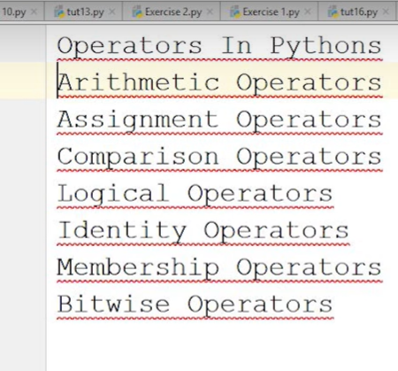

in Arithmetic operator is we do like:-
5/6 => float value
5//6 => integer value
5**6 => 5^6

Logical operator

"and " just this symbol required no need to write symbol like &&
"or"

Identity operator:-
"is" print (5 is 5) => true
"is not" print(5 is not 5) => false

membership operator:-
"in" for name in list1:
"not in" print (345 not in list1)

Bitwise operator :-

"&" -> bit wise and
"|" -> bit waise or

Identity operator
Membership operator

