Doc string in function

now suppose we have function for average of two number :-

def average(a, b):
""" avg of two no """ # this is syntax of doc string
temp = (a+b)/2
return temp

print(average.__doc__) # now this will print doc (info string) of that func

try except in python # not try catch in python

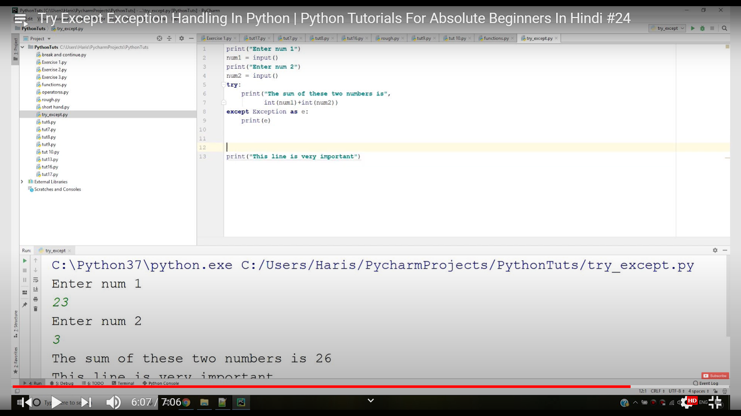

here we can see this , if we put character instead of number, then try will not execute this will show error and this error is except as Exception and we are printing this.
benefit of this try exception block is that below "very important" will execute whether try block fail or not (by not exited) from the program.

"as" keyword we will learn about that later.

File operation in python :-

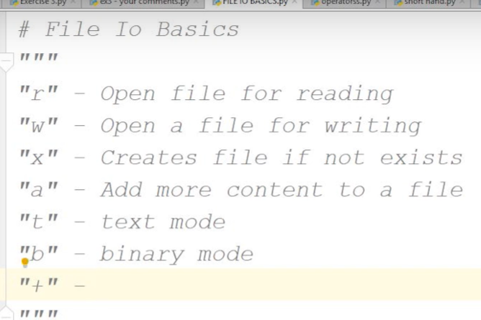

"+" => also we used that to update file.
here we need to note down that "r" and "t" are default mode.

now lets make a file "sample.txt" using vim and write few line in it .

now we are going to read this file using python program:-

file = open("sample.txt") # here "file" is file pointer to that sample.txt
content = file.read() # now content of sample.txt will be store in content.
print(content)
file.close()

here default mode is reading "r" and text "t". we can write first line of above snipet as :
file = open("sample.txt", "rt")
content = file.read(3) # this will going to read 3 character only
print(content)

content = file.read(3) # this will going to read "next" 3 character only
print(content)

file.close()

if we want to read character by character we can done that as:-
for character in content:
print(character)

if we want to read line by line we can done that as:-

for line in file: # here we have give "file pointer".
print(line, end="") # here "end" because sample.txt and print both contain new line

Also we can use "readline" method

print(file.readline()) # this will going to read first line
print(file.readline()) # this will going to read second line

If we want to store all lines into list we need to use "readlines()" function

list1 = file.readlines()
print(list1)

