Math Function:-

round function :-
Use to round decimal values
X = 2.9
Print (round(x)) => o/p => 3

Absolute function :- abs() => this will give +ve number for all -ve number

Print (abs (-2.9)) => o/p => 2.9

Modules:- is a separate file which contain some reusable code.

Like math module, first we need to import that one :- “import math”

To use math function we need to use dot “.” operator. Like “math.acos(x)”

Math module of pyhton3 is slightly different python2 , so always search for “python3 math module”

If condition in pyhton:-

Logical operator in python:-

For && -> “and”
For || -> “or”

For ! -> “not”

Comparable operator in python:-

>=
<=
>
>
==
!=

Remember :- when we multiply a string with a number , the string will repeate that much time

Like print (“$” * 5)

This will repeat “$” 5 times as $$$$$

While loop in python:-

In python while loop is also contain “else” part it means if inside while loop condition is false then it will switch to else part of while loop .
For example reffer :- while_loop_else.py

Small game for start and stop car

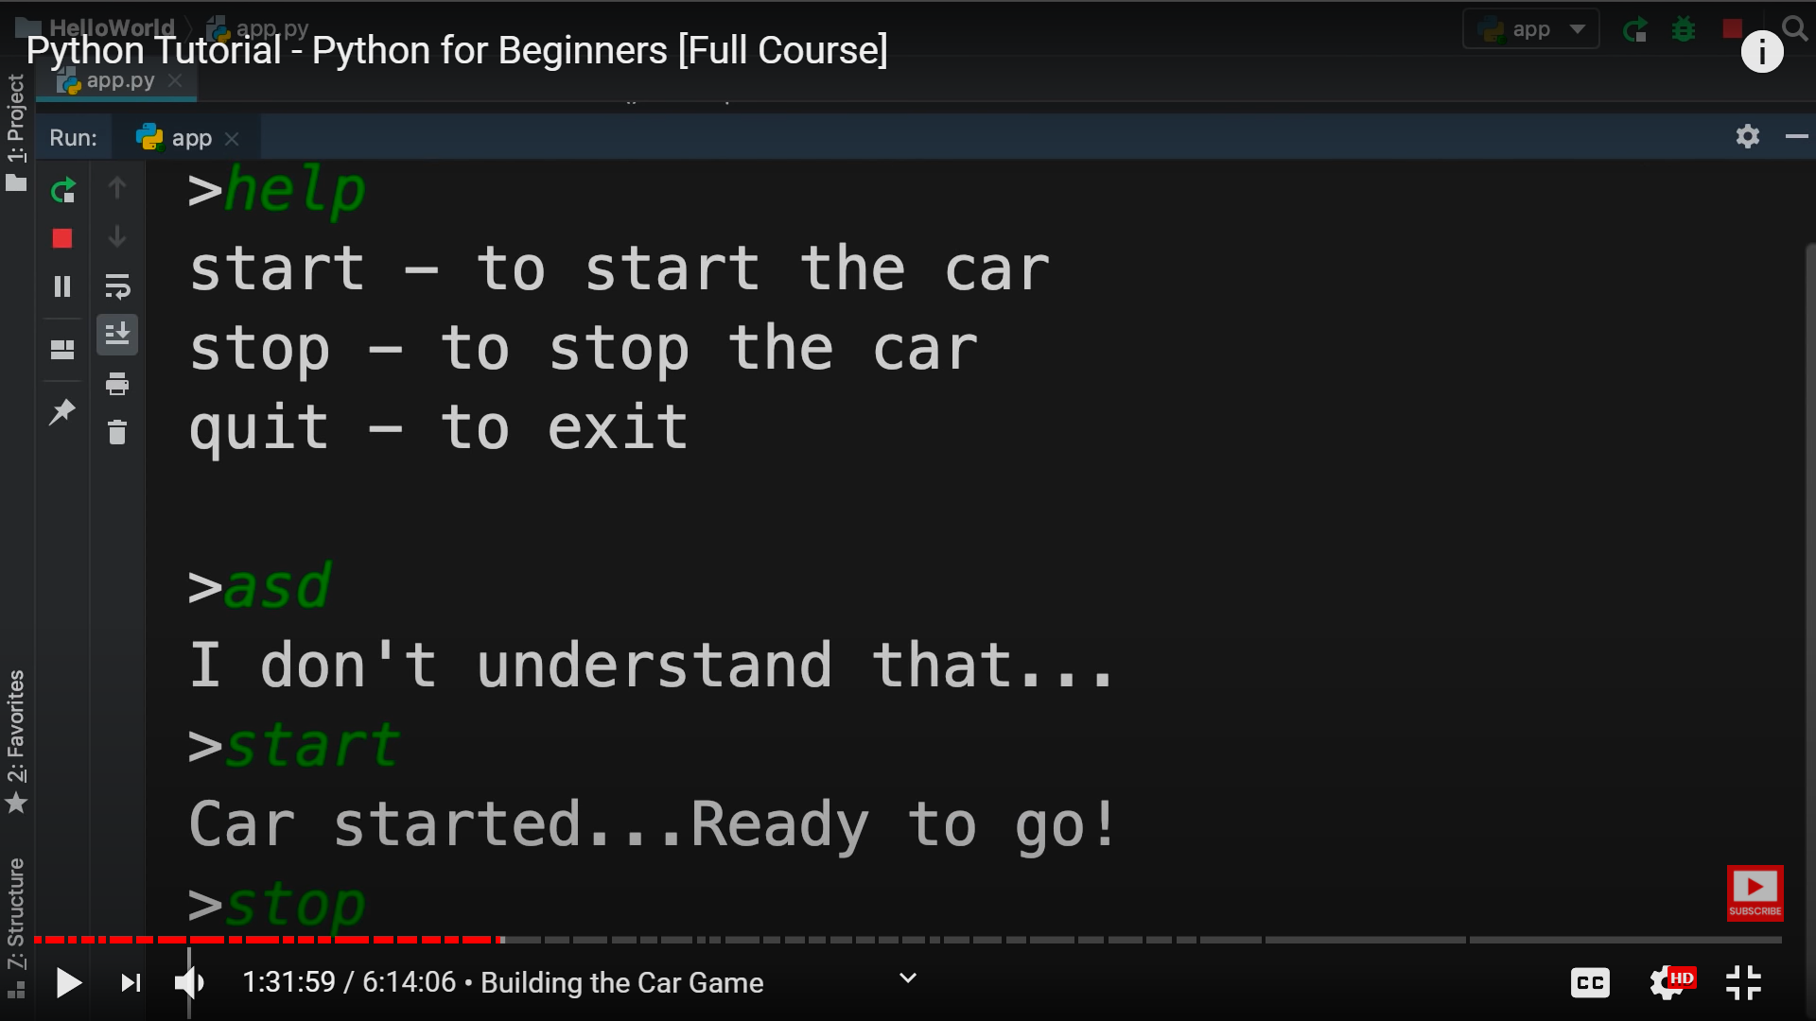

Reffer car_game.py

command = ""

while command !="exit":
command = input ("> ")
if (command.lower() == "start"):
print("you car is running")
elif (command.lower() == "help"):
print("""
start - to start car
stop - to stop car
help
exit - to exit game
""")
elif (command.lower() == "stop"):
print ("car is stopped")
elif (command.lower() == "exit"):
print("we are going to exit , thanks ")
exit()
else:
print("wrong input please see help")

But here we can see that we put “.lower()” in every comparison but is not good idea .
To do that only at once we need to make input line as :-

“command = input (“> ”).lower()” so this command automatically convert this input string as lower.

For loops in pyhton :-

We used to iterate over “items” of a “collection”, such as string.\

Because string is sequence of character looks like collection.

So by for loop we can iterate each character of a string, and do somethings with that.

Like:- for item in “python”:
print item

Reffer:- for_loop_string.py

Also we can do that for “list” as list is also a collection of item

Like :- for item in [1,2,3,4]

Also we can use “range()” function for the number

range(10) => 0 1 2 3 4 5 6 7 8 9

range(5, 10) => 5 6 7 8 9

range(5, 10 , 2) => 5, 7, 9

To print without giving new line we need to do :-

print (“hello”, end =””)

