for more info:- https://www.geeksforgeeks.org/python-dir-function/

help() and dir() are built-in function in python.

now lets imagine you have import a module called "math", but you dont know about variable, function, classes, methods, attribute regards to this module.

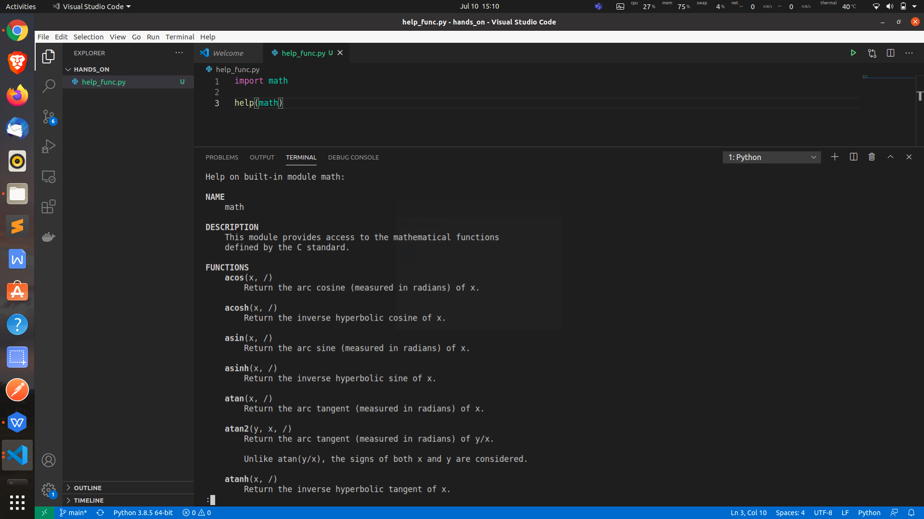

so this function returns many attributes and method regards to this function.

now create out own module and try to fetch some help regards to this module:-

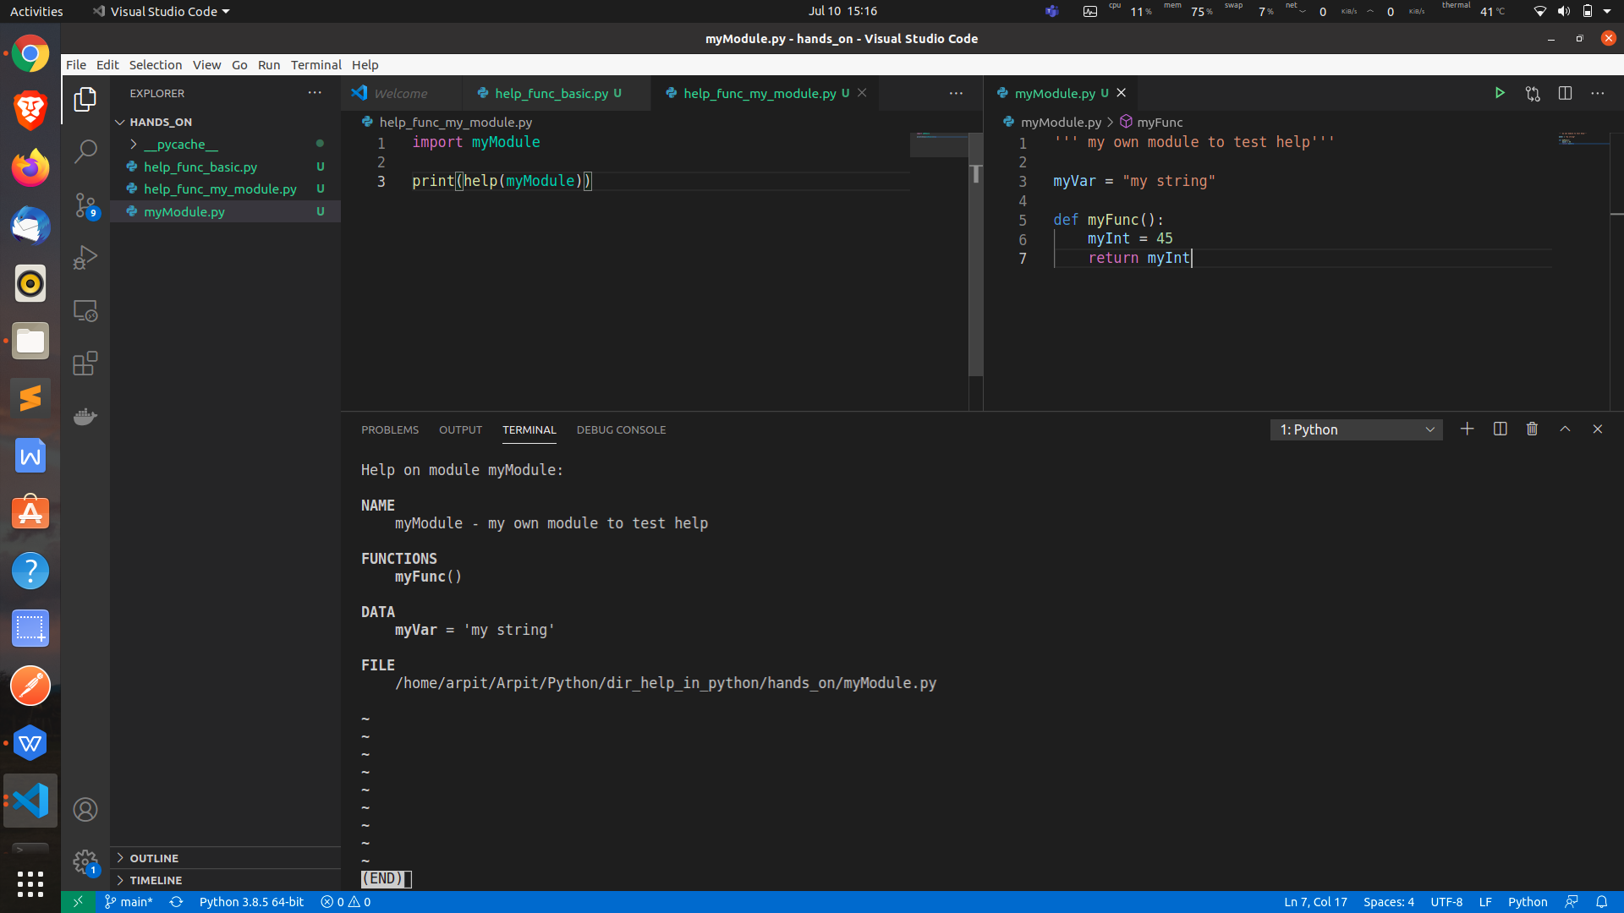

docs-string:- this show information about your module
should be the first line and have three single codes.

dir () function

this wil return list of names of all attribtes and function in your modules or object (of any data structure like class)

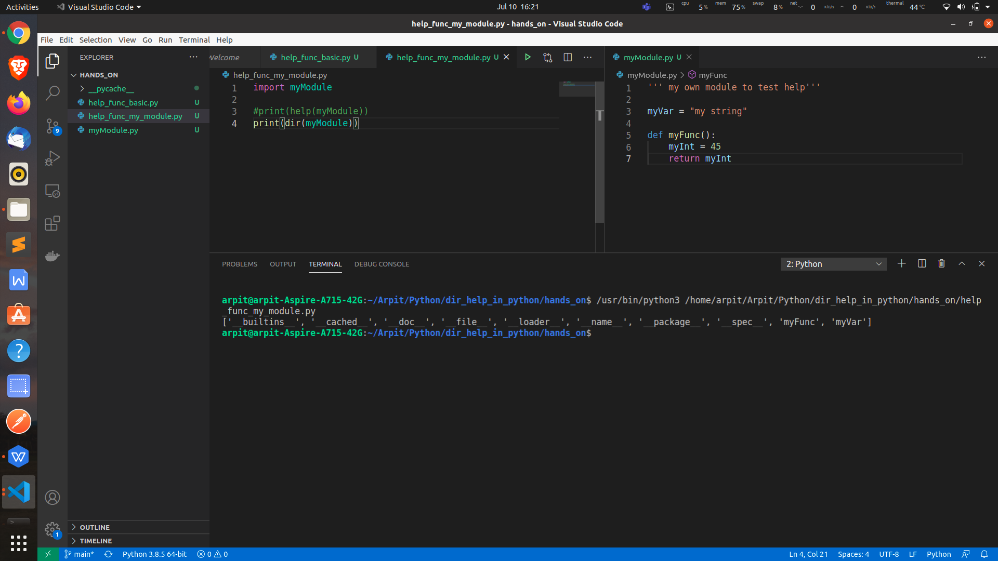

o/p:-

['__builtins__', '__cached__', '__doc__', '__file__', '__loader__', '__name__', '__package__', '__spec__', 'myFunc', 'myVar']

here 'myFunc', 'myVar' ==> regards to module.

and if you didn't pass any parameter to this dir this will tell about current program or root modules.'

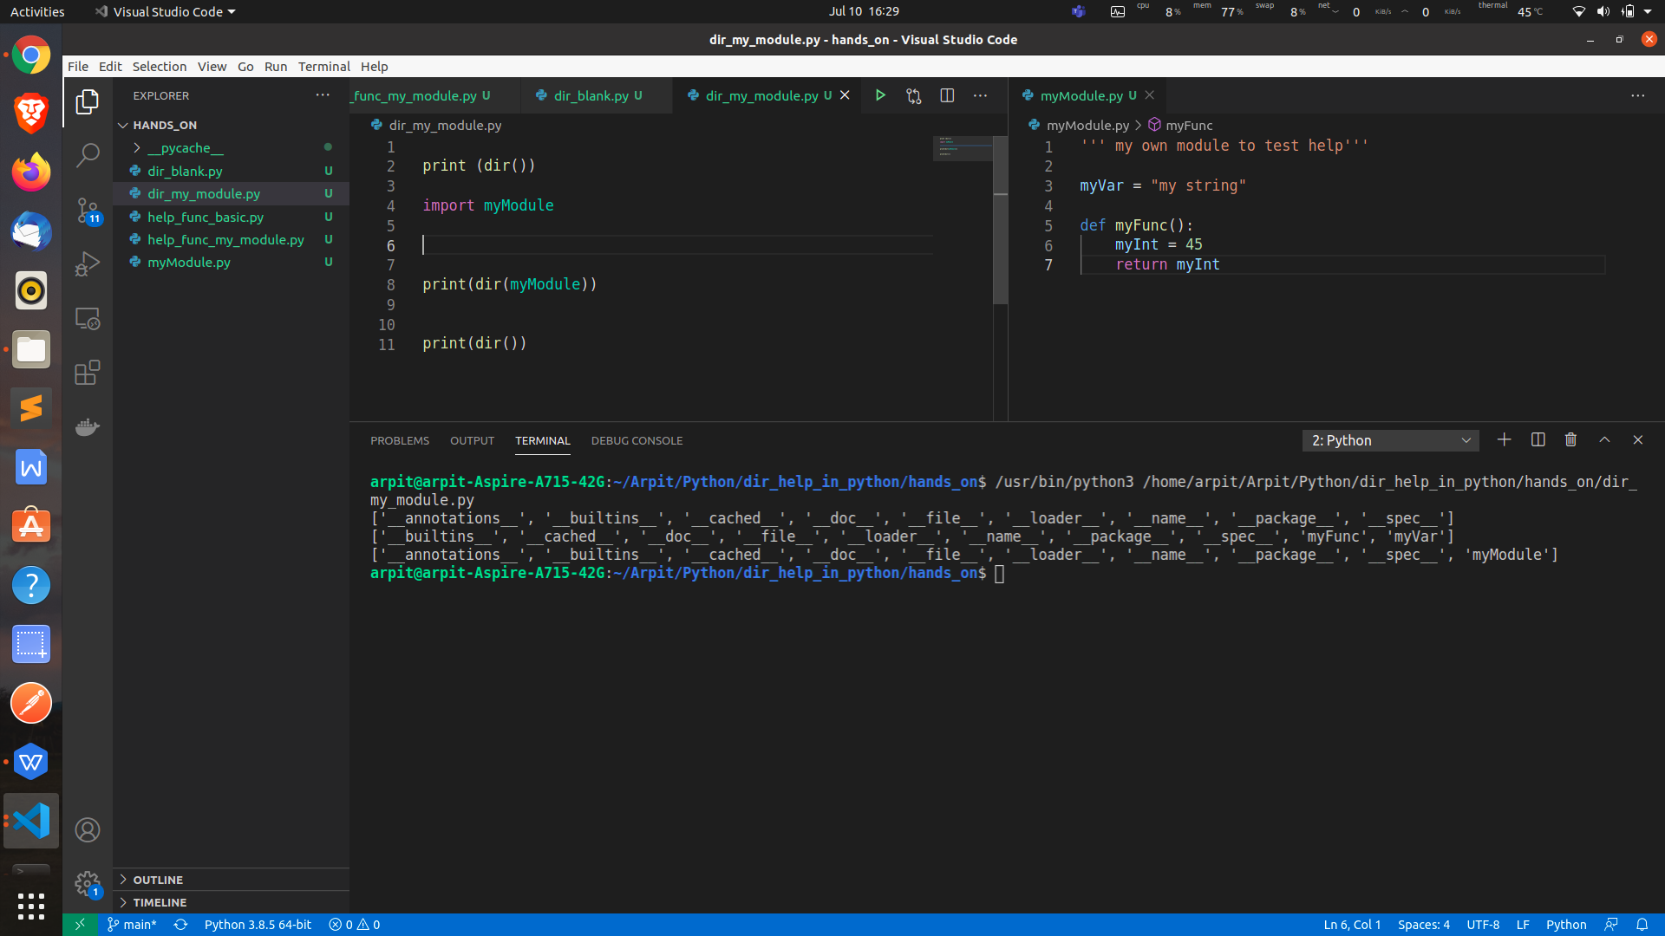

dir for class:-

class Supermarket:

# Function __dir()___ which list all
# the base attributes to be used.
def __dir__(self):
return['customer_name', 'product','quantity', 'price', 'date']
# user-defined object of class supermarket
my_cart = Supermarket()
# listing out the dir() method
print(dir(my_cart))

o/p:-

['customer_name', 'date', 'price', 'product', 'quantity']

