Ldap important point :-

1. Ad -> active directory -> it is used to provide authentication, group and user management.
it is used to create policy.

2. LDAP -> light weight access protocol
so it is light weight client server protocol
it is used to manage and access to directory.
it runs over tcp ip protocol.

so LDAP is a way to access active directory (AD)

so basically LDAP is kind of security policy to provide restricted access to different users.
so basically if we have 10000 computer we can not describe policy one by one to every system.
so we can create a security policy within domain controller.

we need to create all USER in LDAP server, we dont need to create a USER.
so when client try to login using username on client it get verified using LDAP server.

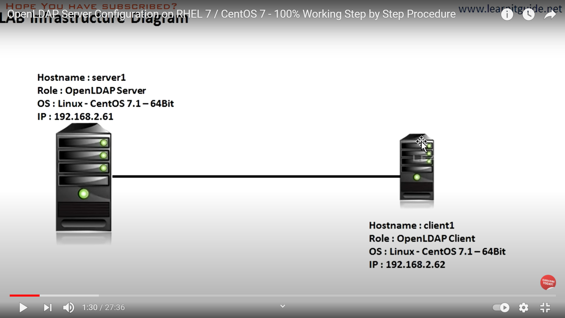

so here is server and client.
Steps required to configure LDAP server.

