Decorator in python

so Decorator is basically function which take argument as function and return as function.

so it take a function and it modify the the functionality of that function and return that modified function.

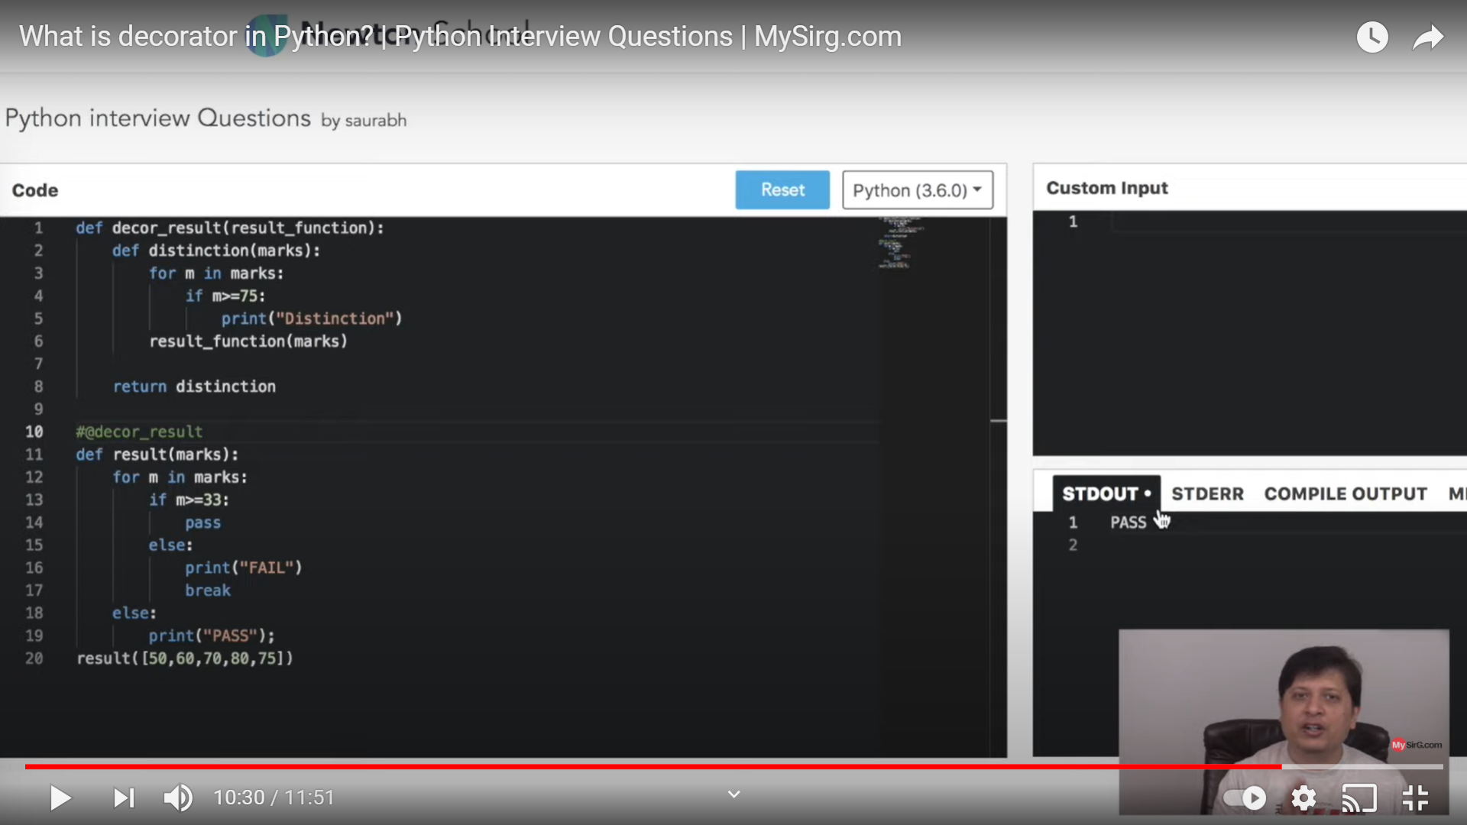

now look at these code snippet:-

here our main moto is to check whether a student is fail or pass but we also want to know if whether we can de

