# pip3 install django

first create project :-

$ django-admin startproject Hello

use visual-studio-code

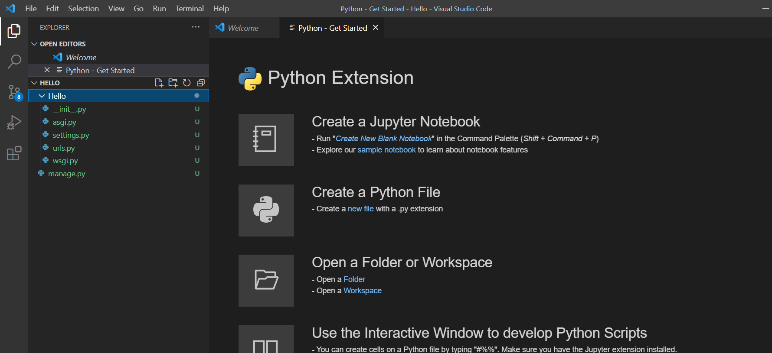

here we can see some code automatically appear by django itself.

$ python manage.py runserver

Now you can see our server start

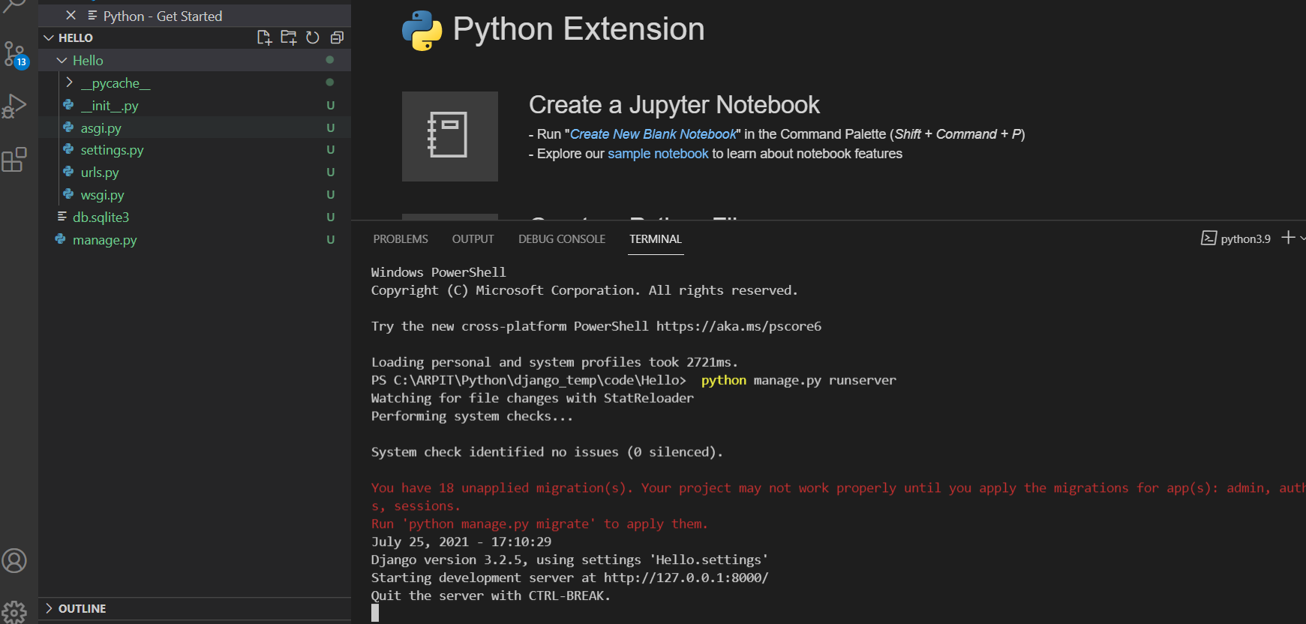

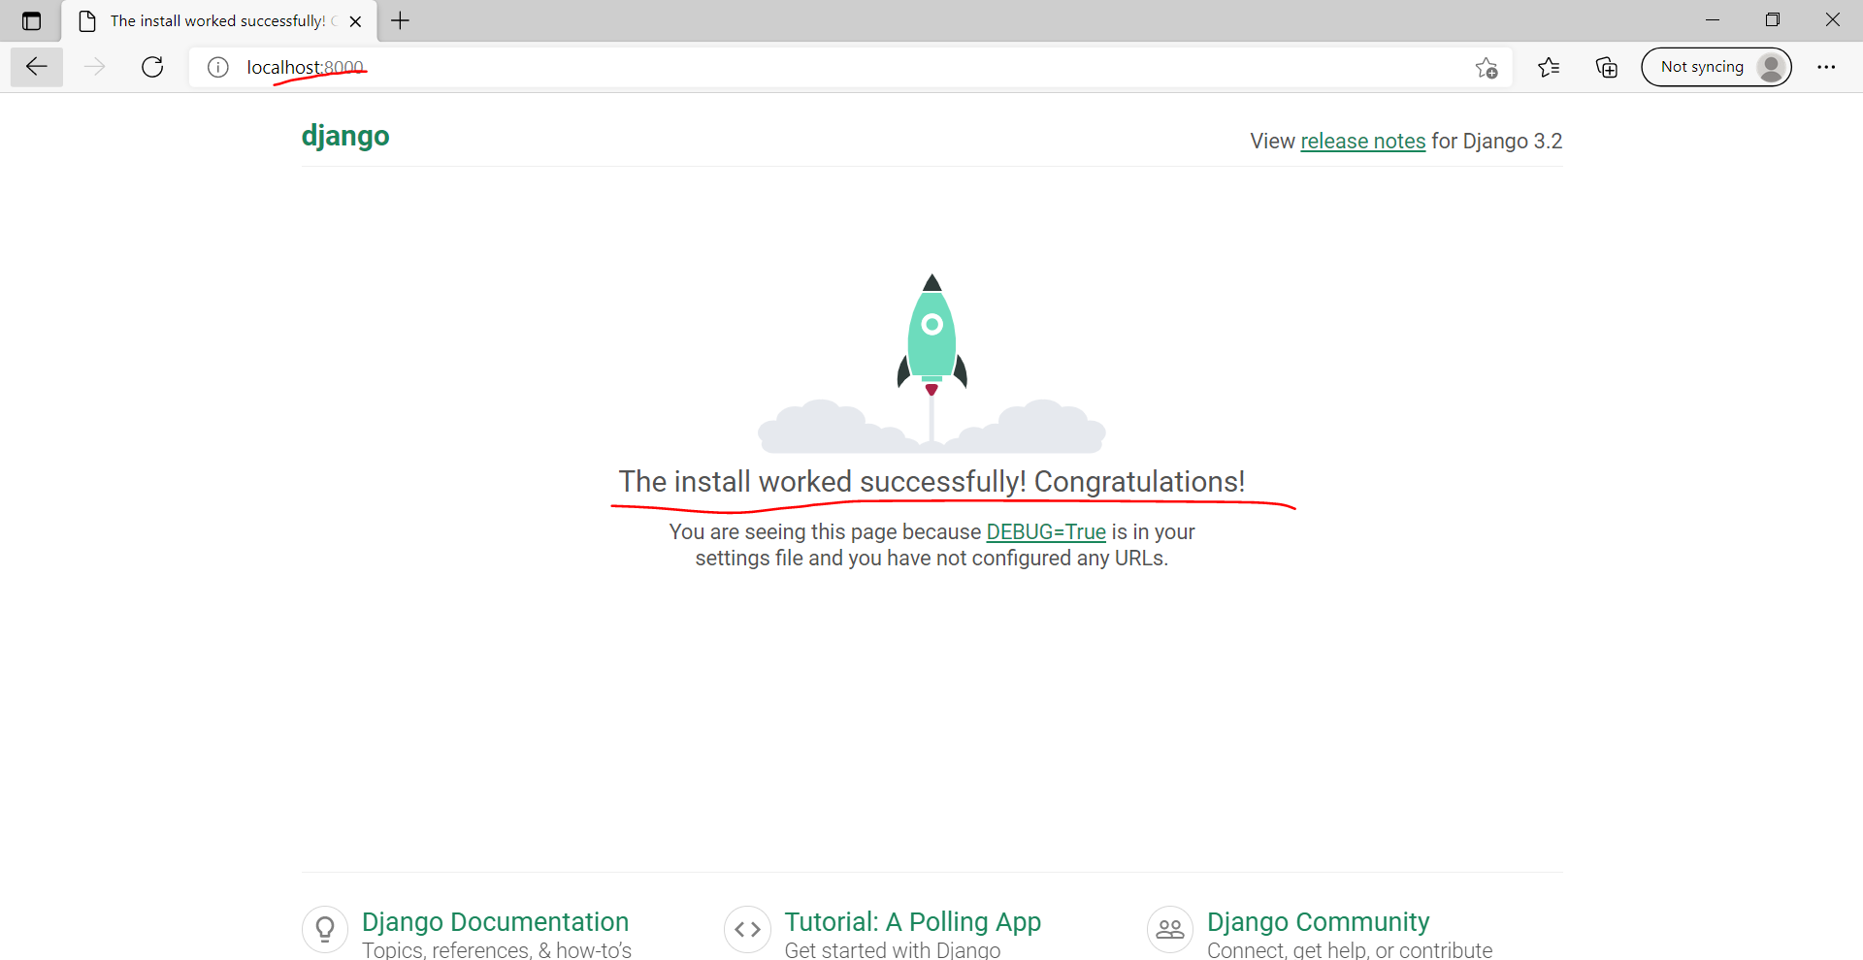

Now you can see server start to run

Now lets see what are the things required to start a website :-

So by the help of this you can render your webpage

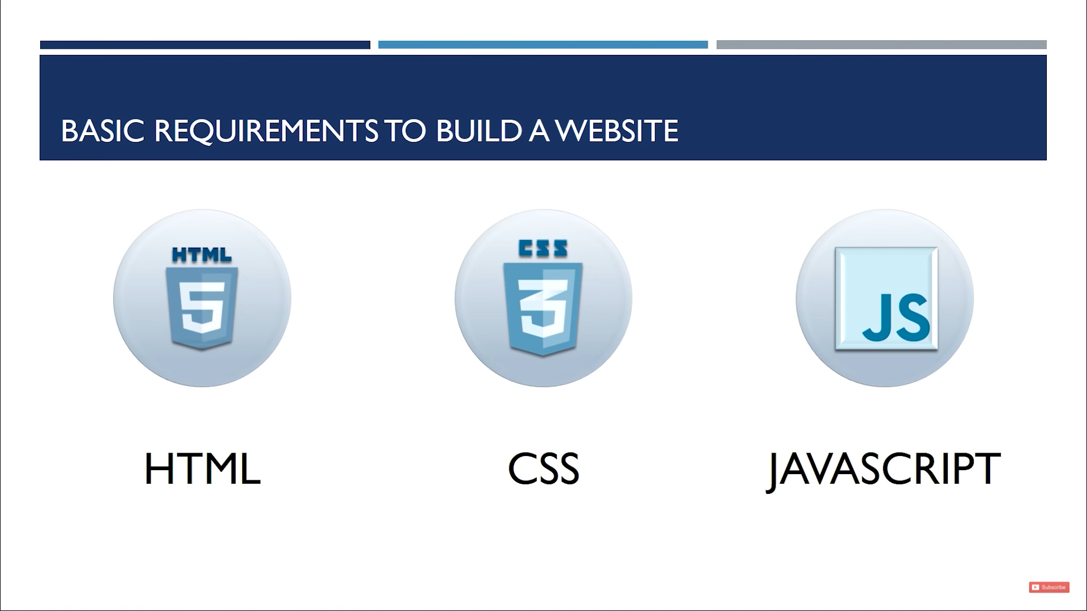

Now when you ask form sever to get response, its gives you in form of HTML, CSS, JavaScript only.

Client side scripting is done by JavaScript, like when you push on select its number goes from 3 to 4. it is working on your browser only.

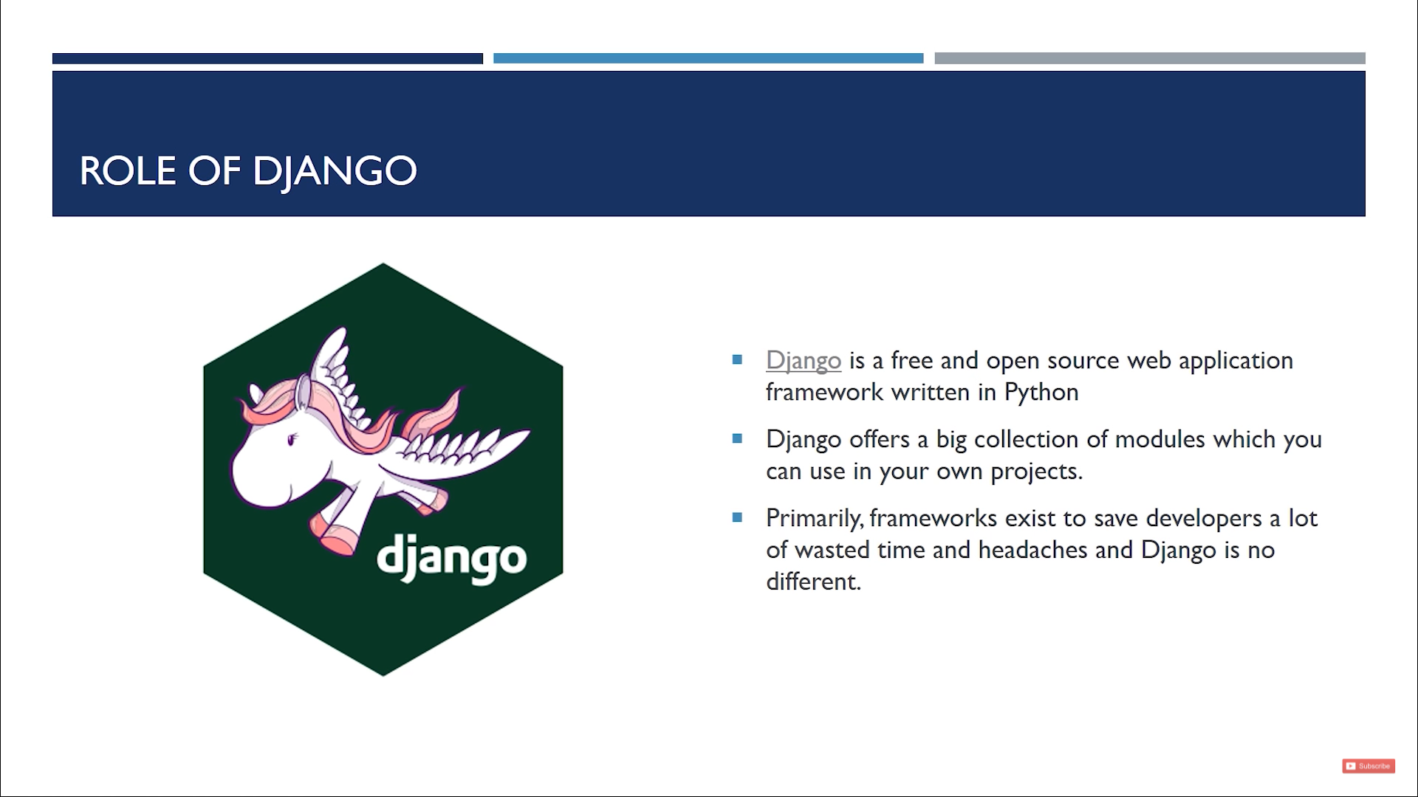

why Django is used, lets suppose you have 1000 user, you will not going to create 1000 webpage for eveyuser, in-spite of that what you can do is like store user information in database and create one HTML template and render that every time when request came for new user.

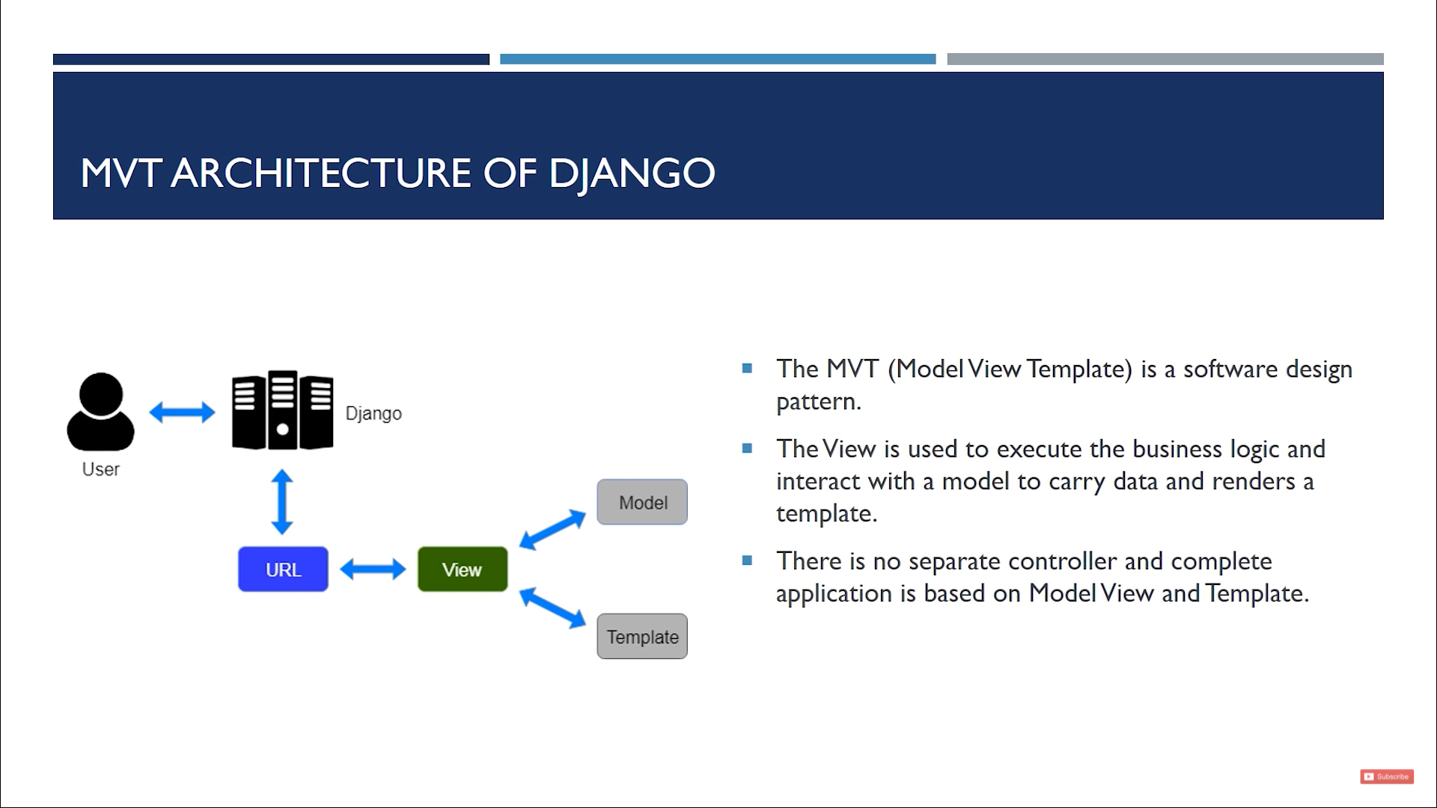

there will be place holder in Template (template is basically html, css and javascript)

data is pulled by model and send to template

Now lets goto vscode.

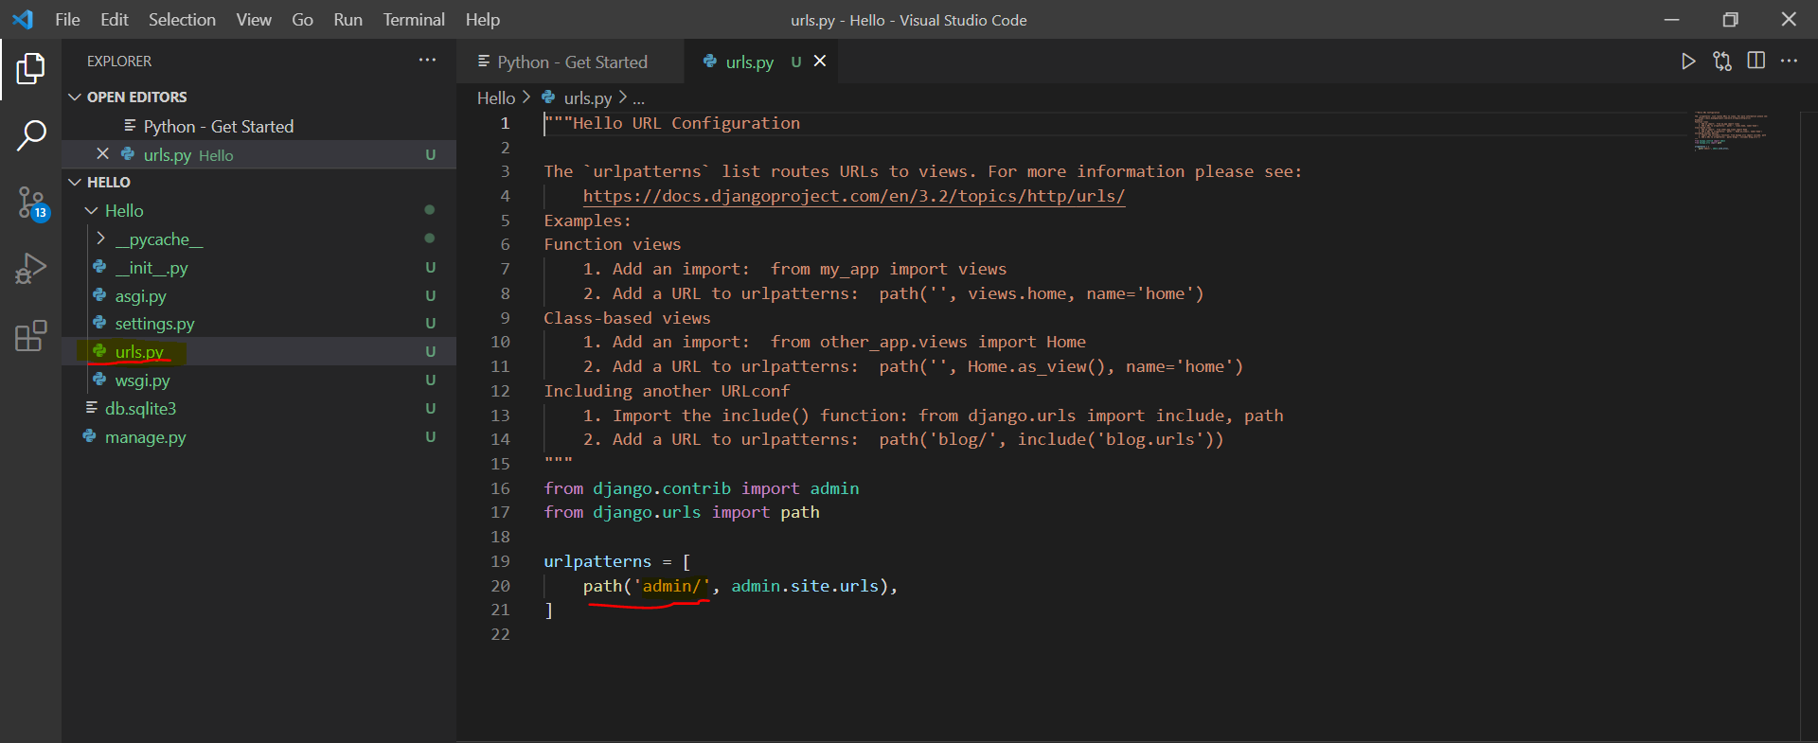

lets see there is urls.py ==> which contain all uri associated with there respective application (app)

this app belong to separate entity.

so inside a project there should be atleast one app, in realworld case there will be many app like cart, galary, blogs etc.

$ python manage.py

go to here you will find list of commad like

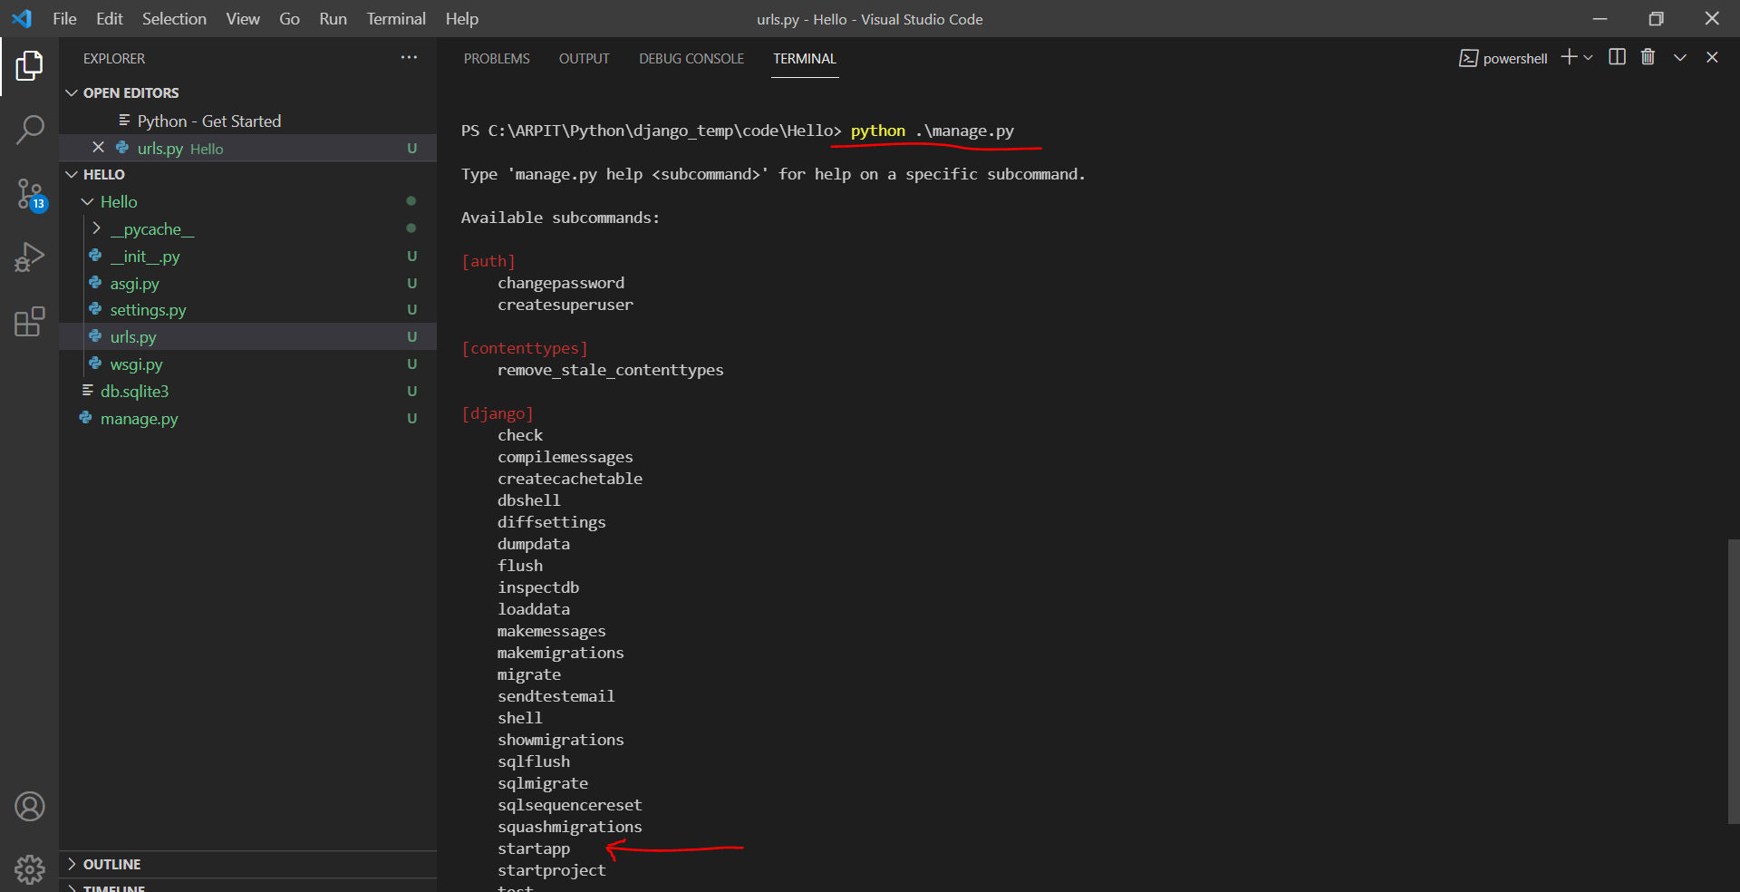

now run $ pyhton manage.py startapp <app-name> ==> this will create app

eg:-

$ python manage.py startapp home

you can see this will generate a folder "home" and it contain all app related file.

Note:- this folder doesn't contain setting.py as this setting.py is related to project not with app.

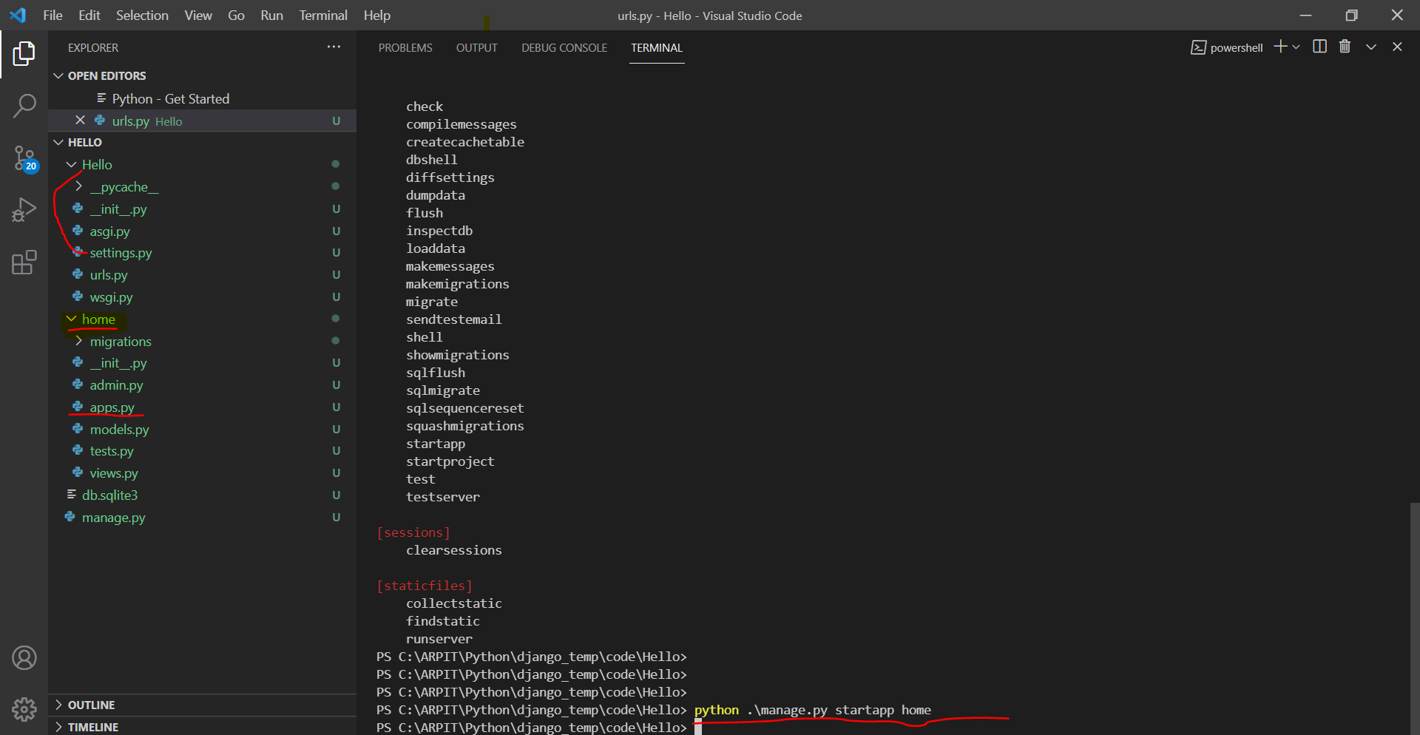

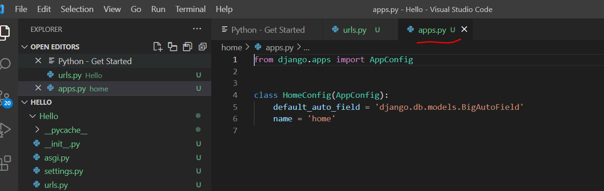

now app "home" doesn’t contain "urls.py", so create here.

also copy content of "Home" (project) 's urls.py to app's urls.py

URL Dispacher :- this is used to route traffic using uri

but lets understand path first.
path(route, view, kwargs=None, name=None) ==> used to route urls
in view attribute we can give "include()" which include from other apps

path('admin/', admin.site.urls),
this line means if somethings comes to "/admin" send that to admin.site.urls

So we will add another "path" that says like

path("", include("home.urls"))

if anything without uri means root uri came send that to app "home" 's Urls

in "home" 's urls.py

from django.contrib import admin
from django.urls import path
from home import views

urlpatterns = [
path("", views.index, name="homepage")
]

here we import views from home.

Also this line :- path("", views.index, name="homepage")
means when somethings comes to root page route it to "view.py" module and in that file you will see a "index" function, and called this

so we will go to view.py file and create a index function like

from django.shortcuts import render, HttpResponse

# Create your views here.
def index(request):
return HttpResponse("this is home page")

here we import HttpResponse

in reality we will call render HTML tempalate inspite of this

now run $ python manage.py runserver

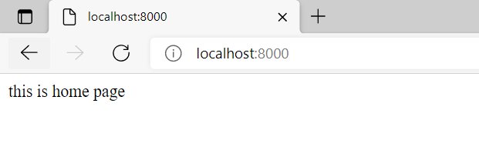
now lets create more URI
go to home's app's urls.py to add path and go to views.py to adds its functionality

urls.py

from django.contrib import admin
from django.urls import path
from home import views
urlpatterns = [
path("", views.index, name="homepage"),
path("about", views.about, name="about"),
path("service", views.service, name="service")
]

views.py

from django.shortcuts import render, HttpResponse

# Create your views here.
def index(request):
return HttpResponse("this is home page")
def about(request):
return HttpResponse("this is about page")
def service(request):
return HttpResponse("this is service page")

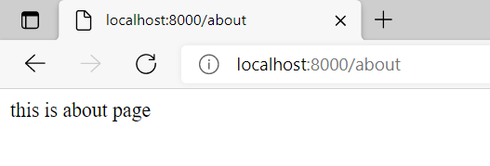

so above whole process is know as URL Dispacher.

Now lets talk about static file those file which we want to be available to public, like some txt, jpeg, mp3.

now lets create two directory in root location of your project

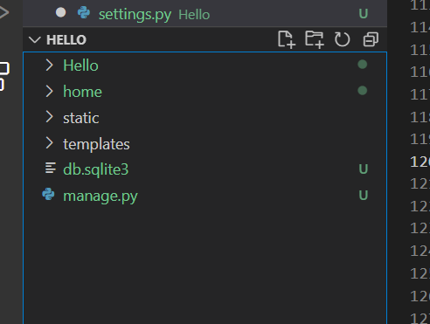

now create a file in static directory

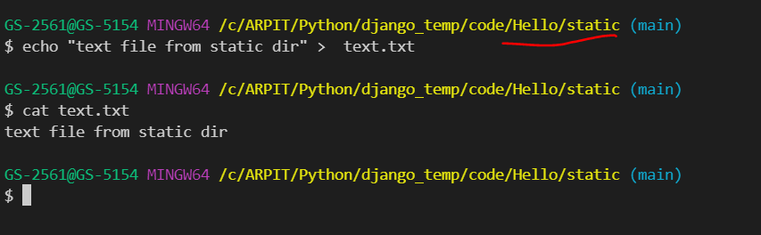

now go to setting.py file

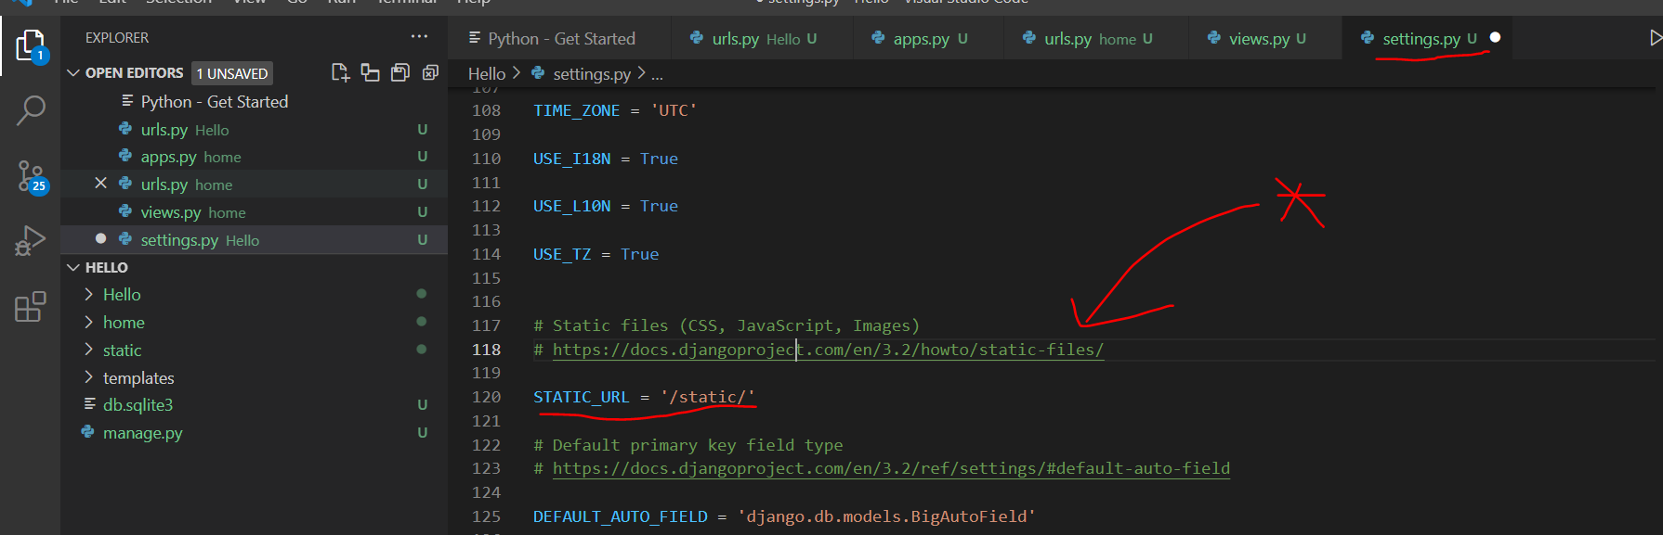

here * ==> go to that link to get more about static file.

add this at last:-

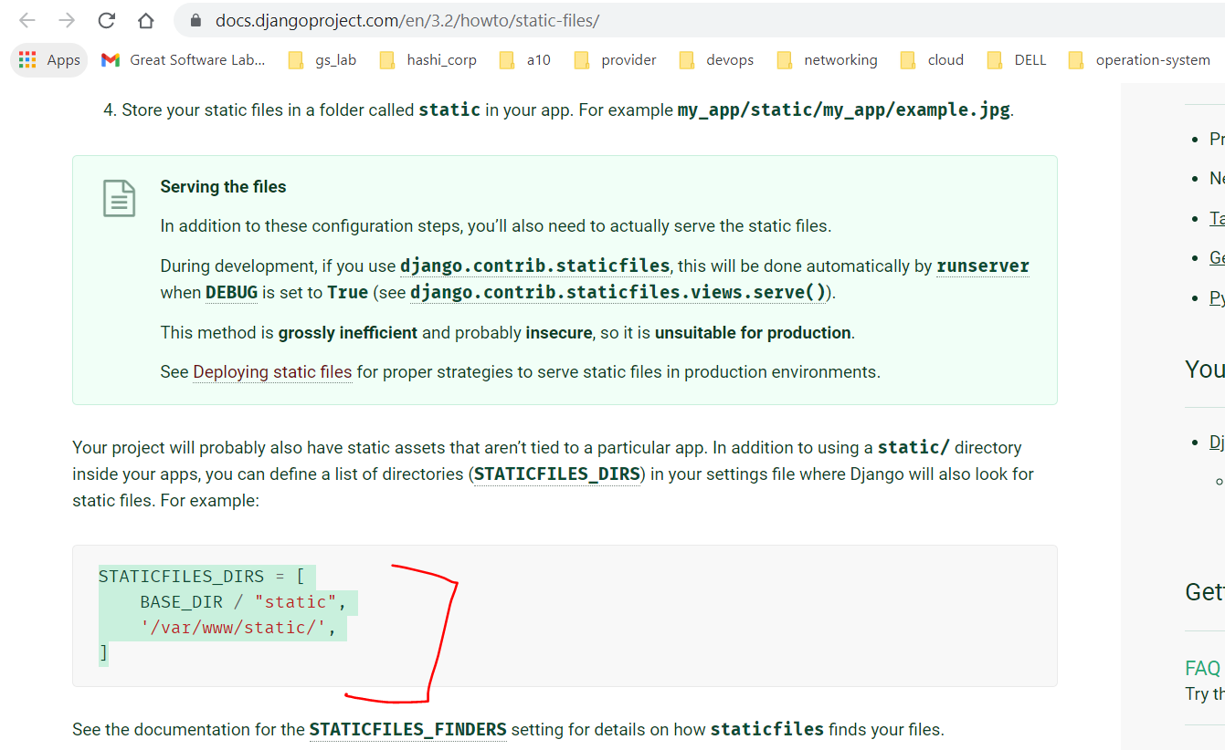

to locate static directory

STATICFILES_DIRS = [
BASE_DIR / "static",
'/var/www/static/', ==> this means it will try this directory as well
]

for simple lets keep only directory like:-

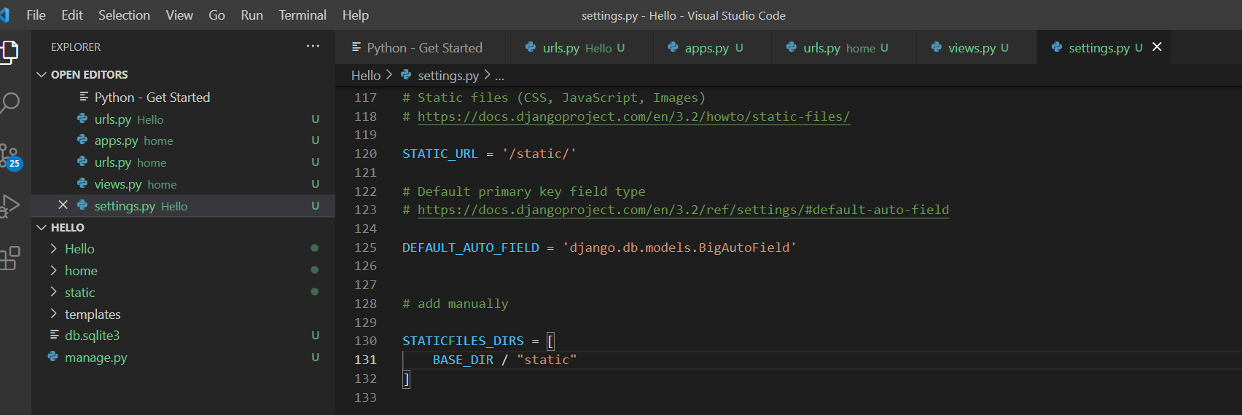

See its start to work

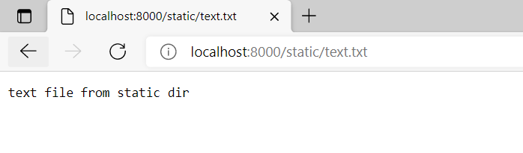
Only put those file in static that you want to be share in public, otherwise it leads to security thread.

Okay now talk about "templates" directory

lets say you have some html file to render that we can send via render
and this render is pick html file from template folder.

Now mention template directory path in setting.py like

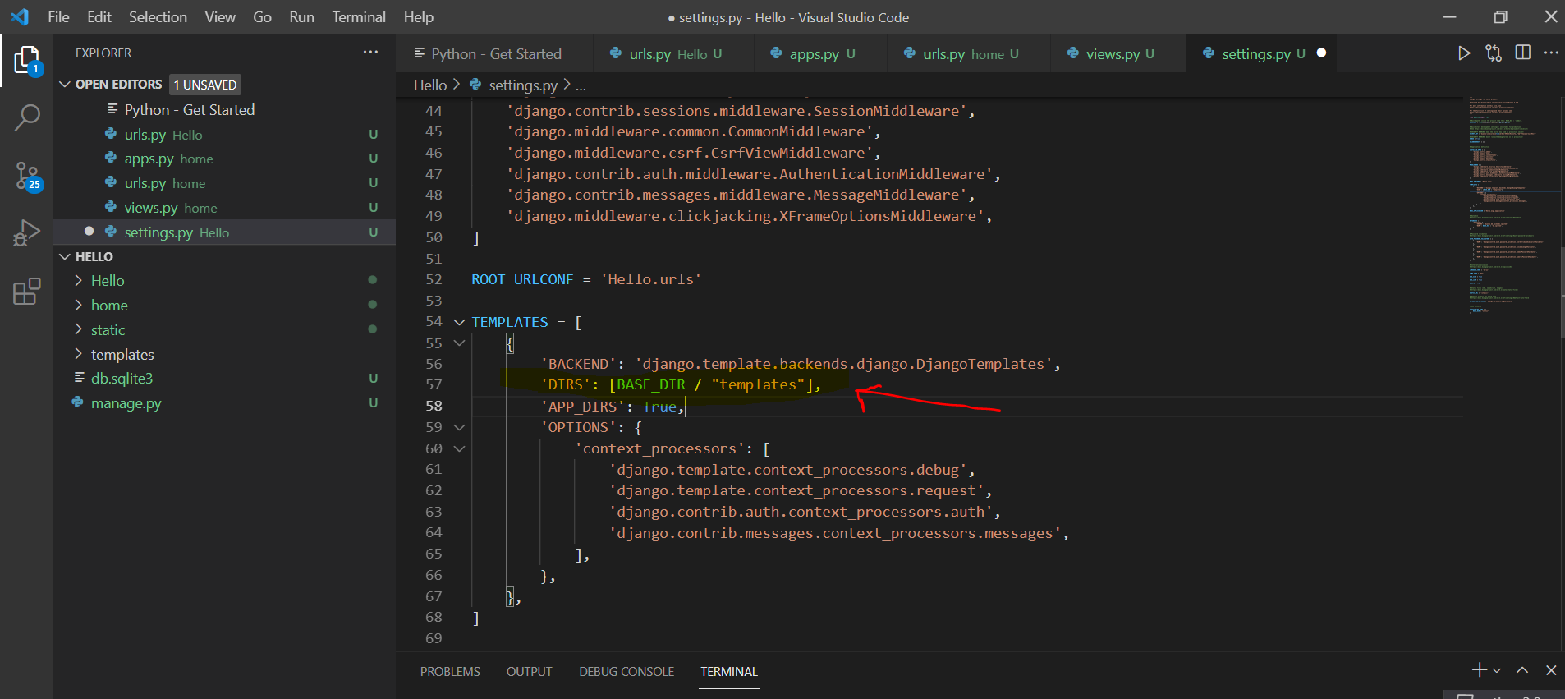

now lets go to templates dir and create an index.html file

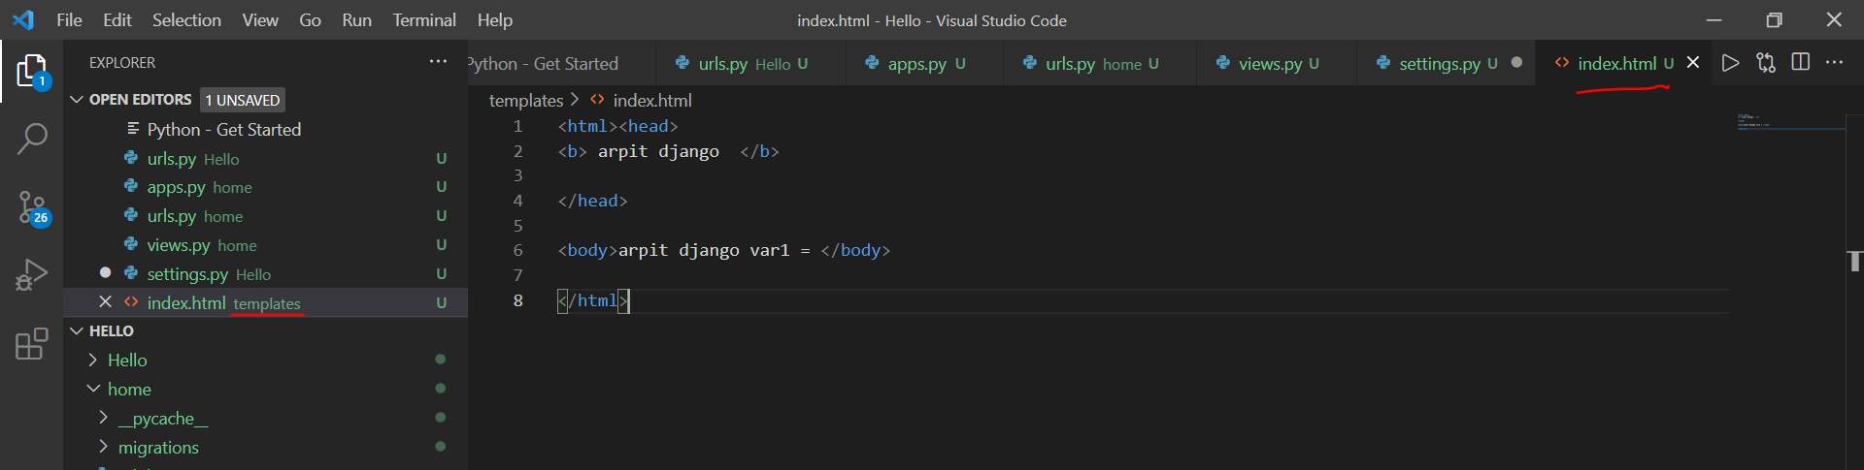

Now go to view.py and render index.html

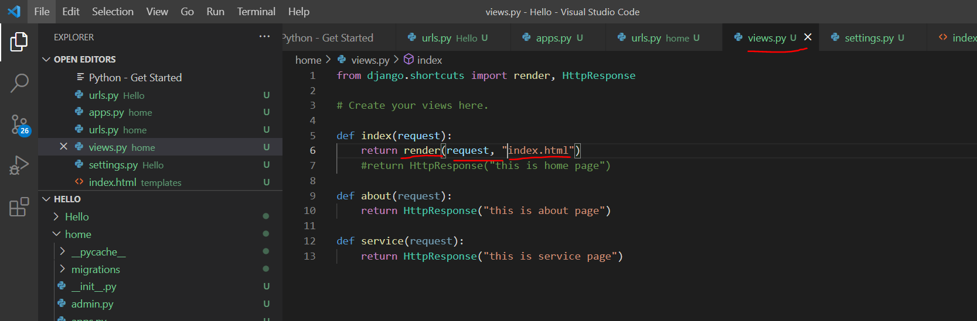

Here you can see our first argument in render is request it self and second element is index.html.

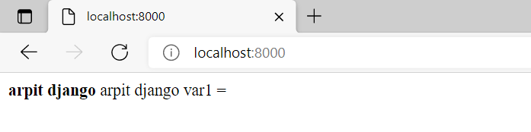

Okay now it s working.

now we need to render variable send by user or service using context

go to your html file and make placeholder like
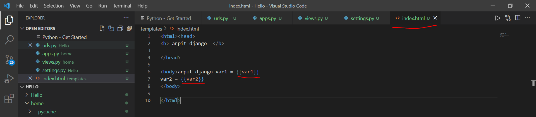

these placeholder is just double curly bracket inside that we put a variable.

now go to view.py file and give "context"
context is basically dictionary of variables

from django.shortcuts import render, HttpResponse

# Create your views here.
context= {
"var1": "foo",
"var2": "bar"
}
def index(request):
return render(request, "index.html", context)
#return HttpResponse("this is home page")
def about(request):
return HttpResponse("this is about page")
def service(request):
return HttpResponse("this is service page")

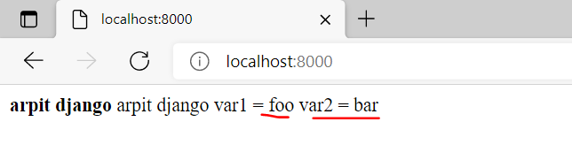

in real world we pick value by "models" or "database" or by some service to put in context.

Now important thing: there is website called bootstrap.com
From here you can pick html and css design already desiged to be production ready then you can customize it

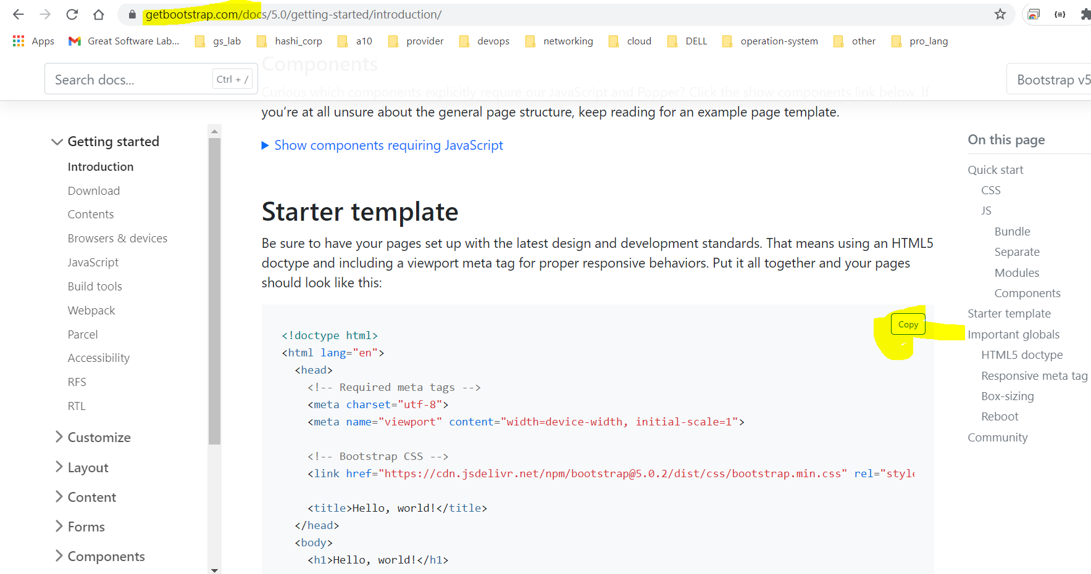

copy this starter template and paste it on our index.html

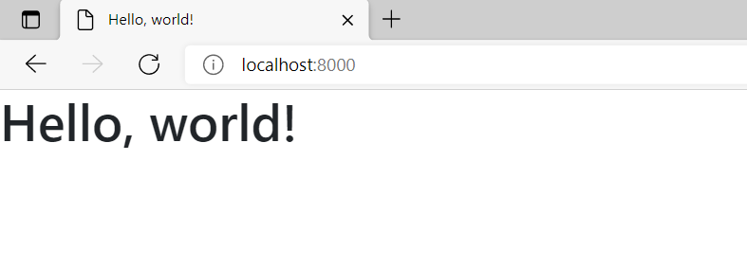

we are able to render that.

Now lets attach navigation bar onto our website

go to bootstrap.com and copy html regards to navigation bar an paste that in body of our index.html

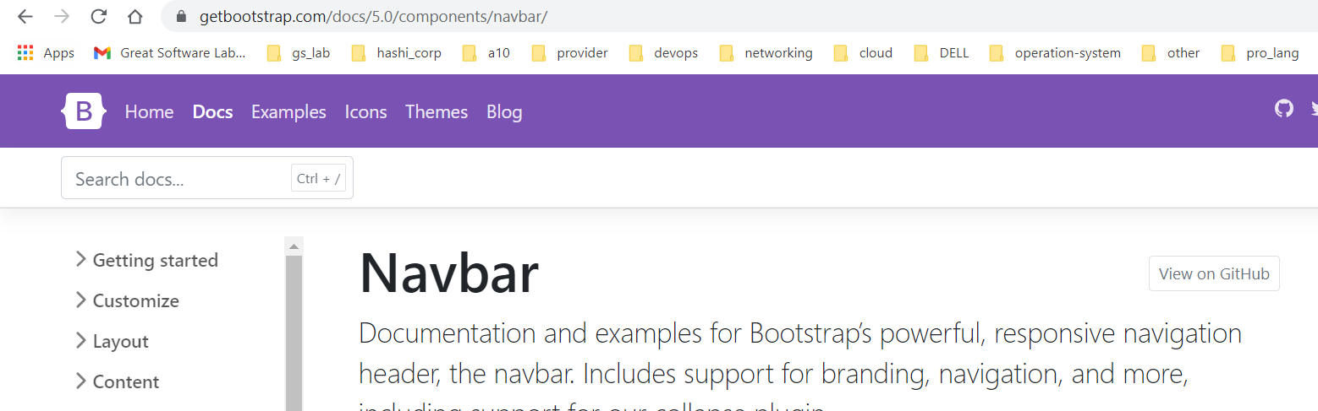

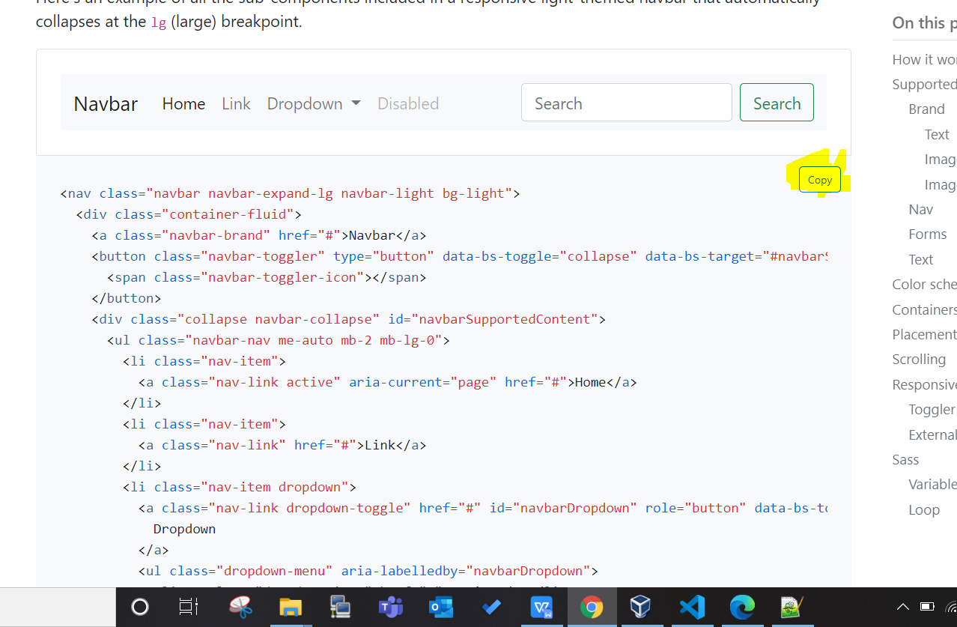

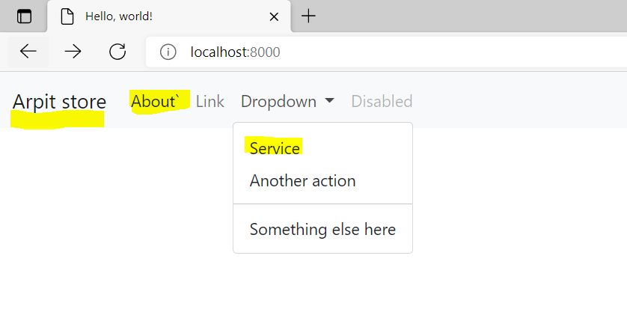

now our navigation bar is attached now, I also change href="/about" for About.

so we when we click to about we will get like :-

