Request module :- <https://docs.python-requests.org/en/master/>

Request module is **higher level** of http module. there is also low level http client as well in pyhton.

This is use to make http request for the website.

that why its tag line is HTTP for Humans.

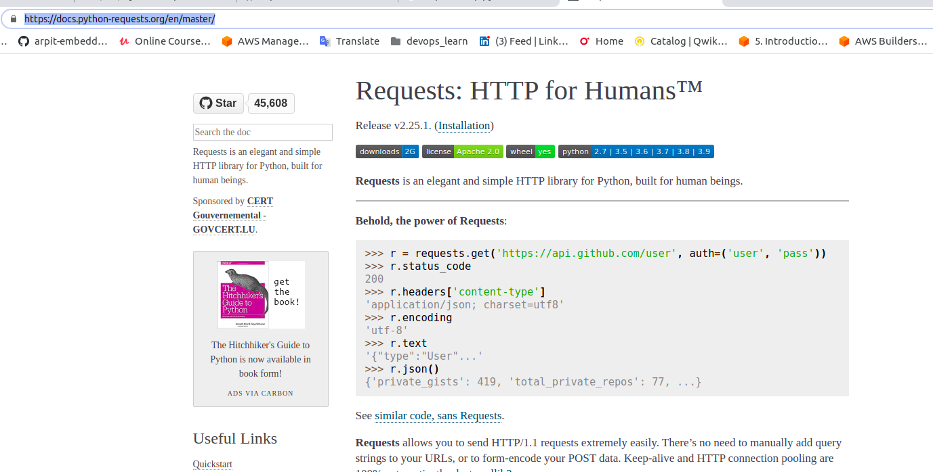

Here we are going to use not just GET but also POST, download image, set authentication, follow redirect.

So Request library is know to get information,not to pasre information.

ans if you want to parse that information then you have to use **beautifulsoap** or may be some other tools.

lets talk about some basic working of request module.

to install request module we need to intall them using pip

$ pip3 install request**s**

we will use this <https://xkcd.com/> this is comics related to python.

import requests

r = requests.get("https://xkcd.com/")

print(r)

print(type(r))

O/p:-

<Response [200]>

<class 'requests.models.Response'>

So this basically gives us response.

Now if we want to see all the attribute regards to this "r" variable

means if you want to see all attribute and methods available for specific object use "dir()"

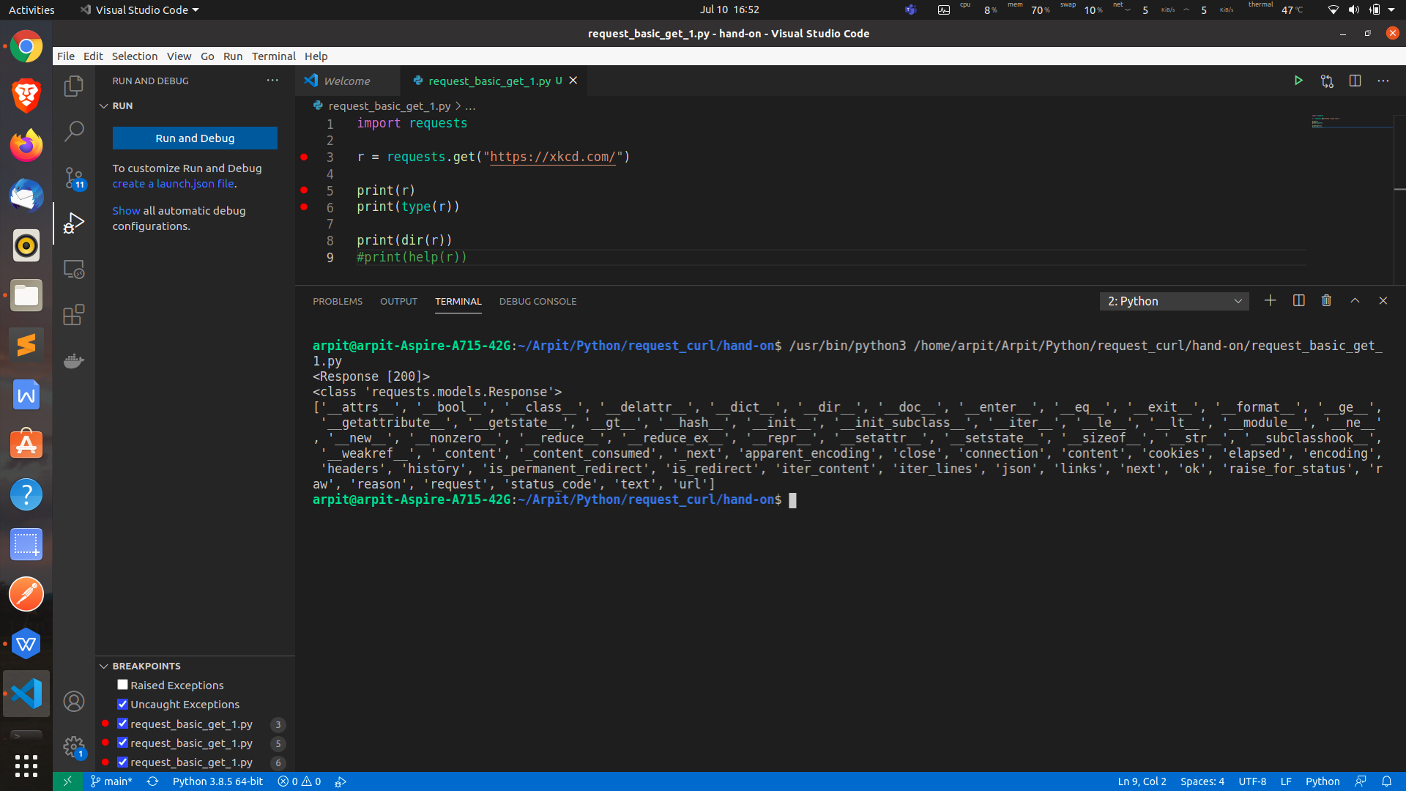

Now suppose you have to print the content of this http request so use "text" attribute.

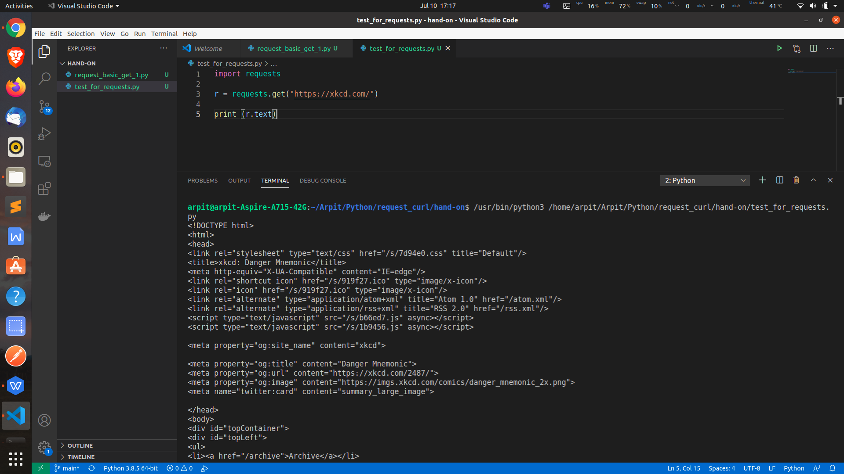

Now lets suppose we want to download an image then we have use **"content"** which give content in **byte**

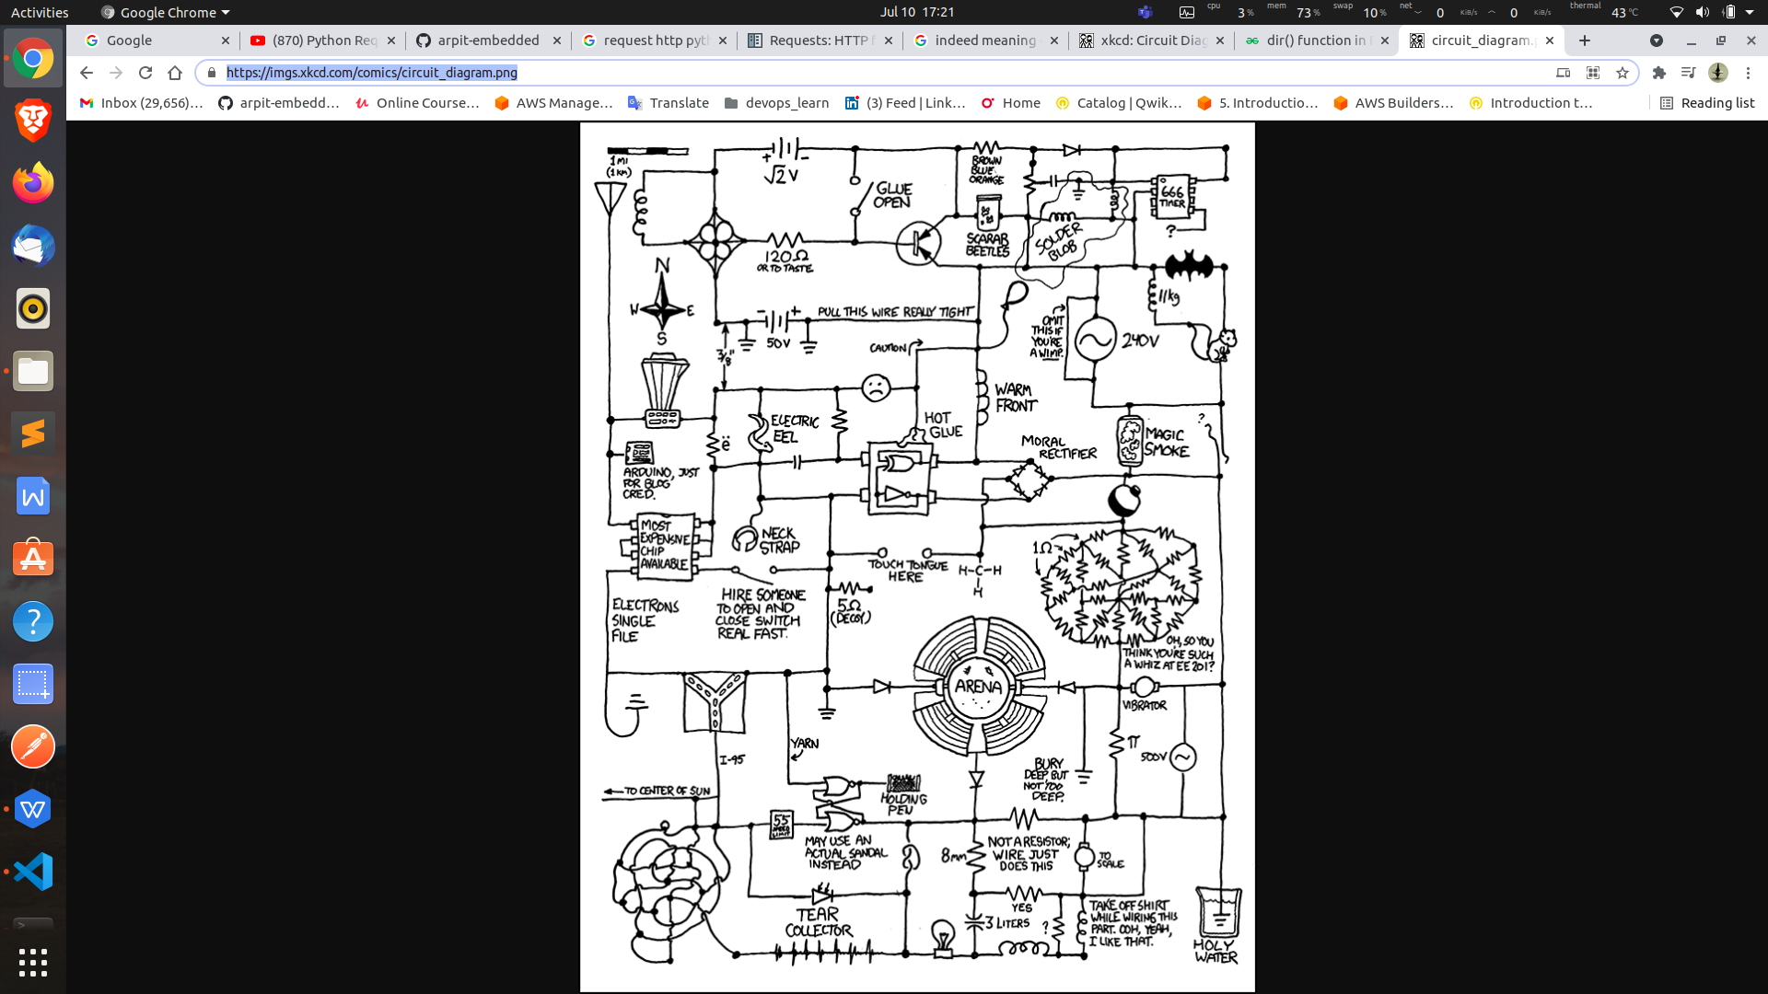

<https://imgs.xkcd.com/comics/circuit_diagram.png>

After execution of below code you will get png file as

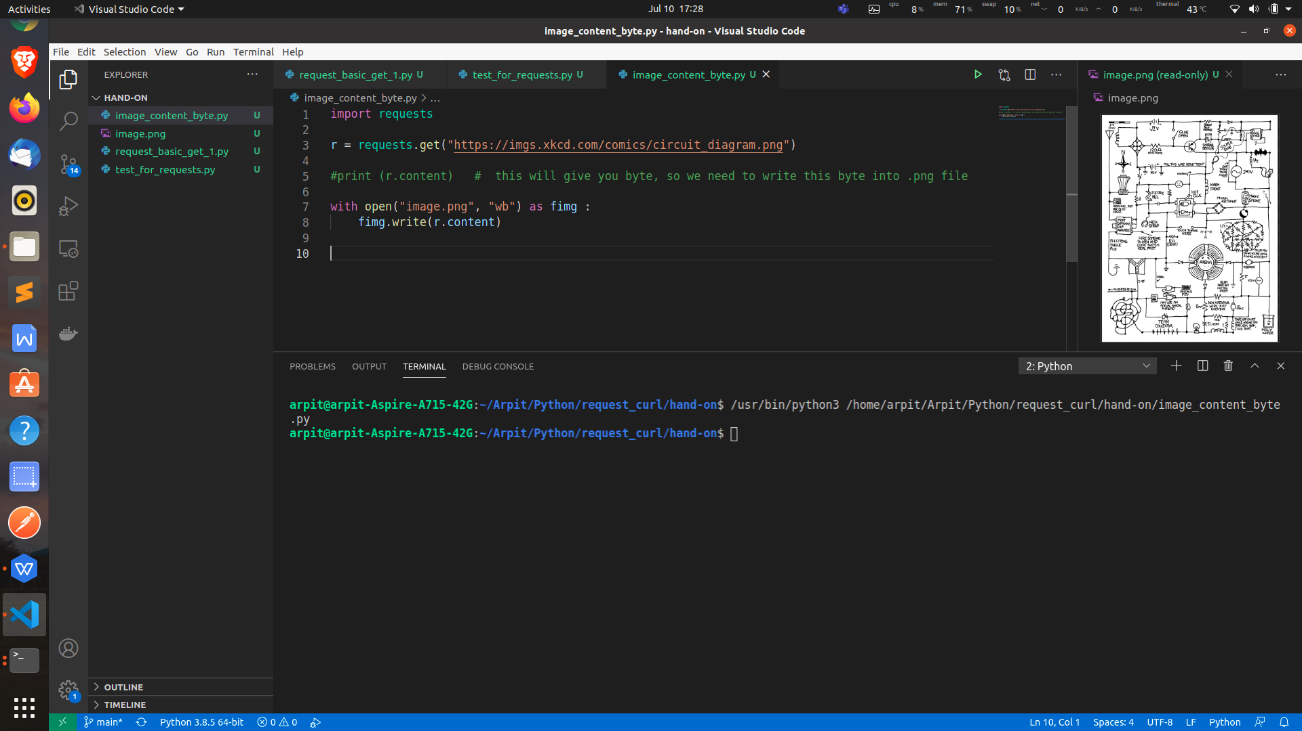

to check http status code and check if website if responding we can use attribute like :-

status_code

ok

import requests

r = requests.get("https://xkcd.com/")

print (r.status_code)

print(r.ok) # True for anything that is less that 400 response code

O/p:-

200

True

status code -->

200 --> responding | Ok true

300 --> redirect | Ok true

400 --> client side error | Ok false

500 --> server side error | Ok false

like wise to print headers, we can use **r.headers**

use this website to test http post put delete get :- <https://httpbin.org/>