Source :- <https://www.youtube.com/watch?v=7JraLCfroyE>

Meta arguments can be specified on any resources and used for things like creating multiple resources with loops, stating dependencies, using a non default provider, ensuring resources are created before they are destroyed.

Meta argument are going to be written in inside resource block.

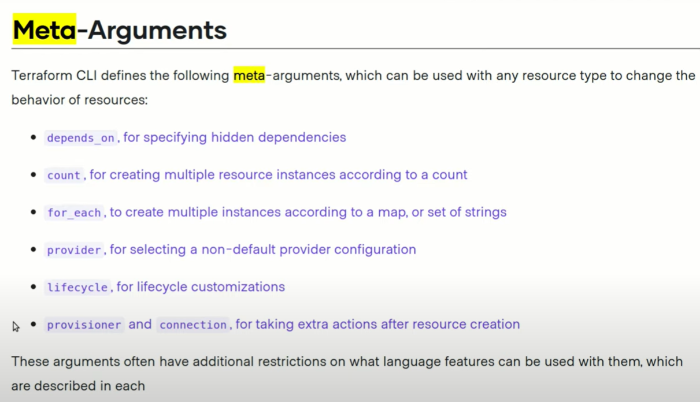

These are reserve keywords

**Count** :- to tell terraform how many time we need to create this resource

Count is used when instance are identical to each other

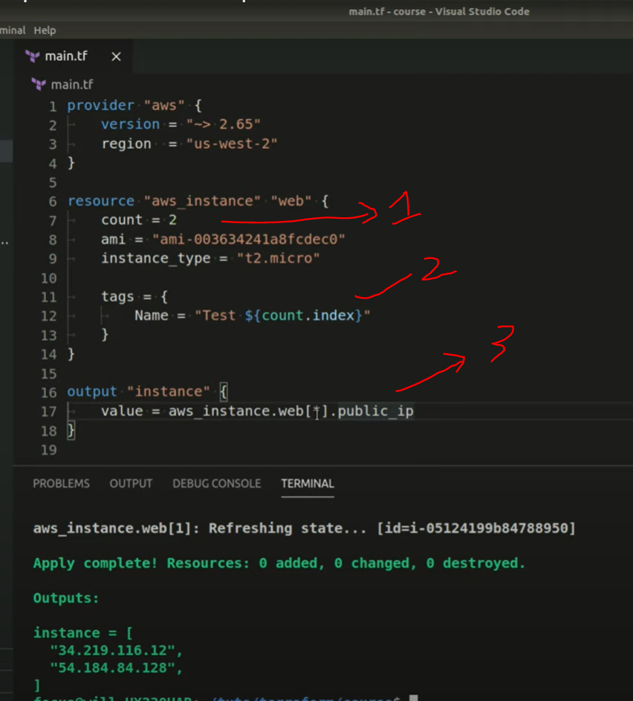

We can parse output using for loop as well

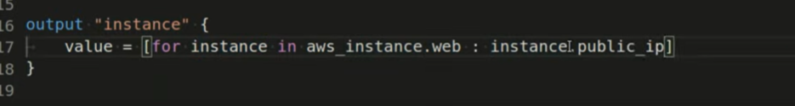

**for_each**

Count is used when instance are identical to each other, not much need to change.

for_each we can specify more detail in instances.

Example :-

Like we want to instance with two different instance type.

Let create a map to achieve this

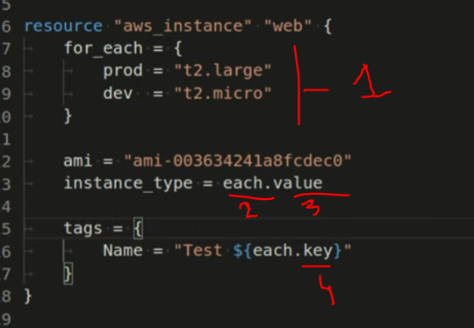

1 🡪 **for_each** is reserve keyword, here we have describe map, this map may contain any key or value.

2. 🡪 **each** is reserve keywork, this is basically an **instance for this above for_each** map. So we can access this map using **each** keywork

3. & 4. 🡪 **each.value** and **each.key** these are two reserve keyword for each that is valid for each iteration

We can output result using map’s key of for_each

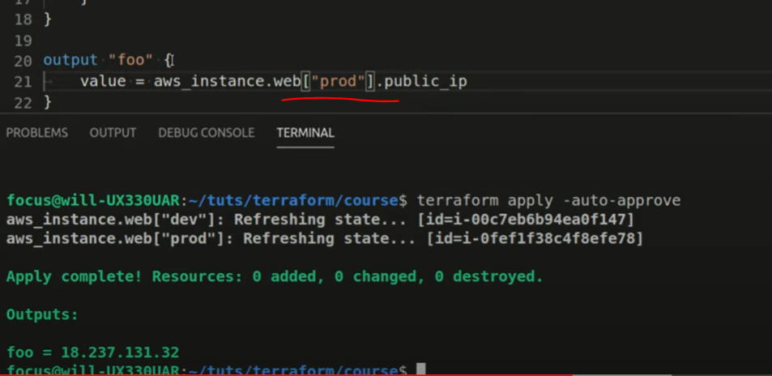

Note:- we can **not** use for_each and count sametime in same resource. Terraform doesn’t allow.

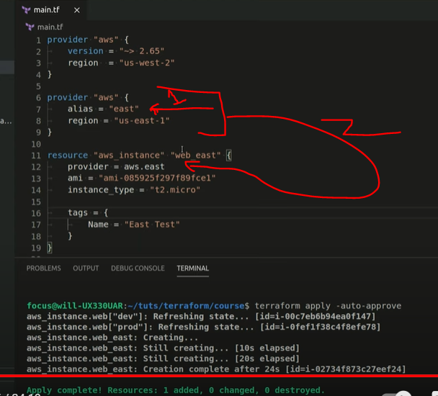

**Lifecycle :-**

Create before destroy :- this means to create resource first after running destroy command.