PlayBook:-

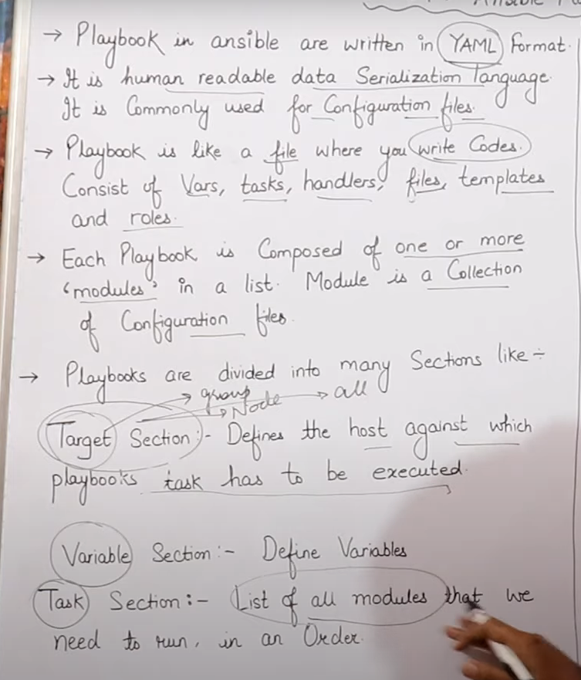

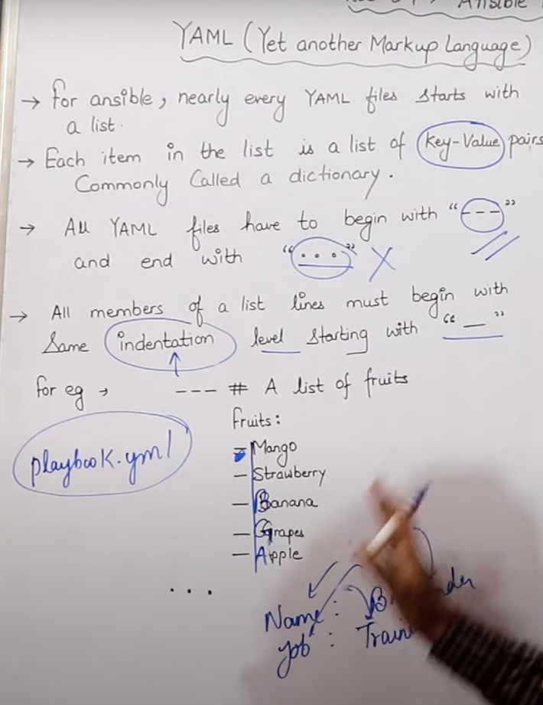

Yaml:-

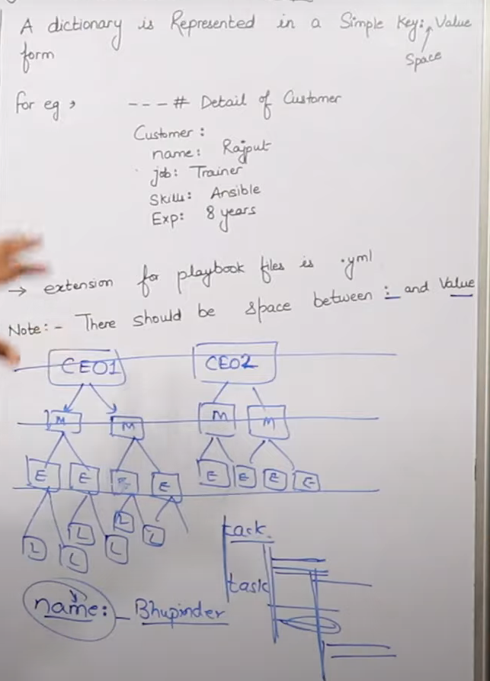

Playbook (target section):-

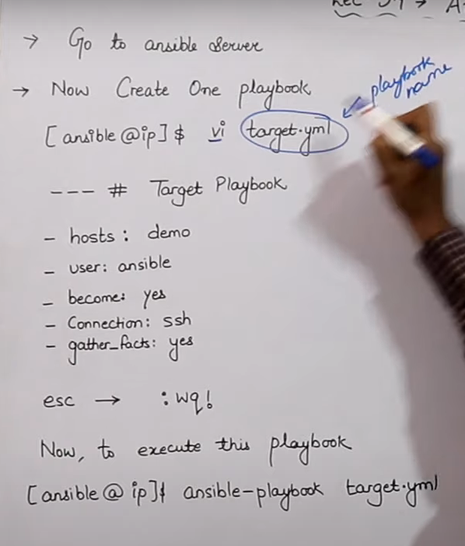

“gather_facts” when you want to print information gather by setup module.

we know that ansible playbook has three section:-

1. target

2. variable

3. task

so here above is target sample

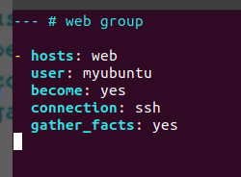

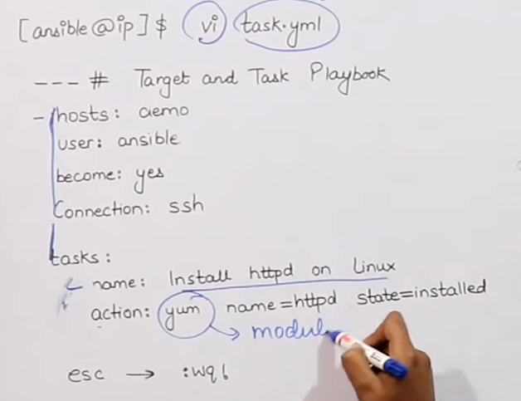here is task.yml sample:-  
  
  
  
here we can see inside “tasks”,

we define “name” (just for our acknowledge /see in console while running)

“action” => this will perform work on actual server.

