till now docker compose has up.

and we have infrastructure, we can access web tty on localhost:1000.



and when we click on "ansible termial" we can see termial for our anisble host.

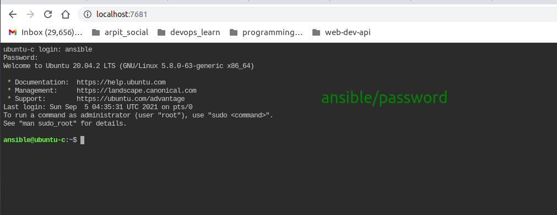

now lets back to this lecture and we will setup ssh connection.

**Ansible is agent less architecture** means connectivity between anible and target a trusted relationship is required for automated passwordless connectivity.

now lets talk what happen when there is ssh connection establish between client and server.

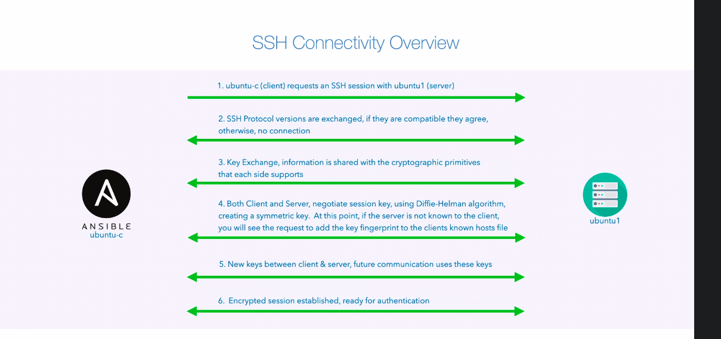

At 4 is will ask for fingerprint to accept

after 6 this will ask for password to be entered.

lets try with ssh to ubuntu1.

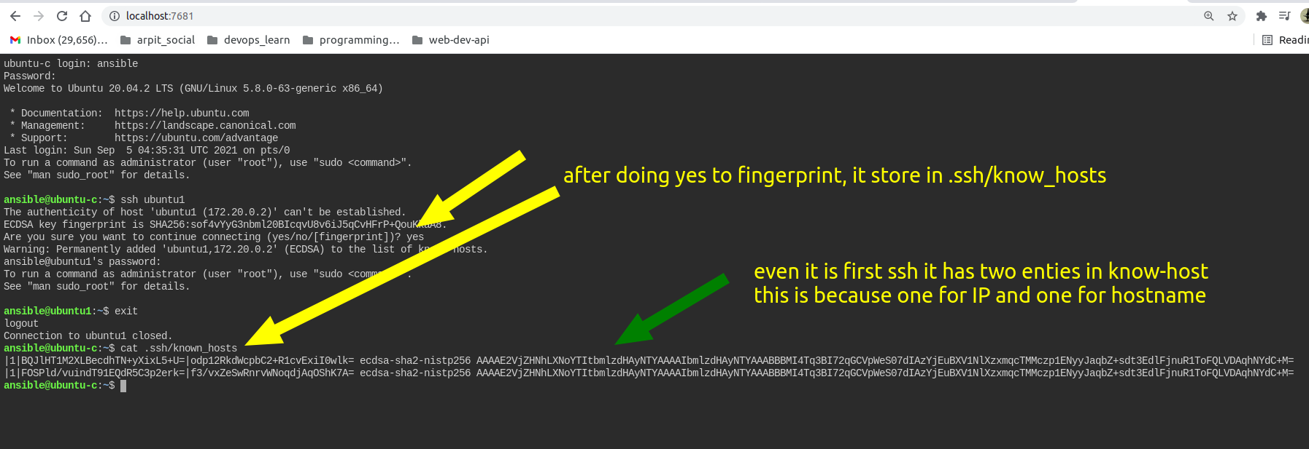

for this lecture series if server glow it means connection establish.



to generate these fingerprint we can use command like:-

$ ssh-keygen -H -F ubuntu1

$ ssh-keygen -H -F <ip address>



now we will connect our sever without use of password.

We will use public and private key for password less auth

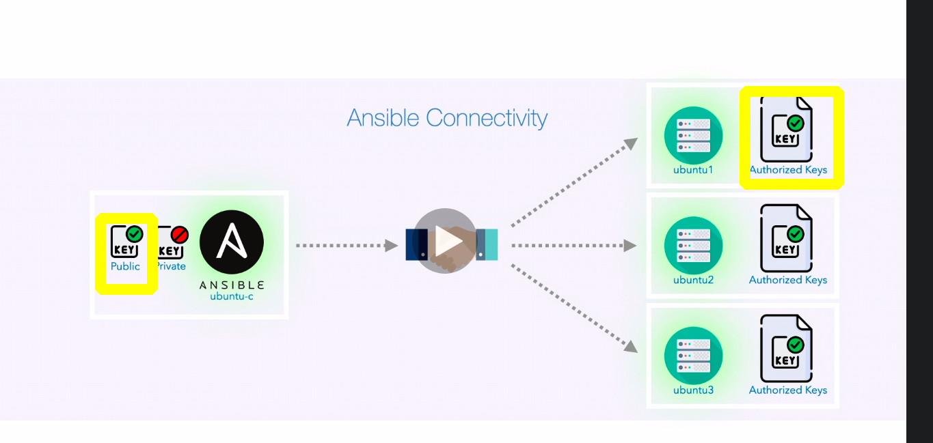

]

$ ssh-keygen => to generate public and private key.

copy the content of public key from ansible machine to authenticate server's authentized key.

also you can use $ ssh-copy-id ansible@ubuntu1

still for large number of server we need to automate this task as well.

for that we will use **sshpass**

first update ubuntu like

$ sudo apt update -y

then

$ **sudo apt install sshpass**

lets create a password.txt file with content as your password like

echo password >> password.txt

as our password is password

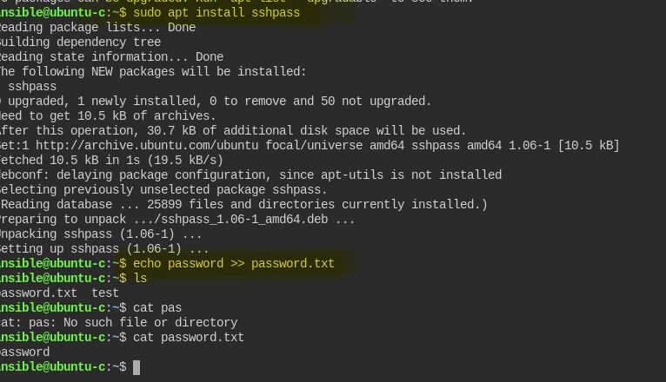

for our current system we have two user for each server like:-

1. root
2. ansible

we need to configure for both user.

i am creating sshpass docs as it seem instresting, please check docs in same folder.

just for hint:-

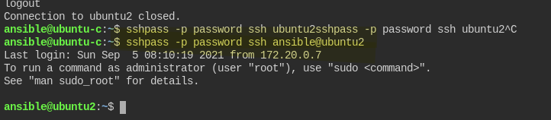

**-o StrictHostKeyChecking=no**

now lets create a script for that

#! /bin/bash

for user in ansible root

do

for os in ubuntu centos

do

for instance in 1 2 3

do

sshpass -f password.txt ssh-copy-id -o StrictHostKeyChecking=no ${user}@${os}${instance}

done

done

done

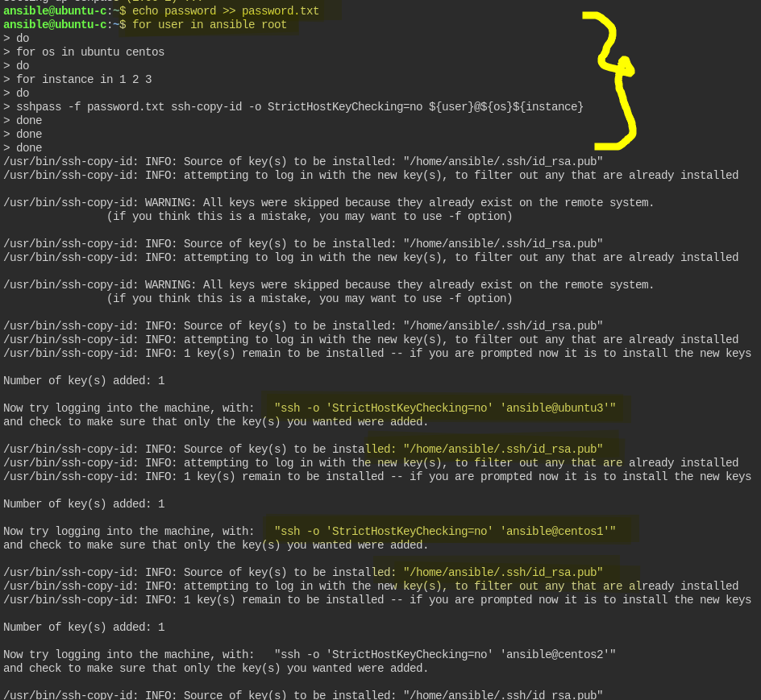

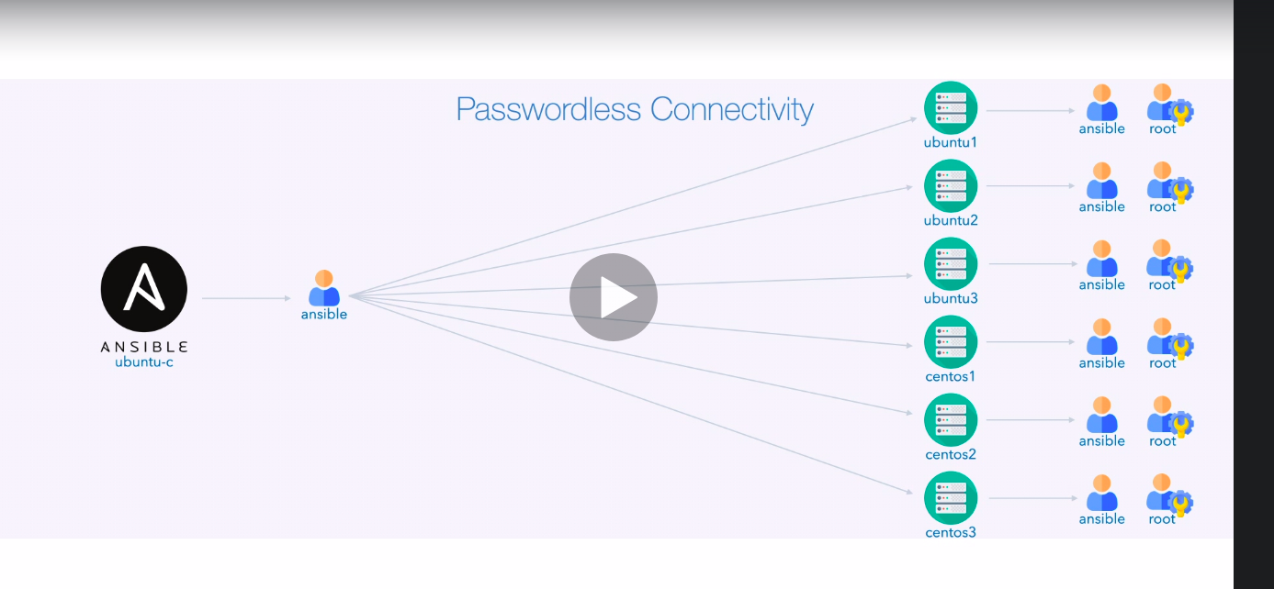

we can check passwordless connectivity using ansible module.

now here you can see

$ ansible -i,ubuntu1,ubuntu2,ubuntu3,centos1,centos2,centos3 all -m ping

here **-i** is actually use to specify inventory file.

but we can use **-i,** to specify raw server as well.

**all** :- this is group of host that need to target.

**-m** :- is for module used which is ping.

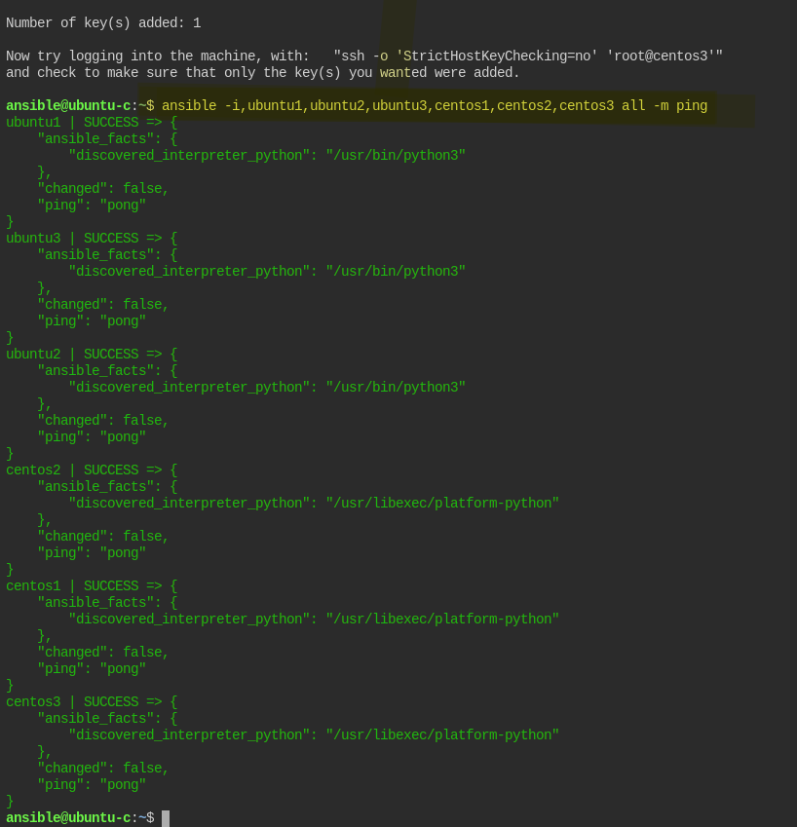

we can see our ping pong command works.