Ansible :-

some linux ssh command like :-

$ adduser <username> to create a user

$passwd <usernname>

to switch between user we use :- $ su - <username>

$ visudo => add a user here to give sudo privilegede. So user can use “sudo”

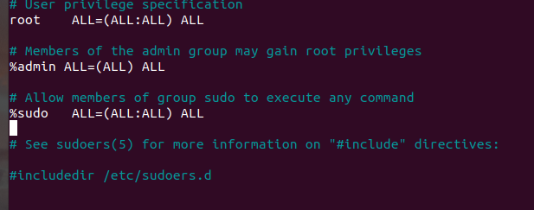Always use visudo to edit the /etc/sudoers file.

Add this line at last to give sudo permission:-

<username> ALL=(ALL) NOPASSWD:ALL

Allow the user to run only specific commands via [sudo](https://linuxize.com/post/sudo-command-in-linux/):-

<username> ALL=(ALL) NOPASSWD:/bin/mkdir,/bin/rmdir

----------------------------------------------------------------------------------------------------------------------

Ansible command:-

add host :- cd /etc/ansible/hosts

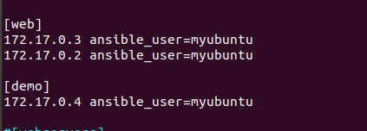

enable this as inventory by removing :- /etc/ansible/ansible.cfg

to list available server in inventory

$ ansible all --list-host

$ ansible web[0:1] –list-host

