EIP is basically a static IP that for EC2 instance.

but EIP is associated with your AWS account not with EC2 instance.

So we can easily detach that IP from one EC2 instance and attach to another EC2 instance.

Use case :-

we have domain associate to 52.78.10.71 and after restart of instance this ip get change to 52.78.10.72

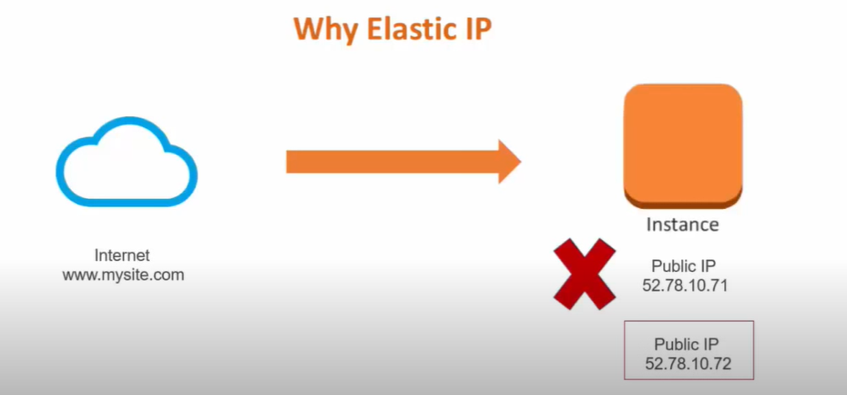

now what happen to domain ??

that means our domain link to that .71 ip is no longer valid

In such case we need elastic IP which does change when instance restart.

under EC2 service

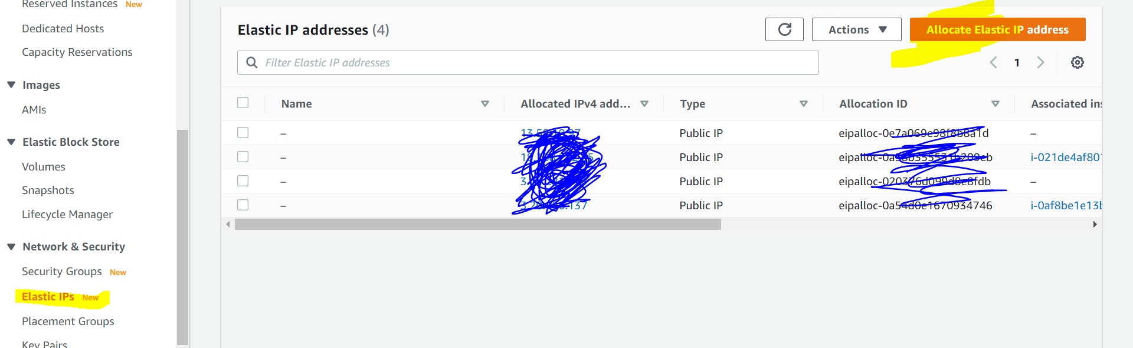

just click on allocate elastic ip, it will automatically give you elastic IP.

now go to Action ---> attach ip to instance.