Now lets switch to other service as well which is “database service”.

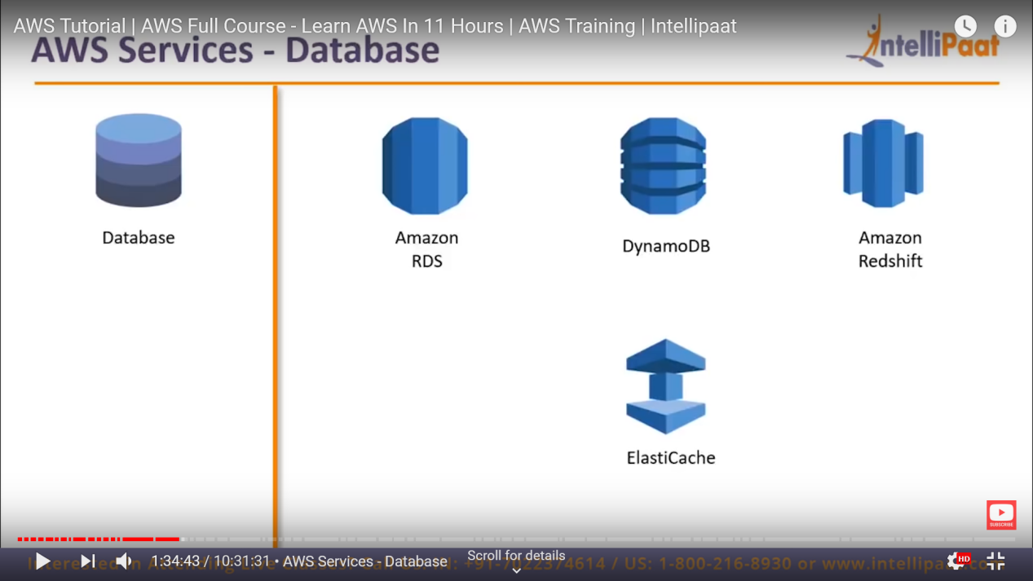

So database service comprise these many services.

Now first we will focus on **Amazon RDS** -> this is actually relational database services.

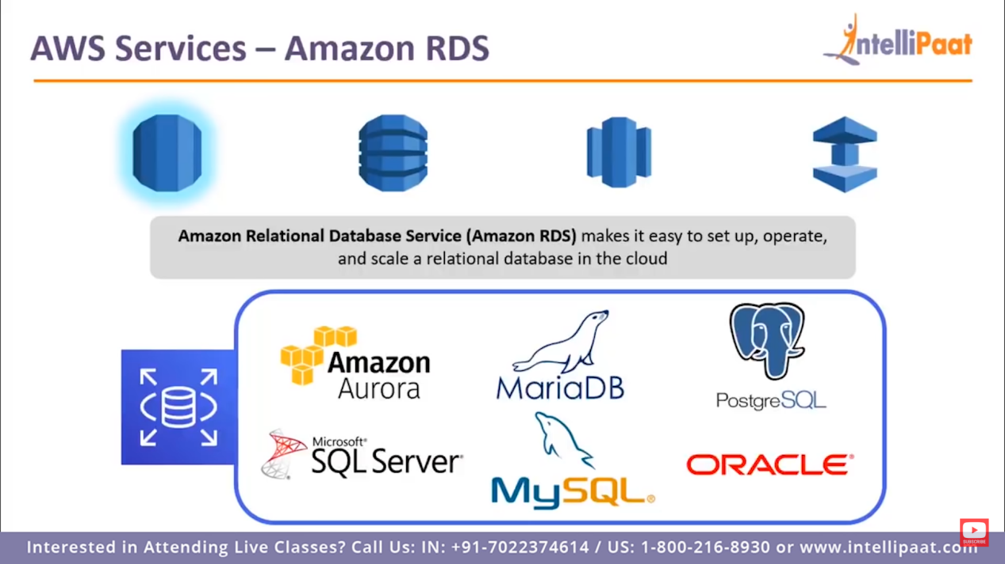

These are above database use in AWS, what RDS does is, it will manage all the database.

**RDS is not a database**

It is just a database service by which we can launch all above data base services and manage these.

It will take automated snapshot of these databases with respect to particular time , now if any replica is required that can also be taken care by RDS.

It also take care of any security patch that has to be applied.

Next database service is DynamoDB

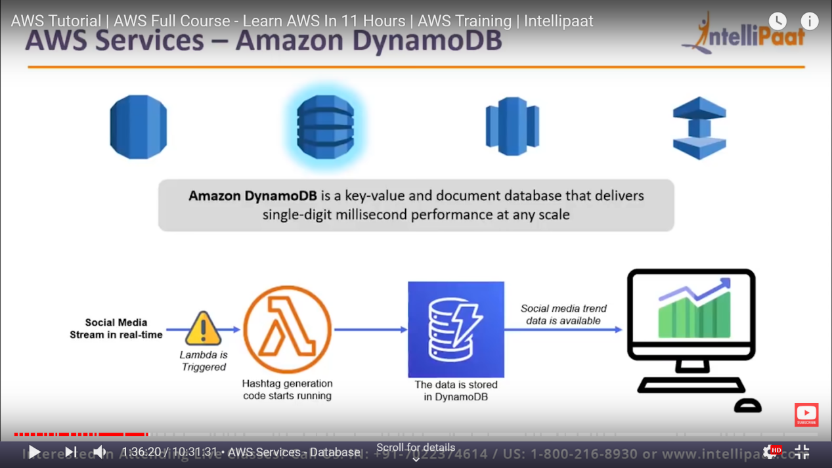

**This is No-SQL database by amazon.**

When you need to store unstructured data ie data doesn’t follow any respective format.

“Simillar to mongoDB”

Next service is “Amazon RedShift”

This is actually Database warehouse where we have multiple different databases and we can use and manage them as single unit database.

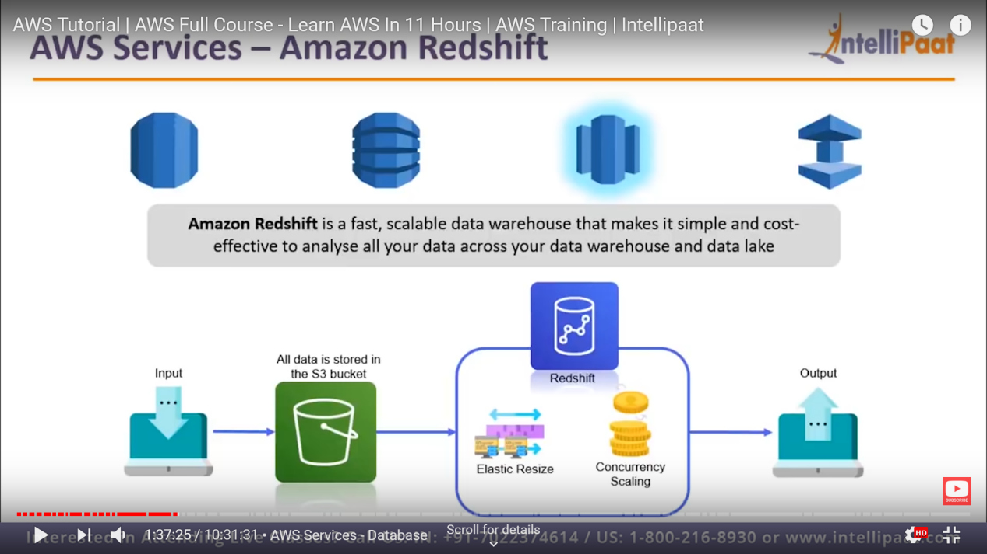

Now next service is “**Elastic Cache**”

When client is requesting same thing frequently, so to avoide quering every time, what server does is it will store that in cache so that, it will not query to database for same resource and give fast reply by cache.

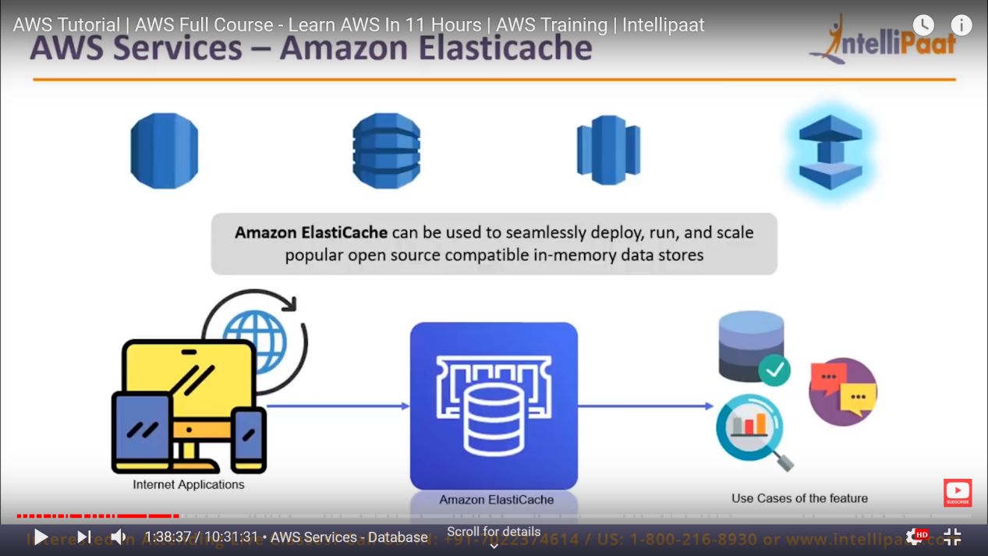

So by this cache we can increase the performance of our system.

Now lets talk about security domain.

Under this domain we have two services

1. IAM
2. AWS KMS

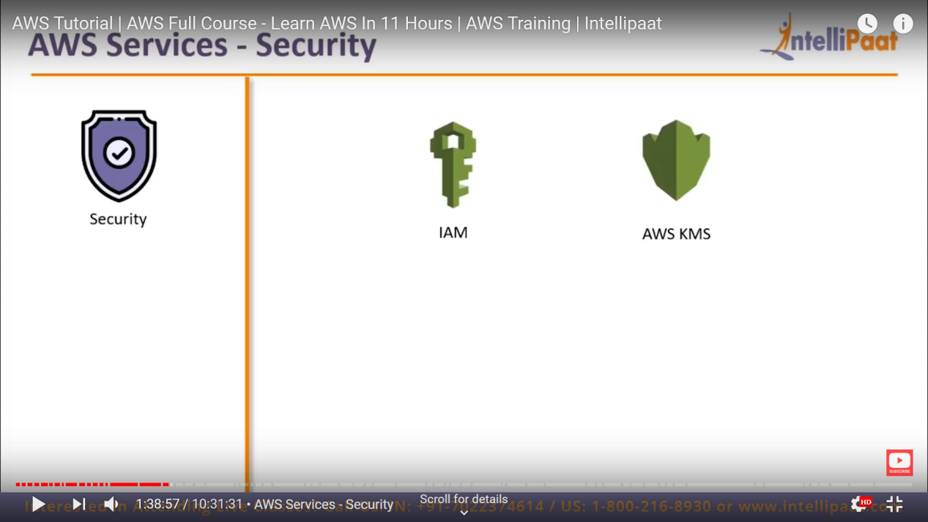

Now lets talk about **IAM service :-**

By this service we can authenticate user for your AWS account.

here the account you have just created is root account.

so big company like Netflix, Airbnb they have only one AWS Account and have multiple users.

so each user can have there own username and password with there own restriction.

and that is possible using AWS IAM.

we can restrict user for particular service access like EC2, DB, and other like you can only just create EC2 instance but not update it like that. or restrict that nobody can terminate an instance how ever user you are adding.