Reference:- https://devops4solutions.medium.com/monitor-aws-ec2-using-prometheus-and-grafana-48100a6231e7

Agenda

- What is Prometheus
- Install Prometheus and configure Prometheus to monitor itself
- Install Node Exporter on other EC2 Instances
- Configure Prometheus for the EC2 Instance
- EC2 Service Discovery for Prometheus
- Install Grafana

Prerequisite:

- Prometheus EC2 instance t2.micro
- Node EC2 instances to monitor
- Security Groups Configured properly
- Clone this git repo => https://github.com/devops4solutions/prometheus-monitoring

Security Groups Configured on EC2 Instances

Port 9090 — Prometheus Server
Port 9100 — Prometheus Node Exporter
Port 3000 — Grafana

Security Group for that EC2 instance where Prometheus is installed:-

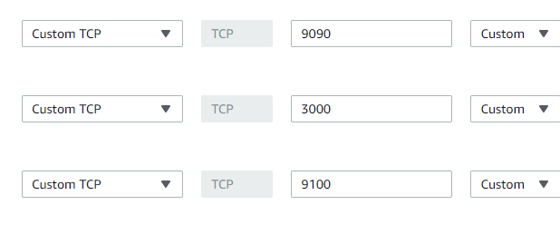

Security group for Node EC2 Instances

Configure the security group on EC2 Instance which you want to monitor and where you will install Node Exporter as shown below:

one entry is from your IP and one entry is the IP of the EC2 instance where Prometheus server is installed so that Prometheus server can read the metrics which is exposed on the Node server

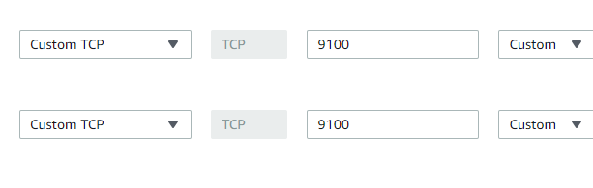

eg:-
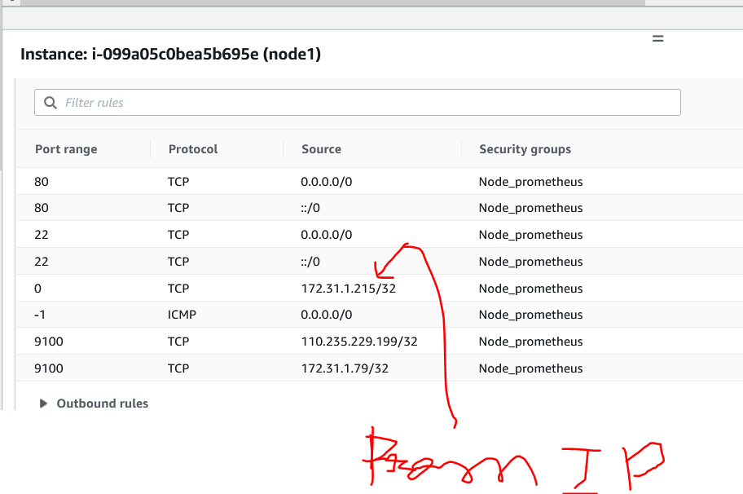

Install Prometheus
Now we will install the Prometheus on one of the EC2 Instance.
You can download the latest version from here
- Clone my git repo
- Run the install-prometheus.sh script
- This script will install everything and configured it. You can change the version as per your project.

This script will do the below steps:
- Create a new user and add new directories
sudo useradd --no-create-home prometheus
sudo mkdir /etc/prometheus
sudo mkdir /var/lib/prometheus
2. Download the Prometheus, extract it and put it in /usr/local/bin folder and finally delete the software
wget https://github.com/prometheus/prometheus/releases/download/v2.23.0/prometheus-2.23.0.linux-amd64.tar.gztar -xvf prometheus-2.23.0.linux-amd64.tar.gz
sudo cp prometheus-2.23.0.linux-amd64/prometheus /usr/local/bin
sudo cp prometheus-2.23.0.linux-amd64/promtool /usr/local/bin
sudo cp -r prometheus-2.23.0.linux-amd64/consoles /etc/prometheus/sudo cp -r prometheus-2.23.0.linux-amd64/console_libraries /etc/prometheussudo cp prometheus-2.23.0.linux-amd64/promtool /usr/local/bin/rm -rf prometheus-2.23.0.linux-amd64.tar.gz prometheus-2.19.0.linux-amd64
3. Now we will configure Prometheus to monitor itself using yaml file. Create a prometheus.yml file at /etc/prometheus/prometheus.yml with the below content
global:
scrape_interval: 15s
external_labels:
monitor: 'prometheus'

scrape_configs:
- job_name: 'prometheus'
static_configs:
- targets: ['localhost:9090']
4. Now we want to run the Prometheus as a Service so that in case of server restart service will come automatically.
Let’s create a file /etc/systemd/system/prometheus.service with the below content:
[Unit]
Description=Prometheus
Wants=network-online.target
After=network-online.target

[Service]
User=prometheus
Group=prometheus
Type=simple
ExecStart=/usr/local/bin/prometheus \
--config.file /etc/prometheus/prometheus.yml \
--storage.tsdb.path /var/lib/prometheus/ \
--web.console.templates=/etc/prometheus/consoles \
--web.console.libraries=/etc/prometheus/console_libraries

[Install]
WantedBy=multi-user.target
4. Change the ownership of all folders and files which we have created to the user which we have created in the first step
sudo chown prometheus:prometheus /etc/prometheus
sudo chown prometheus:prometheus /usr/local/bin/prometheus
sudo chown prometheus:prometheus /usr/local/bin/promtool
sudo chown -R prometheus:prometheus /etc/prometheus/consoles
sudo chown -R prometheus:prometheus /etc/prometheus/console_libraries
sudo chown -R prometheus:prometheus /var/lib/prometheus
5. Now we will configure the service and start it
sudo systemctl daemon-reload
sudo systemctl enable prometheus
sudo systemctl start prometheus
sudo systemctl status prometheus
Now open it on the browser using below url:
http://18.220.110.81:9090/
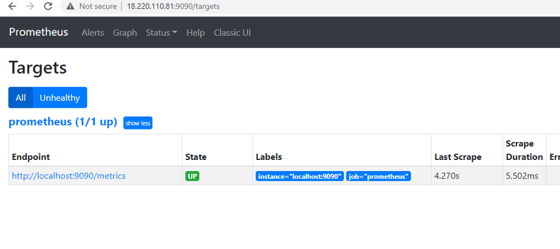
http://3.90.234.147:9090/targets ==> to check whether target are up or not

Install Node Exporter on EC2 instances to which we want to monitor

Setup Node Exporter Binary
Step 1: Download the latest node exporter package. You should check the Prometheus downloads section for the latest version and update this command to get that package.
cd /tmp
curl -LO https://github.com/prometheus/node_exporter/releases/download/v0.18.1/node_exporter-0.18.1.linux-amd64.tar.gz
Step 2: Unpack the tarball
tar -xvf node_exporter-0.18.1.linux-amd64.tar.gz
Step 3: Move the node export binary to /usr/local/bin
sudo mv node_exporter-0.18.1.linux-amd64/node_exporter /usr/local/bin/

Create a Custom Node Exporter Service
Step 1: Create a node_exporter user to run the node exporter service.
sudo useradd -rs /bin/false node_exporter
Step 2: Create a node_exporter service file under systemd.
sudo vi /etc/systemd/system/node_exporter.service
Step 3: Add the following service file content to the service file and save it.
[Unit]
Description=Node Exporter
After=network.target

[Service]
User=node_exporter
Group=node_exporter
Type=simple
ExecStart=/usr/local/bin/node_exporter --web.listen-address=":9100"

[Install]
WantedBy=multi-user.target
Step 4: Reload the system daemon and star the node exporter service.
sudo systemctl daemon-reload
sudo systemctl start node_exporter
Step 5: check the node exporter status to make sure it is running in the active state.
sudo systemctl status node_exporter
Step 6: Enable the node exporter service to the system startup.
sudo systemctl enable node_exporter
Now, node exporter would be exporting metrics on port 9100.
You can see all the server metrics by visiting your server URL on /metrics as shown below.
http://<server-IP>:9100/metrics

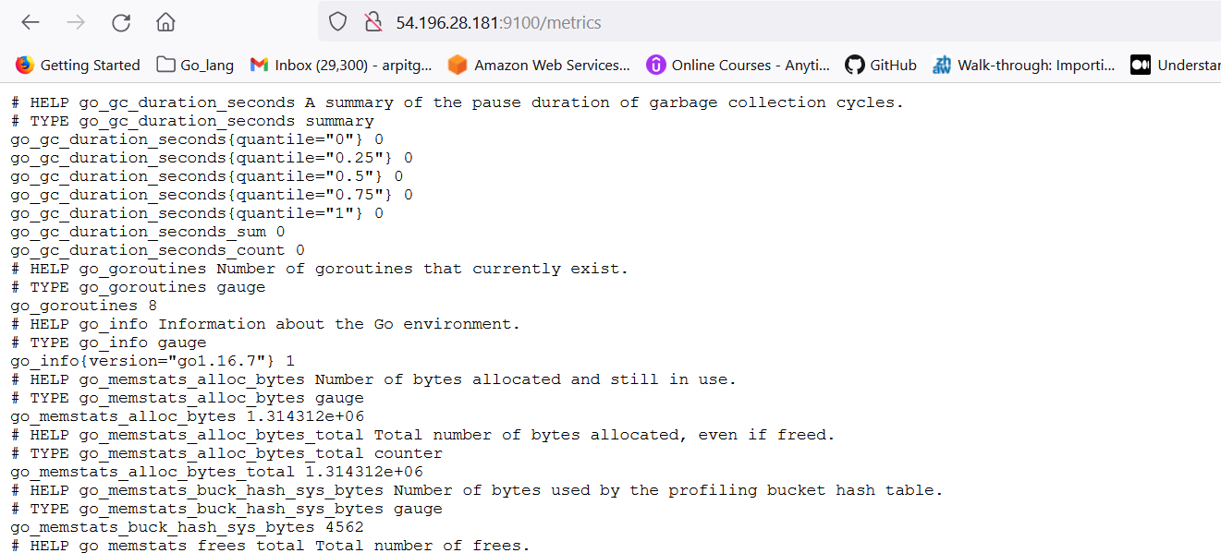

Configure Prometheus for the Nodes
Now we will configure the Prometheus for our EC2 instance where we have installed the node-exporter.
Login to the Prometheus server and edit the file or you can clone this file/etc/prometheus/prometheus.yml
global:
scrape_interval: 15s
external_labels:
monitor: 'prometheus'

scrape_configs:
- job_name: 'node_exporter'

static_configs:
- targets: ['18.219.214.162:9100']
Restart the Prometheus Service
sudo systemctl restart prometheus
sudo systemctl status prometheus

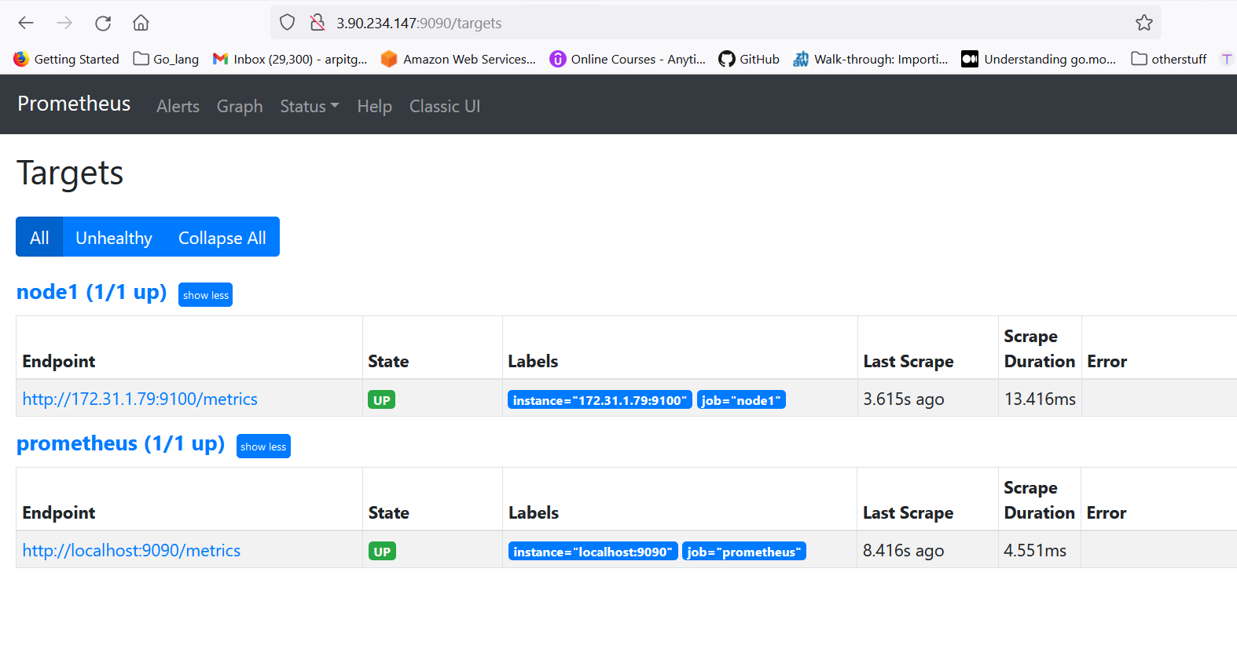

Okay both the target are up.

Install grafana

go to :- https://grafana.com/grafana/download

sudo apt-get install -y adduser libfontconfig1
wget https://dl.grafana.com/enterprise/release/grafana-enterprise_8.2.0_amd64.deb
sudo dpkg -i grafana-enterprise_8.2.0_amd64.deb

1860 as node exporter

