In windows:-

Goto packer.io and hit the download button.
Extract that then copy that exe file and put that file on specific path and then concatenate that with path variable.

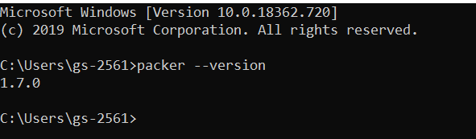

so on MAC and Linux , you can find that, it something like same.

