YAML File :-

main use to write configuration files.

two format
.yml
.yaml

both work same.

it store key value
Example1:-

name: "arpit"
age: 26
gender: "male"

this is simple example.
there should be space between ':' and 'value'
Example2:-
Here we define object like 'list' :-

person:
name: "arpit"
age: 26
gender: "male"

Here list person have one object (dict) and one object (dict) have three KV.

Example3:-
Here we define object like 'list' have many object :-

person:
- name: "arpit"
age: 26
gender: "male"

- name: "rachit"
age: 18
gender: "female"

Here list person have two object (type dict ) and every object have three KV. here we need to use "-" to justify object.

if you don’t have any value you can give like "null"

means gender: null

suppose a list like

hobbies
- cricket
- music
- walk

this can also be define as

hobbies: ["cricket", "music", "walk"]

both above method and this is same.

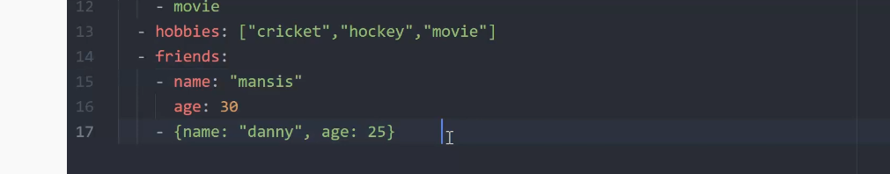

also for dictionary as well.

Note id data is large enought then we can also give ">" now single data can be written in multiple of line as

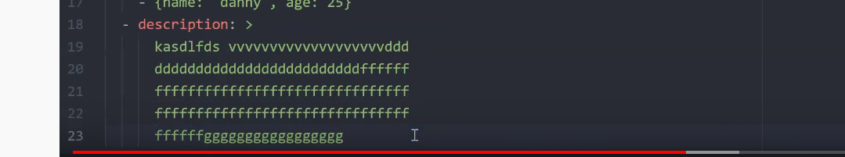

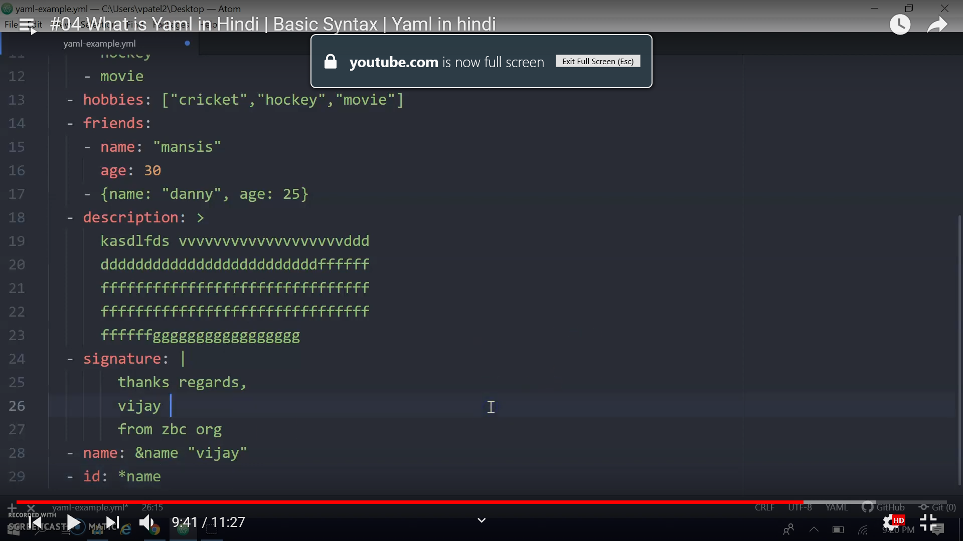

here "|" this symbol mean format will be same.

&name is acts as refference now in next line we can use this value.

To change type of varibale we can give like
age: !! float 30 # this will be 30.0
age: !! str 30 # this will be "30"

