File Module:-

This is core important.
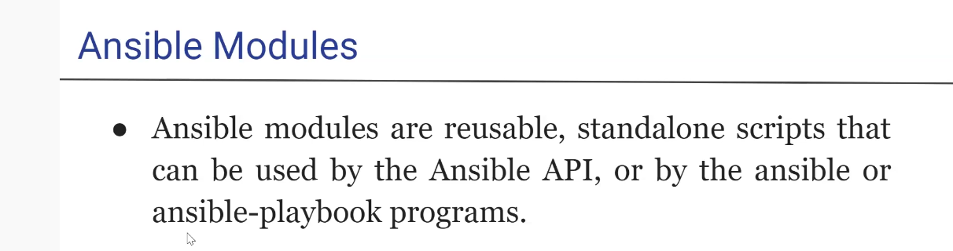

Ansible have thousand of module to perform various function in server.

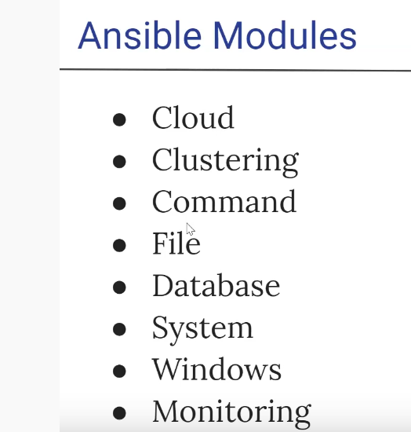

these are most important ansible module type.

- cloud module -> this will work with clould platform like aws, azure and all for instance, storage, config etc. Find more detail in ansible module.
- Clustering :- k8s, service and all.
- Command:- where are actually running script and command on host.
Commands modules

command - Executes a command on a remote node
expect - Executes a command and responds to prompts.
raw - Executes a low-down and dirty SSH command
script - Runs a local script on a remote node after transferring it
shell - Execute commands in nodes.
telnet - Executes a low-down and dirty telnet command

now we will write our first ansible playbook (pwd.yaml) like
---
- name : play1
hosts : localhost
tasks :
- name : "pwd checking"
command : pwd
register : result
- debug : "msg=\"{{ result.stdout }}\""

and save it and $ ansible-playbook pwd.yml

so it is localhost so no need to give inventory path.

here we use two ansible module
- command
- debug
in debug module we first register the result and print it to stdout.

take another example to create directory
---
- name : play1
hosts : localhost
tasks :
- name : "directory making"
command : mkdir /home/an_test creates=/home/an_test
register : result
- debug : "msg=\"{{ result.stdout }}\""

here we mention "creates" mean if directory already exist then don’t create.
this "create" is property of ansible.

Now try to run the same on remote host

---
- name : play1
hosts : ubuntua1
become: yes
tasks :
- name : "directory making"
command : mkdir /home/an_test creates=/home/an_test
register : result
- debug : "msg=\"{{ result.stdout }}\""

"become: yes" is to give root priviledge.

$ ansible-playbook mkdir_host.yml --ask-pass --ask-become-pass -i inventory.txt

This --ask-become-pass => ask for sudo password.
here we have give inventory as well because name as well because ubuntua1 is present in inventory file.

