Index:-
search

udemy_lect_206 ----> Deployment Configuration Files
udemy_lect209 ---> Why Use Services?
Udemy_lect_213 ---> Triggering Deployment Updates, new docker hub image auto-update
Udemy_lect_214 ----> Imperatively Updating a Deployment's Image

------------------------------------------------------------------------------------------------------------------

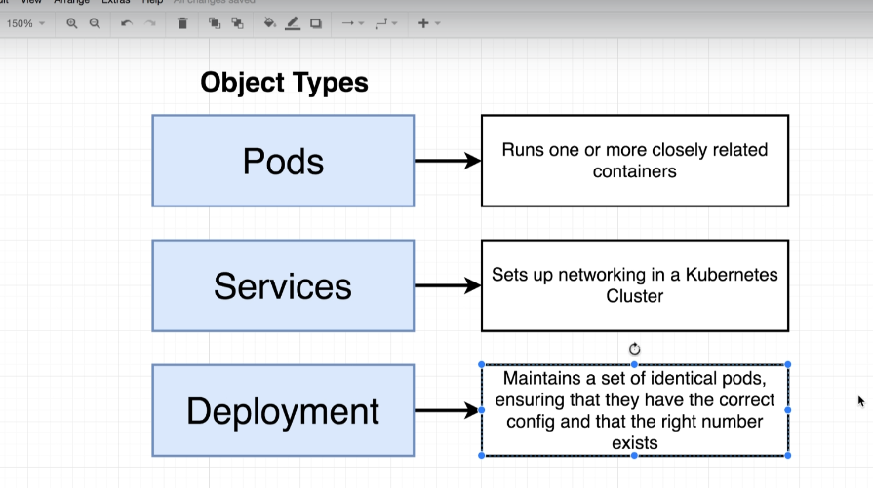

For any serious k8s working we will use Deployment instead of using pod

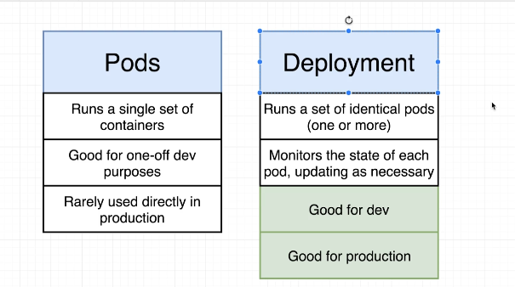

it is better to use deployment to pod creation rather that creating a single pod.

Suppose we want to upgrade our application ,
If we do that with replica-set then we have to first uninstall previous version and after that and create new version . this will consume time whether it was of microsecond.

- To achieve zero downtime , we introduce new concept -> deployment
There are also different statergies to achieve this in deployment, we will see them later

Other benefit of deployment is
- Suppose you during rollback we experiance some error , so we can also rollback to previous version
- We can also apply pause and play during upgradation .

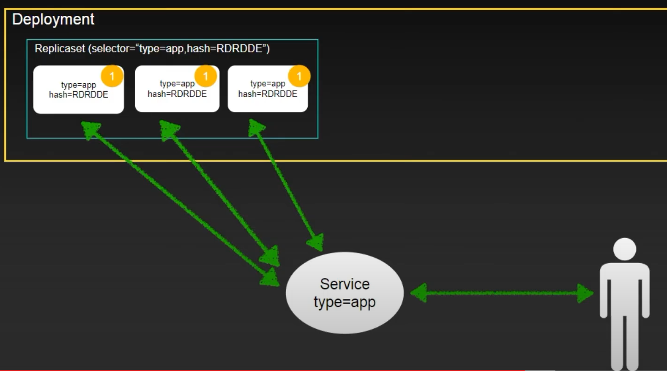

This is previous version 1 of our application and what deployment is doing is that it create replica-set and a hash (will discuss later ) for previous version .

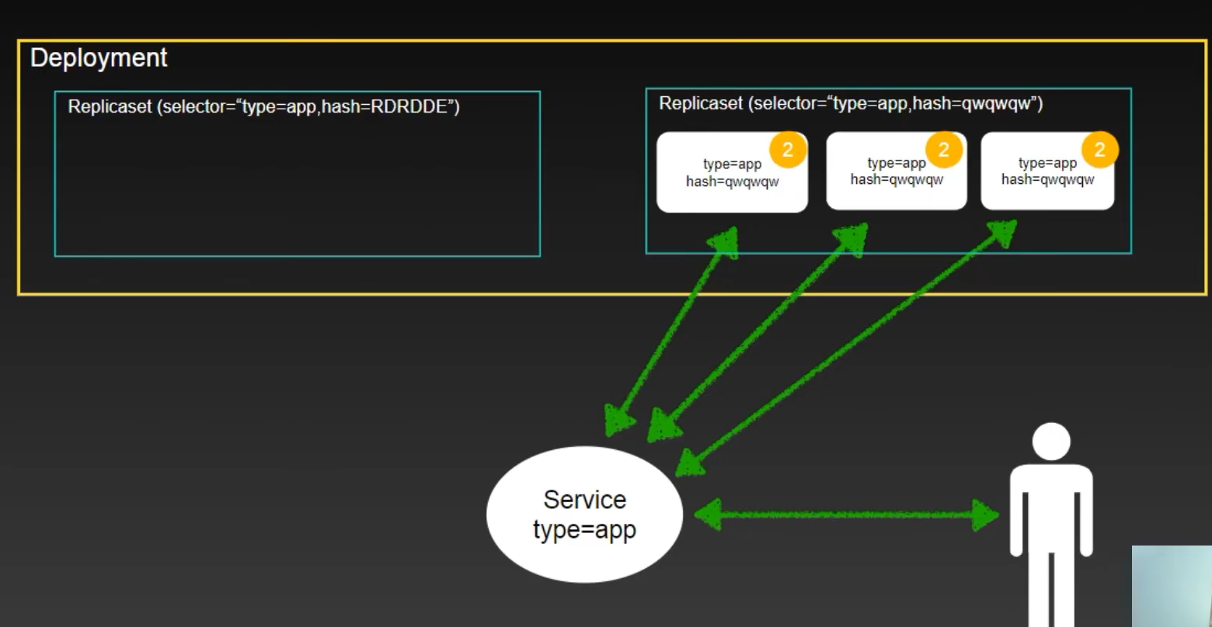

Here we can see that when we want to upgrade it create another replica set and previous replica-set is also not deleted -> which is required when we need rollback .

The above strategics are know as recreation strategics -> it contain some amount of downtime.

Lets move to those strategics which does not have downtime.

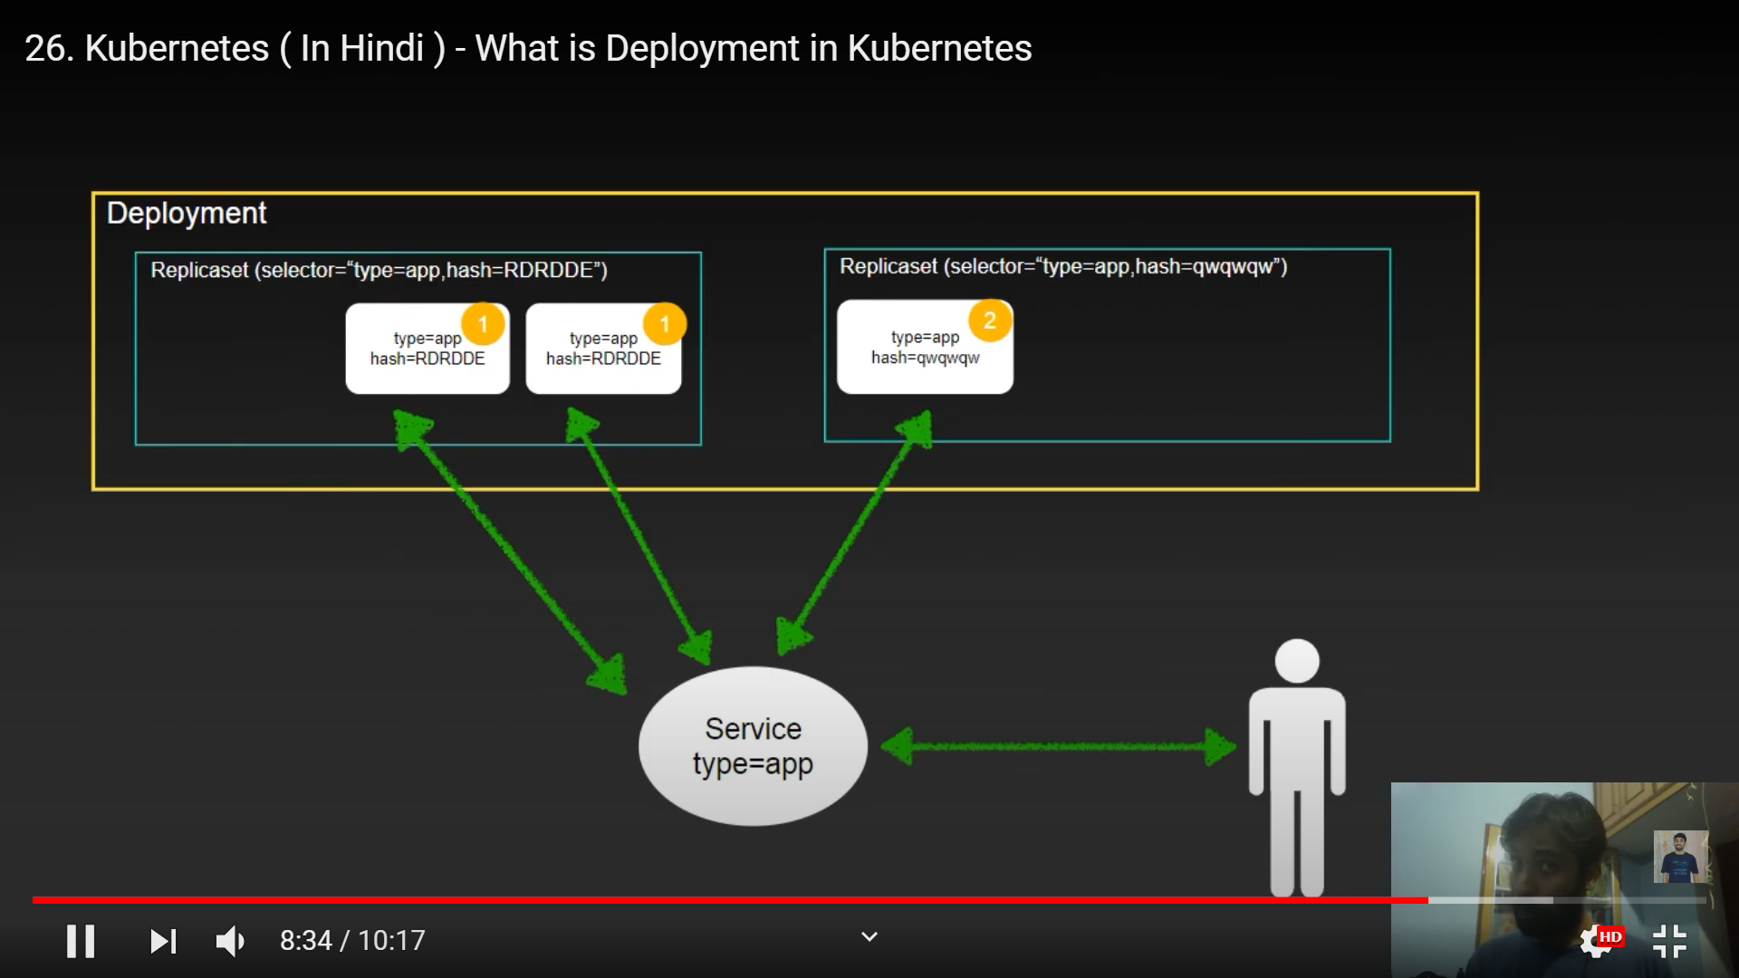

Here in this statergies we have see that when one pod is created then other pod will be created
This stargies are know as rolling update .

K8s deployment will give hash value because inside replica set is uniquely identified.

Deployment having pod template inside it.

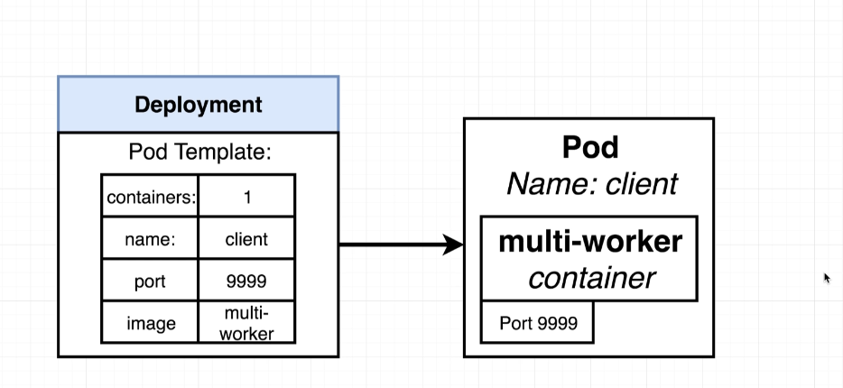

So when we want to make any upgradation to this pod template like changing port what it will do is , it will create a new pod with latest upgradation and kill previous one.

udemy instructor image :- stephengrider/multi-client

udemy_lect_206. Deployment Configuration Files

now we are going write an config file to create a object called deployment where we will create template for pod.

---
apiVersion: apps/v1
kind: Deployment
metadata:
name: client-deployment
spec:
replicas: 1
selector:
matchLabels:
component: web
template:
metadata:
labels:
component: web
spec:
containers:
- name: client
image: stephengrider/multi-client
resources:
limits:
memory: "128Mi"
cpu: "500m"
ports:
- containerPort: 3000

here "apiVersion: apps/v1" means we are going to create a object (deployment) which is under this apiVersion.

template field are pod specification under deployment.

As replicas = 1 so one pod is maintained by deployment. these pod are identical in nature.

Selector :- by this selector Deployment can manage pod created by it.

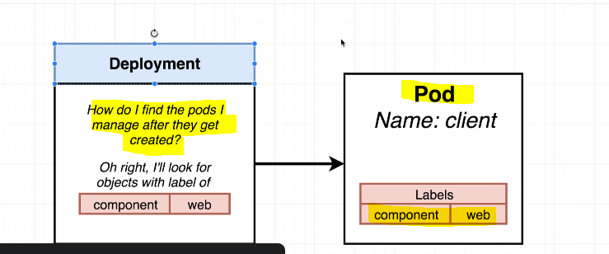

Now lets apply these deployment config file

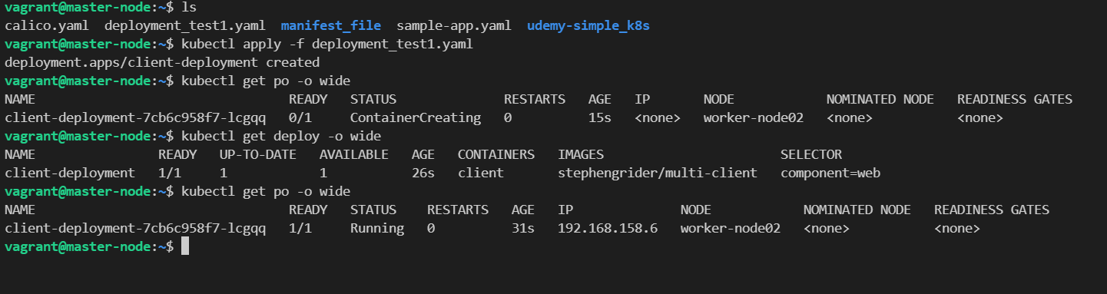

udemy_lect209 ---> Why Use Services?

create this NodePort service so that we can access our deployment from outer browser.

apiVersion: v1
kind: Service
metadata:
name: client-node-port
spec:
type: NodePort
ports:
- port: 3050
targetPort: 3000
nodePort: 31515
selector:
component: web

clusterip:31515

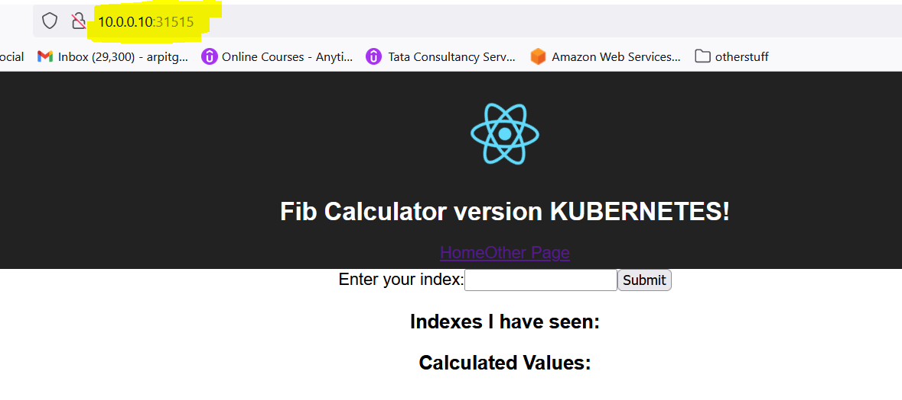
I have seen I can access this deployment application on any master or worker ip for that perticular port.

accessing from worker node IP

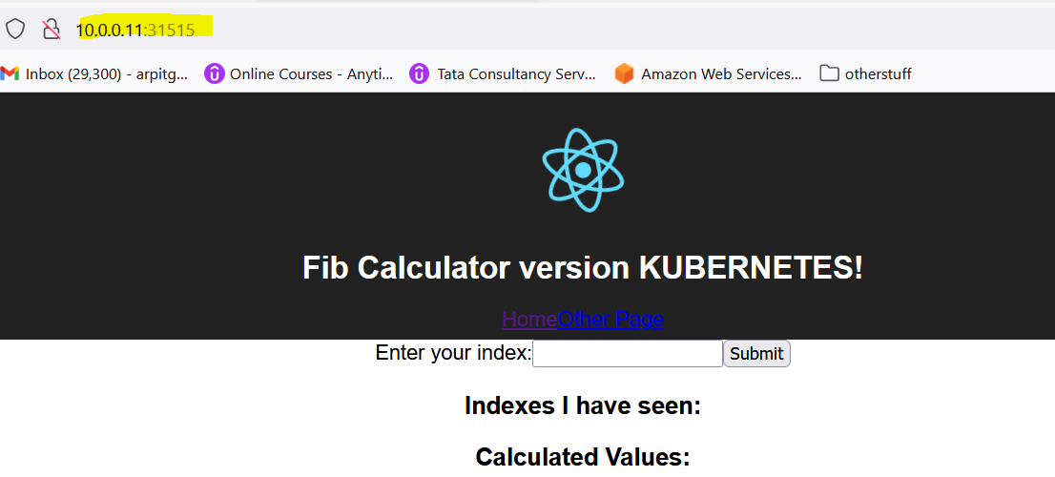

one reason k8s uses service to export not directly pod ip is pod is Ephemeral (I.e may be deleted, recreate with different IP).

but service have single IP that matches to its selector.

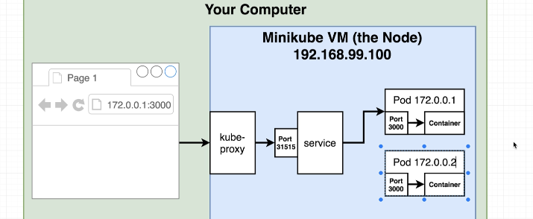

some tryout:-

try1 :- here we are going to change image, no of replica to 5

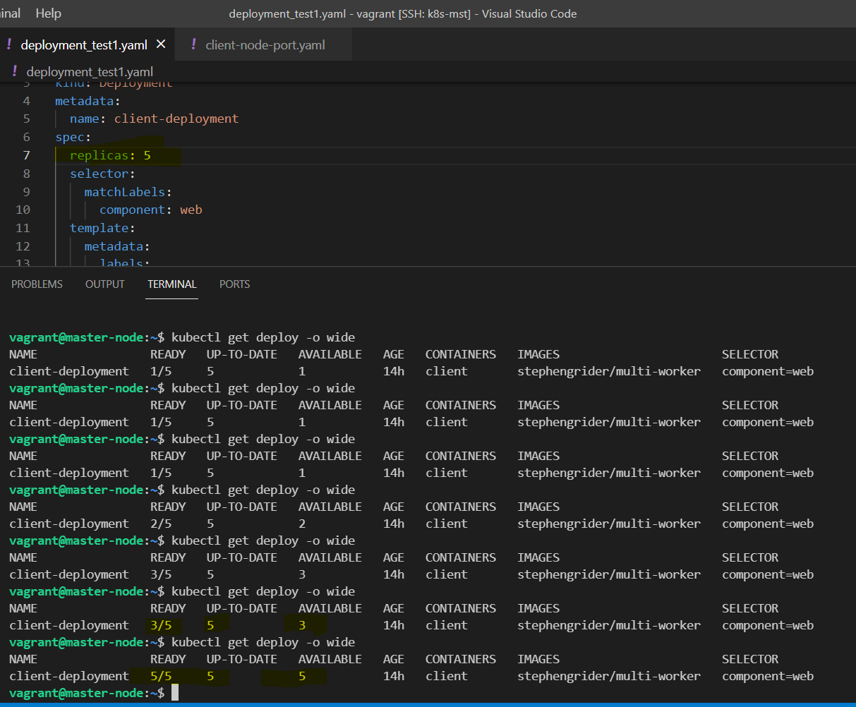

so we can see deploy comes into affect after "apply"
- replica change to 1 to 5 as we can see ready is 5/5
- image is change to "stephengrider/multi-worker"

we can also change container_port as well.

Udemy_lect_213 ---> Triggering Deployment Updates

Now we have already a deployment and a new docker image publish and we want to update our deployment with latest image.

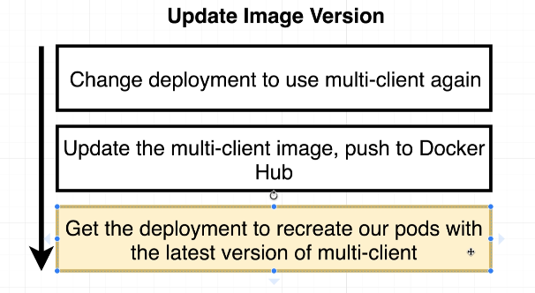

let us clear, updating latest docker image to pre existed deployment is not straight forward task.

visit https://github.com/kubernetes/kubernetes/issues/33664

Now lets to see possible solution for this problem and there pros and cons

Solution 1 :- delete deployment manually and apply new deployment file with proper changes

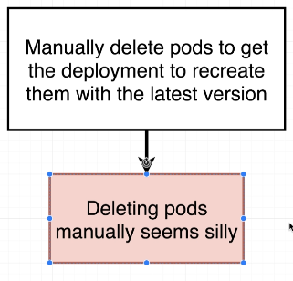

Solution 2:- we can include tags like v1, v0.5.11, v5.5 to image name in configuration file. Valid if image In docker hub have proper versioning.

so while building image we need to mention tags like :-

and then mention that into configuration file.

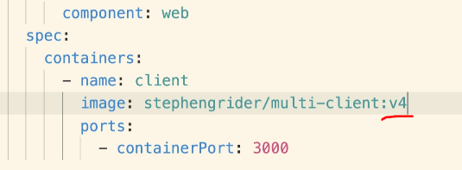
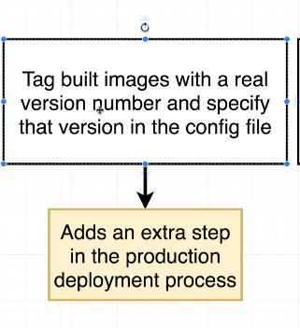

this add extra step to manage version, it is also not a very good solution.
This solution seem good but it is actually pain in real.

we are not allowed to use environment variables in config file.

Solution 3:- use imperative command to update deployment.

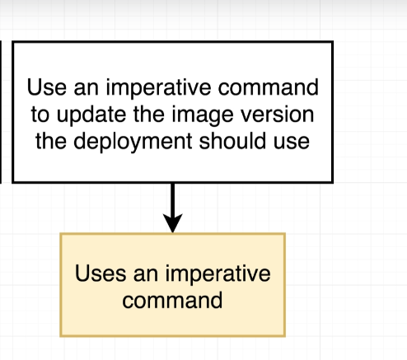

support an imaginary command like $ kubectl set updaxxxxte podxx imxxage --version=v4.0

but problem with approach is that it uses imperative command.
but in production environment solution 3 have more pros then cons. we can integrate this with CI/CD.

Udemy_lect_214 ----> Imperatively Updating a Deployment's Image

there are step for solution 3:-

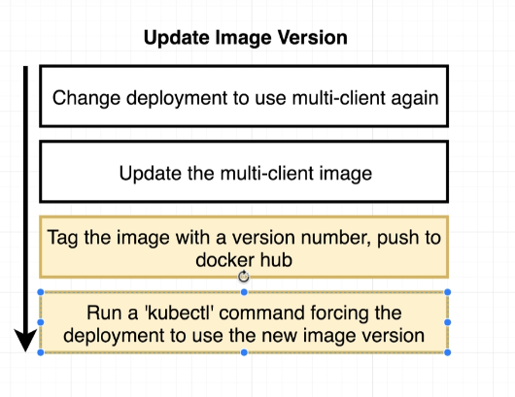

lets see command format :-

complete commad in two snapshot:-

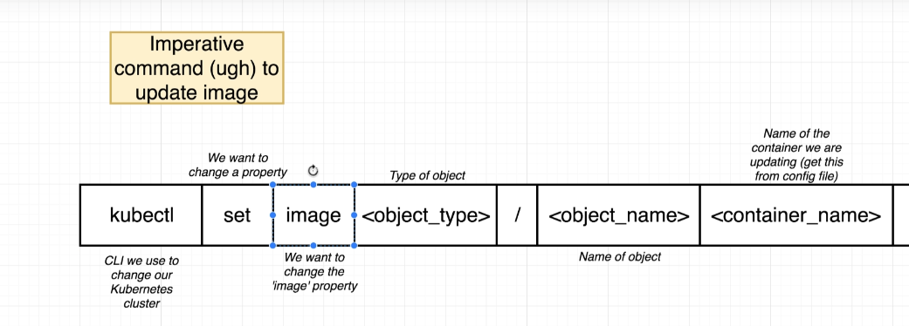

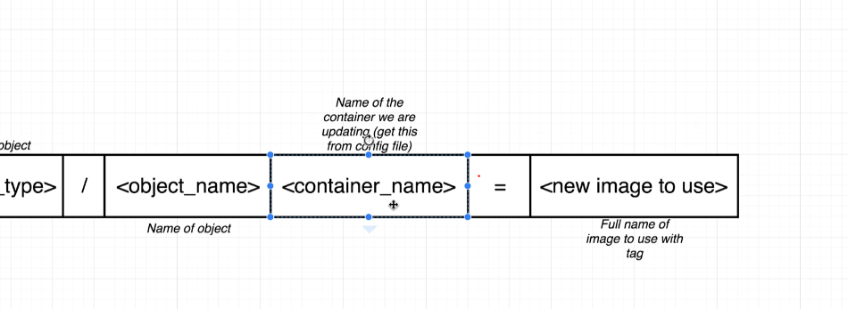

we use set command to update a property on one of our object that exist inside of our cluster.

in our case we want to make change in image

type of object is deployment

object-name is name of our deployment.

container_name --> a deployment contain pods and pod may contain many container, so we use container name as identify to reach container whose image we need to update.

= sign and full docker image name.

lets try out
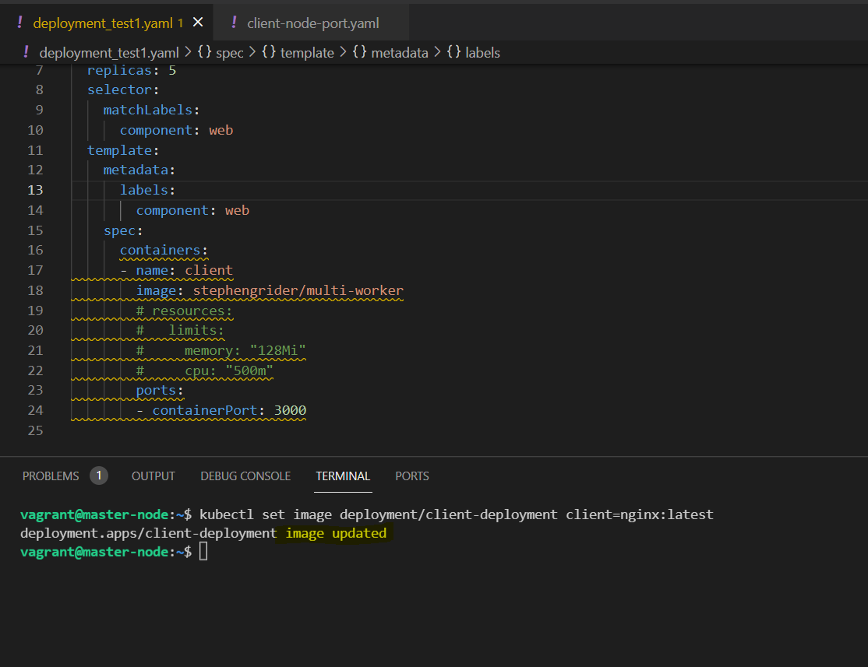

$ kubectl set image deployment/client-deployment client=nginx:latest
deployment.apps/client-deployment image updated

yes we have nginx image running over there.

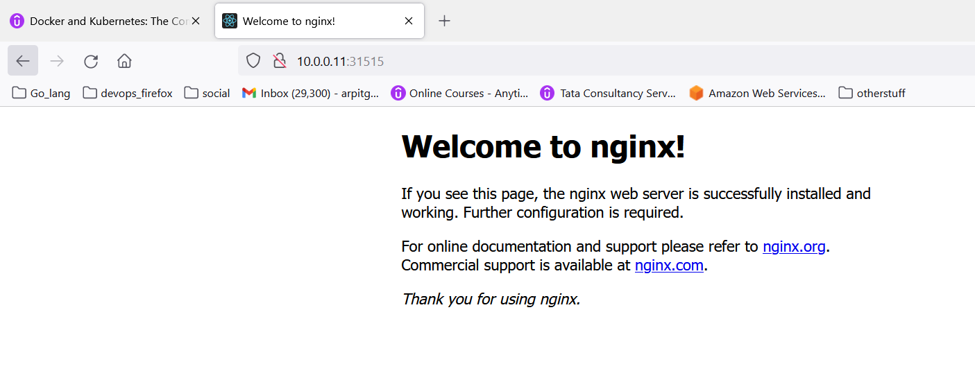

to get logs for pods use :- $ kubectl logs <pod-name>

