Here we are going to create an more complex application that going to store number of visit to page in redis database.
Redis is basically an in-memory database for fast execution.

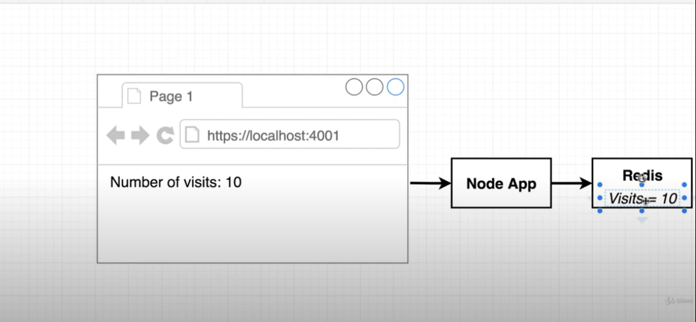
Yes we can also store no of visit in node application, but to make it more complex we are going to use redis application.

There are certain ways of doing that like:-

1. Putting redis and node app under single container, but it has some drawbacks like:-
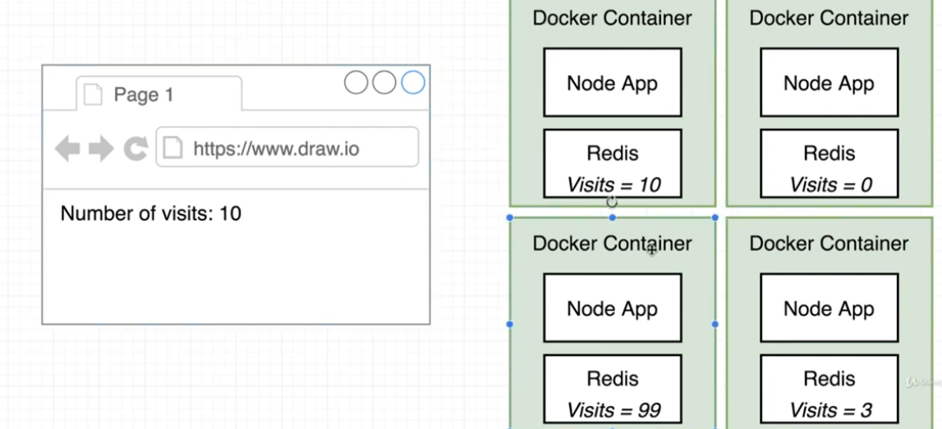
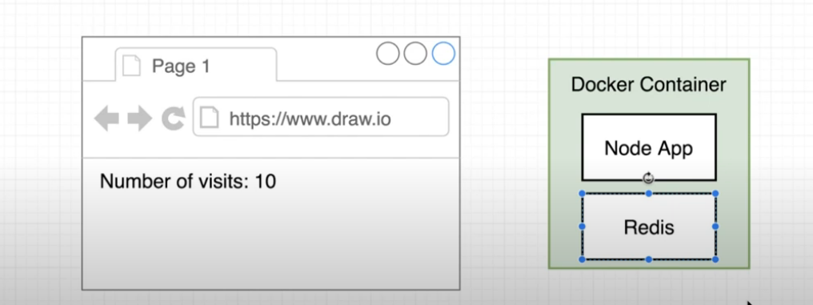
the problem might be every container would be disconnected to each other.

This will leads to every redis server has its own counter when it is called.

More robust way for doing this is like:-

2. many node conatiner that connect to a single redis container. Like:-
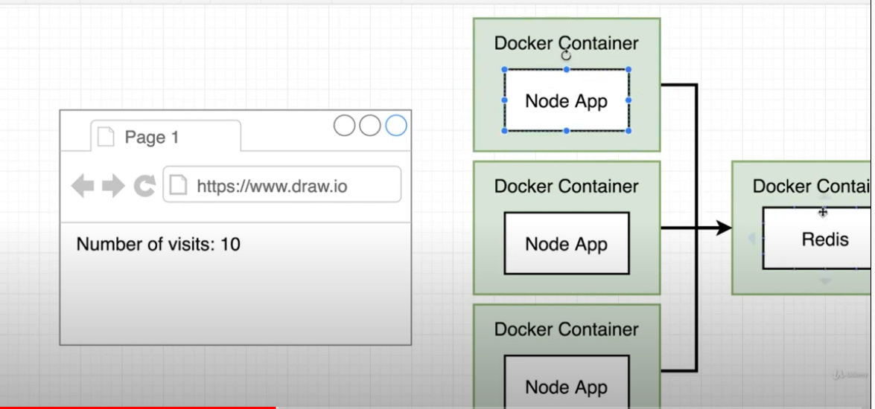
but for our current example we are going to use one docker container and one redis server.

Now we are going to write some nodejs code for our node application.

Lets create an folder called “visits”
and we will do all the stuff there.

You will find this directory inisde this repo ../practical/nodejs/visits

now inside this we are going to create two file:-
1. package.json => that will contain all the dependency for our node application.
2. index.js

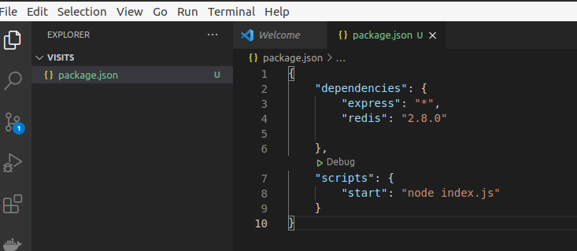
here In package.json :-

“*” => this define like we are using any version of express.
Here in package.json “redis” means not exact redis server, it repesent Nodejs library so that we can interact with redis server throught our nodejs server.

Now we are going to create an whole index.js file which is basically contain all our node js code.

We first mention our library that we import as an package.

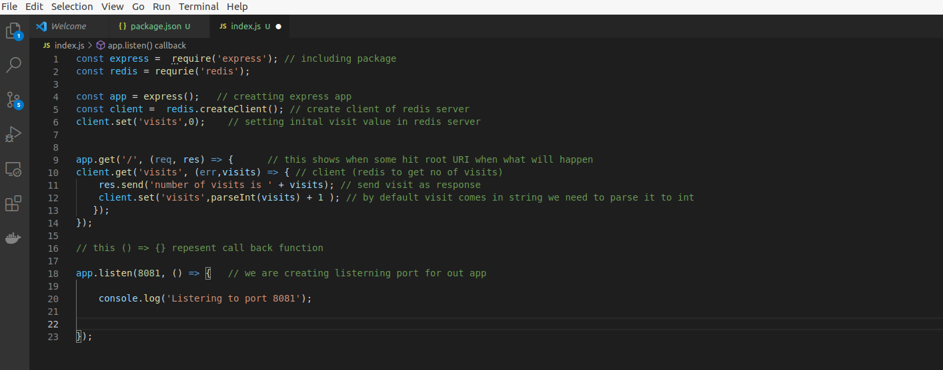
This is our nodejs application

const client = redis.createClient(); // create client of redis server
“()” here we have to put something do that we can connect to redis server.

Now we will try to create a Dockerfile whcih sole purpose is export our nodejs file inside docker container.
Remember it doesn’t have to do anything with redis container.

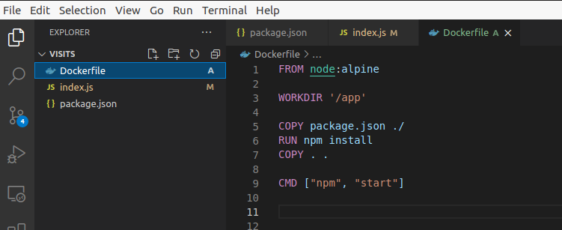
# docker build . => this will build our whole application.

# docker build -t arpitguptadockerhub/noderedisvisits . => this will build with tag

now lets try to run our image, we will get an error redis is not there.
OKAY try to run redis and then our node app.
Still you find you got an error becasuse it doesn’t found redis app.

We know that ever conatiner has its own namespace.

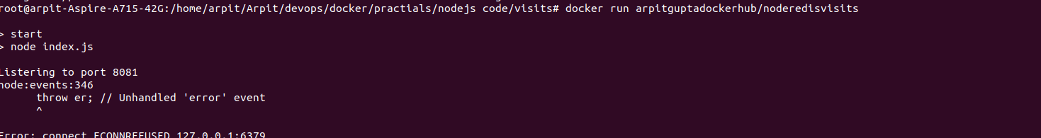
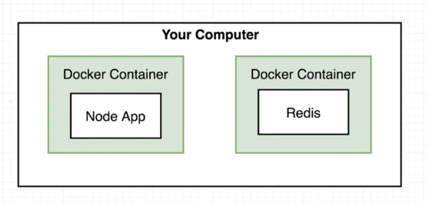
So there two different container have nothing in common/connection. They are isolated to each other. They are two different independent processes.

For these two talk to each other we need to setup some kind of networking infrastructure.

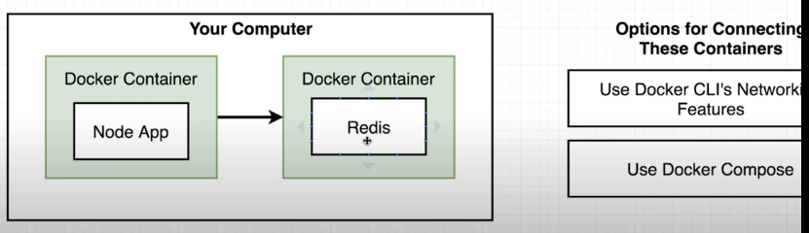
For this task we have two option:-
1. using docker cli , it is complex and we need run these command every time when we want to run those container.
2. docker compose

so docker compose prevent us to write tons of complex repetitive commad that we need to handle in docker cli.

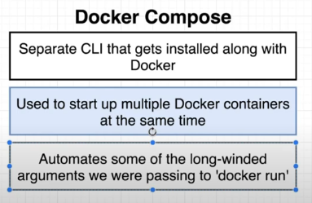

so this will run multiple container and connect them together to form some kind of networking infrastructure.

So what we are going to do is like we put all docker cli command onto a special file call “docker-compose.yml” using some special syntax.

Once we create that file then we will put into docker-compose CLI. And this will be upto docker-compose cli to parse those command with correct configuration that we specify.

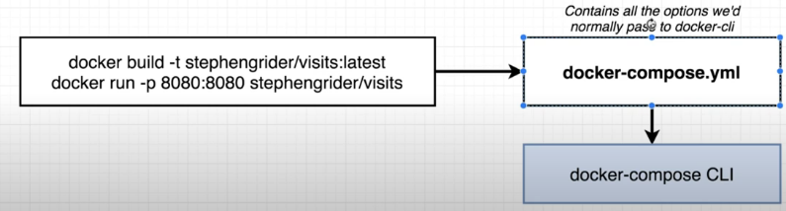
So think more about this docker compose file structure for more clarity.

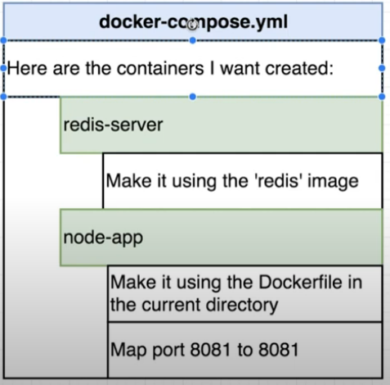

let create a new file “docker-compose.yml”.

And we can write all configuration here.

In docker-compose, we have to first mention “version”.
Then we have to mention “services”, services is some what equivalent to type of container.

So it means we can define two different services which represnt we need to create two conatiner one for redis and another for node-app.

In node-aap service we have “build .” that actually repesent Dockerfile
then we map out local machine port 4000 to container’s 8081

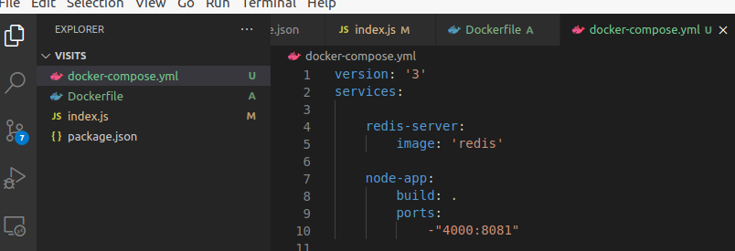
so that it for this docker-compose file.
But we can see that we haven’t put any kind of configuration here for networking between container.

Yeah, this is speciality of docker compose it will automatically create that for us.

Now we have some kind of network between nodejs app and redis.
But we still not configure our nodejs app in such way that it will access redis.
To do so we have to mention some port and url so that we can exactly reach out redis server.

Suppose we don’t have any docker stuff. And we are trying conventional stuff so for that we need to mention redis url on redis client declaration in index.js file.
Like:-
const client = redis.createClient({
host: 'https://my-redis-server.com'
});

but as we are in docker-compose environment,
const client = redis.createClient({
host: 'redis-server',
port: 6379
});

here we mention service name and default port.

Now we are going to start-up docker compose file.
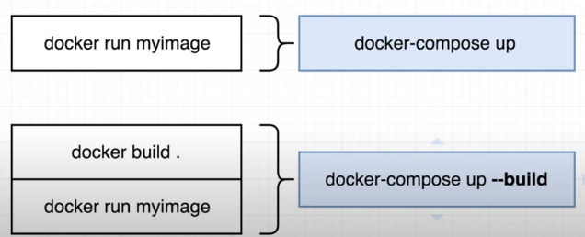
If we want to rebuild our dockerfile we have to use
# docker-compose up –build

The following only builds the images, does not start the containers:
docker-compose build

The following builds the images if the images do not exist and starts the containers:
docker-compose up

If you add the --build option, it is forced to build the images even when not needed:
docker-compose up --build

The following skips the image build process:
docker-compose up --no-build

root@arpit-Aspire-A715-42G:/home/arpit/Arpit/devops/docker/practials/nodejs code/visits# docker-compose up --build
Creating network "visits_default" with the default driver

here you can see it first create network.

Lets see what comes into browser.
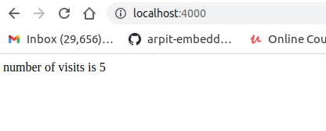

Yeah, its working.

