Register A Domain Name :-

we will also see different routing policy using this domain.

Networking ---> Route 53

We will first look about Domain registration (it is not free)

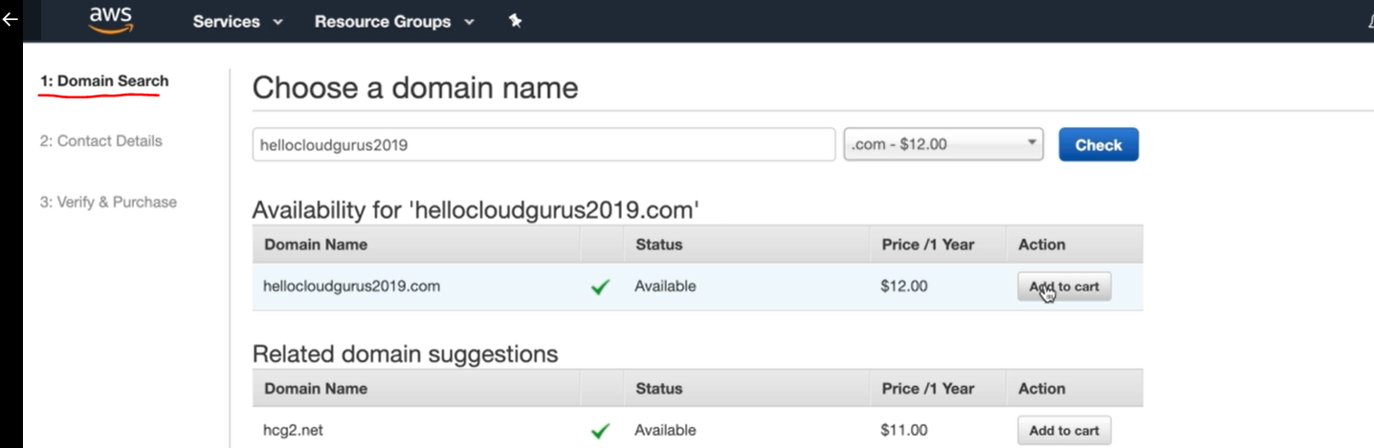

here he search for available domain name.

Now fill form which contain personal information

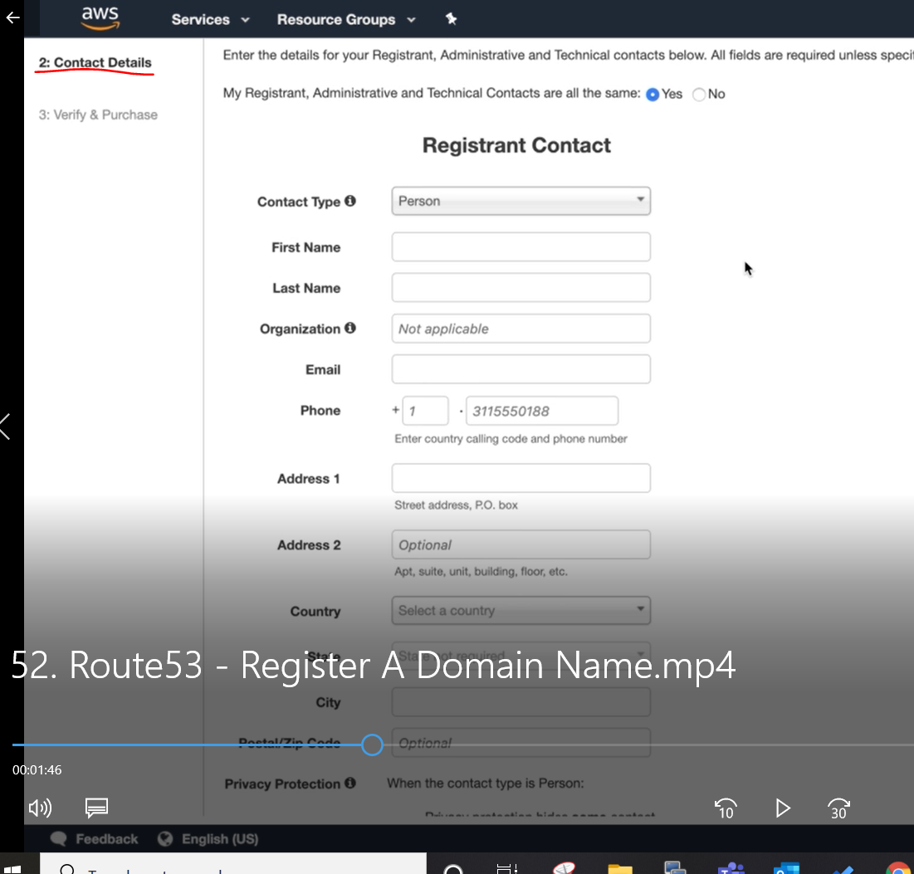

next ----> accept Term and condition ------> complete purchase

sometime domain name take upto 3 day to get registered. but usually it take 1-2 hour

we can see our domain name here.

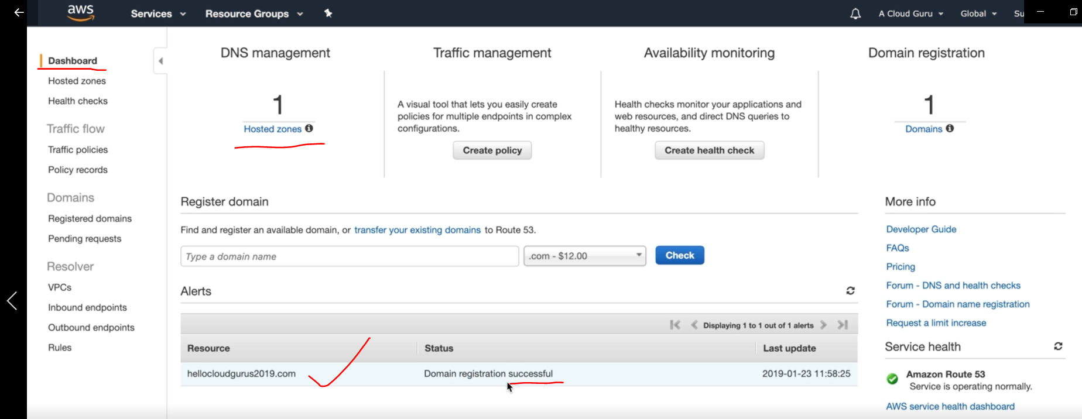

Now once domain name is successfully registered,

Now to your hosted Zone:-

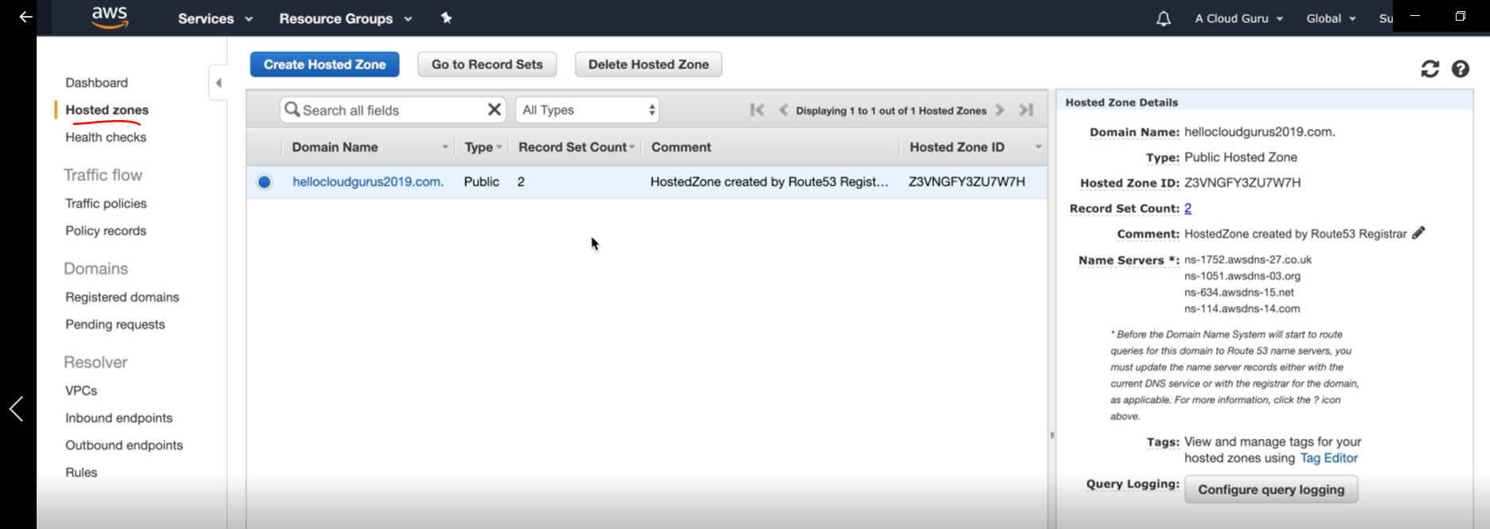

This is where you configure your Route-53.

Here we need to put our Record like "A" , "C" and other.

Now we are going to run our 3 EC2 instance which runs web-server, and we will create those EC2 instance in different region like one very far and very close (geographically) to test latency.

