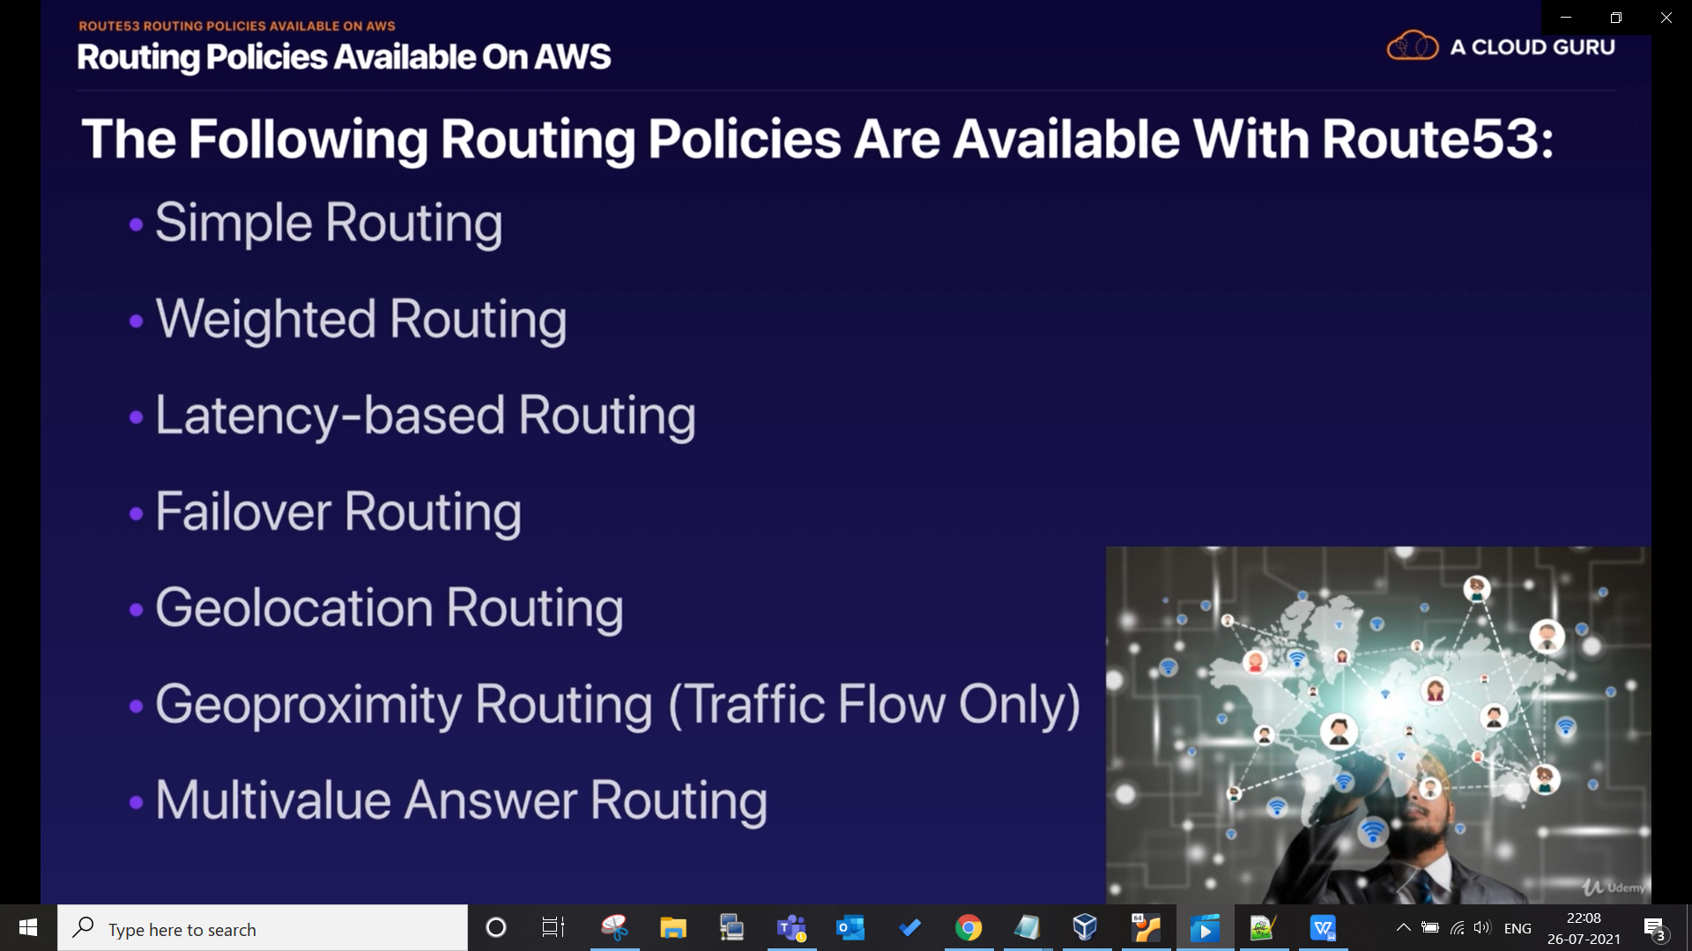

from next lecture we will start with simple routing

