Simple outing policy have only one record with multiple IP address.

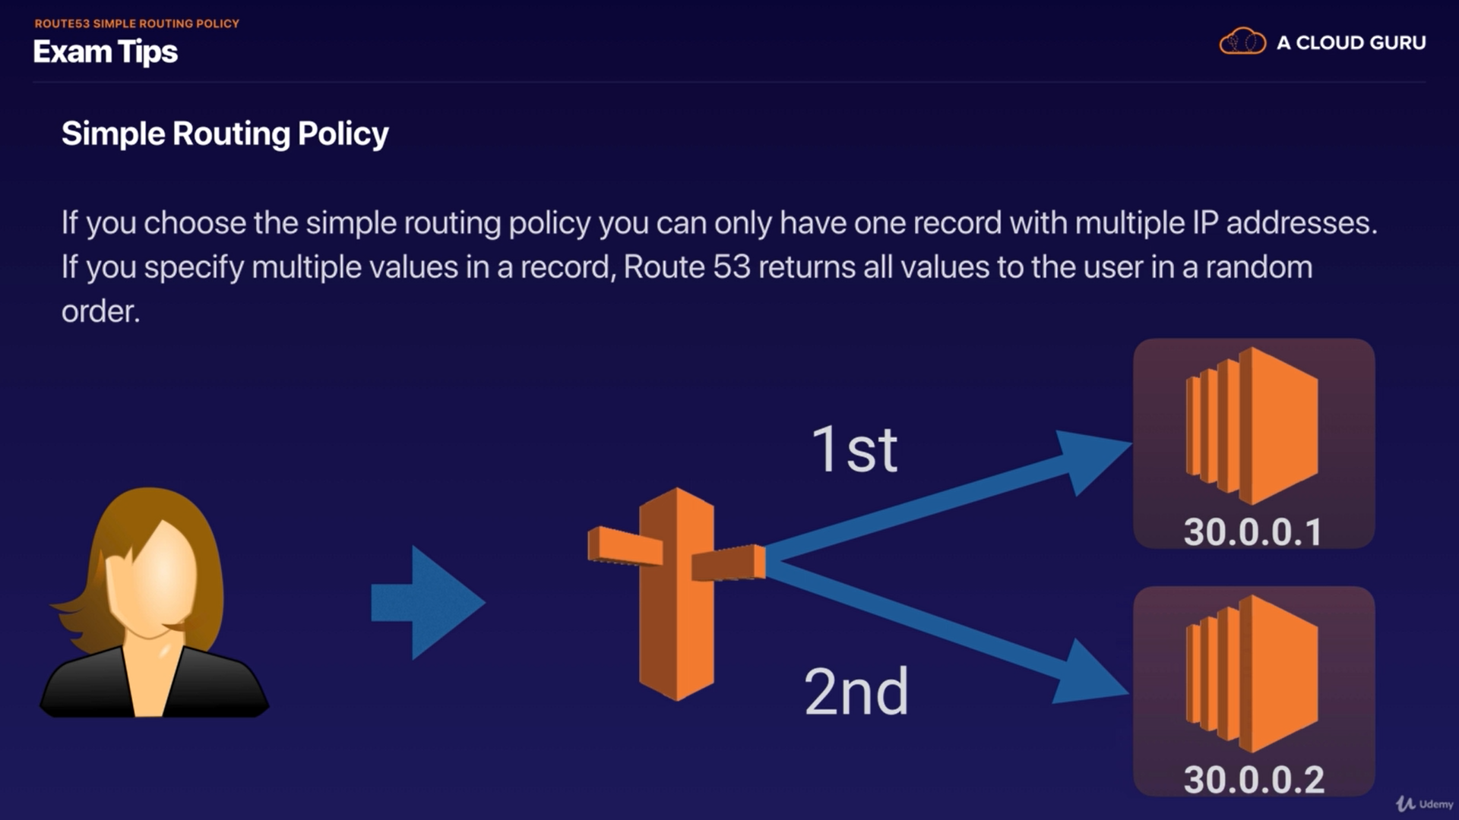

lets suppose you assign two IP address for one DNS, if you hit that DNS then Route53 will randomly select an IP and send request to that IP.

So lets create 3 EC2 instance and write down there IP Address.

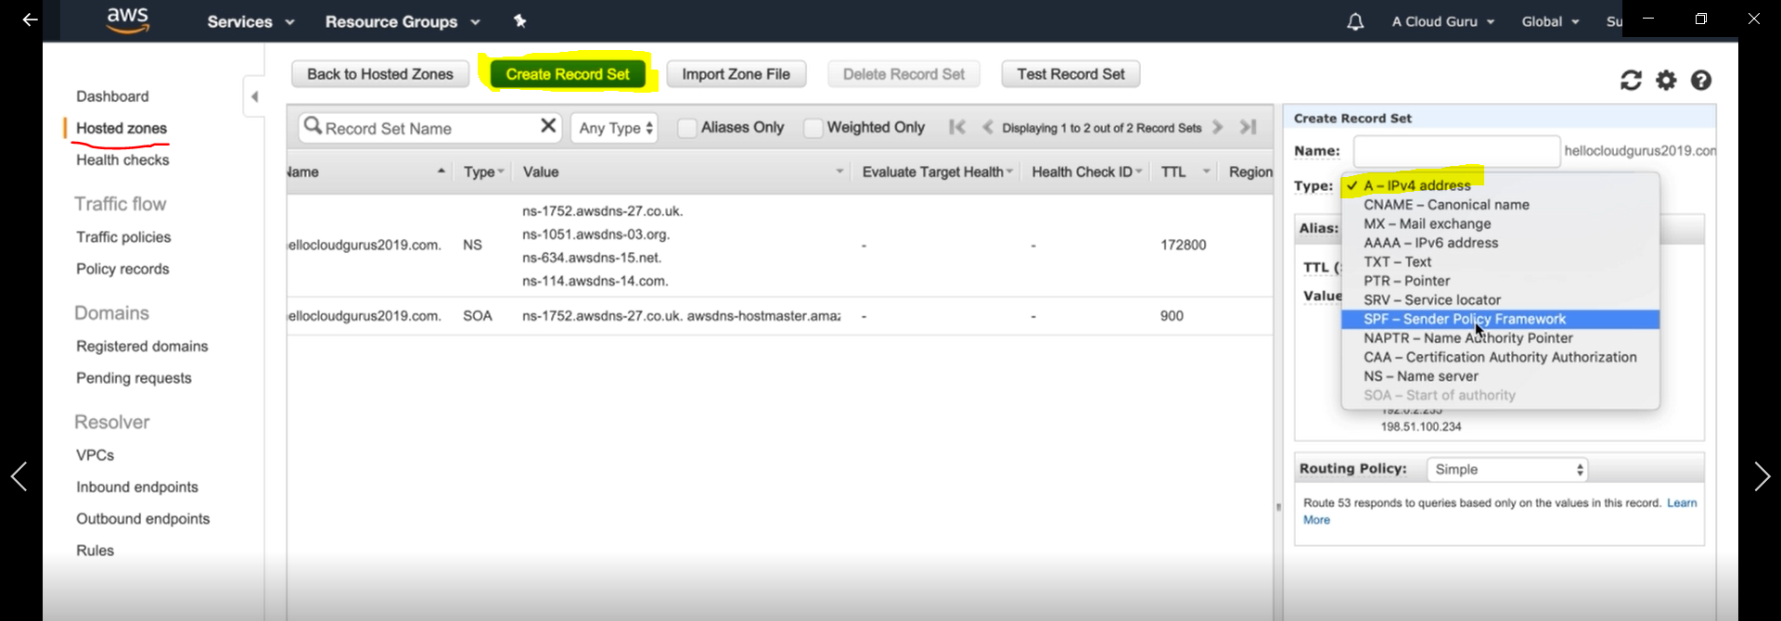

Now go to route53 dashboard ---> create Record set ----> select A record

you can also see in Value that AWS give us other top level domain, if one domain goes down we have other.
suppose if ".co.uk" goes down, then we still have ".org" like this way

Now lets paste you IP address like as single routing policy.

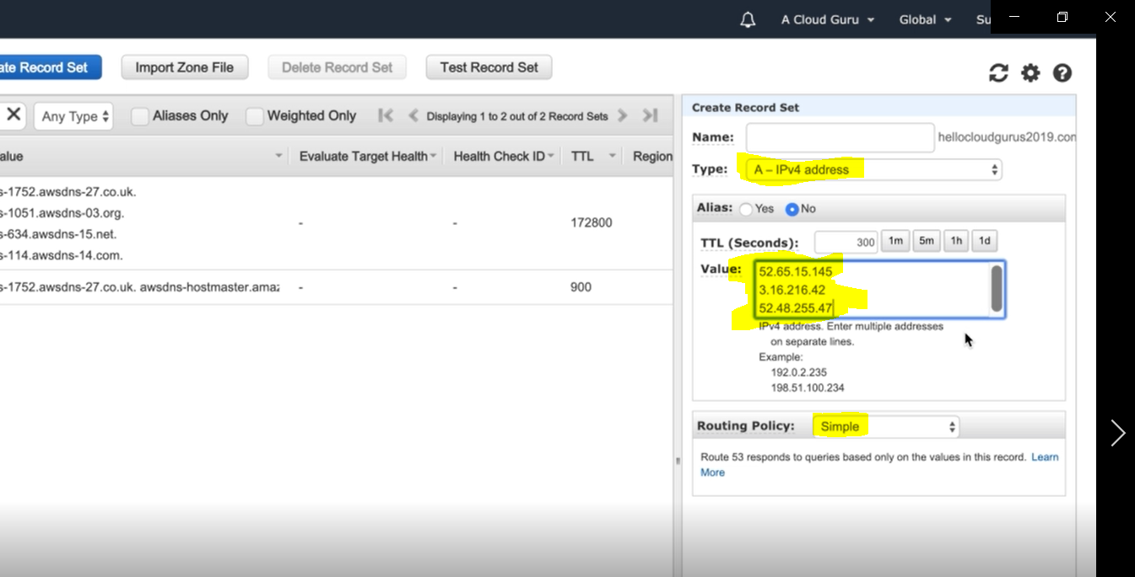

and hit create.

now this has been create:-
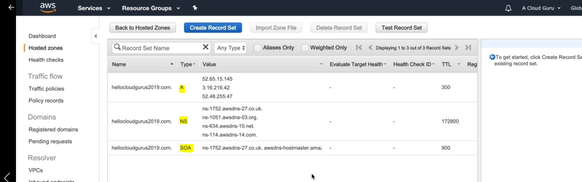

now go and test that.

so DNS seem working:-
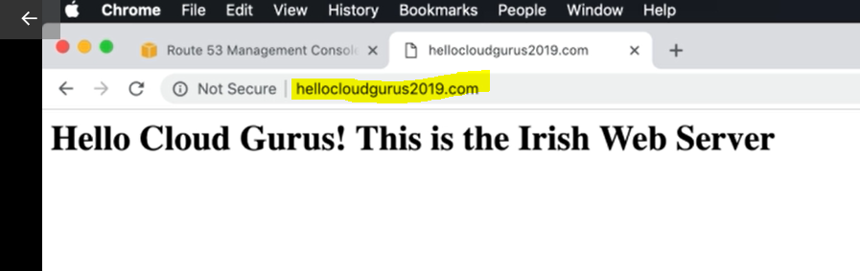
Its pick Irish server.

lets refresh it, but it is struck on Irish server only, it is because browser cache IP address for this DNS.

Now to avoide this behaviour we need to Decrease TTL value (say 1 m)
and hit "save record set"

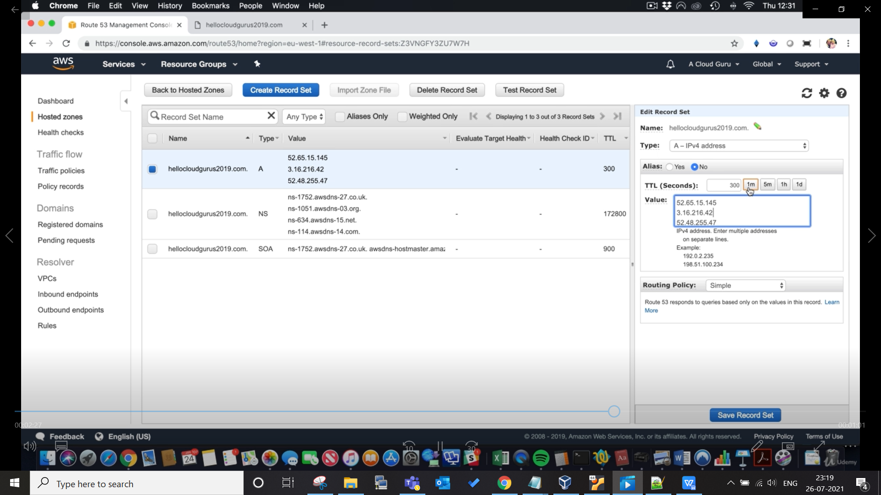

Now wait for 1m and hit refresh this will take you to Ohio server

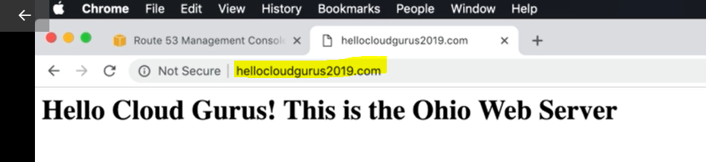

Exam Tip:-

