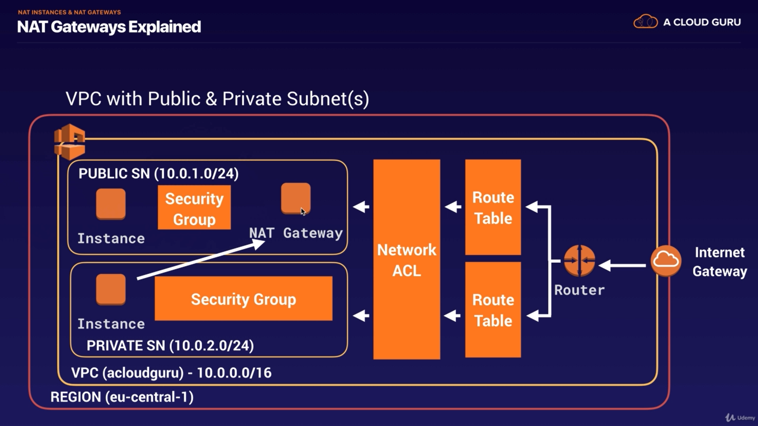

Remember when you create a new NACL, it is by default in denying mode for both in-bound and out-bound.

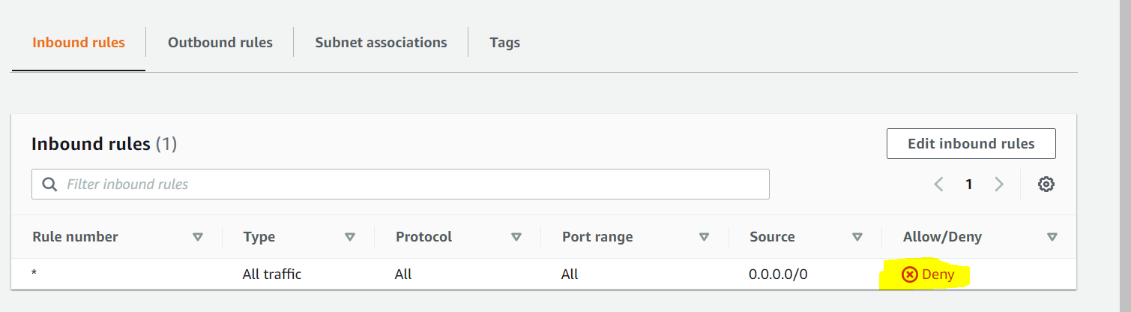

Ephemeral Port :- these are those port on to which server temperately connected to client.
These are shor-lived port, that why called as Ephemeral.

like client send http request to server at port 80 but server is connect to client may be on some random port in of some range like 1024-65535.

So these rules are need to be allowed in OutBound rules , so that our server can send data to client on this Ephemeral Port.
An ephemeral port is a temporary communication hub used for Internet Protocol (IP) communications. It is created from a set range of port numbers by the IP software and used as an end client's port assignment in direct communication with a well-known port used by a server.
Ephemeral means temporary or short-lived, as is the characteristic of this type of port.
why we choose this port range 1024-65535 :- because NAT gateway choose that port range.

Also in NACL table rules are evaluates in upward to downward priority.
top rules have higher priority that lower one.
Now this priority is define by rule number

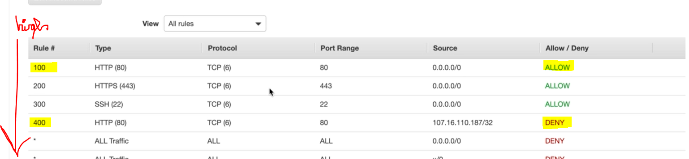

so lower the rule number higher the priority.

NACL have multiple subnet associated with it.

Below is way to deny a specific IP to access service:-
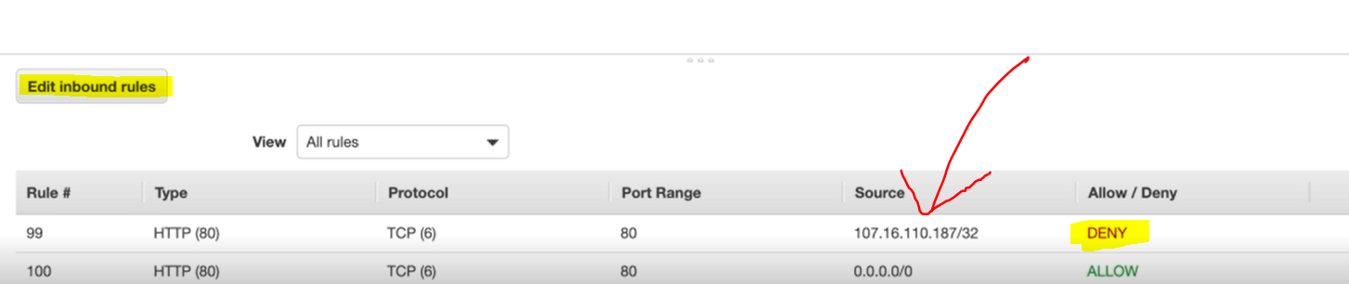

NACL > Security group

NACL acts first before security groups

This blocking IP address can only be done using NACL but not with Security Group.

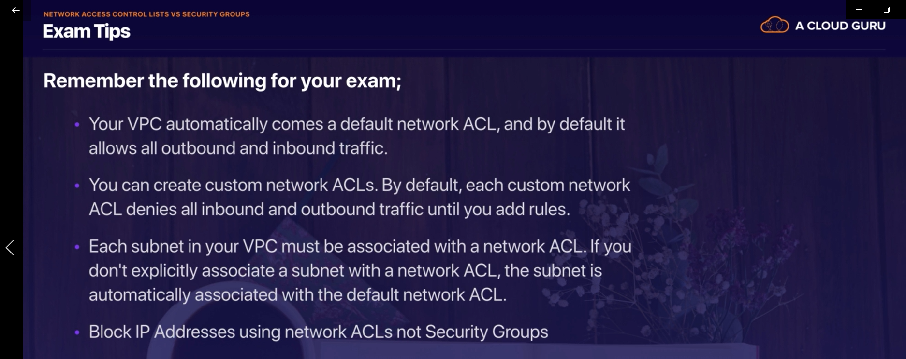

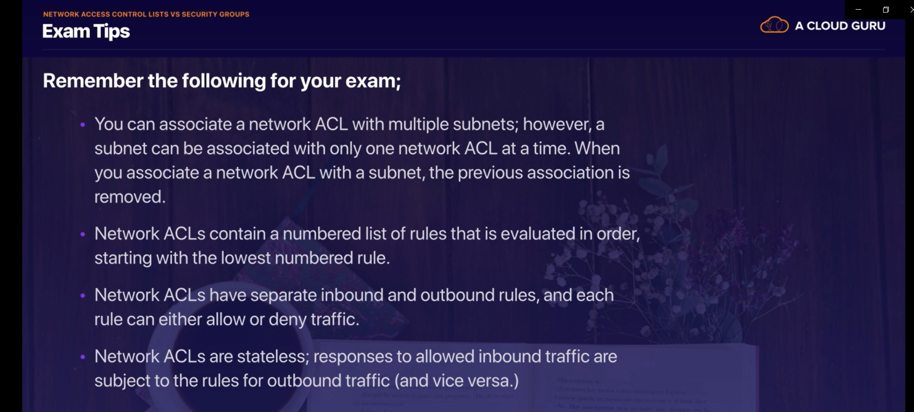

Here we need to configure both Inbound and outbound rules, as NACL are stateless.

