Regular expression:-

refer here and comple stuff :- https://www.youtube.com/watch?v=rhzKDrUiJVk 6 min

suppose you want to fetch some things from a string there we have to use regular expression.

So conventional way is apply for loop, manipulate and other stuff. --> this way is tedious

so we will use regular expression.

use this website to make our work easy :- https://regexr.com/

almost every time regular expression going to start with '/' and end with '/'

so everything between /…. / is going to be our regular expression.

after end of regular expression is some flag like

'g' --> global ===> it will match in all over string
'i' ---> case insensitive
'm' --> multi-line
's' ---> single line

eg :- /the/g ----> match all "the"
while /the/ ----> match one or first only "the"

the above are simple search only

for more elaborate search we need add special symbol

- '+' ==> select atleast one and all successive occurrence as one result. but select atleast one.
eg :- /s+/g

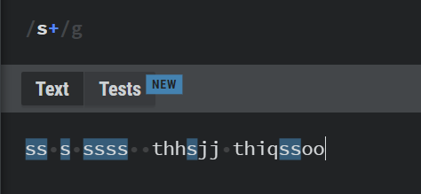

- '?' ==> this repesent optional to left attach alphabet
eg:- /sj?/g ---> this will search for all occurrence of 's' and if 'sj' present it will select that as well

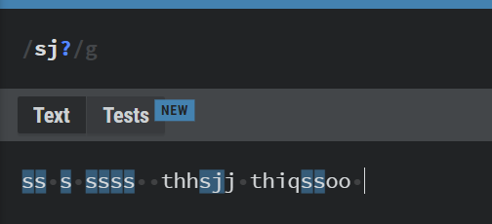

- '*' ==> this combination of '+' and '?' , match as many as you can.
ex :- /sj*/g

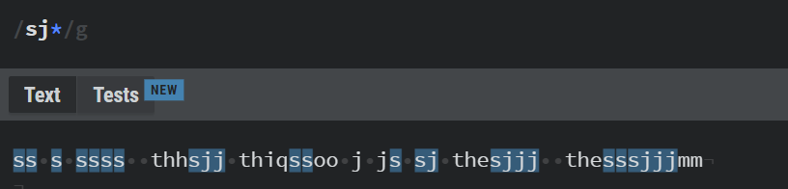

- '\' ===> now suppose we want to search symbol so for that we need to use "\"
eg:- /\*/g => this will search all *

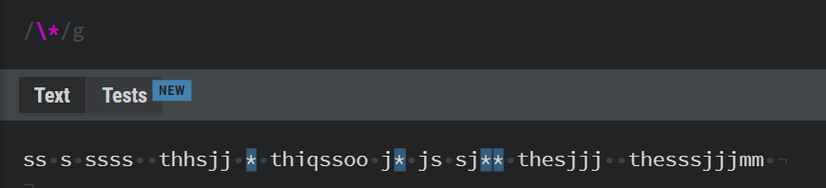

- '.' ==> called as period (.) will select all match and don’t go beyond new line
eg1 :- /./ => this will select all as single reference
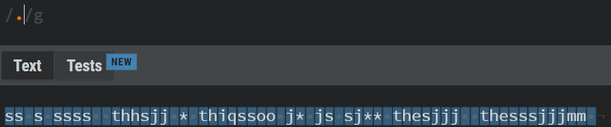

eg2:- /.sj/g

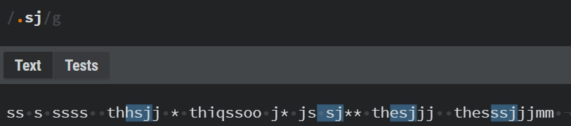

it is just like select _sj where _ is blank (or anything)

eg3:- /..sj./g

