we install docker and docker-compose on linux machine.

go to docker hub and search for jenkins image.

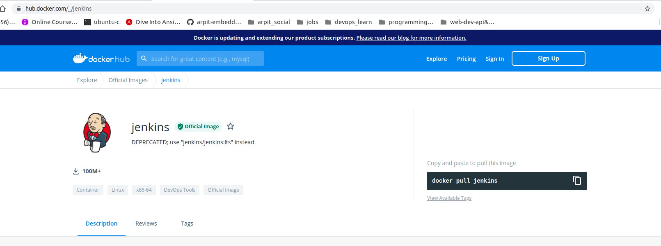

use $ docker pull jenkins/jenkins

$ docker info ==>

you can see Docker Root Dir: /var/lib/docker

here you will find all images and meta data.

$ du -sh /var/lib/docker ==> to check total size taken by docker.

here "-s" denote sumrize.

create a directory called jenkins-data in home directory.

pwd :- /home/arpit/jenkins-data

also let create a directory like:-
/home/arpit/jenkins_home ==> this will works as volume for jenkins container.

lets create a "docker-compose.yml" file here.

---
version: '3' # this is version for docker compose
services:
jenkins:
container_name: jenkins
images: jenkins/jenkins
ports:
- "8080:8080"
volumes:
- $PWD/jenkins_home:/var/jenkins_home
networks:
- net # attaching this service to network
networks:
net: # creating a network net.
...

Now one issue is owner of this "jenkins-data" directory is root.
we want our current user arpit (check using "$id")

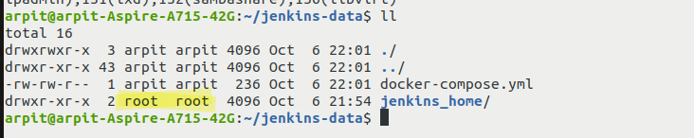

$id

uid=1000(arpit) gid=1000(arpit) groups=1000(arpit),4(adm),24(cdrom),27(sudo),30(dip),46(plugdev),120(lpadmin),131(lxd),132(sambashare),136(libvirt)

$ sudo chown 1000:1000 jenkins_home -R
-R for recusively

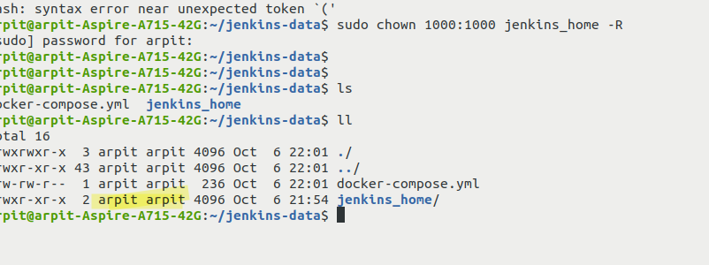

now $ docker-compose up -d

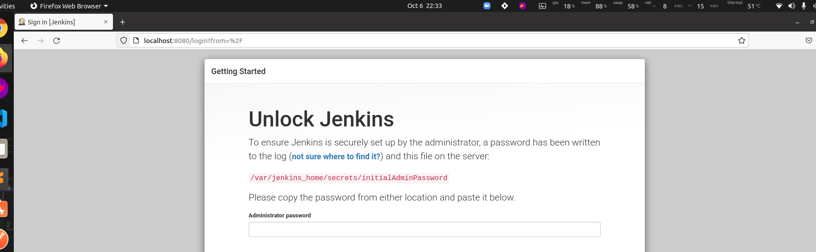

Okay now that start to work.

$ docker logs -f jenkins

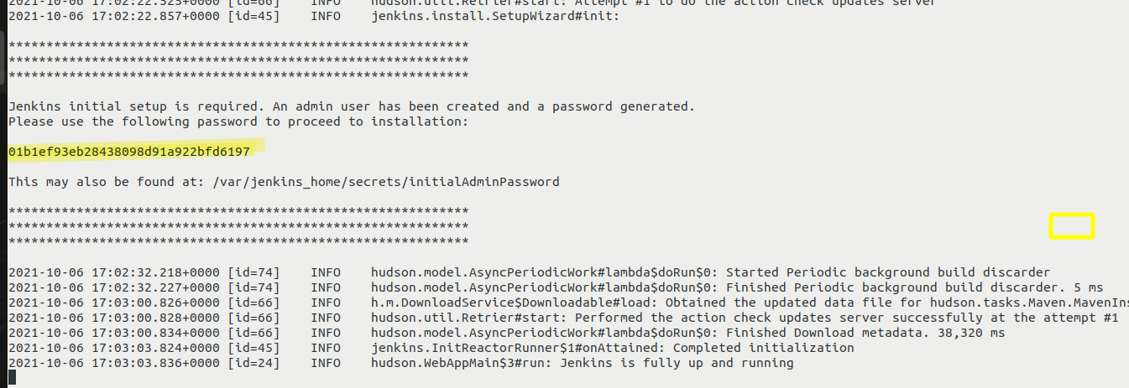

this is one wearied hash, we will use this to authenticate jenkins on browser.

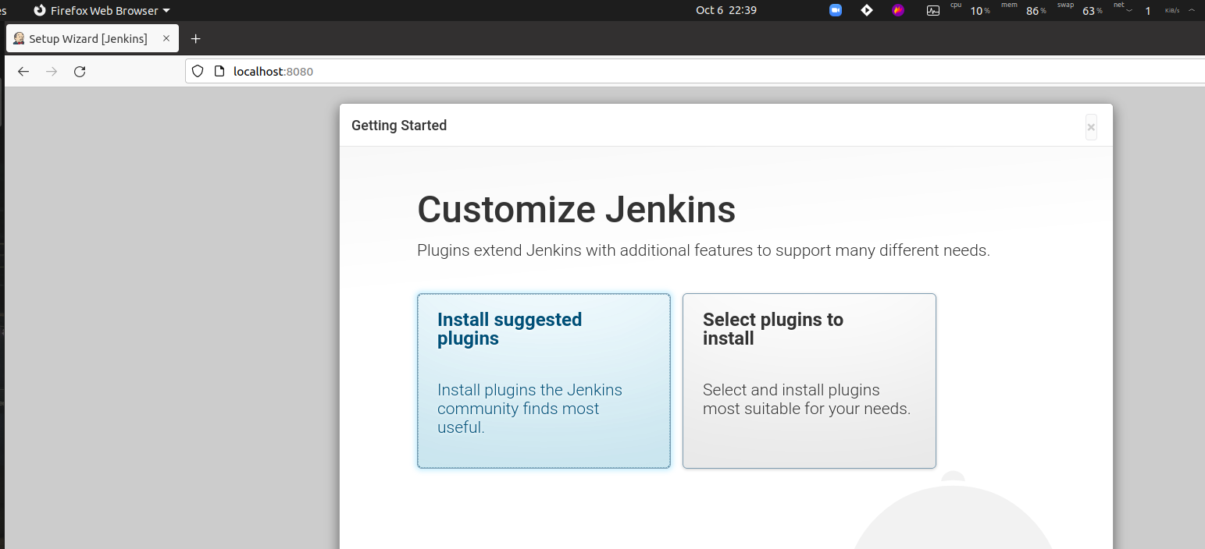

okay now done we came to here.

click on install suggested plugin.

it is now installing plugin by its own:-

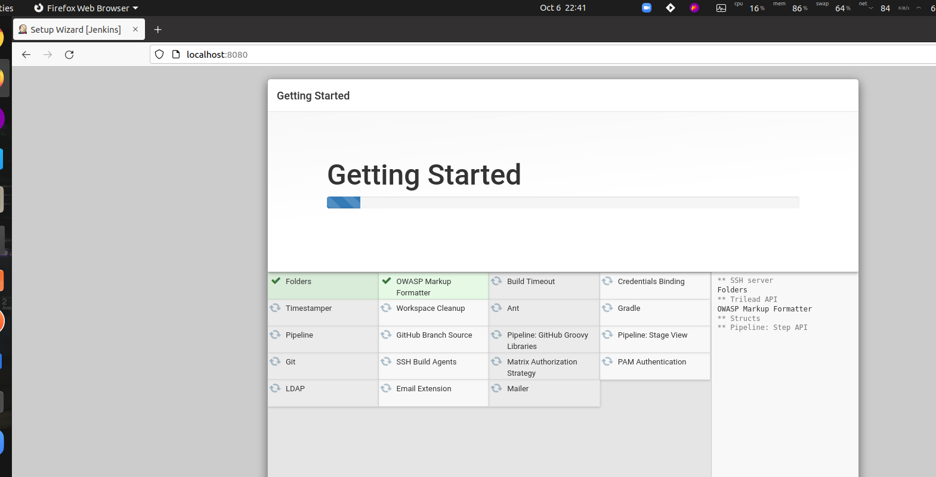

Now after that create a admin user then do next next

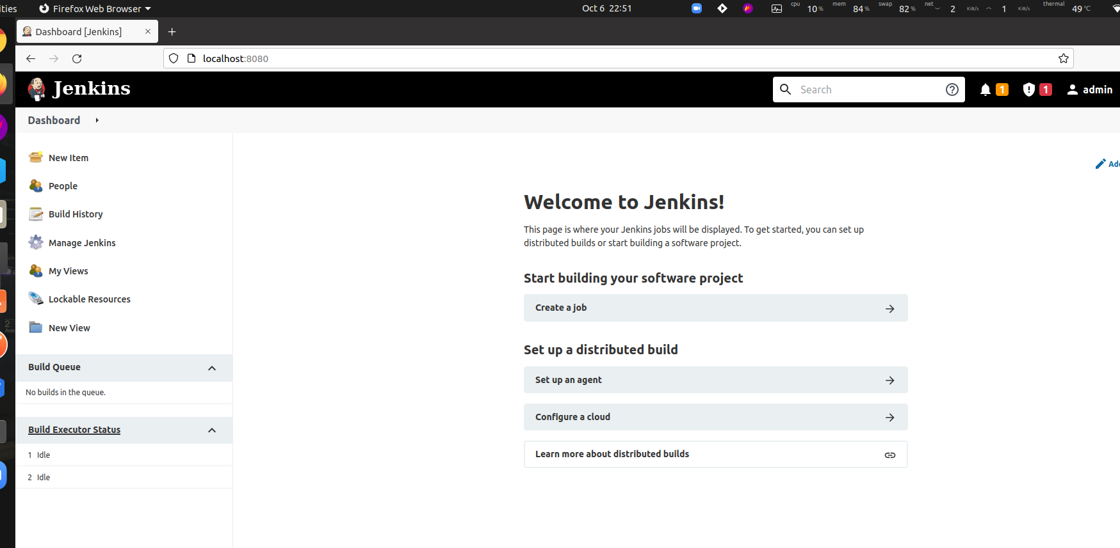

troubleshoot jenkins upto here (if required)

Troubleshooting: Jenkins not coming up?
Hey, there!

There's a chance that your jenkins container won't come up. If you can't see your container by using docker ps, this will help! Otherwise, you can just ignore it :D

Issue:

docker ps doesn't show the running container.

Debug:

docker ps -a shows the container with exit status.

docker logs jenkins shows a volume permission error.

Reason:

* Inside of the Jenkins container, there's a user named "jenkins" which has a Linux uid of 1000.

* You are mounting a docker volume to /var/jenkins_home which is the home directory of that user. If the directory doesn't have 1000 permissions, then the user won't be able to write/delete files, which causes the container to exit.

Resolution:

Apply 1000 permissions to your jenkins-data folder, and then restart the container.

sudo chown 1000:1000 -R ~/jenkins-data
docker-compose up -d

