

some other theory about delegation:-
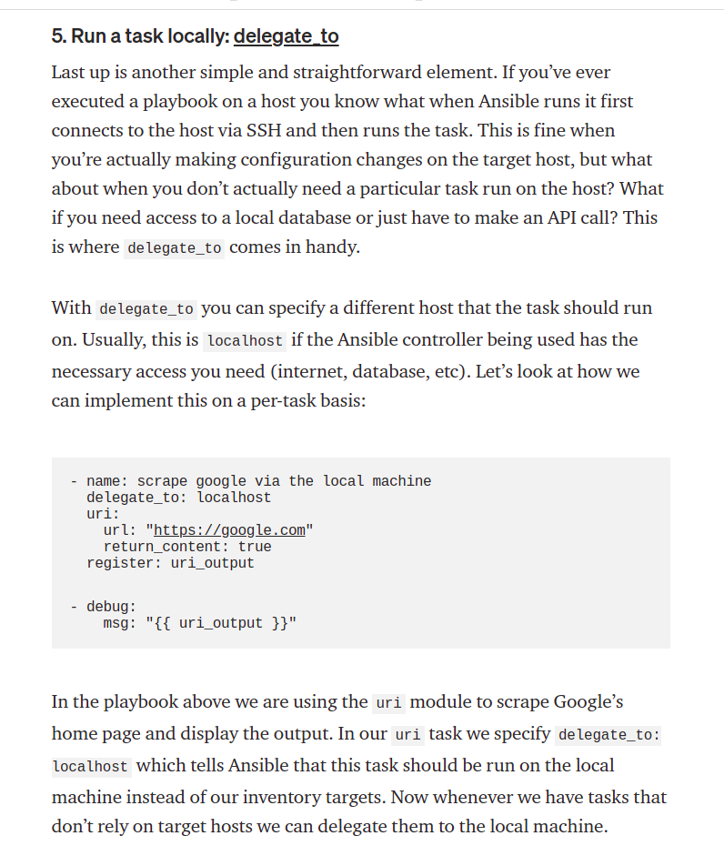

we should have permission to run command on control host and target host.

In this video, we're going to be using the facts derived from our target host and will be delegate this information to a specific host so it can open TCP wrapper rule.

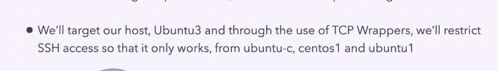

pwd :- /home/ansible/diveintoansible/Ansible Playbooks, Deep Dive/Task Delegation/01

In this playbook we have 3 plays.

- create a ssh key pair for host "ubuntu-c" ( our control host). we will use key for ubuntu3 target host.
- copy this ssh key to all our target system.
her the owner is "root".

