Ansible has thousands of inbuilt module.

here we are going to explore those module which are going to use in everyday playbook creation.

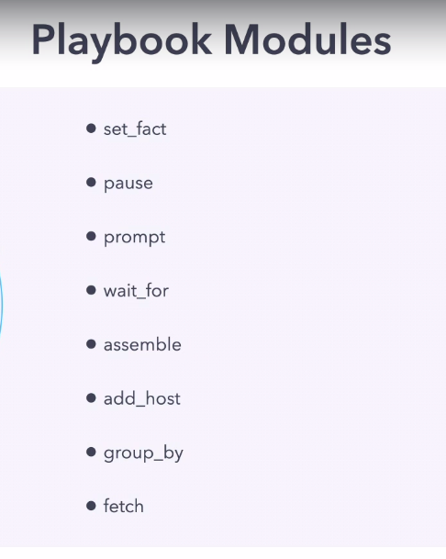

- set_facts:-

This module allow you to dynamically add or change facts during execution.

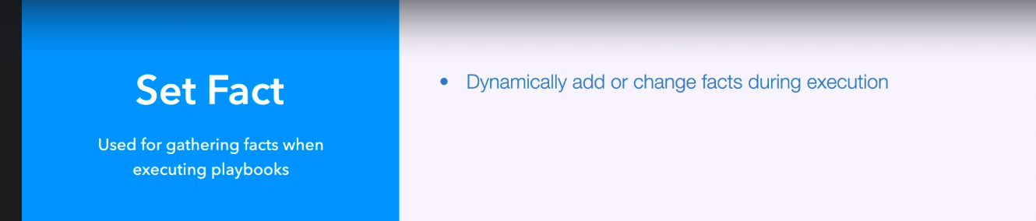

Revision 1

pwd:- /home/ansible/diveintoansible/Ansible Playbooks, Deep Dive/Playbook Modules/01

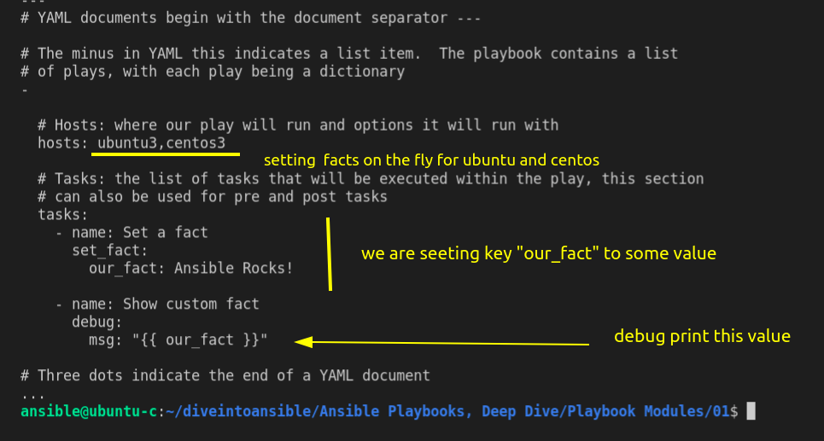

lets give it a try.

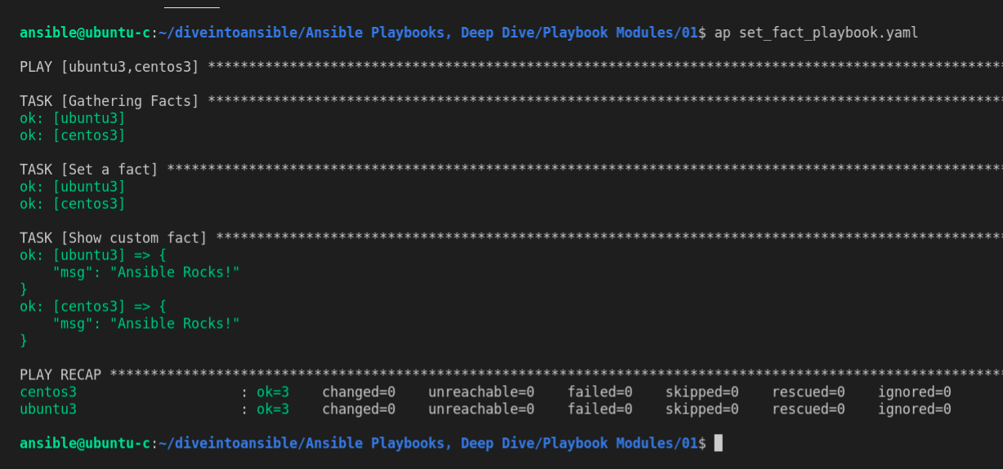

Revision 2

we can set multiple facts in one iteration of facts module.

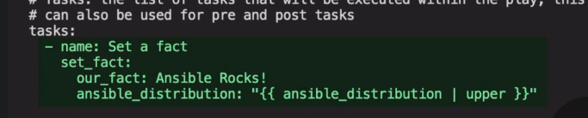

here we have two facts:-

- our_facts
- ansible_distribution --> this is basically a default ansible facts. but we are overwriting this to upper case.

as a reminder {{ }} double curly braces used for jinja 2 templating.

lets run this:-

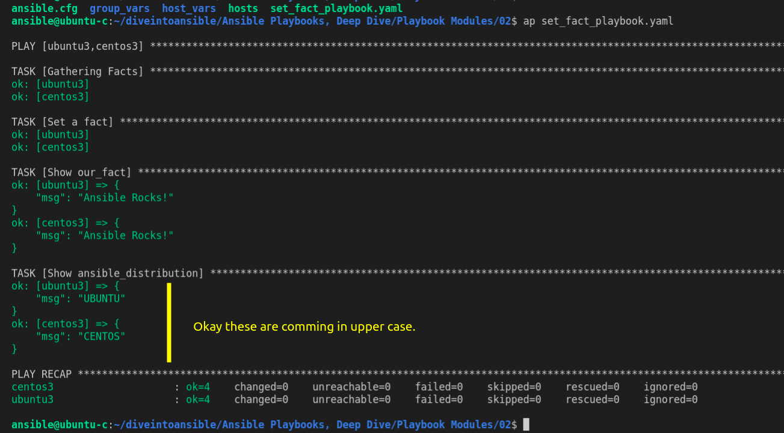

Revision 3

we can set facts according to distribution (or other facts) using when
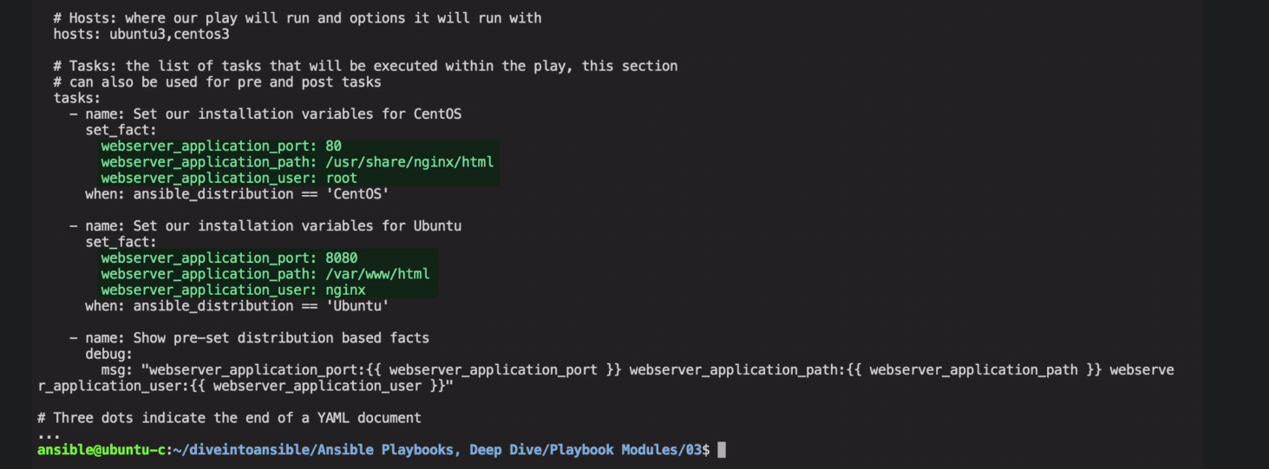

this help us to reduce dependency of setting variable in inventory variables.
as we did when setting up nginx index.html file.

lets run this

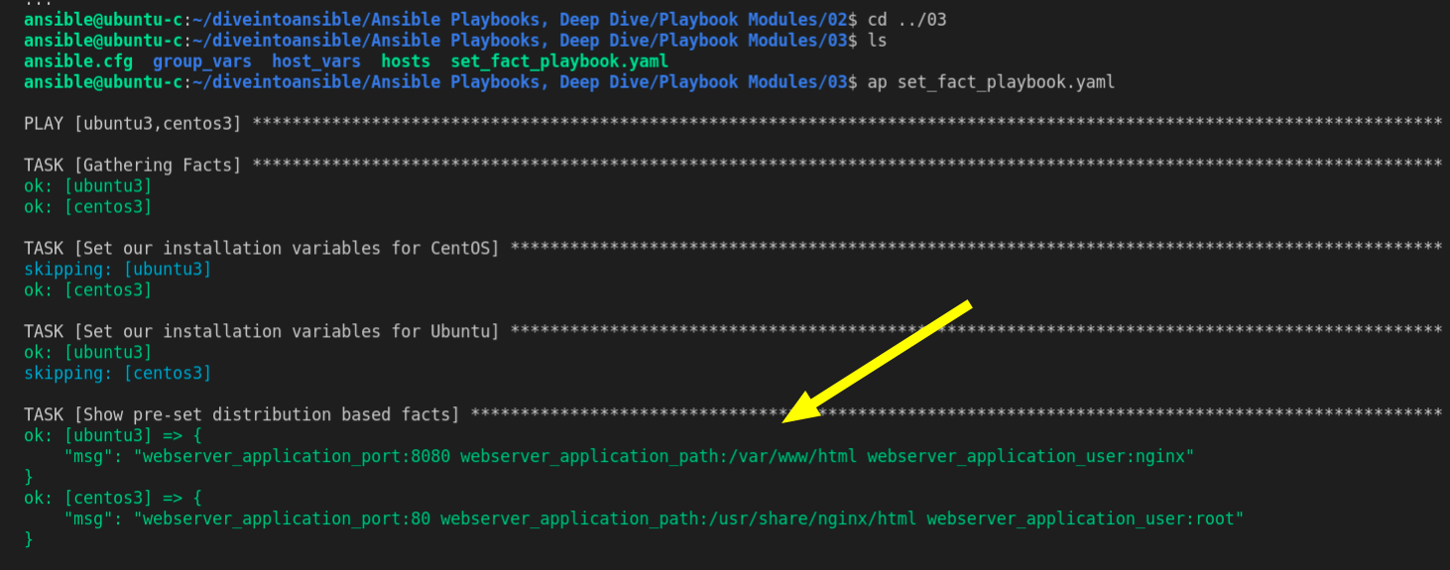

2. Pause Module



it will pause playbook execution for given period of time.
it also allow to pause until a specific prompt get acknowledge.

Revision 4

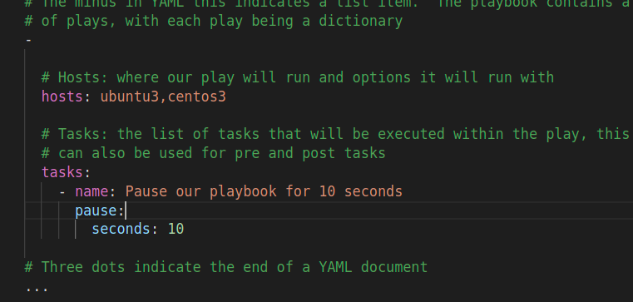

run this

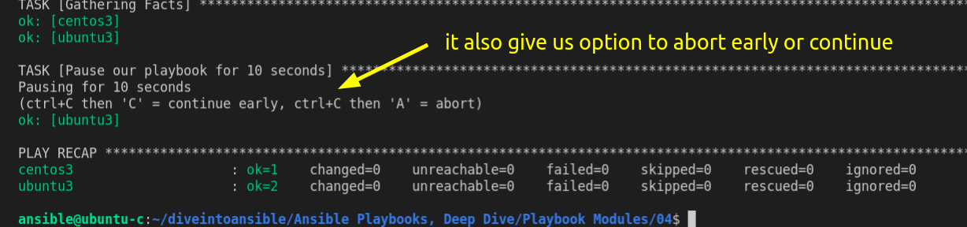

Revision 5

prompt feature of pause module - is really useful, it prompt user to manually intervene and continue the execution.

suppose we need to check webserver are running then we can continue with playbook we can use prompt

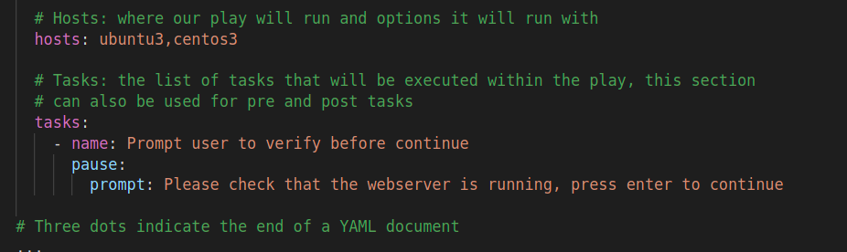

lets run this playbook.

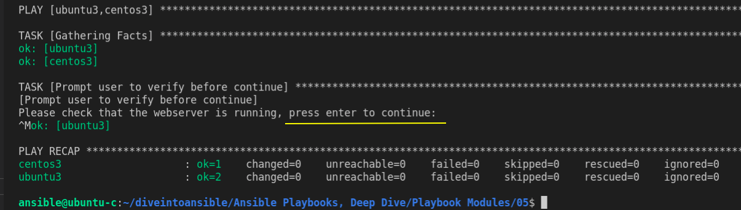

Revision 6:-

The problem here is user have to manually intervene, to remove this boundation we use some wait condition

- wait_for module

the wait_for module is use to accomplish manual intervention.

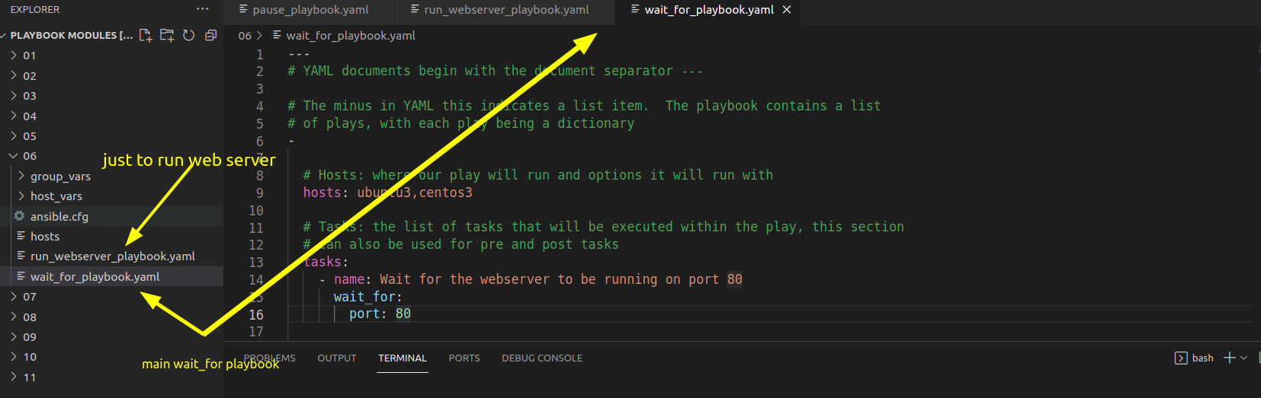

In wait_for_playbook file we are basically waiting for port 80 to be in use.

Be sure webserver are running or use this run_webserver_playbook.yaml.

now run this wait_for_playbook

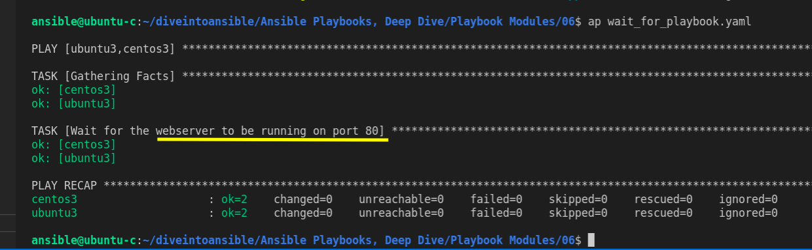

so we are basically waiting for port 80 to be in use.

lets stop this server and then try

to stop

$ ansible centos3 -m service -a "name=nginx state=stopped"

and run wait playbook
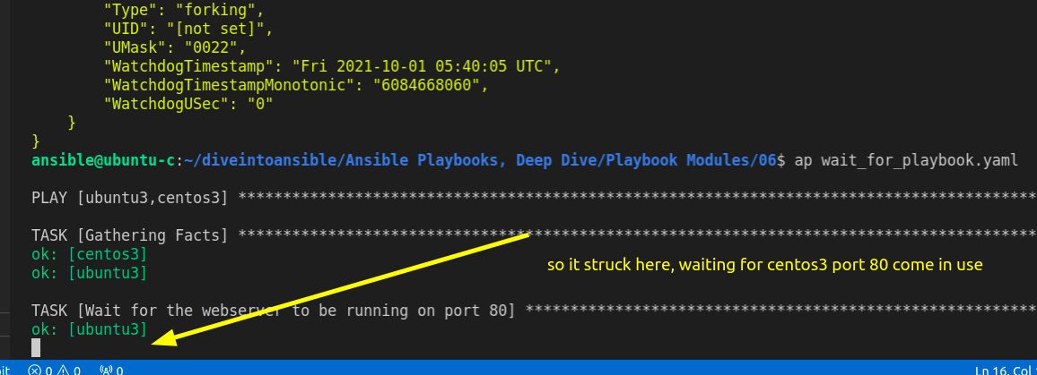

- Assemble module

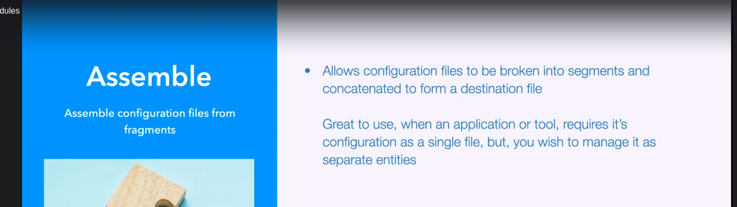

we know that ansible can handle 1000 of host.
when we are working for such a magnitude then configuration file can become very large.
suppose every server has one entry that we need to manage.

we can preffer to segregate configuration into files for each particular system.

so here Assemble module comes into play it allow collection of file in into one file.

Revesion 7

take an example we know that our centos1 host is running on port 2222, so we need to take care of that.
open conf.d, we can find two file one is default and other related to centos1

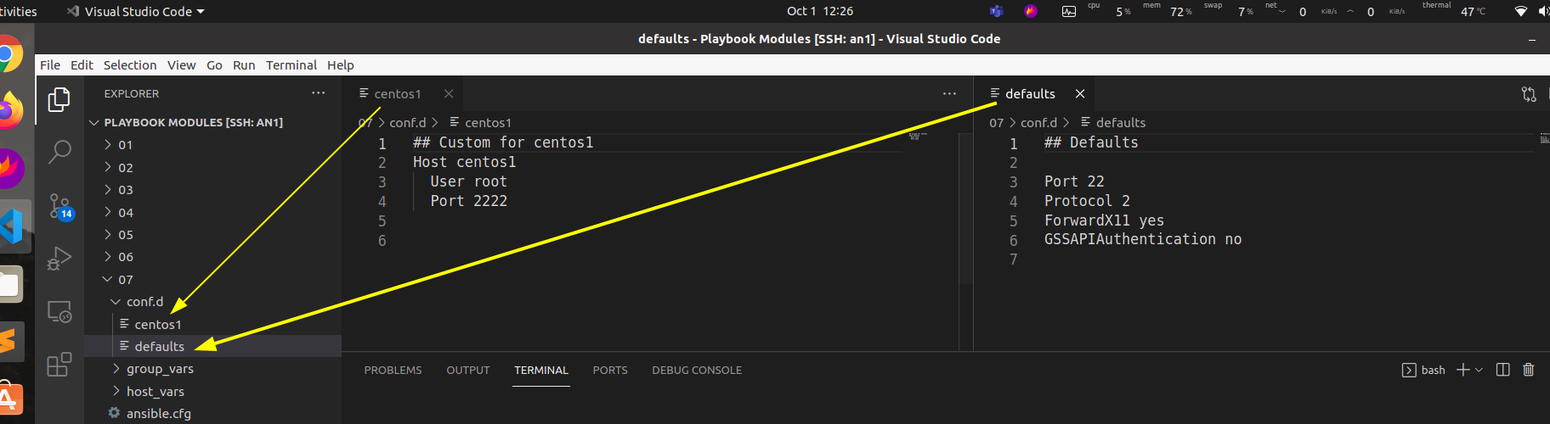

here we have only one server file for centos1 which have different attribute. suppose if we have 1000 servers with different attribute. it will be difficult to accommodate all.

Now lets open our playbook
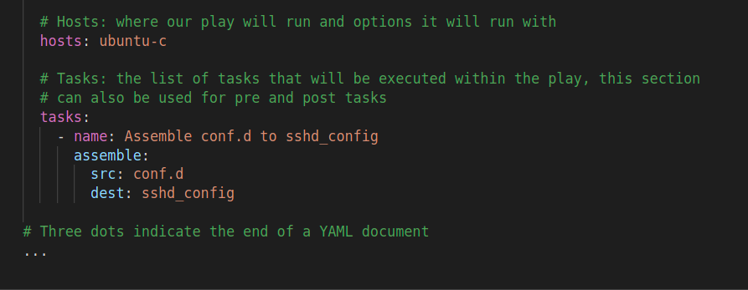

so it will assemble all file in conf.d into sshd_config file.

lets run this.

okay a new file is create sshd_config

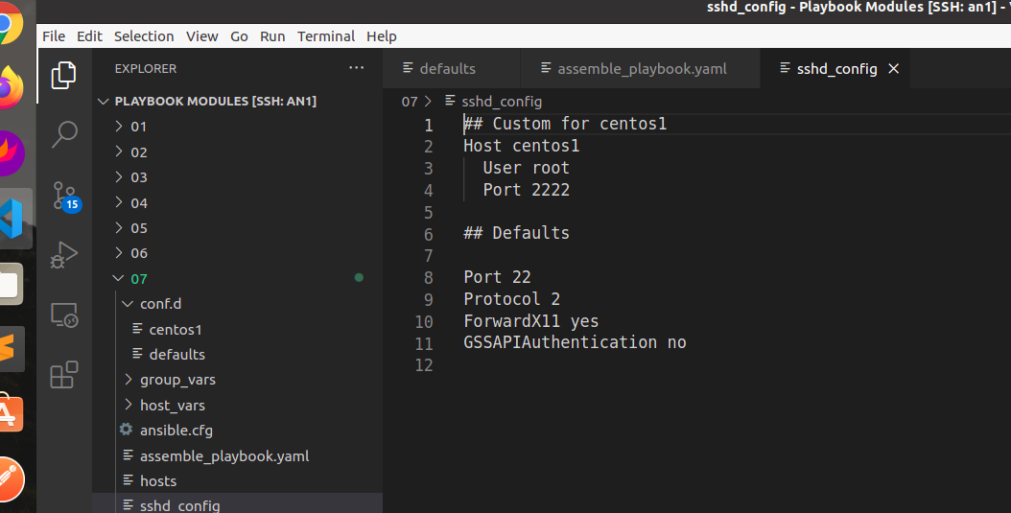

use this file to ssh to centos1.

$ ssh -F sshd_config centos1

Last login: Thu Sep 30 15:28:12 2021 from 172.20.0.9
[root@centos1 ~]#

- Add host module

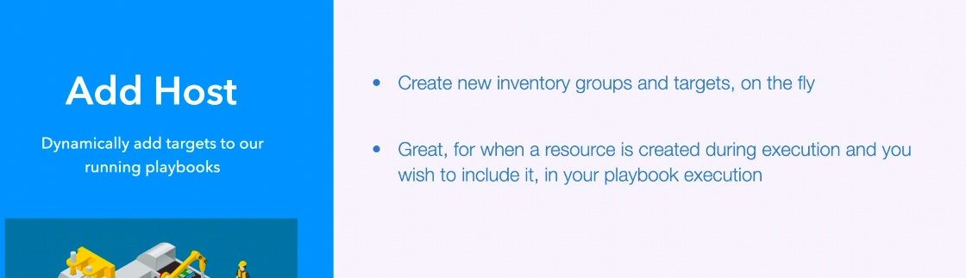

this will allow us to dynamically add host to playbook. for subsequent plays.
currently our playbook consist of one play we but we can use multiple.

Revision 8

Lets look at playbook which have multiple plays.

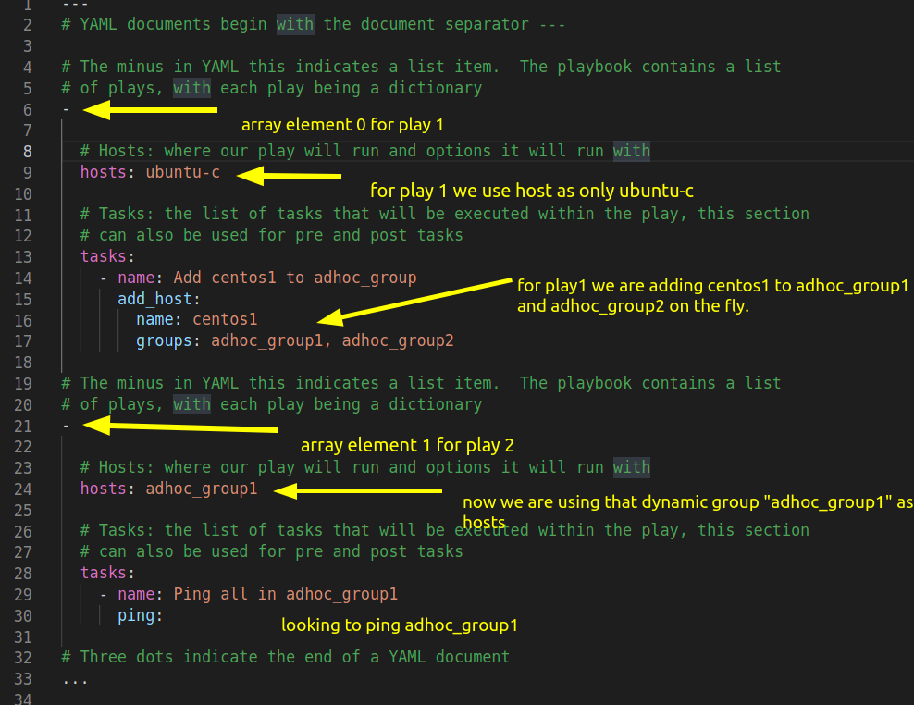

lets run this playbook.

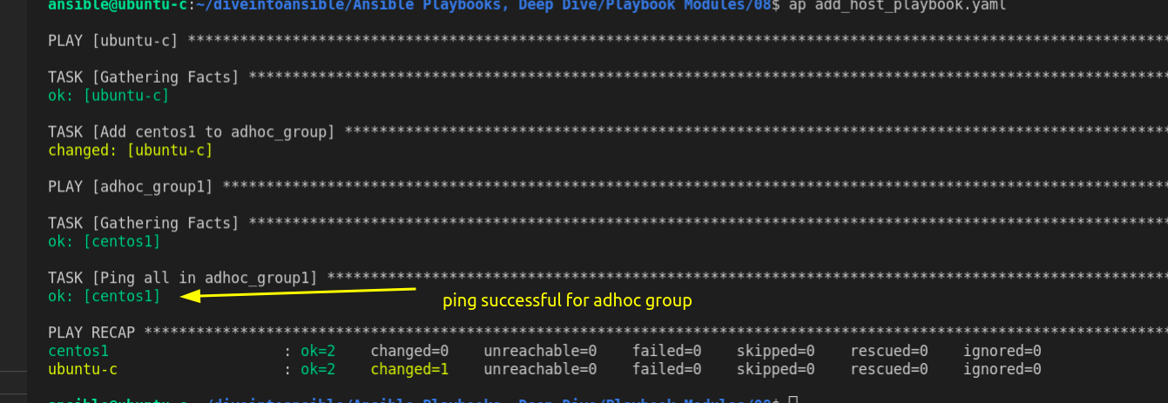

- Fetch Module

to capture file from remote host.



Revision 11

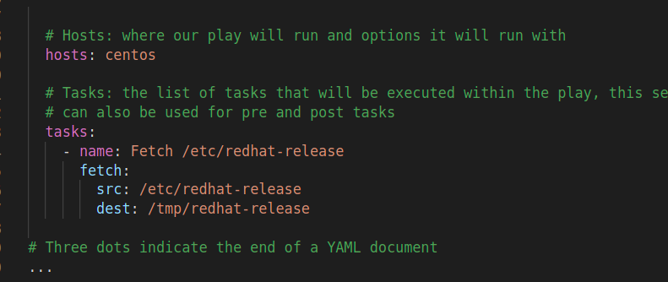

we are fetching release information file form remote centos group to local.

in local machine it will create sub-directory in /tmp/redhat-release to name of remote machine, this means this file belong to that host.

