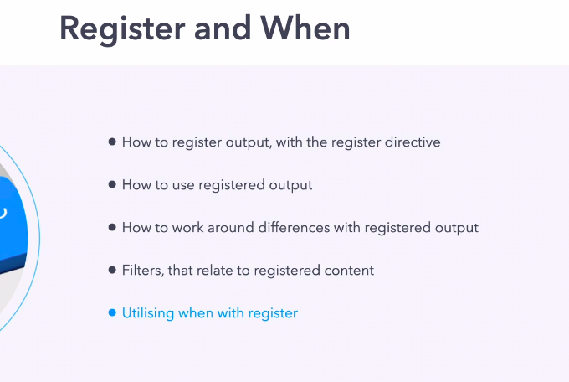

Basically register a an attribute (like when), which basically used to put output value into a variable i.e. registering a variable.

Example we will run "hostname -s" command module in remote machine and register (store) that value into a varibale.

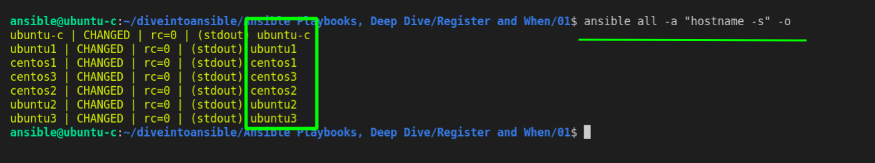

Revision 1

pwd :- /home/ansible/diveintoansible/Ansible Playbooks, Deep Dive/Register and When/01

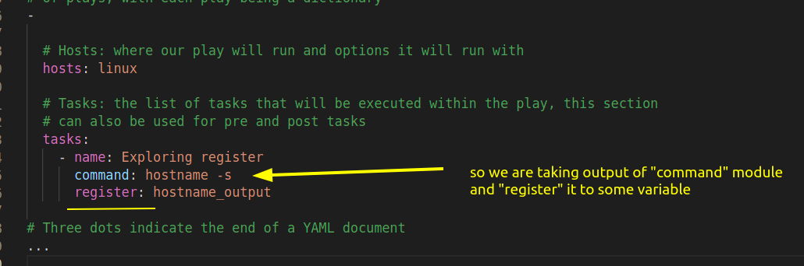

lets run this

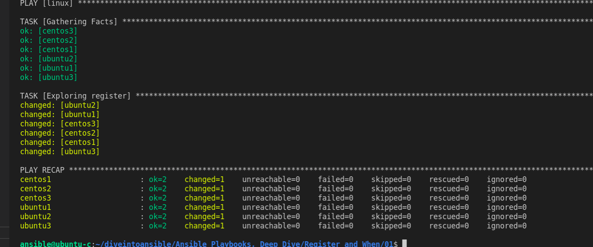

Okay its run successfull, we didn't ask to output anything that why it would not print.

Revision 2

how can we access information that we have register.

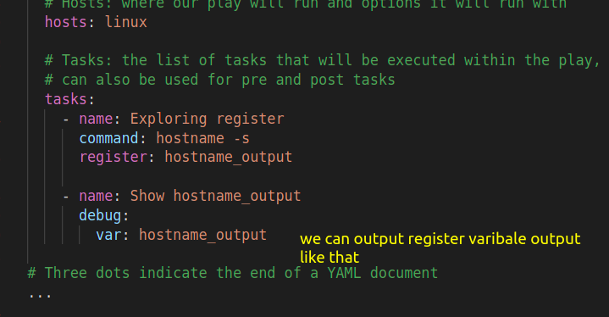

lets run that.

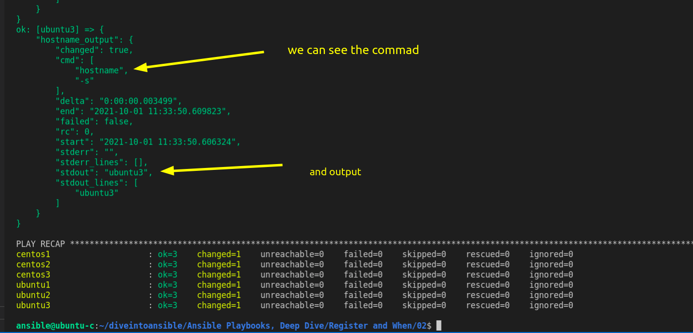

we can also see, return code (rc), start and end time, fail status as well.

lot of information are there.

Revision 5

better when condition

# Hosts: where our play will run and options it will run with
hosts: linux
# Tasks: the list of tasks that will be executed within the play, this section
# can also be used for pre and post tasks
tasks:
- name: Exploring register
command: hostname -s
when: ( ansible_distribution == "CentOS" and ansible_distribution_major_version == "8" ) or
( ansible_distribution == "Ubuntu" and ansible_distribution_major_version == "20" )
# Three dots indicate the end of a YAML document

or if we want only specific version of os is required :-

Revision 6

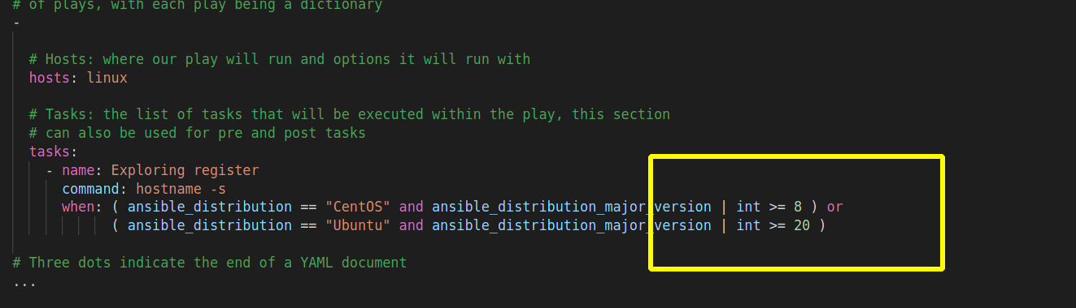

for when statement you can also provide the list of condition in yaml. like

Revision 7
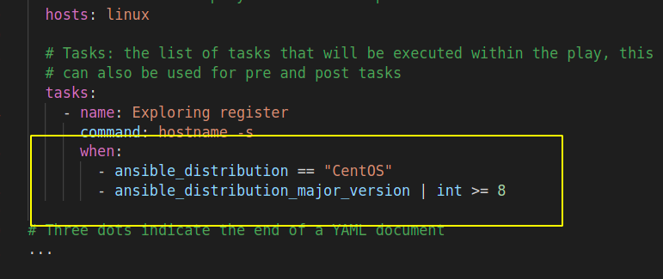

This automatically converted to AND logic

combining register output with when

Revision 8

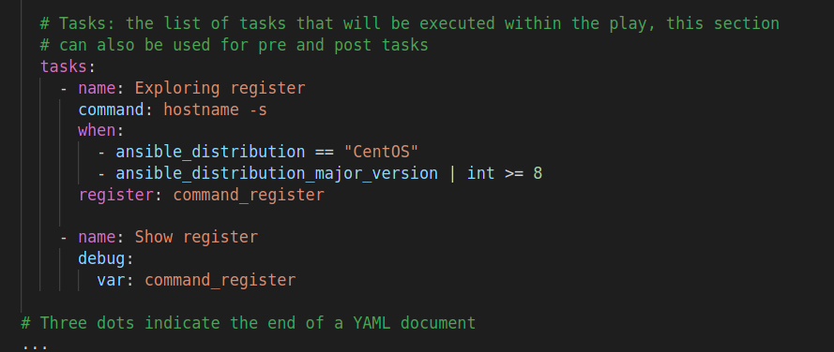

lets run this :-

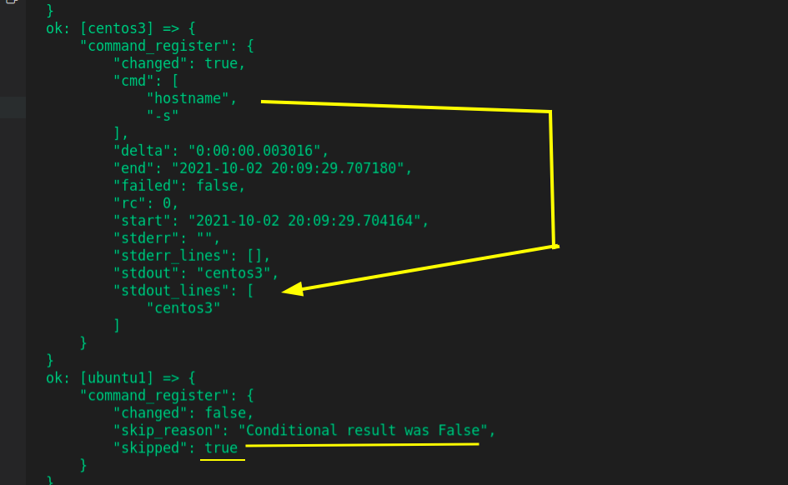

so we can see condition true for centos also it capture register information and condition is false for ubuntu so it skip.

using register condition in when
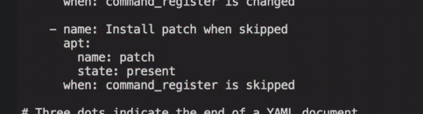

"is" means inside command_register's json there is a field called as skip if it is true. install patch.

