Looping through list

Here we are performing same task for variety of hosts.

for example creating user in each host.

this user module allow us to create user in linux system.

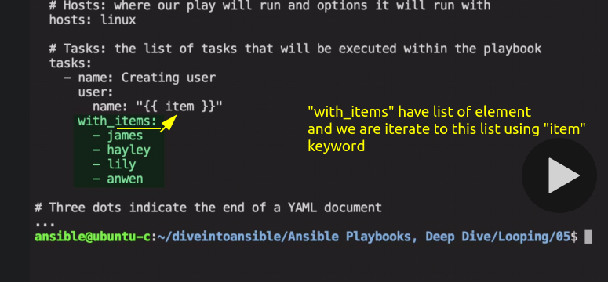

this list is passed to task as an item

Revision 5

lets run this :-

PWD :- /home/ansible/diveintoansible/Ansible Playbooks, Deep Dive/Looping/05

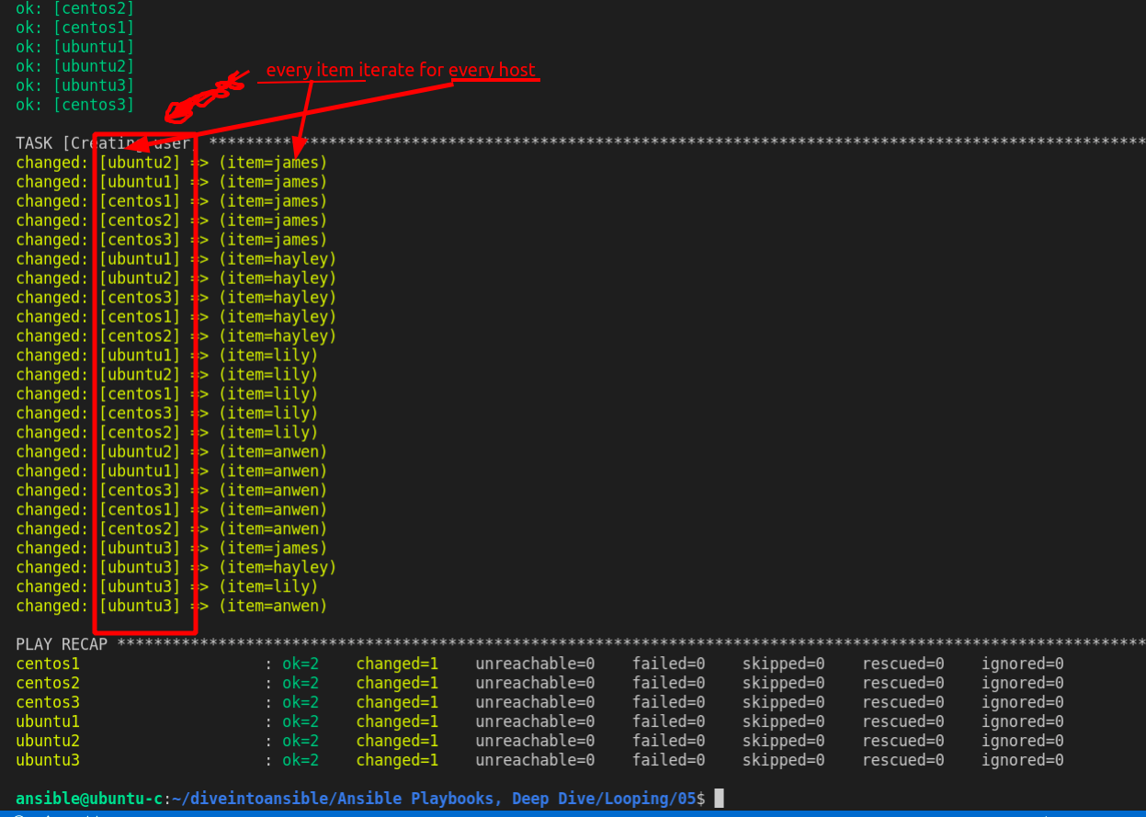

Okay user has been created.

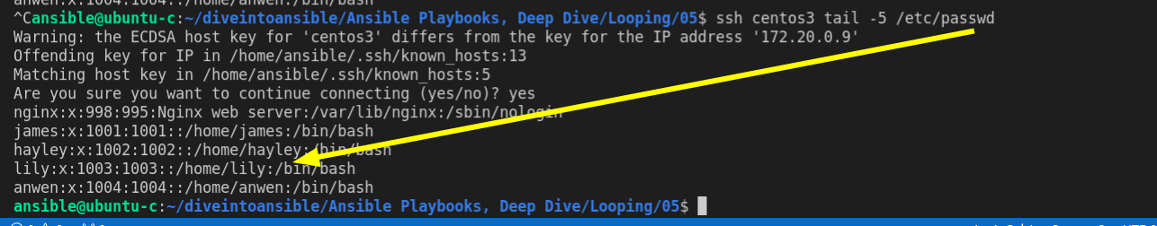

Revision 6

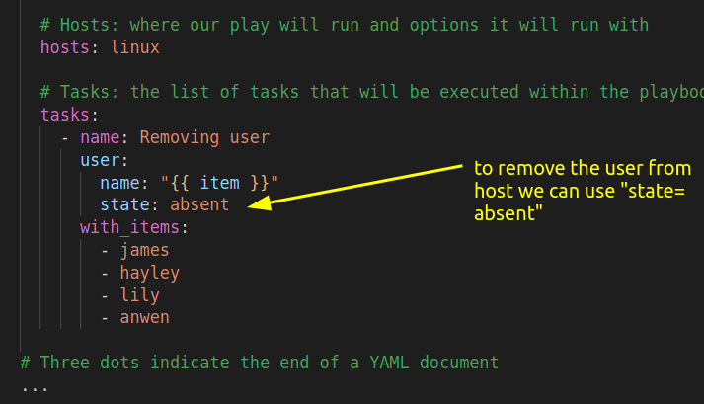

Looping through Dictionary

Revision 7

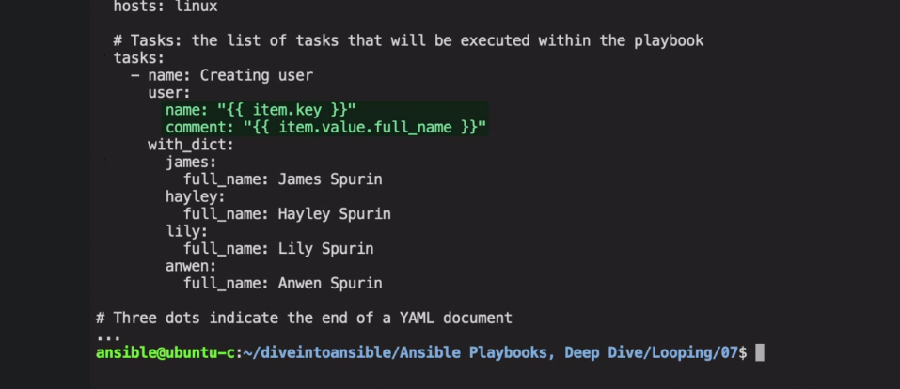

Here are using "with_dict" attribute, which define a dictionary in yaml format, (focus on indentation for dictionary creation in yaml format)

this dict is passed to task as an item

we are using dot notation to access each item.

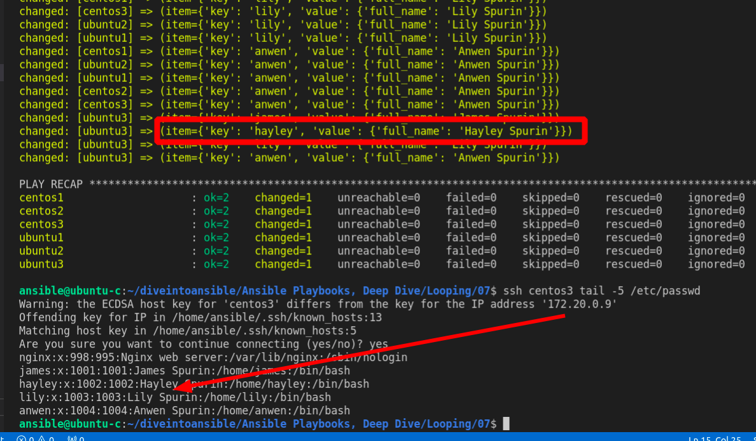

Revision 12

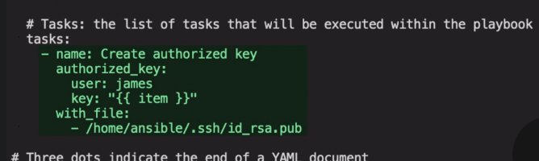

with_file use to pass file as item to task.

authorized_key is module for setting ssh-auth-key

