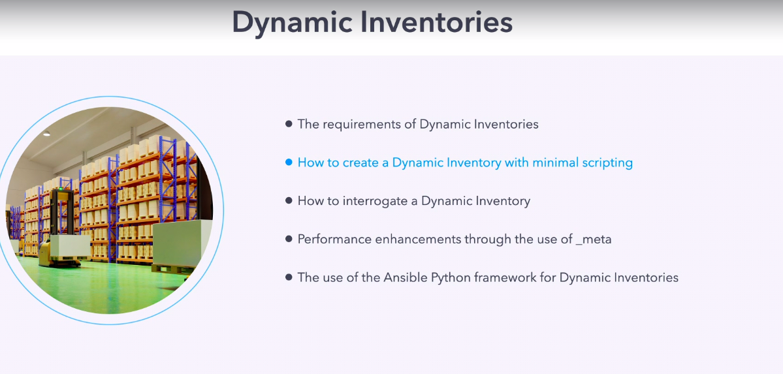

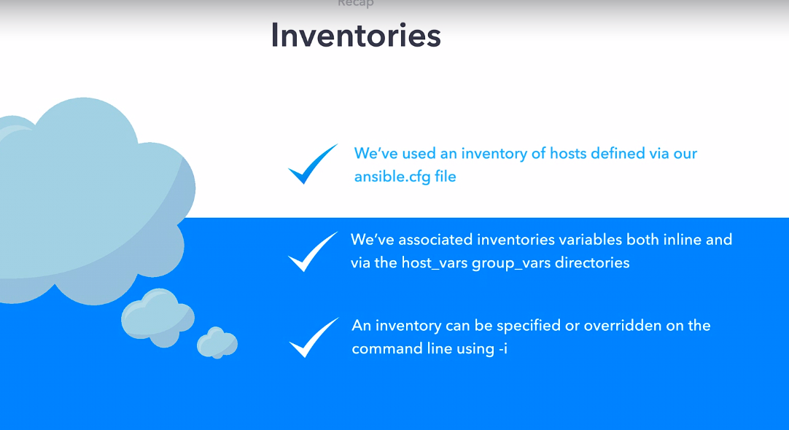

we know that in cli we can specify inverntory using "-i" flag, so suppose if inventory file is executable and this executable file return dynamic content according to inventory, we can use this file as dynamic inventory

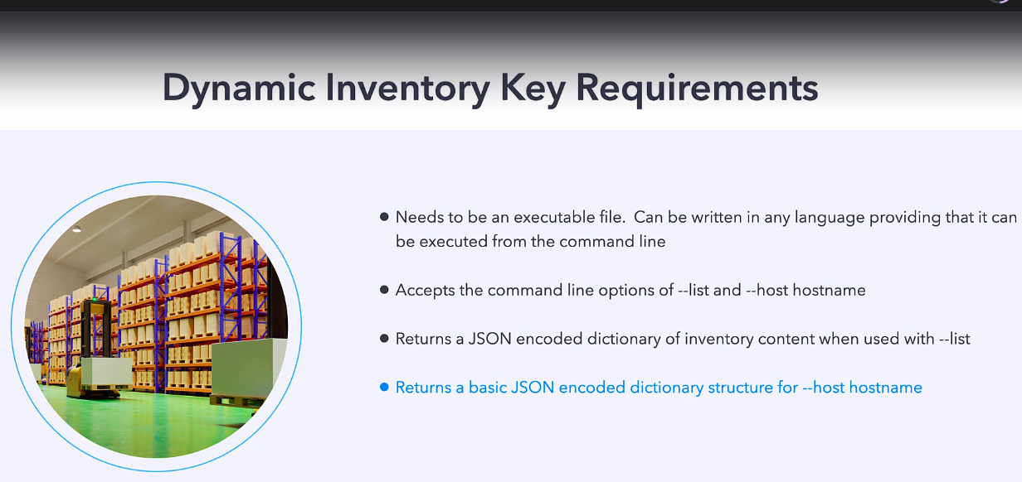

lets see dynamic inventory executable command :-

Revision 1

there is inventory.py file
let run this $ ./inventory.py

pwd :- /home/ansible/diveintoansible/Ansible Playbooks, Deep Dive/Dynamic Inventories/01

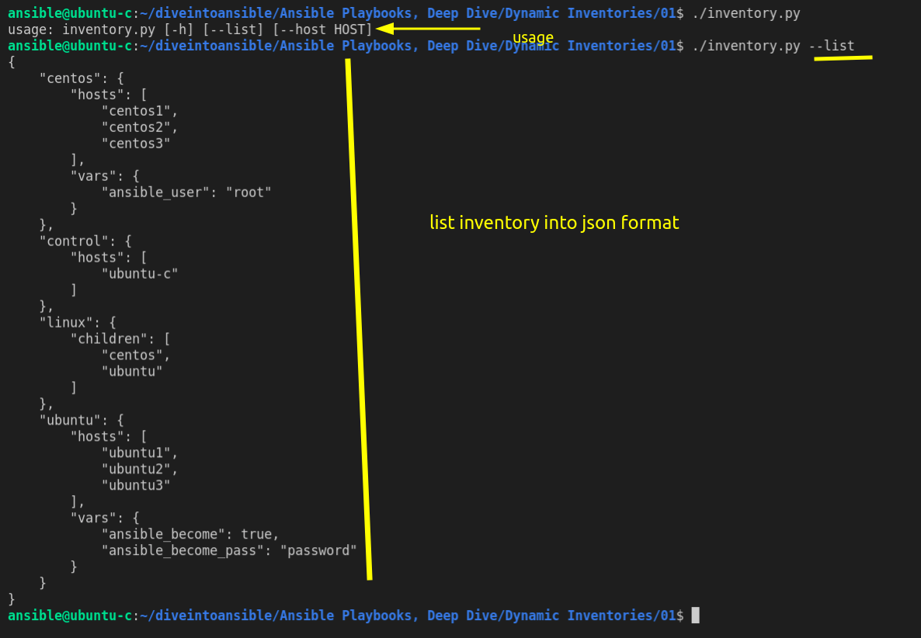

we can see above "linux" group has children specified.



/inventory.py --host centos1 ==> this will print host related vars.

so this is required as per input and output from executable script irrespective of language it is written.
If it fulfull this criteria we can use this as inventory.

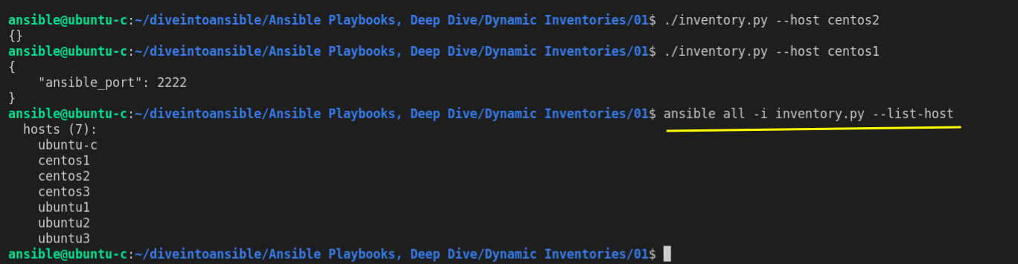
try ping module:-
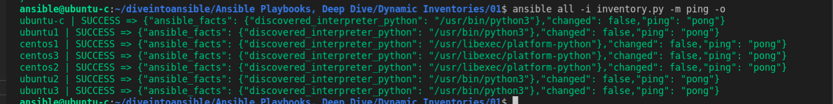

Revision 2

here we have same file but debugging turn on

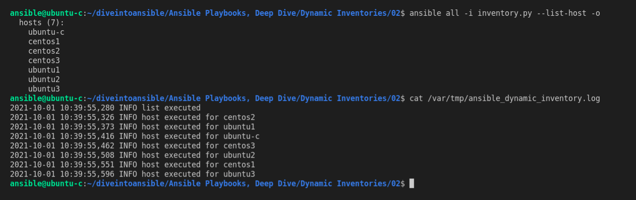

cat /var/tmp/ansible_dynamic_inventory.log

Basically what happen is :-
- it calls "--list"
- then it call "--host" for each item in list.

it take significant amount of time for doing that as:-

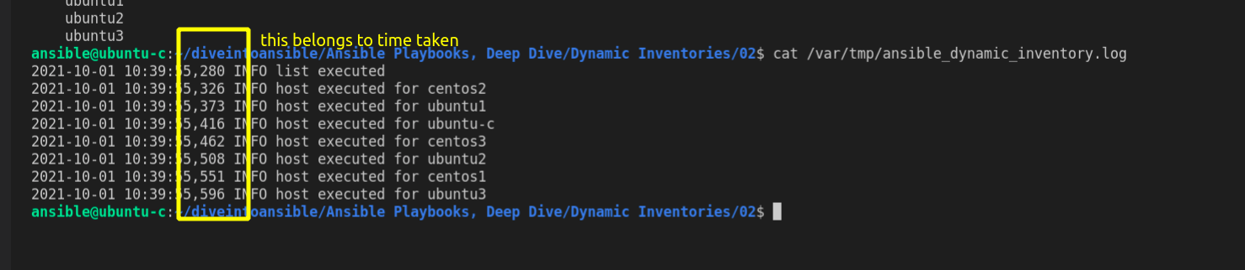

but suppose if we have thousand of server. this will not be efficient way.

Revision 3

we are going to create fake hosts to see problem

