CloudFront LAB

we are going to use S3 as Origin. it is not part of S3. it is part of network deliverly and content.

click on cloudFront --> it a gobal service.

click on create distribution ---> there are two option to select like :-
- Web --> website static/dynamic
- RTMP (now Deleted by AWS)

there is something around 205 edge location for cloudFront through which we can serve our content.
but there is no relation of edge location with region. CloudFront main motive is to cache you data.
Edge location can communicate with region but they both are independent entity.

there may be 11 region onto which regional cache is present its use is like if cloudfront edge has less popular data so it will send this data to regional cache to free up some cache space, this ways CloudFront avoide to query more from main server.

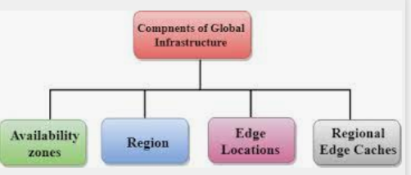

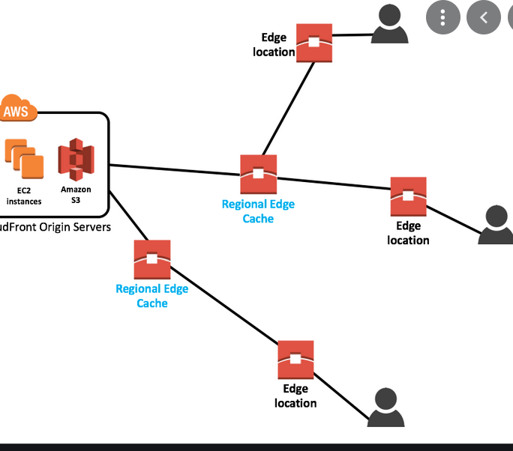

CloudFront also keeps persistance connection with origin server so that files are fetch from origin serve as quickly as possible. (so this is keep alive session)

this is strictly for regional cache , not with cloudfront edge:-
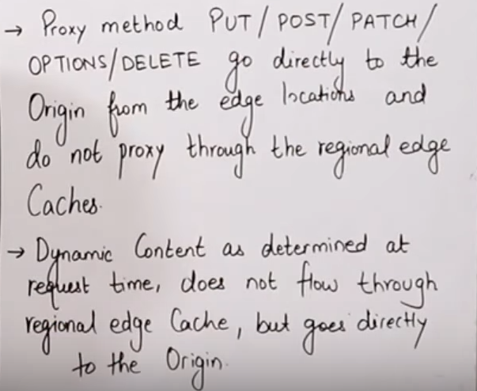

Practical:-

Step1:- create bucket with public access which have index.html file with is make public.

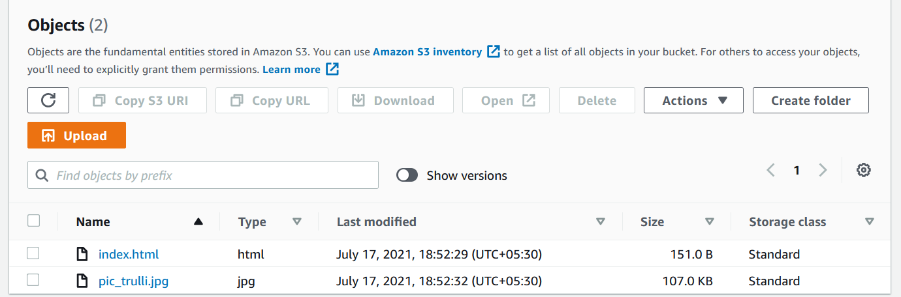

Step2:- Now go to CloudFront
  - origin Domain --> select your bucket
  - origin path (optional) ---> if you content lie inside any folder, give the name of folder.

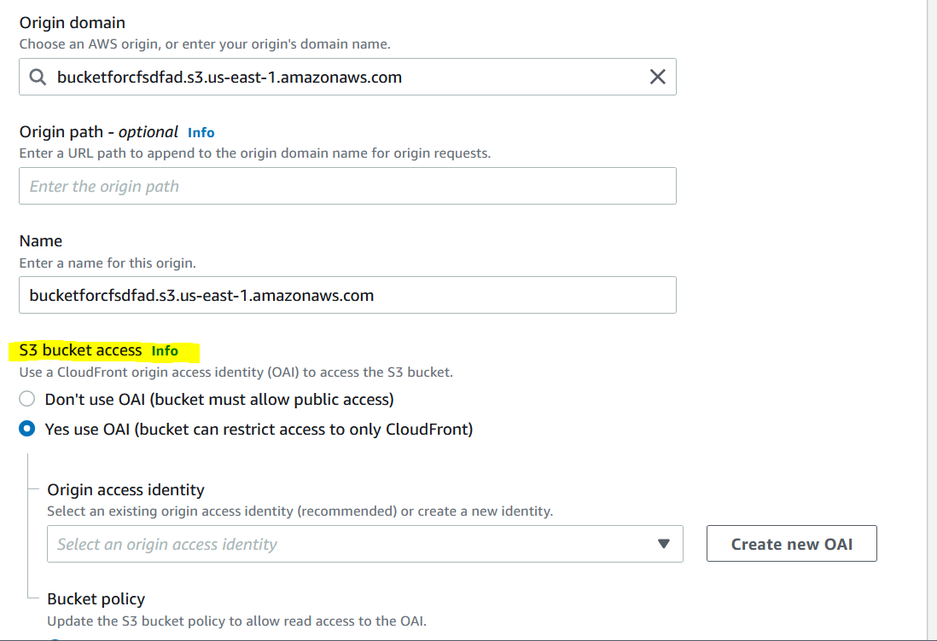

here this S3 Bucket option is important as Allowing this option will let only CloudFront to access the bucket.

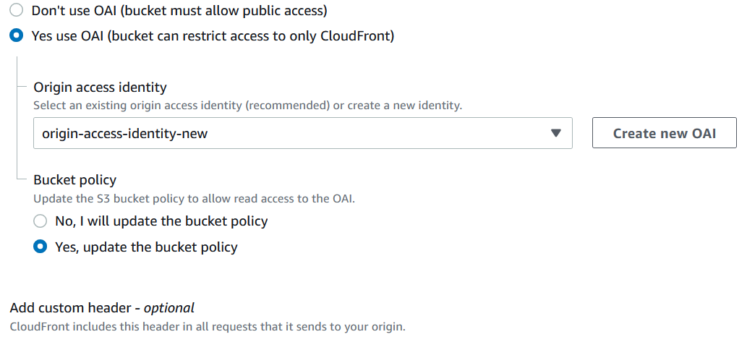

An Origin Access Identity (OAI) is used for sharing private content via CloudFront. The OAI is a virtual user identity that will be used to give your CF distribution permission to fetch a private object from your origin server (e.g. S3 bucket).

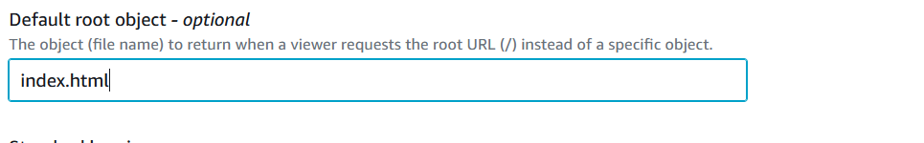

so it will directly open index.html, so we don’t need to add "/" in uri

lets put remaining things as default and create your distribution

now our CloudFront distribution is created and we are able to browse with that URl

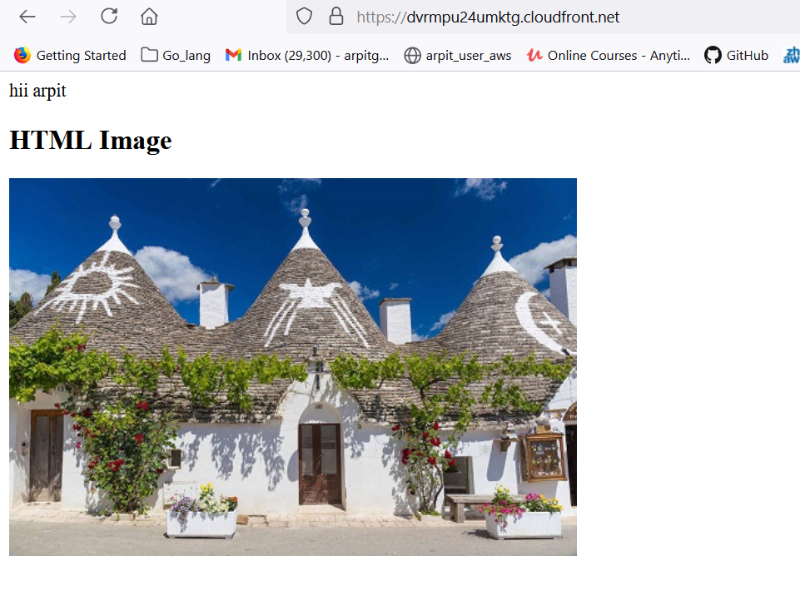

https://dvrmpu24umktg.cloudfront.net/pic_trulli.jpg by this "/" we are able to see image individually.

we are also restrict some object if we don’t want to serve that.

