We basically use AMI wrt

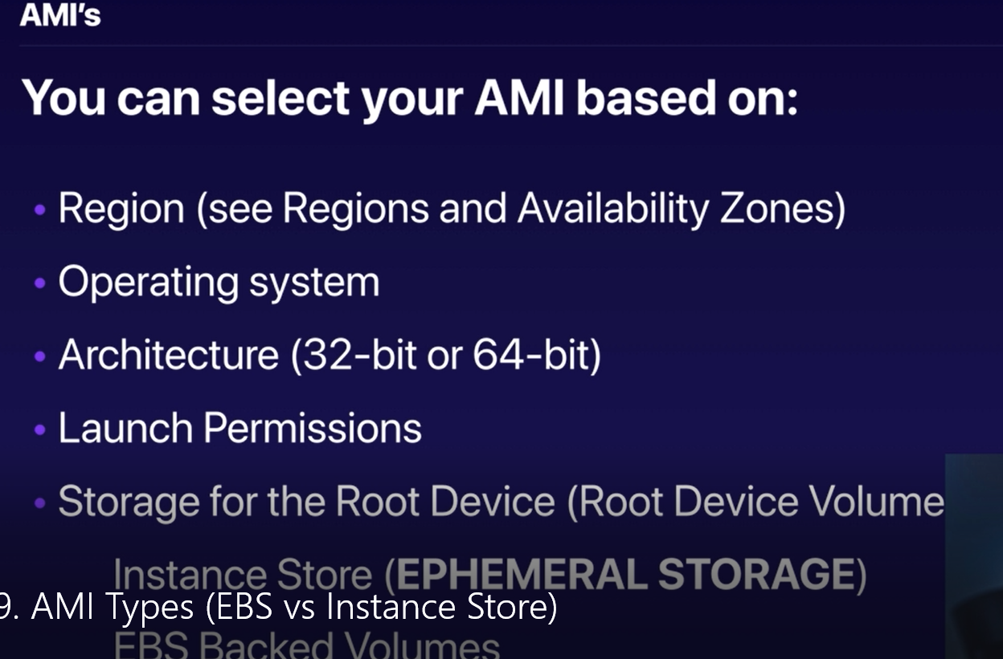

here we have two kind of storage:-
- Instance storage (somethimes called as EPHERAL STORAGE) ie here you can loss data.
as these where running strictly on specific hypervisor, also we it by default do not generate EBS volume.
- EBS Backend volumes (which we generally use) => here you can stop this, after start it can run on different hypervisor, no case for data loss.

